Figures S28 to S44 show Gene Solvent Accessible Surface Area (SASA) plots for 17 protein-ligand complexes:

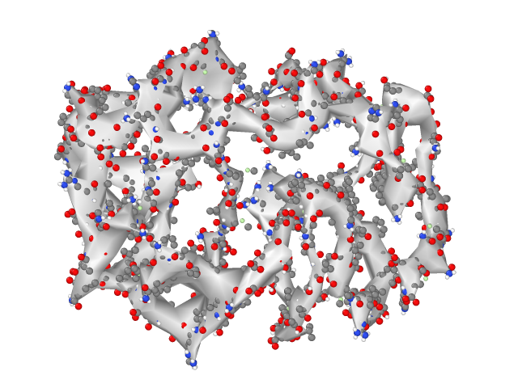
Figure S28 - Complex 01 – SASA plot of the Moracin P–GPD2 complex over the 500 ns MD simulation.

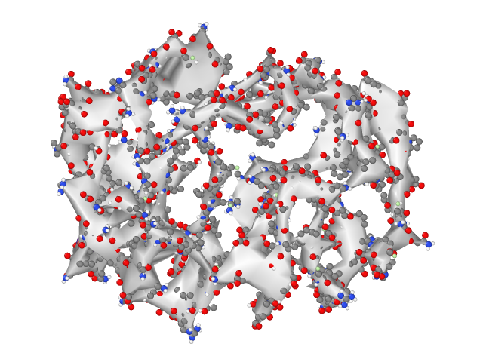
Figure S29 - Complex 02 – SASA plot of the Moracin D–GPD2 complex over the 500 ns MD simulation.

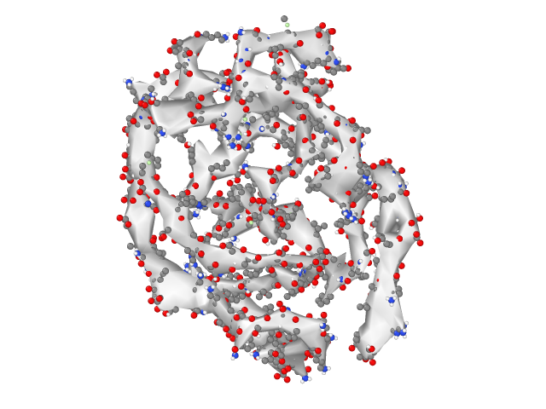
Figure S30 - Complex 03 – SASA plot of the Plantagineoside A–PPARG complex over the 500 ns MD simulation.

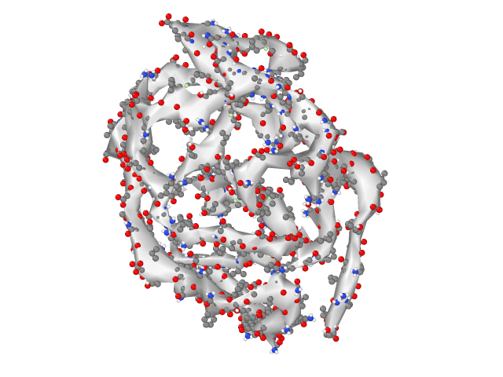
Figure S31 - Complex 04 – SASA plot of the Pyrene–PPARG complex over the 500 ns MD simulation.

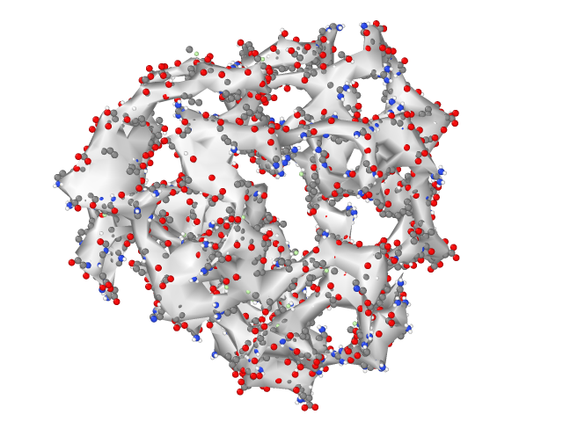
Figure S32 - Complex 06 – SASA plot of the Rohitukine–GCK complex over the 500 ns MD simulation.
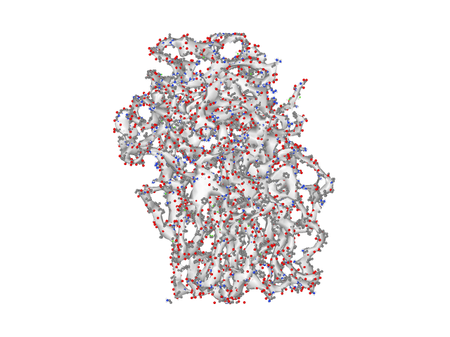
Figure S33 - Complex 07 – SASA plot of the Berberrubine–ABCC8 complex over the 500 ns MD simulation.

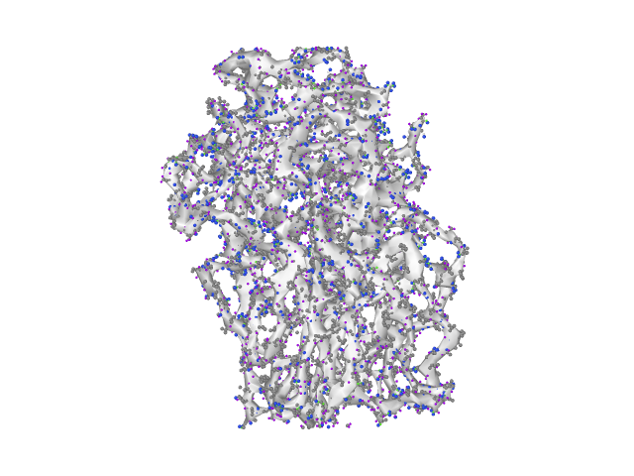
Figure S34 - Complex 08 – SASA plot of the Berberine Chloride–ABCC8 complex over the 500 ns MD simulation.

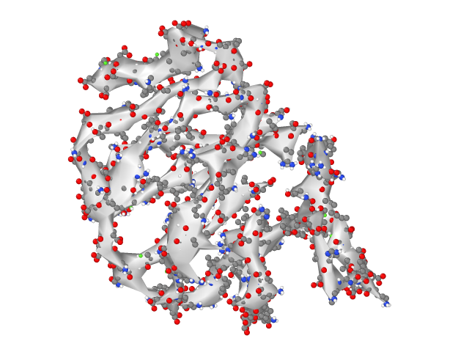
Figure S35 - Complex 09 – SASA plot of the Apigenin–MAPK8 complex over the 500 ns MD simulation.

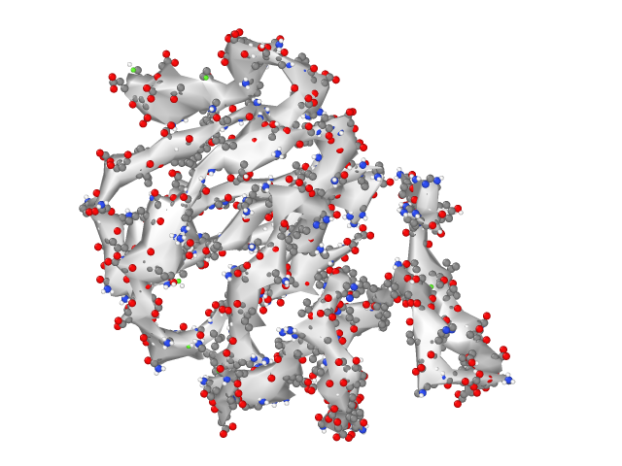
Figure S36 - Complex 10 – SASA plot of the Emodin–MAPK8 complex over the 500 ns MD simulation.

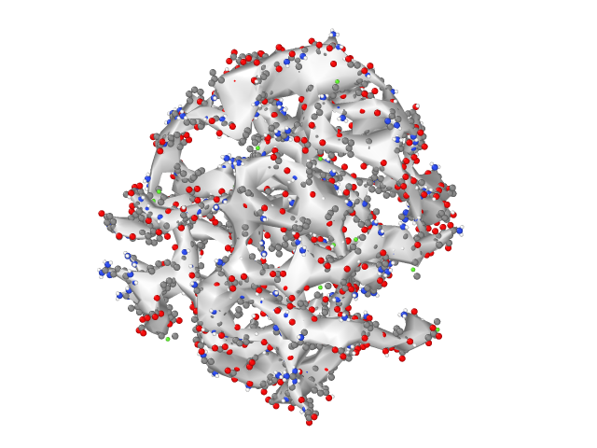
Figure S37 - Complex 11 – SASA plot of the Chelerythrine–AKT2 complex over the 500 ns MD simulation.

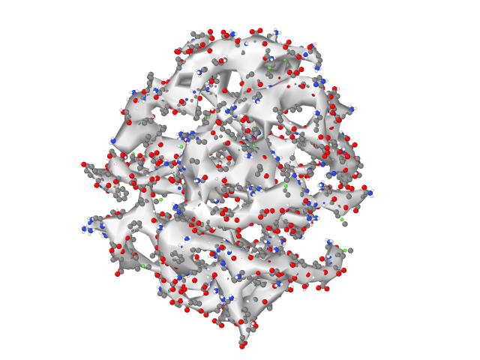
Figure S38 - Complex 12 – SASA plot of the Alvocidib–AKT2 complex over the 500 ns MD simulation.

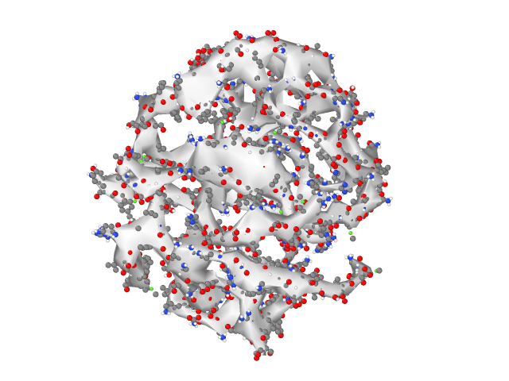
Figure S39 - Complex 13 – SASA plot of the A-443654–AKT2 complex over the 500 ns MD simulation.

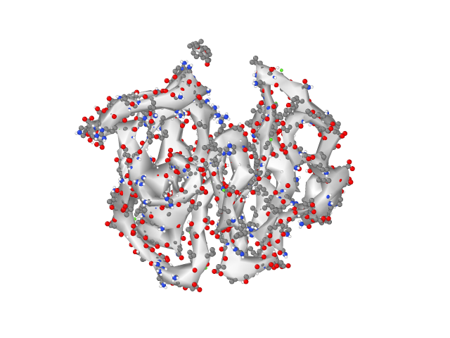
Figure S40 - Complex 14 – SASA plot of the Xambioona–PTPN1 complex over the 500 ns MD simulation.

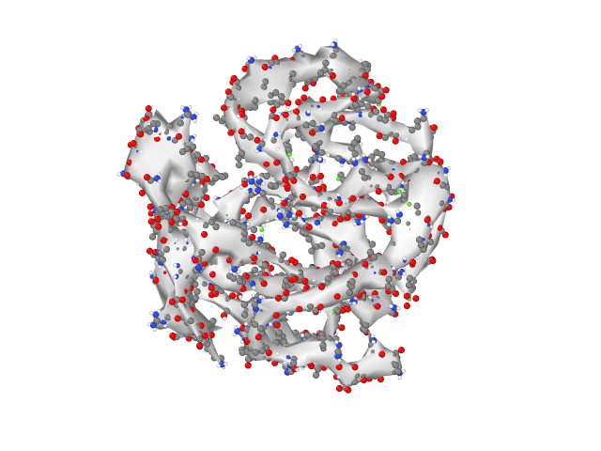
Figure S41 - Complex 15 – SASA plot of the Altertoxin I–INSR complex over the 500 ns MD simulation.

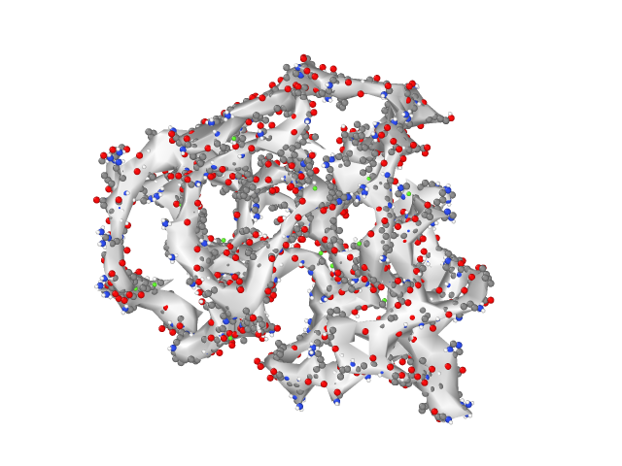
Figure S42 - Complex 16 – SASA plot of the Chelerythrine–AMPK complex over the 500 ns MD simulation.

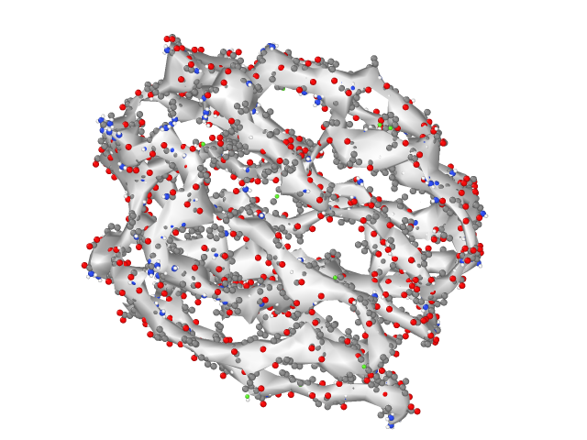
Figure S43 - Complex 17 – SASA plot of the Ursolic Acid–SLC2A4 complex over the 500 ns MD simulation.

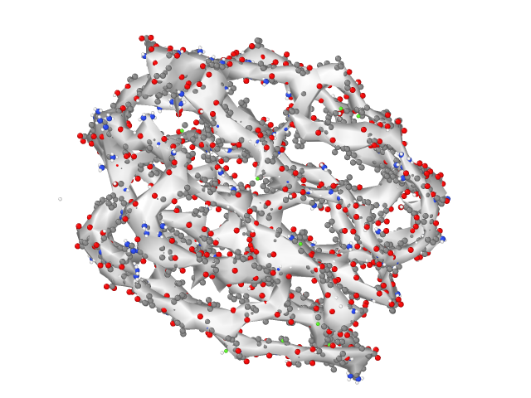
Figure S44 - Complex 18 – SASA plot of the Oleanolic Acid–SLC2A4 complex over the 500 ns MD simulation.

