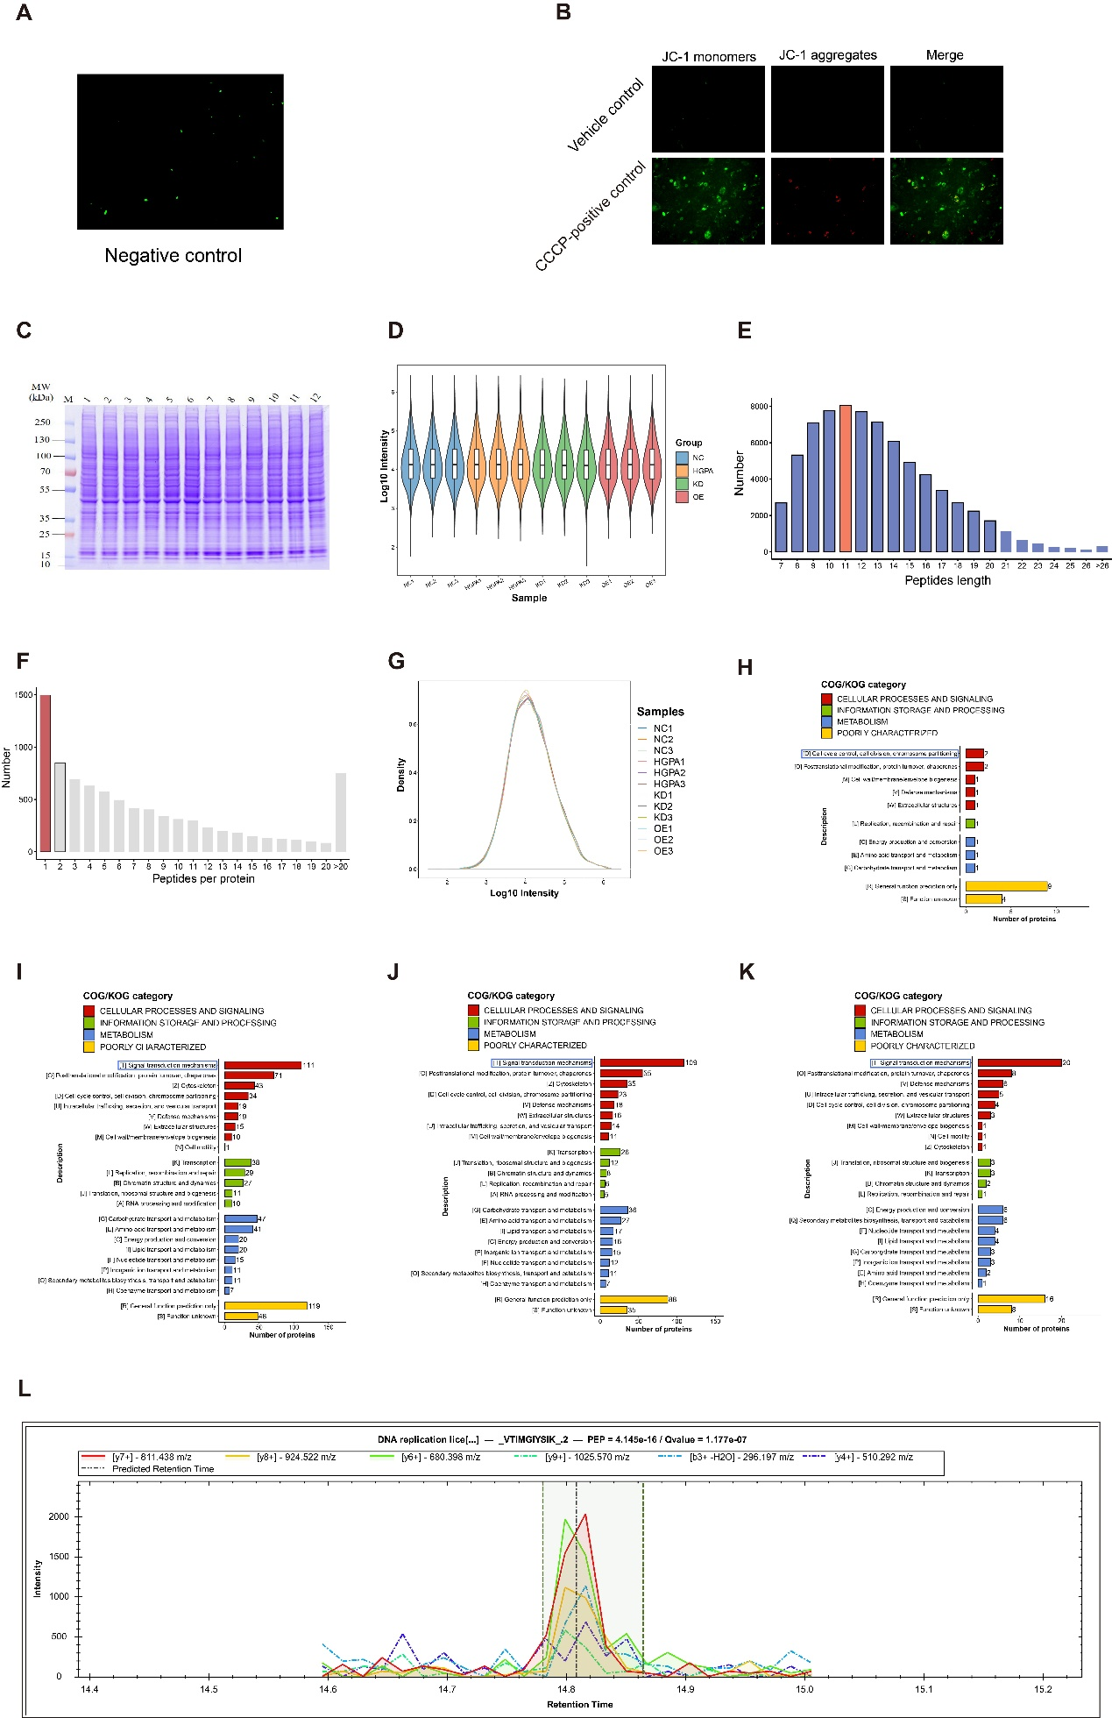
Supplementary Figure S3：(A) Control images of cells lacking fluorescent protein lentivirus. (B) JC-1 detection negative controls (no dye/vehicle control) and positive controls (CCCP treatment). (C) SDS–PAGE analysis of total protein from three biological replicates per group, demonstrating integrity and sufficient yield for LC-MS/MS.(D) Violin plots of log₁₀-transformed protein intensities for each sample (x-axis: sample; y-axis: log₁₀ intensity), with embedded boxplots showing the interquartile range and outer kernel density reflecting distribution probability.(E) Distribution of identified peptide lengths.（F）Distribution of the number of peptides per protein.(G) Density plot of log₁₀-transformed protein intensities across all samples (x-axis: log₁₀ intensity; y-axis: probability density).(H-K) COG/KOG functional classification bar charts for DEPs in the four comparisons. The x‑axis indicates the number of DEPs assigned to each entry; the y‑axis shows COG/KOG category codes and descriptions. Bar colors denote COG/KOG functional classes. （L）Supplementary Fig. S3L | Extracted ion chromatogram (XIC) of a representative unique MCM5 peptide VTIMGIYSIK (2+). Colored traces show extracted fragment ions: y7⁺ (m/z 811.438, red), y8⁺ (m/z 924.522, yellow), y6⁺ (m/z 680.398, green), y9⁺ (m/z 1025.570, light green), b3⁺–H₂O (m/z 296.197, cyan) and y4⁺ (m/z 510.292, purple). The dashed vertical line indicates the predicted retention time and the shaded area denotes the integration window. Peptide identification is high confidence (PEP = 4.145×10⁻¹⁶; q = 1.177×10⁻⁷). The clear co-elution of multiple fragment ions at ~14.8 min, consistent peak shapes and strong signal intensity support a robust MS identification (and reliable quantitation) of MCM5 in our dataset.

