Real-world efficacy and safety of pembrolizumab plus lenvatinib in patients with metastatic renal cell carcinoma: A multi-institutional retrospective study

Taigo Kato^{1*}, Yasutomo Nakai², Mototaka Sato³, Tetsuya Takao⁴, Toshichika Iwanishi⁵, Shingo Toyoda⁶, Hiroki Osaki⁷, Masao Tsujihata⁸, Koichi Okada⁹, Kenichi Kakimoto¹⁰, Hiromu Horitani¹¹, Yutaka Ono¹¹, Kensaku Nishimura⁹, Shingo Takada⁷, Kazutoshi Fujita⁶, Hitoshi Takayama⁵, Osamu Miyake³, Masashi Nakayama², Yu Ishizuya¹, Takuji Hayashi¹, Yoshiyuki Yamamoto¹, Koji Hatano¹, Atsunari Kawashima¹, Norio Nonomura¹

¹Department of Urology, The University of Osaka Graduate School of Medicine, Osaka, Japan
² Department of Urology, Osaka International Cancer Institute, Osaka, Japan
³ Department of Urology, Toyonaka Municipal Hospital, Osaka, Japan.
⁴ Department of Urology, Osaka General Medical Center, Osaka, Japan.
⁵ Department of Urology, Sakai City Medical Center, Osaka, Japan.
⁶ Department of Urology, Kindai University, Osaka, Japan.
⁷Department of Urology, Osaka Police Hospital, Osaka, Japan.
⁸ Department of Urology, Osaka Rosai Hospital, Osaka, Japan.
⁹ Department of Urology, National Hospital Organization Osaka National Hospital, Osaka, Japan
¹⁰ Department of Urology, Nippon Life Hospital, Osaka, Japan
¹¹ Department of Urology, Higashiosaka City Medical Center, Osaka, Japan

Supplementary Table S1: Detailed patients' characteristics according to age
Variable | Age<75 | Age>=75 | p value
Total number | 83 | 35
Sex, n(%)
Male | 64 (84.8) | 21 (60.0) | 0.060
Female | 19 (15.2) | 14 (40.0)
KPS
80-100 | 78 (94.0) | 31 (88.6) | 0.312
< 80 | 5 (6.0) | 4 (11.4)
Number of metastatic sites
Single | 44 (53.0) | 24 (68.6) | 0.118
Multiple | 39 (47.0) | 11 (31.4)
Tissue type
Clear | 74 (89.2) | 32 (91.4) | 0.709
Non-clear | 9 (10.8) | 3 (8.6)
IMDC risk
Favorable | 18 (21.7) | 9 (25.7) | 0.963
Intermediate | 41 (49.4) | 19 (54.3)
Poor | 24 (28.9) | 7 (20.0)
NLR
Low (< 4) | 34 (41.0) | 24 (68.6) | 0.006
High (≥ 4) | 49 (59.0) | 11 (31.4)
CRP
Low (< 1.0) | 62 (74.7) | 11 (31.4) | 0.0001
High (≥ 1.0) | 21 (25.3) | 24 (68.6)
Discontinuation of drugs
Pembrolizumab | 37 (44.6) | 20 (57.1) | 0.212
Lenvatinib | 40 (48.1) | 26 (74.3) | 0.009
Reason for discontinuation
Disease progression | 11 (13.3) | 6 (17.1) | 0.583
Adverse events | 24 (28.9) | 11 (31.5) | 0.785
Others | 4 (4.8) | 0 (0) | 0.186

CRP; C-reactive protein, IMDC; International Metastatic RCC Database Consortium, KPS; Karnofsky performance status, NLR; Neutrophil-lymphocyte ratio

Supplementary Figure S1: Survival analysis for patients with International Metastatic RCC Database Consortium (IMDC) favorable- and those with intermediate/poor- risk
Kaplan-Meier curve of (A) progression-free survival (PFS) and (B) overall survival (OS) in patients with IMDC favorable/intermediate- (n = 27) and poor-risk (n = 91) groups. (C) Comparative analysis of baseline C-reactive protein levels between IMDC intermediate/poor- and favorable risk-groups.
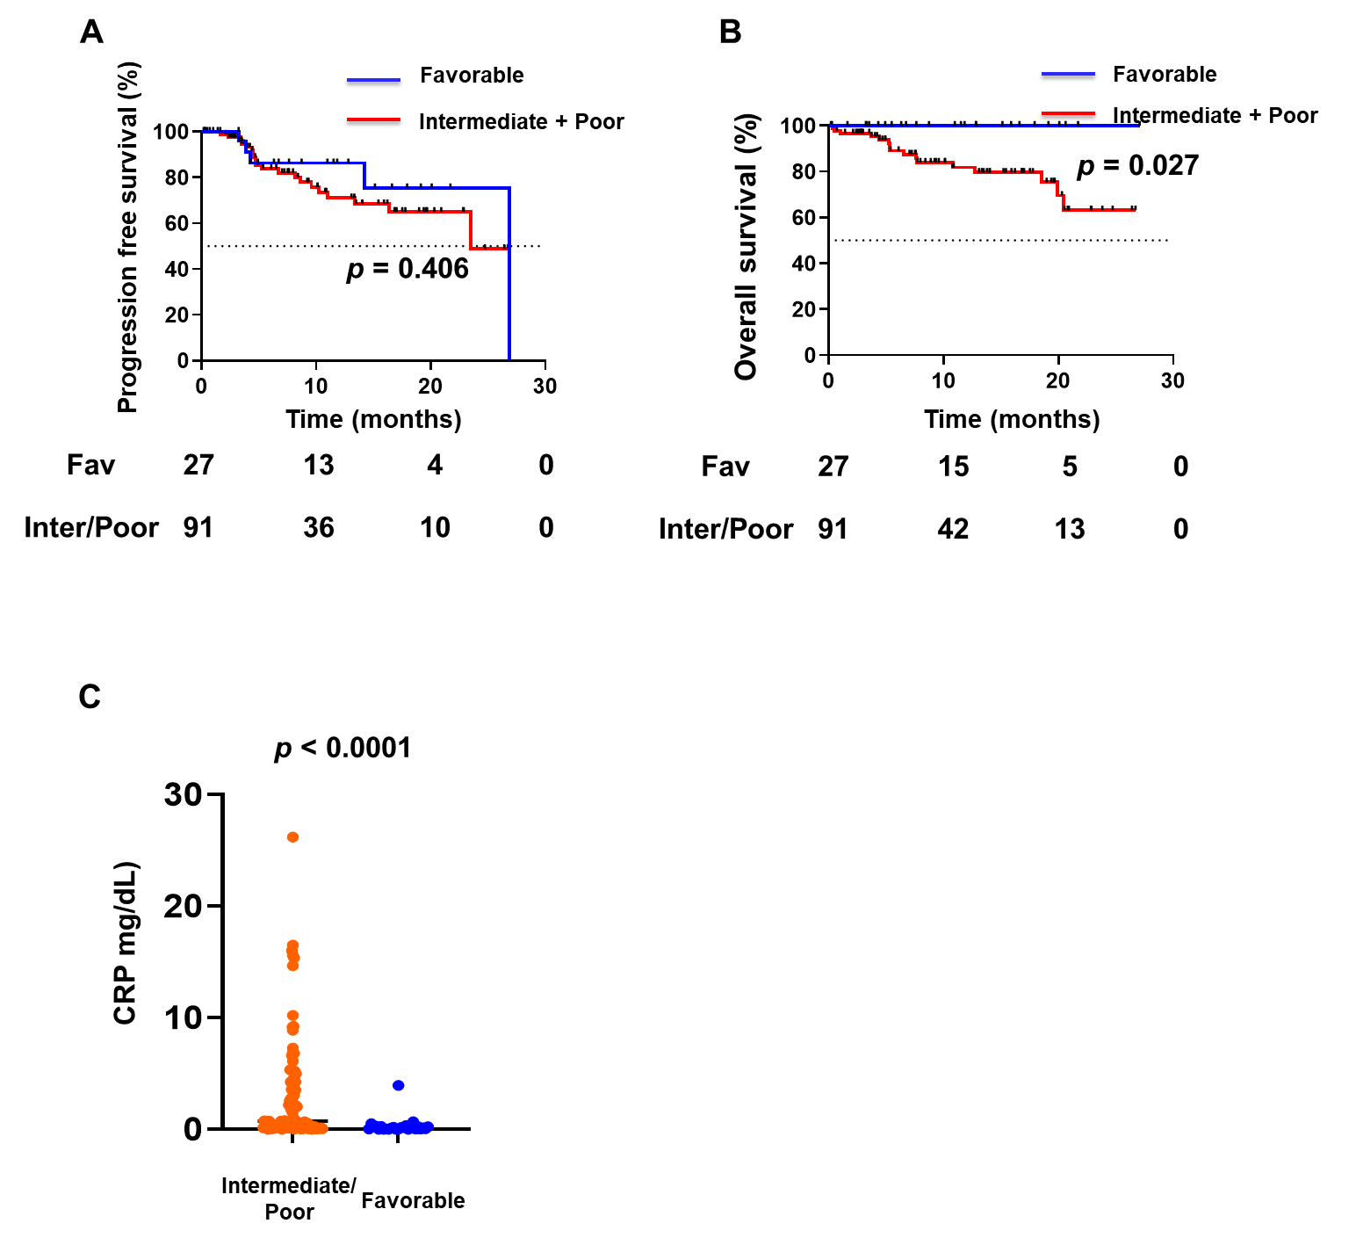

Supplementary Figure S2: Progression-free survival according to prior cytoreductive nephrectomy prior to initiating treatments in patients with International Metastatic RCC Database Consortium (IMDC) intermediate- or poor- risk group
(A) Progression-free survival (PFS) in patients with IMDC intermediate- risk (n = 32) according to the presence or absence of upfront cytoreductive nephrectomy (CN). (B) PFS in patients with IMDC poor- risk (n = 29) stratified by upfront CN status. NR; not reached.
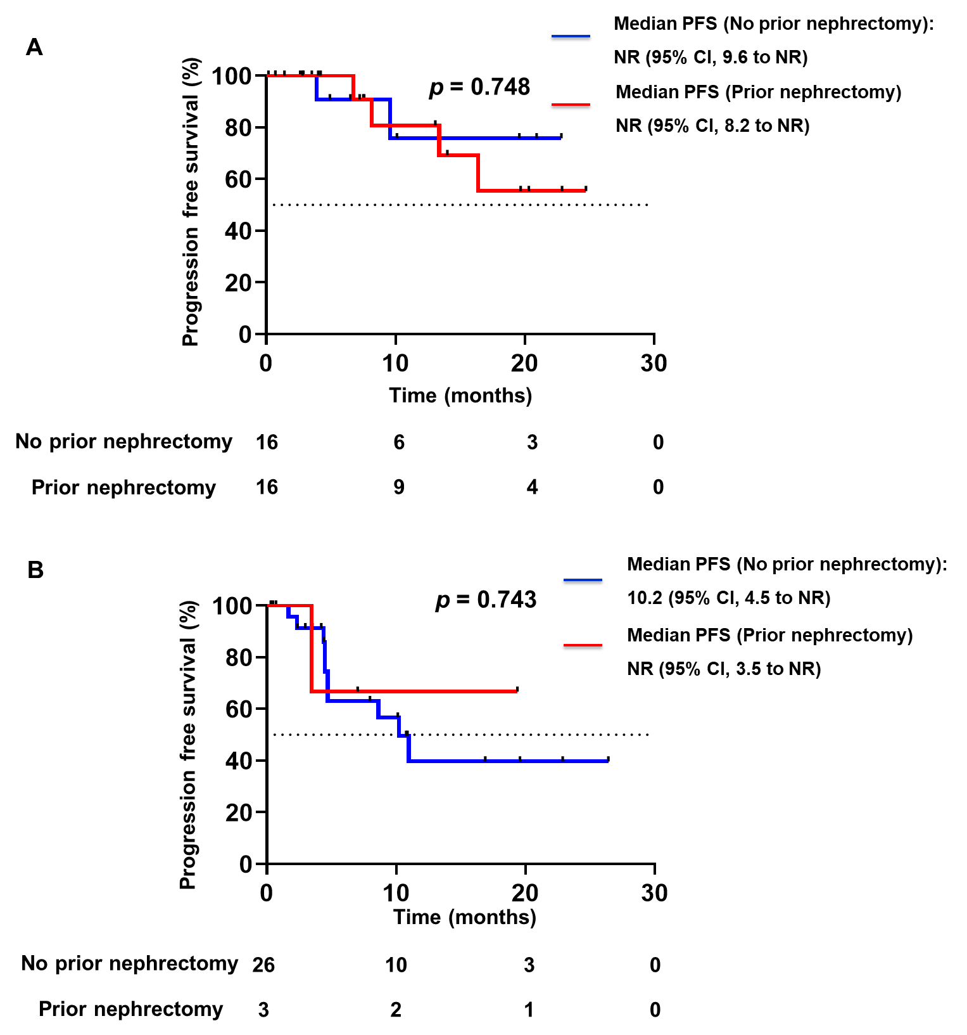

Supplementary Figure S3: Overall survival according to prior cytoreductive nephrectomy prior to initiating treatments in patients with International Metastatic RCC Database Consortium (IMDC) intermediate- or poor- risk group
(A) Overall survival (OS) in patients with IMDC intermediate- risk (n = 32) according to the presence or absence of upfront cytoreductive nephrectomy (CN). (B) OS in patients with IMDC poor- risk (n = 29) stratified by upfront CN status. NR; not reached.
