Supplementary Information
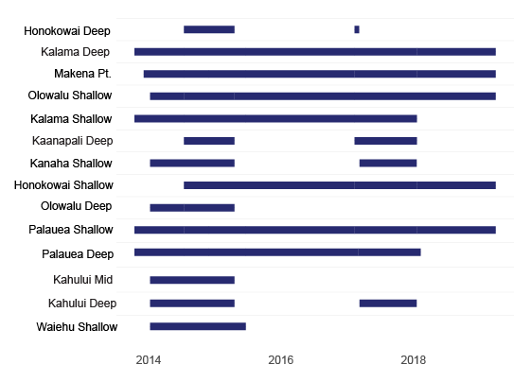
Figure S1. Gantt chart of Maui receiver coverage throughout monitoring period.
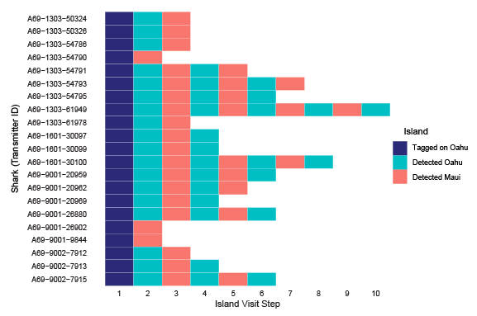
Figure S2. O‘ahu-Tagged shark inter-island movement sequences. First visit step indicates their capture and tag around O‘ahu, regardless of their first detection island.

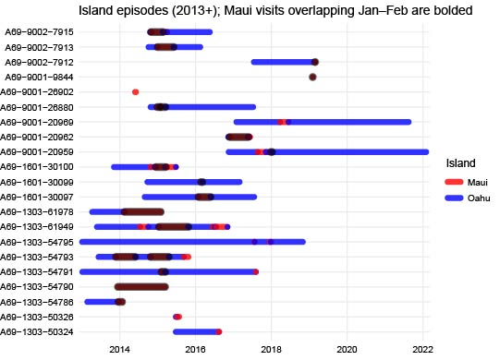
Figure S3. Island visitation timelines for Oahu-tagged sharks. Maui trips that overlapped with any part of the peak mating season (Jan/Feb) are bolded with black shading.
Acoustic Monitoring System
Receivers were deployed on subsurface moorings consisting of an end weight or sand screw, 2 to 3 meters of polypropylene rope, and a hard float. Receivers were attached to the mooring rope using heavy-duty nylon cable ties and stainless-steel hose clamps. SCUBA divers or snorkelers recovered shallow receivers, while deep receivers incorporated an acoustic release (AR-60-E, Sub Sea Sonics LLC, El Cajon, CA, USA) between the end weight and the polypropylene rope. To recover deep receivers, a surface control box with a hydrophone activated burn wires attaching the acoustic release to the end weight, freeing the mooring from the seabed and allowing it to float to the surface.

