Supplementary Figures
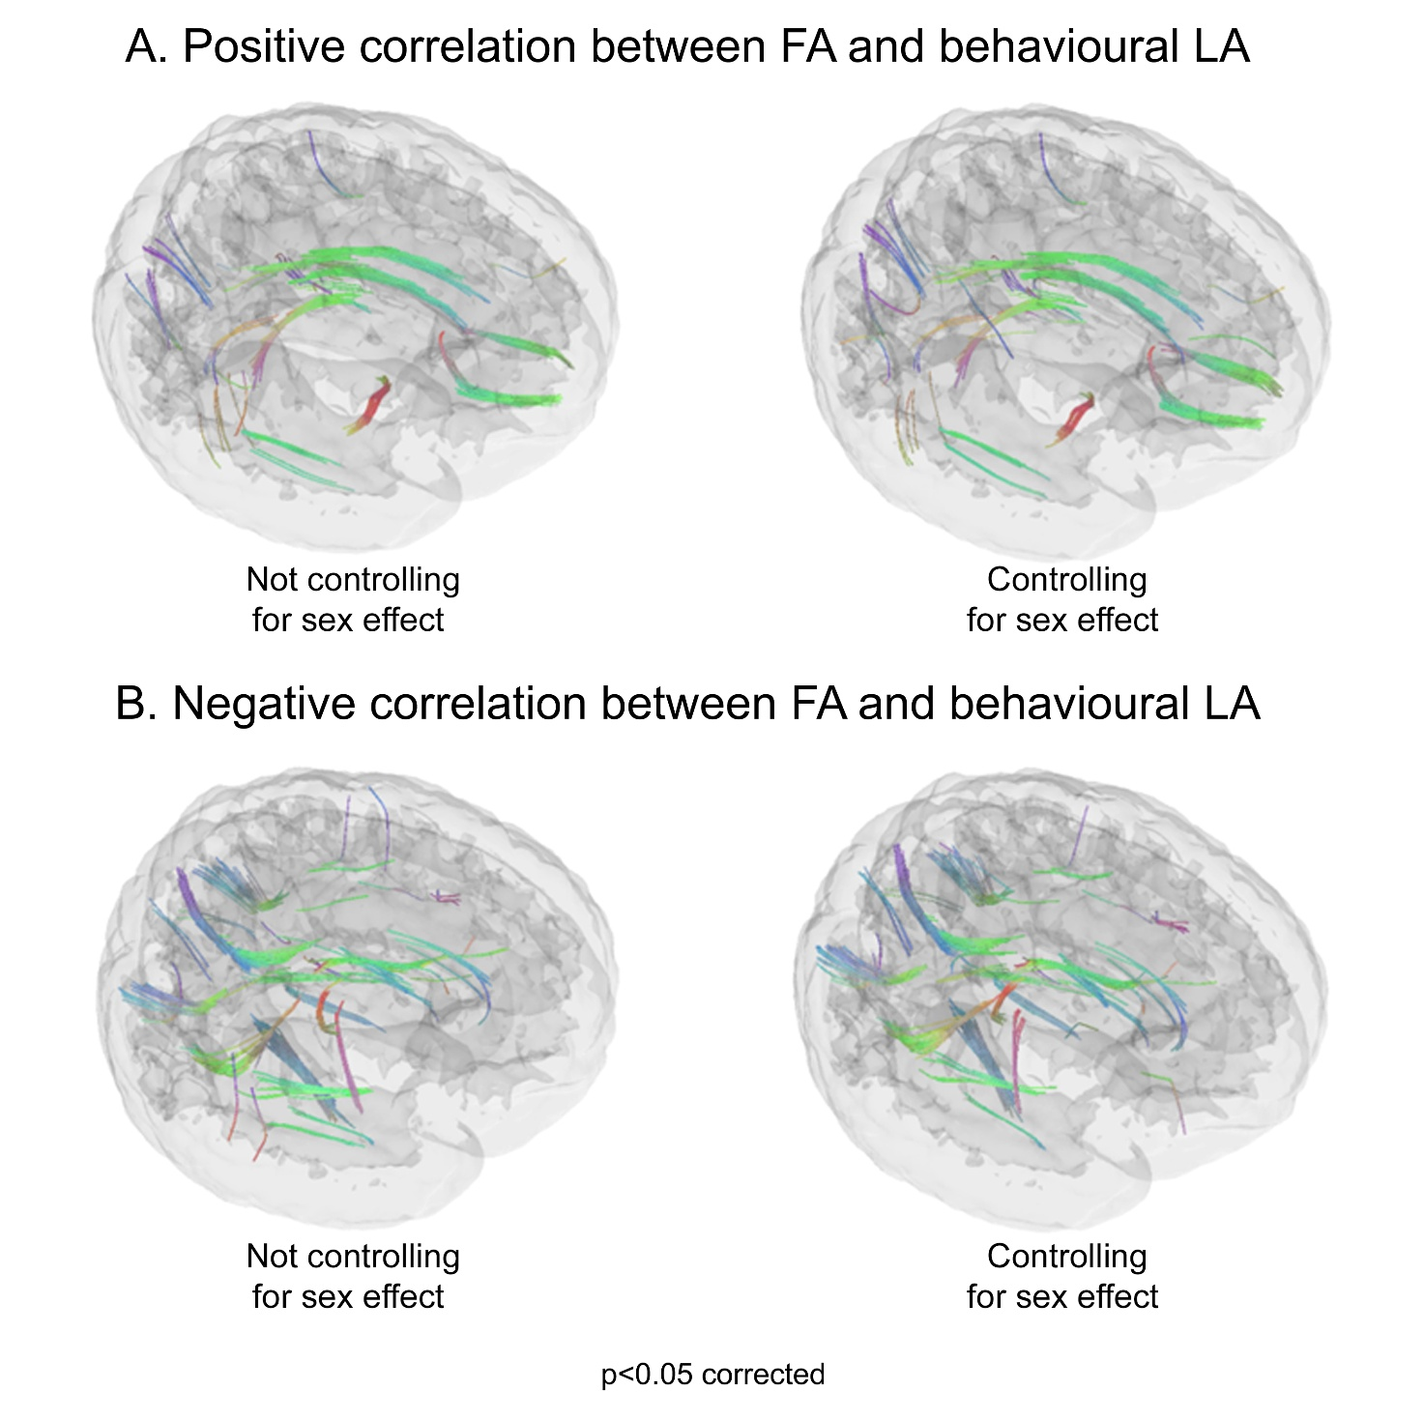
Supplementary Figure 1. The top and bottom figure sectors depict 3D tractograms of WM bundles showing positive or negative correlations between behavioural LA and FA, either controlling (left) or not controlling (right) for the potential effect of sex. Statistics were thresholded at p<0.05, corrected for multiple comparisons with False Discovery Rate. Unlike main figures, a minimum number of tracts was not specified, to show that differences across analyses involved only small bundles. In both analyses, a positive correlation between behavioural LA and FA was found in the fornix, cingulum, and forceps minor. Negative correlations were found, regardless of sex, with the bilateral dorsal part of the superior longitudinal fasciculus and left inferior longitudinal fasciculus, as well as in the bilateral inferior fronto-occipital fasciculus, bilateral parahippocampal cingulum, right frontal aslant tract and right forceps major.

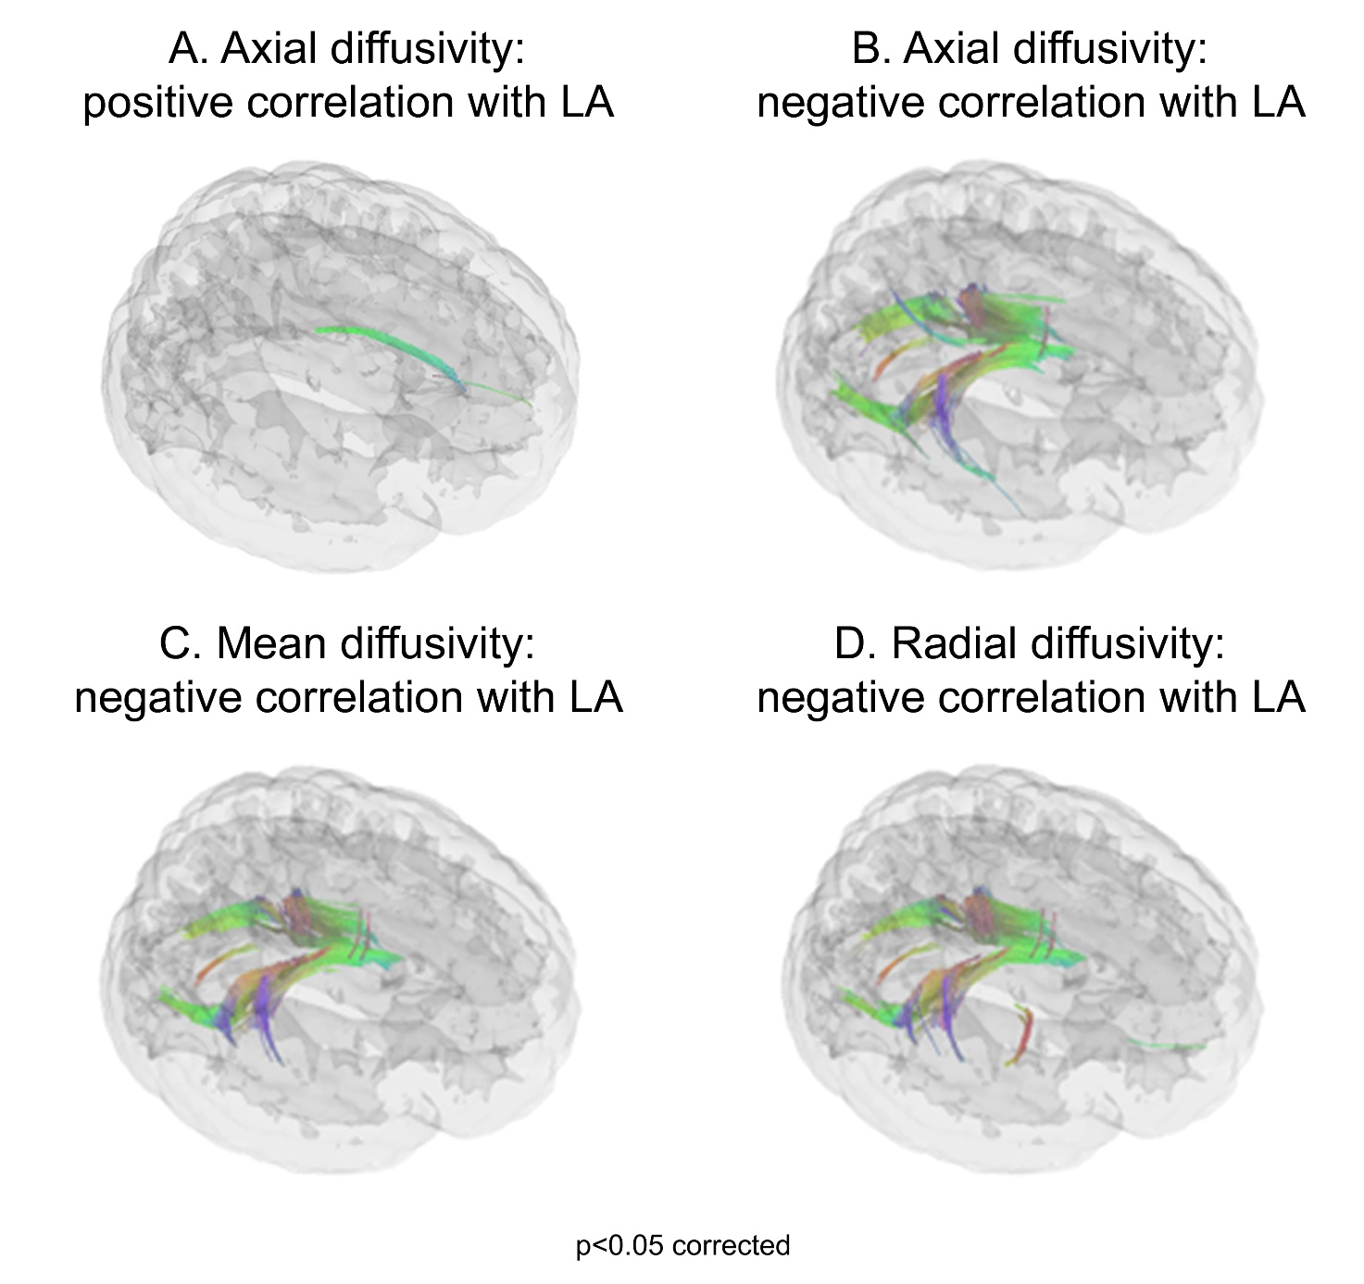
Supplementary Figure 2. The top figure sector shows that behavioural LA was positively correlated with AD in the right cingulum (left, A), and negatively correlated with AD in bundles spreading bilaterally towards the forceps major and the tapetum of the corpus callosum (right, B). The latter negative relationship was also found with MD (left, C) and RD (right, D), that instead displayed no significant positive correlation with LA.

