Online Supplementary Material
Effects of Adjunctive Corticosteroids Therapy in Non-HIV Pneumocystis jirovecii Pneumonia: A Real-world Multicenter Cohort Study
Ting-Wei Kao, Sheng-Yuan Ruan, Chia-Jung Liu, You-Yi Chen, Yu-Tsung Huang, Chong-Jen Yu, Jung-Yien Chien, and TACTICS (TAiwan CollaboraTive Intensive Care Study) Group
Contents
Supplementary Table S1. Potential confounders for propensity score page 2
Supplementary Table S2. Univariable and multivariable analysis of 60-day all-cause mortality using Cox model page 3
Supplementary Table S3. Baseline demographics after propensity score matching page 4
Supplementary Table S4. Baseline demographics by adjunctive corticosteroids in patients without shock page 5
Supplementary Figure S1. Kaplan-Meier curve of 60-day all-cause mortality in steroid users stratified by steroid dosage page 6
Supplementary Figure S2. Study design of cohort inclusion. The propensity score matching was performed with a caliper width of 0.2 times of the pooled standard deviation page 7
Supplementary Figure S3. Distribution of propensity scores page 8
Supplementary Figure S4. Love plot showed the standardized differences before and after propensity score matching page 9
Supplementary Figure S5. Kaplan-Meier curve of 60-day all-cause mortality in patients with or without adjunctive corticosteroids after propensity score matching page 10
Supplementary Figure S6. Impact of adjunctive corticosteroids on 60-day mortality according to subgroups after propensity score matching. ALC: absolute lymphocyte count; CI: confidence interval; RR: relative risk page 11
Supplementary Table S1. Potential confounders for propensity score
 | Variables
Demographic | Age, sex, body mass index
Medical comorbidities | Hypertension, diabetes, stroke, heart failure, chronic kidney disease, dialysis, cirrhosis, asthma, chronic obstructive pulmonary disease, interstitial lung disease, hematological malignancy, peripheral blood stem cell transplantation, solid cancer, solid organ transplantation, autoimmune disease
Disease severity | Shock, PaO2/FiO2, respiratory failure, initial cycle threshold value
Hemogram | Absolute lymphocyte count
PaO2/FiO2, arterial oxygen tension/inspiratory oxygen fraction ratio
Supplementary Table S2. Univariable and multivariable analysis of 60-day all-cause mortality using Cox model
 | All subjects |  |  |  | Subjects without shock
 | Univariable |  | Multivariable |  | Univariable |  | Multivariable
 | HR (95% CI) | P | HR (95% CI) | P | HR (95% CI) | P | HR (95% CI) | P
Adjunctive steroid | 2.18 (1.32-3.61) | 0.002 |  |  | 3.27 (1.54-6.94) | 0.002
Prior steroid exposure | 1.31 (0.93-1.84) | 0.12 |  |  | 2.02 (1.18-3.47) | 0.01
Age (year) | 1.01 (1.00-1.02) | 0.09 |  |  | 1.02 (1.00-1.04) | 0.07
Sex (male) | 1.00 (0.69-1.45) | 0.99 |  |  | 1.12 (0.65-1.91) | 0.69
Body mass index (kg/m²) | 0.99 (0.95-1.04) | 0.74 |  |  | 0.98 (0.91-1.04) | 0.47
Initial Ct value of PCR | 0.97 (0.93-1.02) | 0.24 |  |  | 0.97 (0.90-1.04) | 0.33
Trimethoprim dose (g//BW/d) | 1.06 (1.00-1.11) | 0.04 |  |  | 0.80 (0.44-1.47) | 0.47
Hypertension | 0.96 (0.64-1.44) | 0.84 |  |  | 0.80 (0.44-1.47) | 0.48
Diabetes mellitus | 1.16 (0.76-1.77) | 0.48 |  |  | 1.29 (0.70-2.35) | 0.42
Stroke | 0.71 (0.33-1.55) | 0.39 |  |  | 0.77 (0.27-0.24) | 0.63
Heart failure | 1.48 (0.75-2.92) | 0.25 |  |  | 0.99 (0.36-2.72) | 0.99
Chronic kidney disease | 0.91 (0.54-1.54) | 0.72 |  |  | 0.86 (0.36-2.02) | 0.72
Dialysis | 1.60 (0.85-3.01) | 0.15 |  |  | 2.50 (1.10-5.68) | 0.03
Cirrhosis | 1.89 (0.57-6.19) | 0.30 |  |  | 1.74 (0.24-12.9) | 0.59
Chronic obstructive pulmonary disease | 0.80 (0.42-1.53) | 0.51 |  |  | 0.60 (0.21-1.71) | 0.34
Malignancy | 1.49 (1.03-2.14) | 0.03 | 1.50 (1.04-2.16) | 0.03 | 1.84 (0.99-3.44) | 0.06
PBSCT | 0.90 (0.38-2.13) | 0.80 |  |  | 0.82 (0.25-2.74) | 0.75
Autoimmune disease | 1.43 (0.89-2.29) | 0.14 |  |  | 1.33 (0.68-2.63) | 0.40
ALC | 0.98 (0.91-1.06) | 0.63 |  |  | 0.99 (0.80-1.23) | 0.96
PaO2/FiO2 | 0.99 (0.99-1.00) | < 0.001 | 0.99 (0.99-1.00) | < 0.001 | 0.99 (0.99-1.00) | < 0.001 | 0.99 (0.99-1.00) | < 0.001
Shock | 1.97 (1.40-2.77) | < 0.001 | 1.42 (1.00-2.01) | 0.048
HR, hazard ratio; CI, confidence interval; Ct, cycle threshold; PCR, polymerase chain reaction; PBSCT, peripheral blood stem cell transplantation; ALC, absolute lymphocyte count; PaO2/FiO2, arterial oxygen tension/inspiratory oxygen fraction ratio

Supplementary Table S3. Baseline demographics after propensity score matching
 | All (n=134) | With steroids (n=67) | Without steroids (n=67) | P
Age (year) | 62.8±13.7 | 62.3±12.1 | 63.3±15.3 | 0.68
Sex (male) | 72 (53.7%) | 34 (50.7%) | 38 (56.7%) | 0.49
Body height (cm) | 161.7±9.7 | 161.2±8.5 | 162.2±10.8 | 0.68
Body weight (kg) | 58.9±12.4 | 58.5±12.4 | 59.3±12.4 | 0.71
Body mass index (kg/m²) | 22.5±4.0 | 22.4±4.1 | 22.5±4.0 | 0.89
Initial Ct value of PCR | 27.0±3.6 | 27.3±3.0 | 26.8±4.1 | 0.42
Trimethoprim dose (g//BW/d) | 11.5±3.3 | 11.8±3.4 | 11.2±3.3 | 0.30
Hypertension | 29 (21.6%) | 12 (17.9%) | 17 (25.4%) | 0.29
Diabetes mellitus | 26 (19.4%) | 13 (19.4%) | 13 (19.4%) | 1.00
Stroke | 7 (5.2%) | 4 (6.0%) | 3 (4.5%) | 0.70
Heart failure | 13 (9.7%) | 8 (11.9%) | 5 (7.5%) | 0.39
Chronic kidney disease | 22 (16.4%) | 11 (16.4%) | 11 (16.4%) | 1.00
Dialysis | 6 (4.5%) | 3 (4.5%) | 3 (4.5%) | 1.00
Cirrhosis | 3 (2.2%) | 2 (3.0%) | 1 (1.5%) | 0.56
Asthma | 4 (3.0%) | 2 (3.0%) | 2 (3.0%) | 1.00
Chronic obstructive lung disease | 17 (12.7%) | 10 (14.9%) | 7 (10.4%) | 0.44
Interstitial lung disease | 1 (0.7%) | 0 (0.0%) | 1 (1.5%) | 0.32
Malignancy | 80 (59.7%) | 39 (58.2%) | 41 (61.2%) | 0.72
PBSCT | 13 (9.7%) | 7 (10.4%) | 6 (9.0%) | 0.79
Solid organ transplantation | 12 (9.0%) | 6 (9.0%) | 6 (9.0%) | 1.00
Autoimmune disease | 11 (8.2%) | 5 (7.5%) | 6 (9.0%) | 0.75
Ct, cycle threshold; PCR, polymerase chain reaction; PBSCT, peripheral blood stem cell transplantation
Supplementary Table S4. Baseline demographics by adjunctive corticosteroids in patients without shock
 | All  (N=205) | With steroids (n=143) | Without steroids (n=62) | P
Age (year) | 62.4±16.0 | 61.7±15.4 | 63.9±17.1 | 0.36
Sex (male) | 124 (60.5%) | 85 (59.4%) | 39 (62.9%) | 0.64
Body height (cm) | 162.4±8.1 | 161.9±7.4 | 163.6±9.4 | 0.17
Body weight (kg) | 59.7±11.4 | 59.2±11.3 | 61.1±11.7 | 0.28
Body mass index (kg/m²) | 22.6±3.9 | 22.5±4.0 | 22.8±3.9 | 0.62
Initial Ct value of PCR | 26.6±3.7 | 26.5±3.5 | 26.8±4.2 | 0.60
Trimethoprim dose (g//BW/d) | 11.5±3.4 | 12.0±3.2 | 10.3±3.5 | < 0.001
Hypertension | 65 (31.7%) | 48 (33.6%) | 17 (27.4%) | 0.38
Diabetes mellitus | 41 (20.0%) | 29 (20.3%) | 12 (19.4%) | 0.88
Stroke | 12 (5.8%) | 9 (6.3%) | 3 (4.8%) | 0.67
Heart failure | 20 (9.8%) | 13 (9.1%) | 7 (11.3%) | 0.63
Chronic kidney disease | 35 (17.1%) | 25 (17.5%) | 10 (16.1%) | 0.81
Dialysis | 15 (7.3%) | 12 (8.4%) | 3 (4.8%) | 0.36
Cirrhosis | 2 (1.0%) | 2 (1.4%) | 0 (0%) | 0.35
Asthma | 6 (2.9%) | 4 (2.8%) | 2 (3.2%) | 0.88
Chronic obstructive lung disease | 22 (10.7%) | 16 (11.2%) | 6 (9.7%) | 0.75
Interstitial lung disease | 8 (3.9%) | 8 (5.6%) | 0 (0%) | 0.06
Malignancy | 125 (61.0%) | 89 (62.2%) | 36 (58.1%) | 0.30
PBSCT | 12 (5.9%) | 6 (4.2%) | 6 (9.7%) | 0.12
Autoimmune disease | 42 (20.5%) | 37 (25.9%) | 5 (8.1%) | 0.004
Ct, cycle threshold; PCR, polymerase chain reaction; PBSCT, peripheral blood stem cell transplantation
Supplementary Figure S1. Kaplan-Meier curve of 60-day all-cause mortality in steroid users stratified by steroid dosage. Higher dose was defined as that greater than median
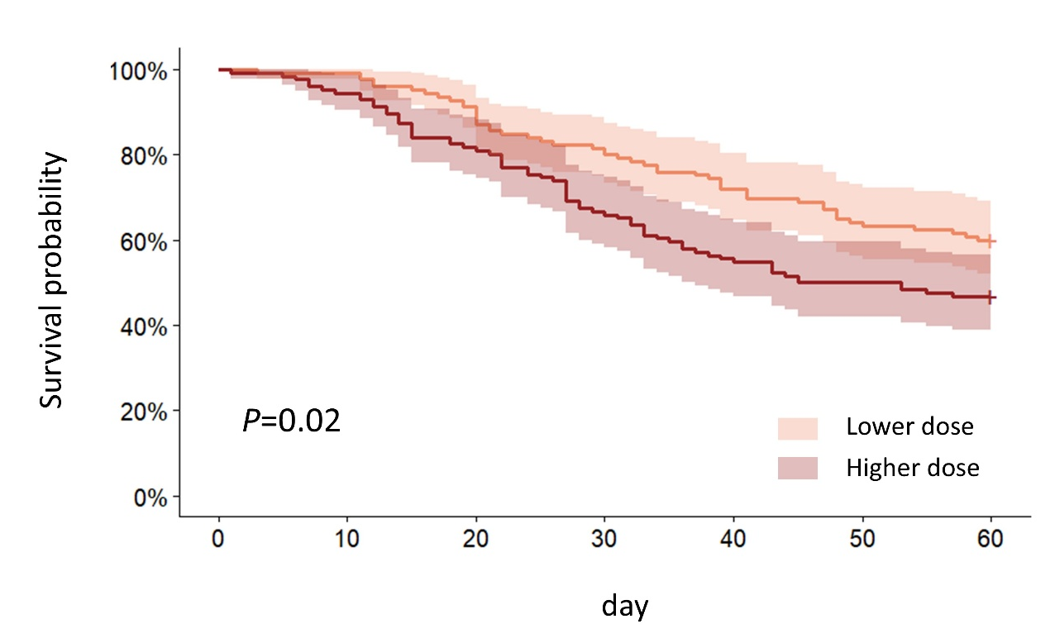
Supplementary Figure S2. Study design of cohort inclusion. The propensity score matching was performed with a caliper width of 0.2 times of the pooled standard deviation. HIV, human immunodeficiency virus
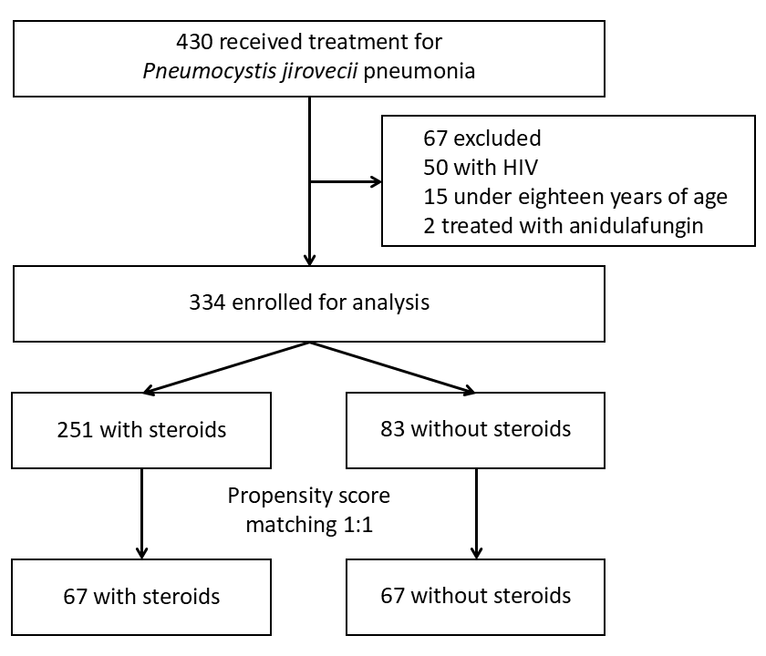

Supplementary Figure S3. Distribution of propensity scores

Supplementary Figure S4. Love plot showed the standardized differences before and after propensity score matching. PaO2/FiO2, arterial oxygen tension/inspiratory oxygen fraction ratio; Ct, cycle threshold; PCR, polymerase chain reaction
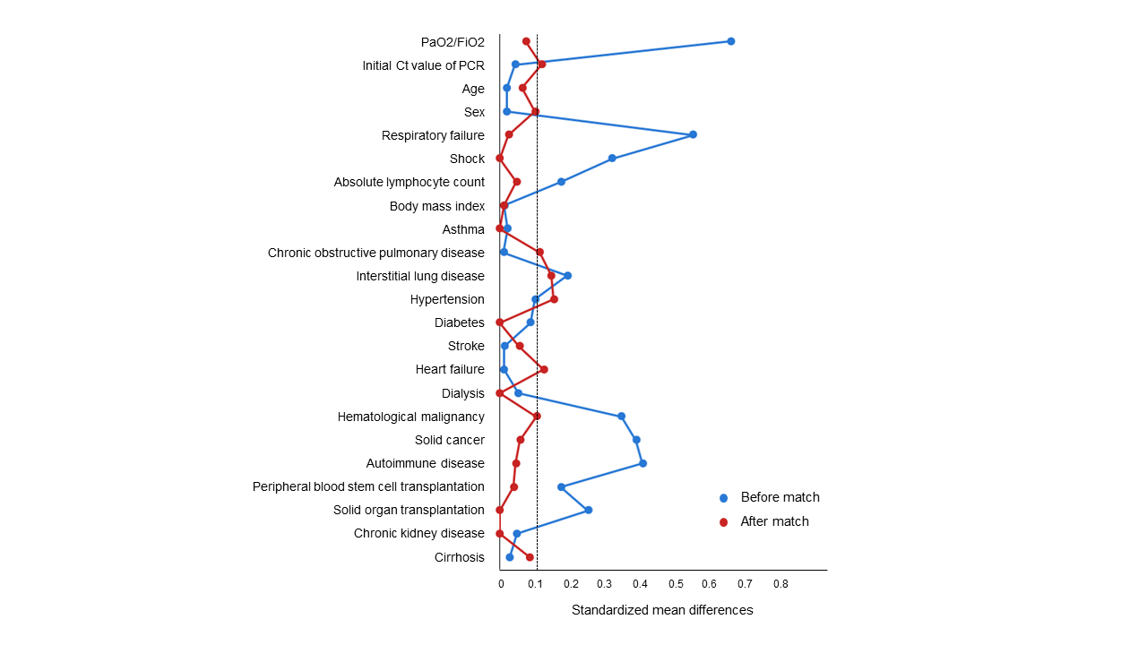
Supplementary Figure S5. Kaplan-Meier curve of 60-day all-cause mortality in patients with or without adjunctive corticosteroids after propensity score matching
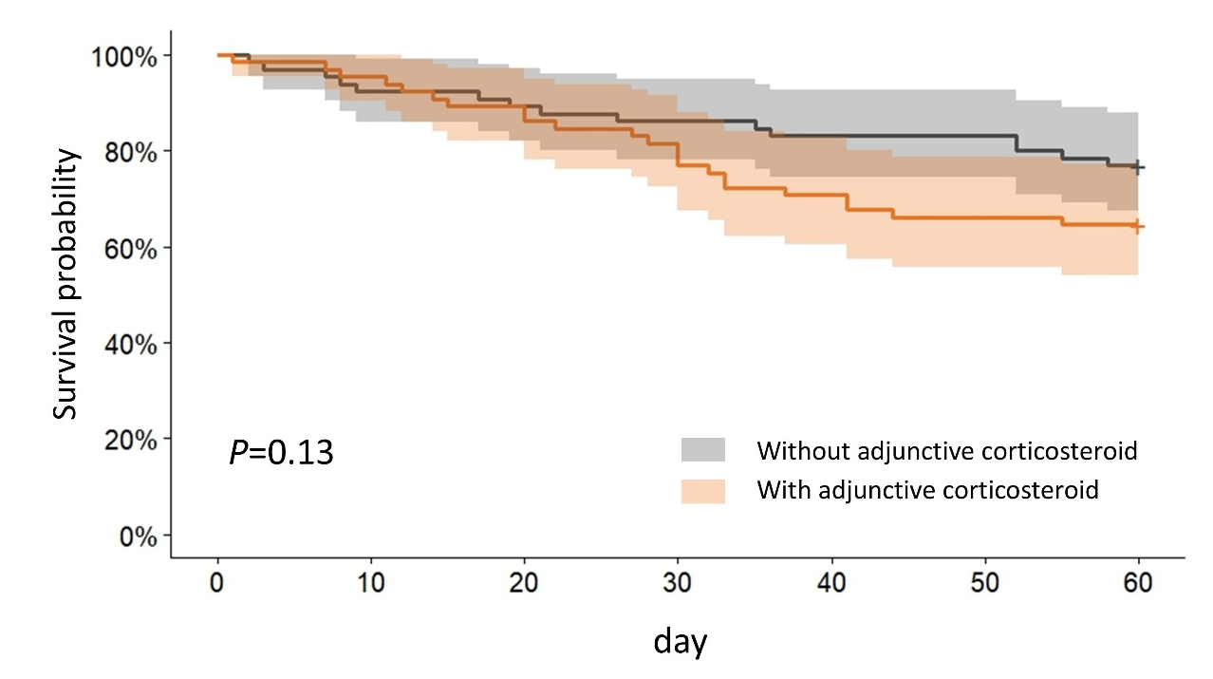

Supplementary Figure S6. Impact of adjunctive corticosteroids on 60-day mortality according to subgroups after propensity score matching. ALC, absolute lymphocyte count; CI, confidence interval; RR, relative risk
