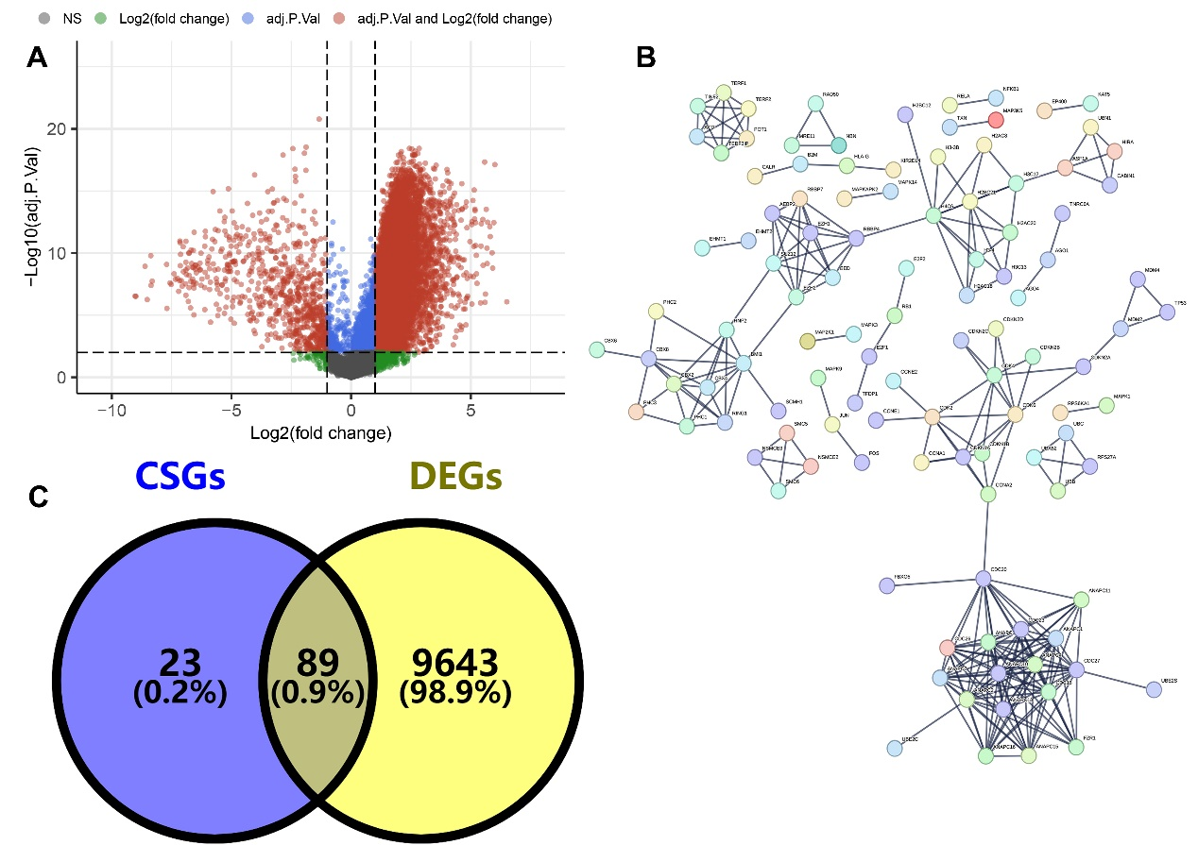
Supplementary Figure 1. The different expressed genes among different expressed genes of cholangiocarcinoma cases. (A) The different expressed genes between cholangiocarcinoma tissue and normal tissue. (B) The PPI network analysis showing the interactions among each other of cellular senescence related genes. (C) The overlap between different expressed genes and cellular senescence related genes.

