Supplementary methods:
Body condition was visually assessed from the research vessel using three anatomical reference regions: (1) the vertebral column, (2) the post-cranial region, and (3) the flanks. Each region was scored separately: 1 if the feature was highly noticeable (indicative of poor condition), 2 if visible (moderate condition), and 3 if not visible (good condition). The overall body condition score represents the average of these three anatomical evaluations, with “Not determined” assigned when the region could not be evaluated from photographs or field observation. Two individuals (Bm022, Bm023) were in poor condition (1/3), two individuals (Bm045, Bm057) in regular condition (2/3), and eight individuals in good condition (3/3). The remaining samples were classified as “Not determined” due to limited visibility of the evaluated regions during the encounter.

Supplementary figures:

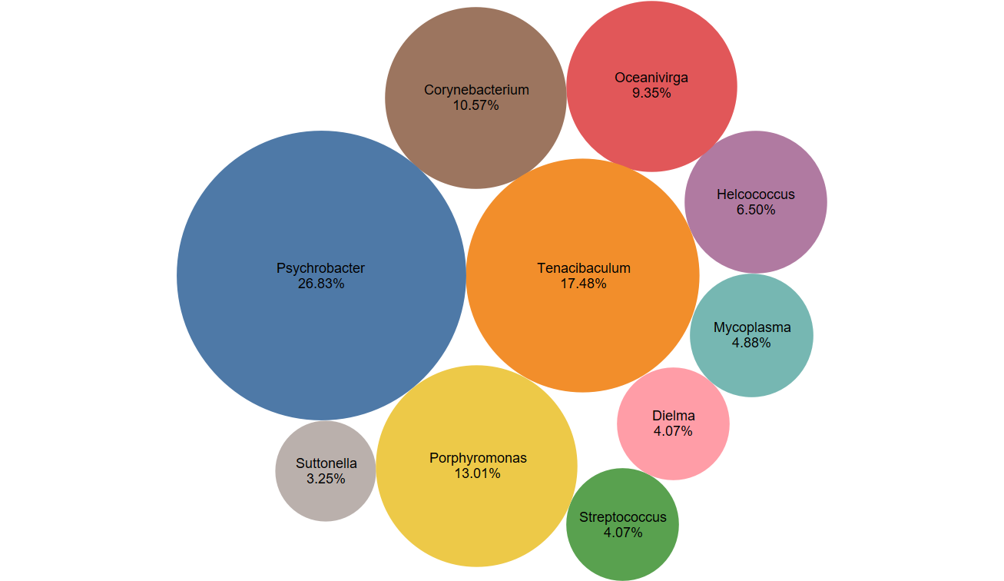

Figure S1. Contribution of the top 10 bacteria to functional pathways identified in the respiratory bacteriome of blue whales.

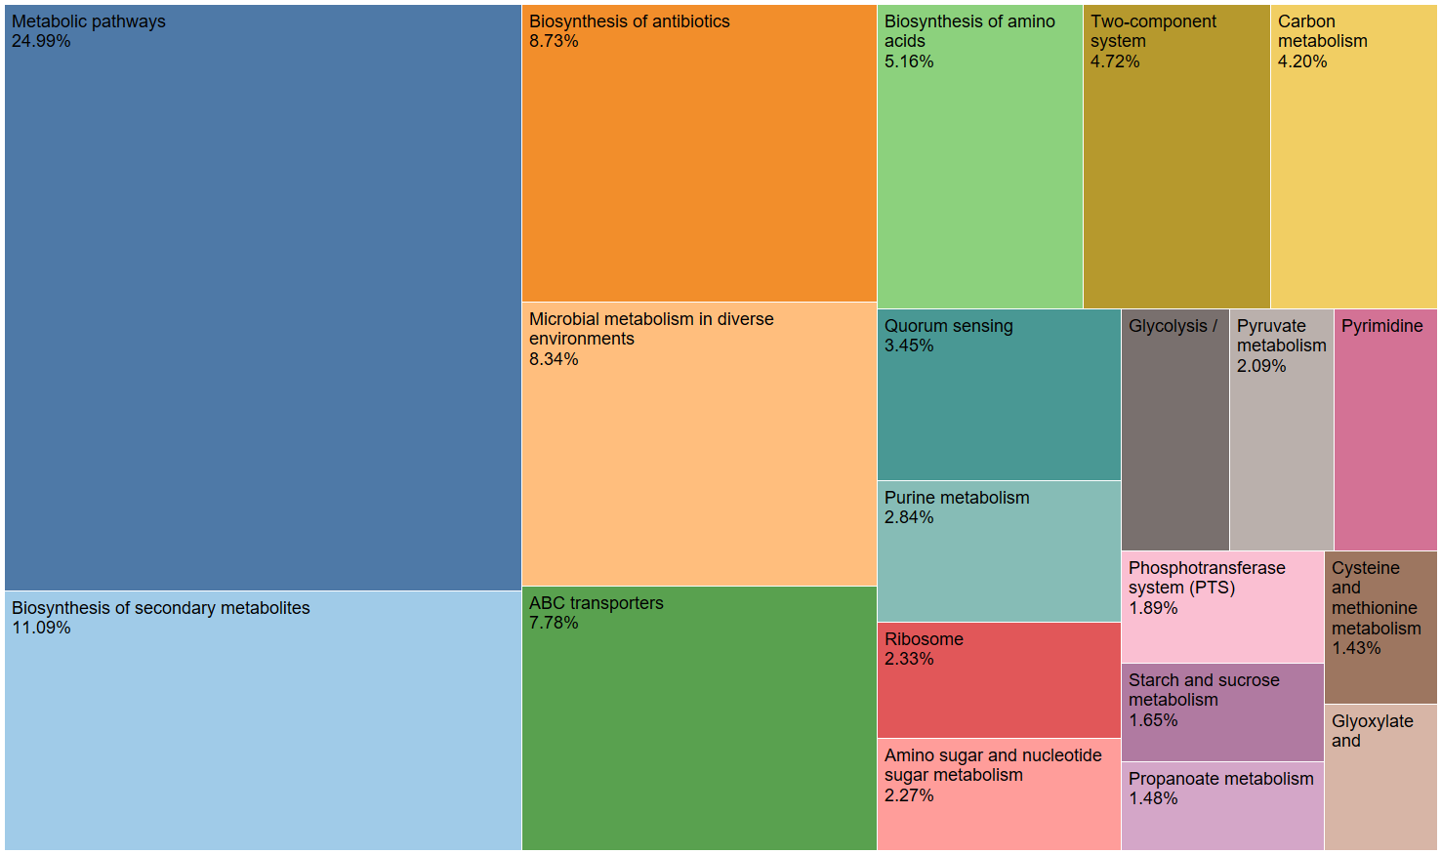
Figure S2. Functional pathways of the core respiratory bacteriome of Blue Whales. Relative abundance at KEGG level 3 (Kanehisa et al. 2016).

Kanehisa, M., Sato, Y. & Morishima, K. BlastKOALA and GhostKOALA: KEGG Tools for Functional Characterization of Genome and Metagenome Sequences. J Mol Biol 428, 726–731 (2016).

a)
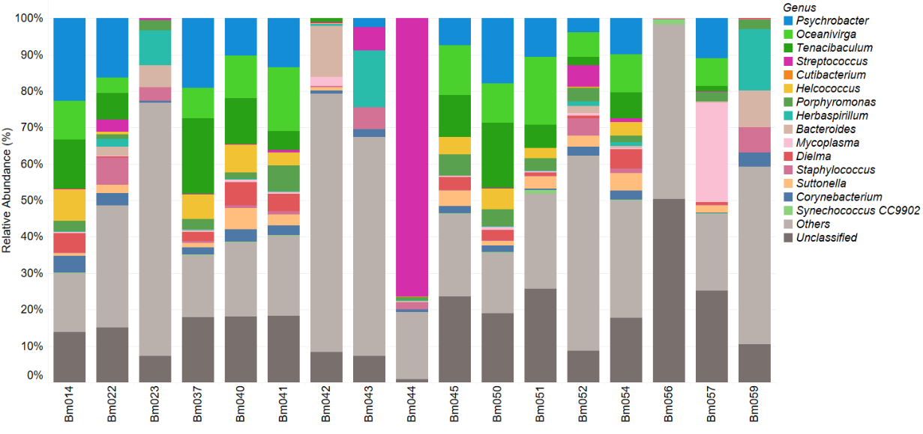
b)
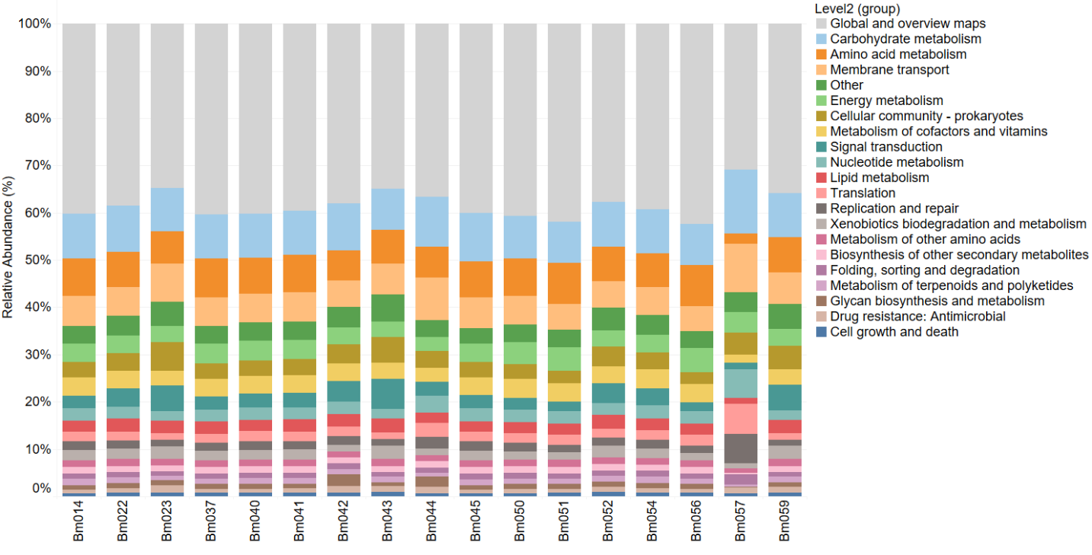
Figure S3. Comparative analysis of microbiome composition (a) and predicted functional pathways (b) in blue whale blow samples

Supplementary tables

Genus | Bm056 | Bm042 | Bm023 | Bm043 | Bm052 | Bm059 | Bm051 | Bm054 | Bm045 | Bm057 | Bm022 | Bm041 | Bm040 | Bm050 | Bm037 | Bm014 | Bm044 | SeaWater | Mean | SD
Psychrobacter |  |  |  | 2.40 | 3.95 |  | 10.57 | 9.94 | 7.36 | 11.00 | 16.37 | 13.53 | 10.18 | 17.81 | 19.05 | 22.68 |  |  | 12.07 | 6.09
Oceanivirga |  |  |  |  | 6.61 |  | 18.73 | 10.45 | 13.72 | 7.54 | 4.09 | 17.51 | 11.81 | 10.81 | 8.47 | 10.54 |  |  | 10.93 | 4.43
Tenacibaculum |  | 0.97 |  |  | 2.29 |  | 6.34 | 7.03 | 11.44 | 1.41 | 7.43 | 5.05 | 12.52 | 17.92 | 20.67 | 13.49 |  |  | 8.88 | 6.40
Streptococcus |  | 0.49 | 0.52 | 6.46 | 5.84 | 0.06 |  | 1.01 |  | 0.05 | 3.21 | 0.77 | 0.07 | 0.06 | 0.21 | 0.03 | 76.35 |  | 6.80 | 20.14
Cutibacterium |  |  |  |  | 0.26 | 0.13 |  |  |  |  |  |  |  |  |  |  | 0.03 |  | 0.14 | 0.11
Helcococcus |  | 0.16 |  |  | 0.23 |  | 2.83 | 3.74 | 4.79 | 0.08 | 0.85 | 3.50 | 7.80 | 5.80 | 6.77 | 8.94 |  |  | 3.79 | 3.10
Porphyromonas |  |  | 2.89 |  | 3.61 | 2.84 | 3.31 | 1.81 | 5.90 | 2.82 | 1.25 | 7.12 | 1.78 | 4.77 | 2.86 | 2.83 | 1.12 |  | 3.21 | 1.71
Herbaspirillum |  | 0.49 | 9.45 | 15.65 | 1.37 | 16.82 | 0.10 | 1.07 |  |  | 2.04 | 0.12 | 0.04 | 0.06 | 0.17 | 0.06 | 0.03 | 20.23 | 3.39 | 5.97
Bacteroides | 0.21 | 13.96 | 6.04 |  | 1.89 | 10.14 |  | 0.62 |  | 0.37 | 2.55 | 0.14 | 0.07 | 0.21 | 0.37 | 0.06 | 0.48 | 5.16 | 2.65 | 4.36
Mycoplasma |  | 2.44 |  |  | 0.74 |  | 0.43 | 0.36 | 0.36 | 27.22 | 0.13 | 0.53 | 0.78 | 0.73 | 0.17 | 0.43 |  |  | 2.86 | 7.70
Dielma |  |  |  |  | 0.74 |  | 0.96 | 5.22 | 3.63 | 0.77 | 0.29 | 4.74 | 6.28 | 2.83 | 2.49 | 5.31 |  |  | 3.02 | 2.15
Staphylococcus | 0.05 | 0.49 | 3.76 | 5.99 | 4.78 | 6.81 | 0.19 | 1.31 | 0.02 | 0.05 | 7.56 | 0.84 | 0.74 | 0.17 | 0.54 | 0.03 | 1.94 | 2.79 | 2.07 | 2.63
Suttonella |  | 0.81 |  |  | 2.92 |  | 3.41 | 4.78 | 4.30 | 2.07 | 2.18 | 3.11 | 5.91 | 1.16 | 1.20 | 0.90 |  |  | 2.73 | 1.65
Corynebacterium |  | 0.97 | 0.61 | 2.09 | 2.58 | 3.91 | 0.19 | 2.49 | 1.98 | 0.08 | 3.42 | 2.69 | 3.34 | 1.86 | 1.87 | 4.56 | 0.65 | 0.13 | 2.08 | 1.34
Synechococcus CC9902 | 1.40 |  |  |  |  |  | 1.10 | 0.09 | 0.03 | 0.03 |  | 0.10 | 0.19 | 0.11 | 0.04 | 0.06 |  |  | 0.32 | 0.50
Others | 47.91 | 70.94 | 69.47 | 60.07 | 53.48 | 48.83 | 26.03 | 32.38 | 22.81 | 21.35 | 33.48 | 21.92 | 20.32 | 16.64 | 17.14 | 16.21 | 18.44 | 62.28 | 35.12 | 19.20
Unclassified | 50.44 | 8.28 | 7.26 | 7.33 | 8.70 | 10.46 | 25.79 | 17.69 | 23.65 | 25.15 | 15.15 | 18.33 | 18.16 | 19.07 | 17.97 | 13.88 | 0.95 | 9.41 | 16.96 | 11.07

Table S1. Relative abundance of the top 15 bacterial genera, Unclassified, and "Others" (sum of bacteria that did not reach the detection threshold of 0.02%).

Family | ASV | Genus | Bm054 | Bm040 | Bm037 | Bm050 | Bm041 | Bm022 | Bm045 | Bm052 | Bm051 | Bm057 | Bm023 | Bm042 | Bm043 | Bm044 | Bm059 | Bm056 | Mean | SD
Bacteroidaceae | ASV101 | Bacteroides | 7.80 |  | 3.59 | 3.96 | 2.43 | 16.76 |  | 8.20 |  |  | 47.40 | 33.33 |  | 4.49 | 20.41 |  | 14.84 | 14.27
Corynebacteriaceae | ASV26 | Lawsonella | 44.79 | 11.88 |  |  | 8.77 | 17.00 |  | 20.08 | 4.05 | 5.27 |  | 66.67 | 31.99 | 5.31 |  |  | 21.58 | 19.49
Corynebacteriaceae | ASV36 | Corynebacterium | 13.87 | 16.80 | 6.21 | 9.71 | 22.15 | 12.85 | 15.72 | 7.67 | 4.05 | 5.27 |  |  |  |  |  |  | 11.43 | 5.54
Corynebacteriaceae | ASV133 | Corynebacterium | 3.18 | 3.76 | 5.07 | 2.29 | 5.95 | 14.08 |  | 13.60 | 4.05 |  |  |  | 20.32 | 6.35 | 16.98 |  | 8.69 | 6.03
Flavobacteriaceae | ASV3 | Tenacibaculum | 28.11 | 46.15 | 57.62 | 49.33 | 8.77 | 22.63 | 20.01 | 13.90 | 27.78 | 25.82 |  |  |  |  |  |  | 30.01 | 15.13
Flavobacteriaceae | ASV6 | Tenacibaculum | 27.01 | 40.10 | 34.22 | 34.54 | 28.76 | 25.70 | 38.59 | 12.30 | 25.63 | 5.27 |  |  |  |  |  |  | 27.21 | 10.53
Fusobacteriaceae | ASV74 | Fusobacterium | 8.42 | 10.62 | 9.49 | 9.71 | 12.63 | 5.75 | 17.15 | 11.95 | 10.72 | 7.45 |  |  |  |  |  |  | 10.39 | 2.98
Lachnospiraceae | ASV27 | unclassified | 14.23 | 18.01 | 15.22 | 12.10 | 18.19 | 11.49 | 25.33 | 15.06 | 14.61 | 20.41 |  |  |  |  |  |  | 16.47 | 3.94
Leptotrichiaceae | ASV7 | Oceanivirga | 17.43 | 24.91 | 20.92 | 28.57 | 40.17 | 19.91 | 34.31 | 23.73 | 48.46 | 29.34 |  |  |  |  |  |  | 28.78 | 9.26
Leptotrichiaceae | ASV15 | Oceanivirga | 19.88 | 27.08 | 22.40 | 23.10 | 21.33 | 14.93 | 17.83 | 7.67 | 10.72 | 5.27 |  |  |  |  |  |  | 17.02 | 6.81
Leptotrichiaceae | ASV16 | Oceanivirga | 19.88 | 21.57 | 12.43 | 15.51 | 21.05 | 17.00 | 26.91 | 13.28 | 33.17 | 40.82 |  |  |  |  |  |  | 22.16 | 8.62
Micrococcaceae | ASV158 | Kocuria | 11.48 |  | 5.07 | 2.29 | 4.86 | 9.95 |  | 13.60 |  | 5.27 |  |  | 15.85 | 2.84 | 24.68 |  | 9.59 | 6.69
Moraxellaceae | ASV8 | Psychrobacter | 20.38 | 13.54 | 41.53 | 37.31 | 21.33 | 9.53 | 24.98 | 21.89 | 22.56 | 18.26 |  |  |  |  |  |  | 23.13 | 9.25
Moraxellaceae | ASV11 | Psychrobacter | 28.11 | 30.74 | 28.70 | 27.26 | 18.83 | 34.36 | 22.76 | 9.17 | 25.63 | 9.13 |  |  |  |  |  |  | 23.47 | 8.20
Porphyromonadaceae | ASV25 | Porphyromonas | 20.87 | 15.02 | 9.49 | 14.47 | 18.35 | 8.13 | 26.58 | 14.20 | 9.06 | 30.73 |  |  |  |  |  |  | 16.69 | 7.16
Porphyromonadaceae | ASV57 | Porphyromonas | 6.37 | 9.94 | 14.79 | 17.12 | 13.09 | 11.85 | 8.40 | 5.02 | 18.12 | 19.00 |  |  |  |  |  |  | 12.37 | 4.67
Prevotellaceae | ASV32 | Alloprevotella | 19.62 | 11.27 | 8.02 | 9.71 | 19.60 | 2.87 | 25.21 | 12.96 | 15.69 | 21.73 |  |  |  |  |  |  | 14.67 | 6.58
Staphylococcaceae | ASV24 | Staphylococcus | 16.23 | 11.27 | 8.02 | 6.05 | 14.38 | 34.12 |  | 28.99 | 7.02 | 7.45 |  | 19.25 | 33.09 | 8.75 |  | 6.54 | 15.47 | 9.92
Streptococcaceae | ASV1 | Streptococcus | 17.72 | 5.31 | 7.17 | 3.96 | 13.75 | 31.48 |  | 38.57 |  |  |  | 33.33 | 16.95 | 94.70 | 5.66 |  | 24.42 | 25.07

Table S2. Relative abundances of bacterial genera that form the core respiratory bacteriome of the blue whale.

