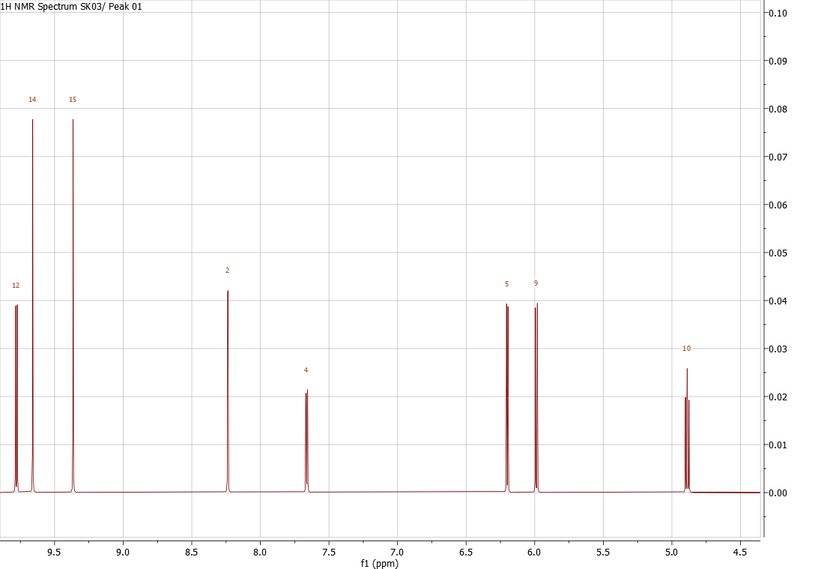
Figure S1. Proton NMR spectrum of the compound
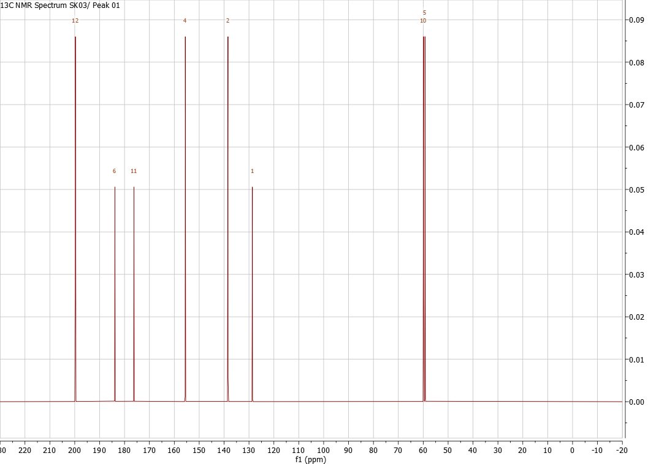
Figure S2. ¹³C NMR spectrum of the compound
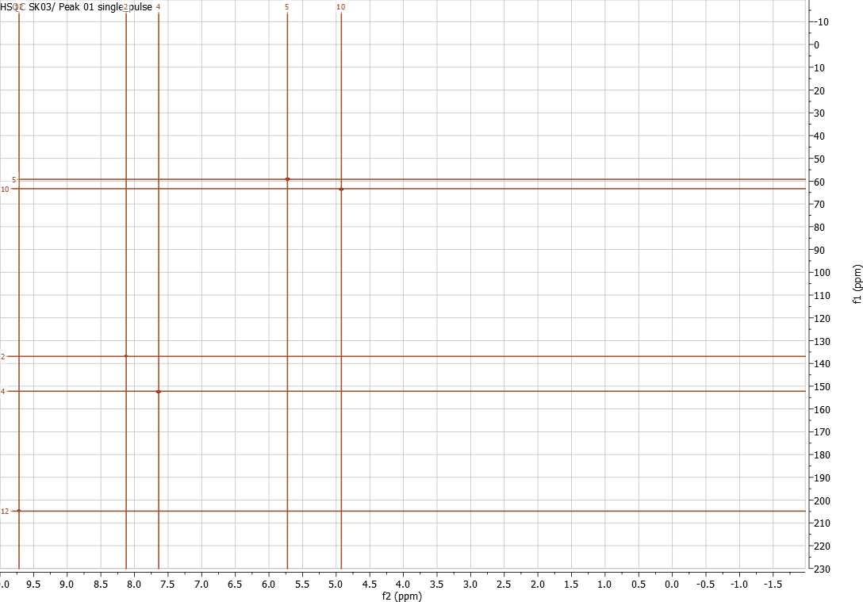
Figure S3. HSQC spectrum of the compound
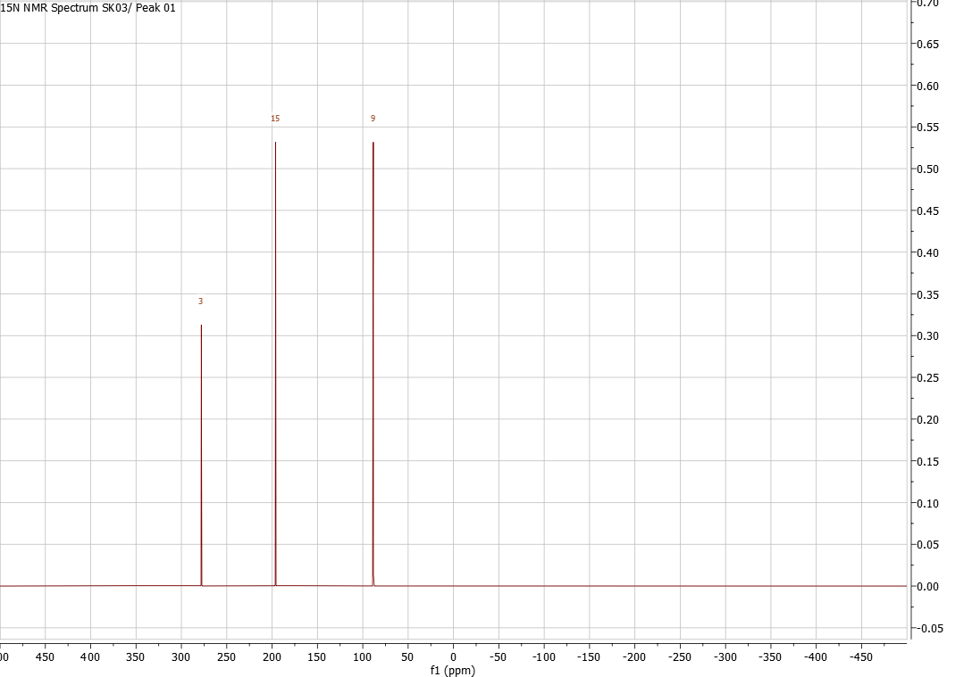
Figure S4. 15N spectrum of the compound
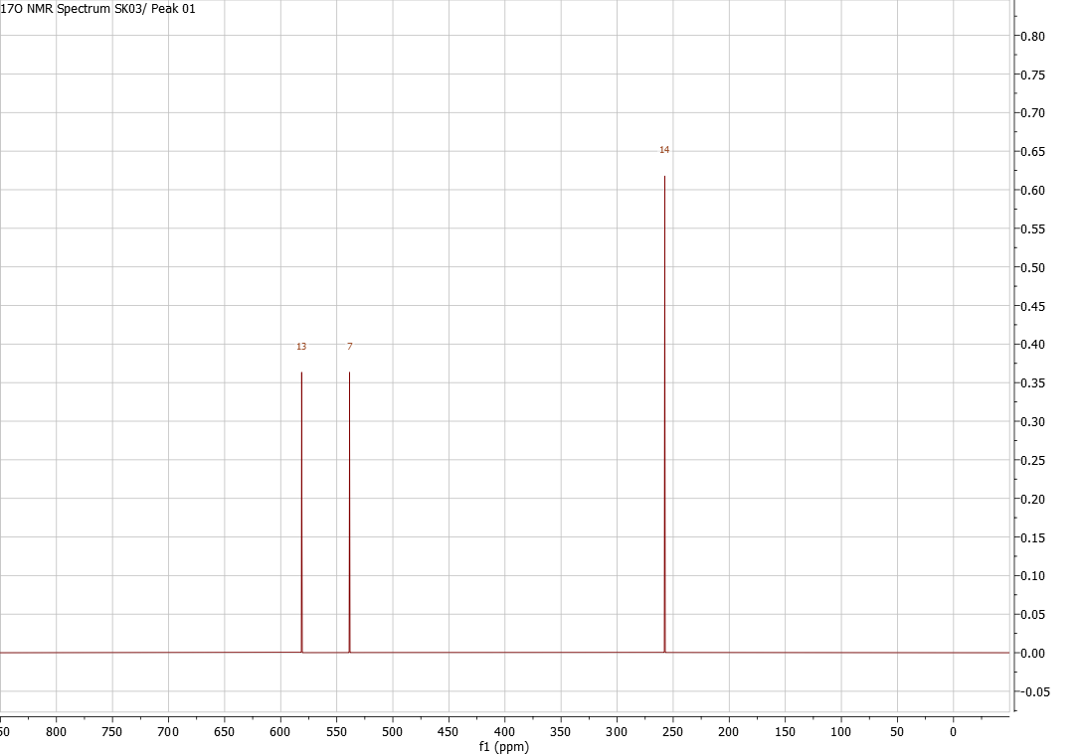
Figure S5. 17O spectrum of the compound

