A Baseline Study of Interpretable Machine Learning Using GC-MS Breath VOCs for Classifying Asthma, Bronchiectasis, and COPD

Eun-Ji Ko†, Si-On Bae† and Daesung Kang*

School of Bio-Health Convergence, College of Natural Sciences, Sungshin Women’s University Woonjung Green Campus, Seoul, Republic of Korea

Figure S1. Class-wise ROC curves for seven classification models using the one-vs-rest (OvR) strategy. Each panel shows ther per-class ROC curves (asthma, bronchiectasis, COPD) together with the macro-average ROC curve obtained from outer cross-validation. (kNN: k-nearest neighbors, LR: logistic regression, NB: naïve Bayes, DT: decision tree, SVM: support vector machine, RF: random forest, XGBoost: extreme gradient boosting.
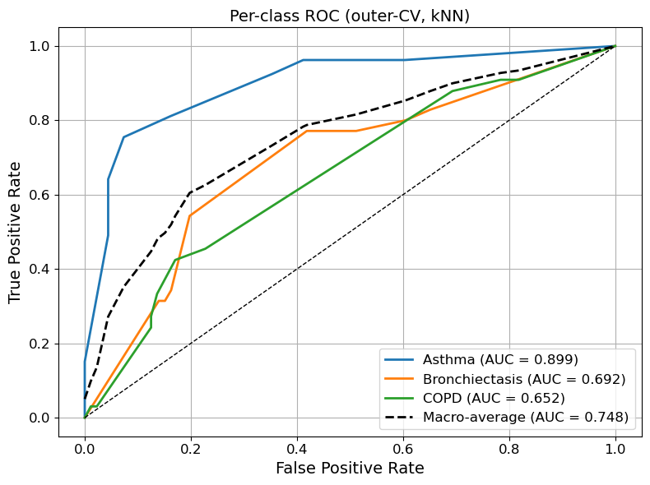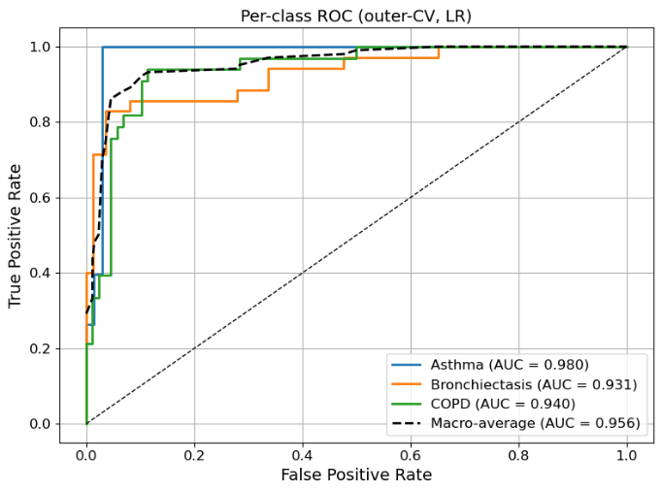
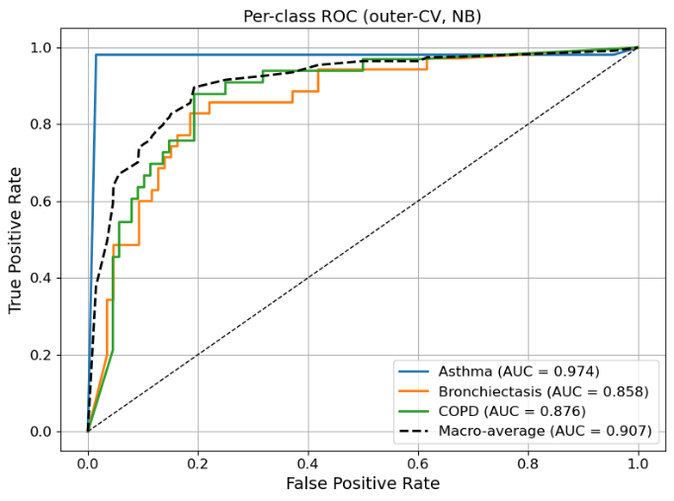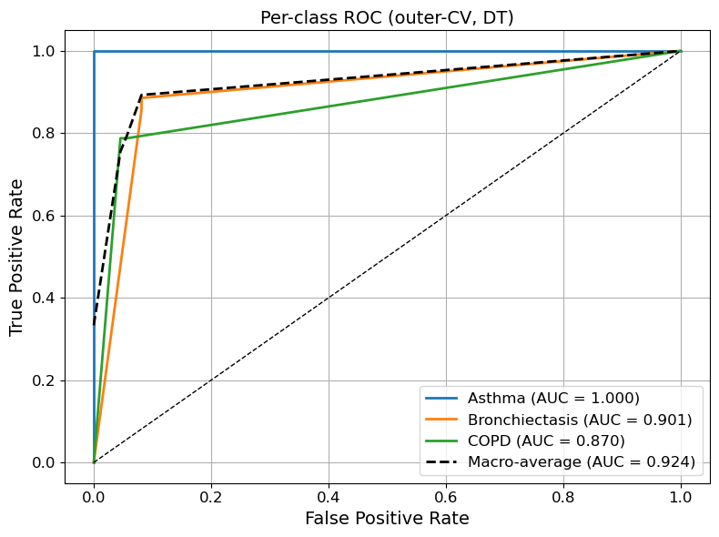
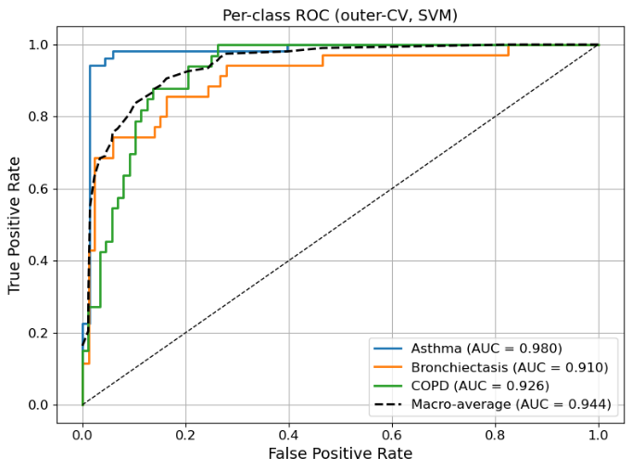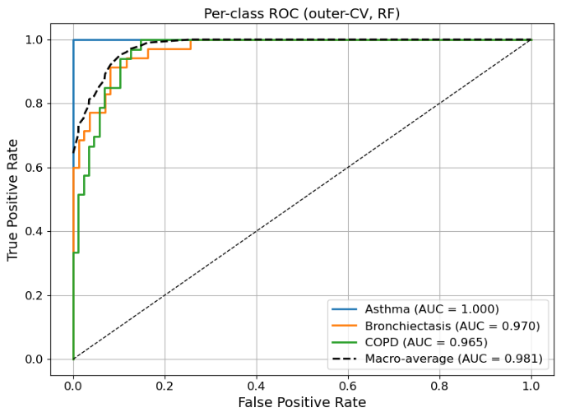
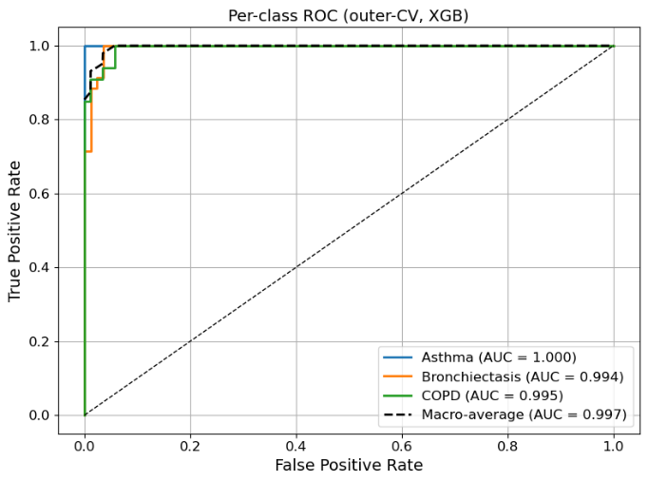

Figure S2. Class-wise SHAP feature importance plots for all 76 shared VOCs. Each bar chart presents the mean absolute SHAP values of all compounds, calculated separately for asthma, bronchiectasis, and COPD, based on the refitted XGBoost model using the best hyperparameters from nested cross-validation. VOCs are identified by their PubChem CID numbers on the y-axis, and bar lengths represent the average contribution of each VOC to the corresponding class prediction.

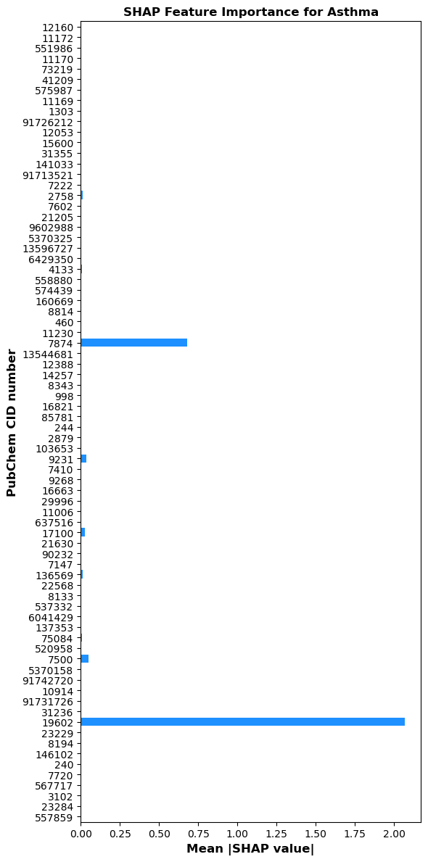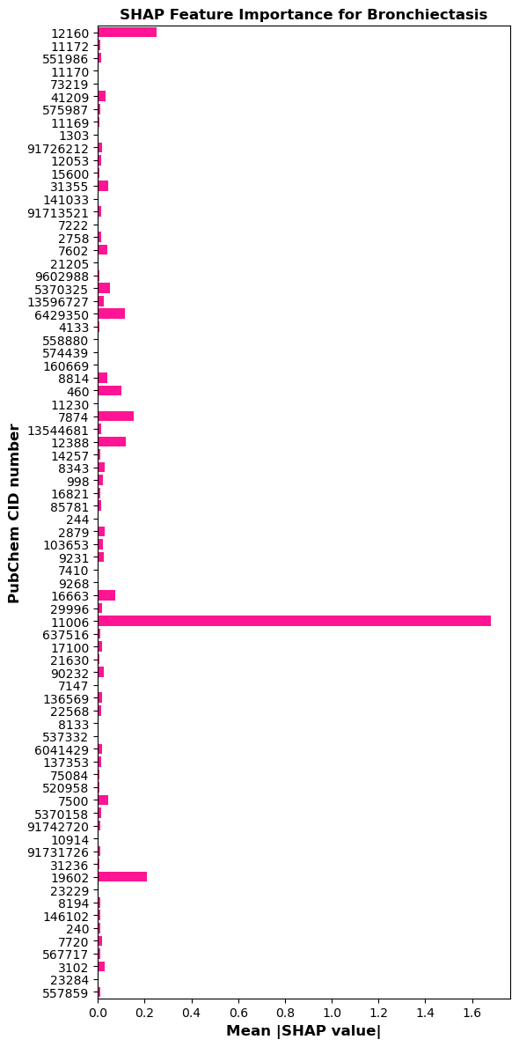
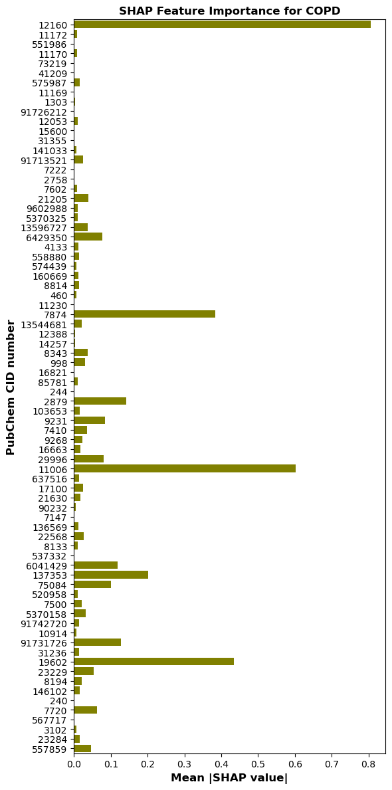
Figure S3. SHAP summary plot showing the top 10 VOCs contributing to classification across asthma, bronchiectasis, and COPD. Each horizontal bar represents a VOC, identified by its IUPAC names on the y-axis, with bar length and color indicating the magnitude and class-specific contribution.

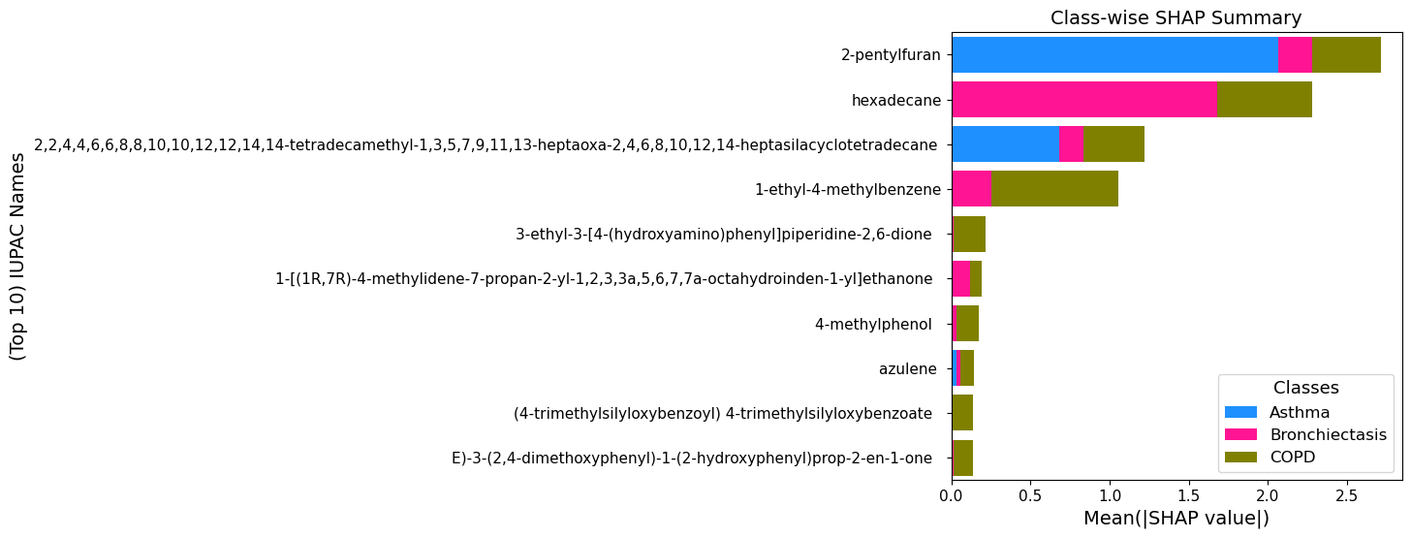

Figure S4. Class-wise SHAP feature importance plots for all 76 shared VOCs. Each bar chart presents the mean absolute SHAP values of all compounds, calculated separately for asthma, bronchiectasis, and COPD, based on the refitted XGBoost model using the best hyperparameters from nested cross-validation. VOCs are identified by their IUPAC names on the y-axis, and bar lengths represent the average contribution of each VOC to the corresponding class prediction.

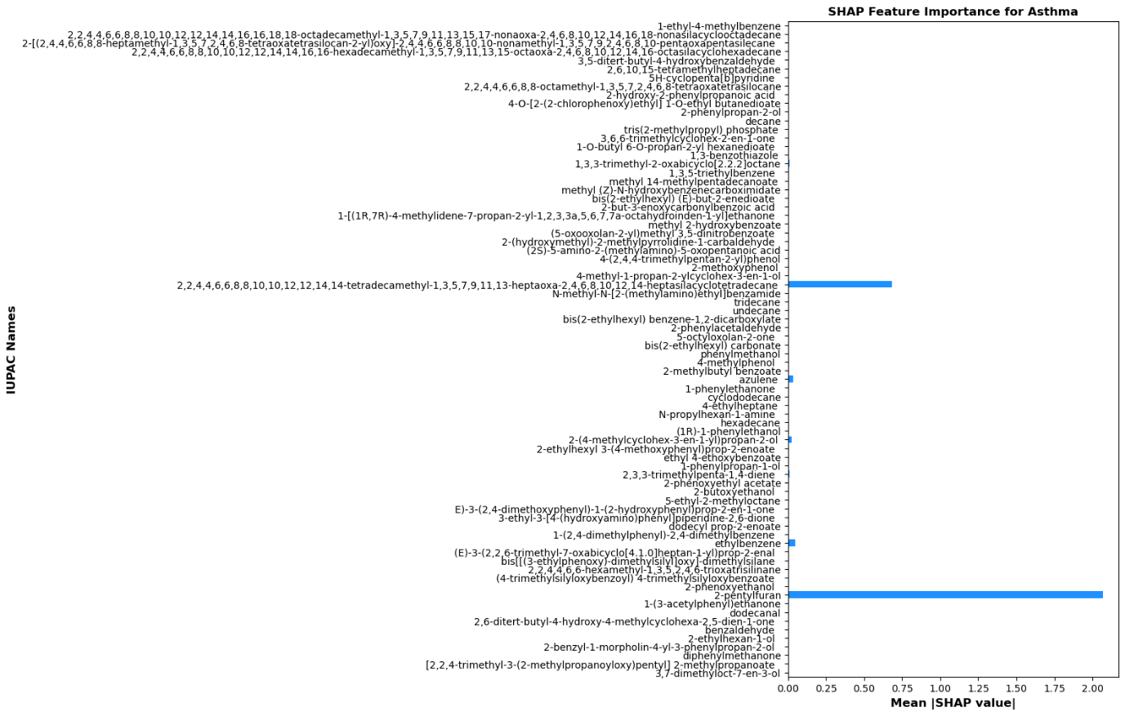
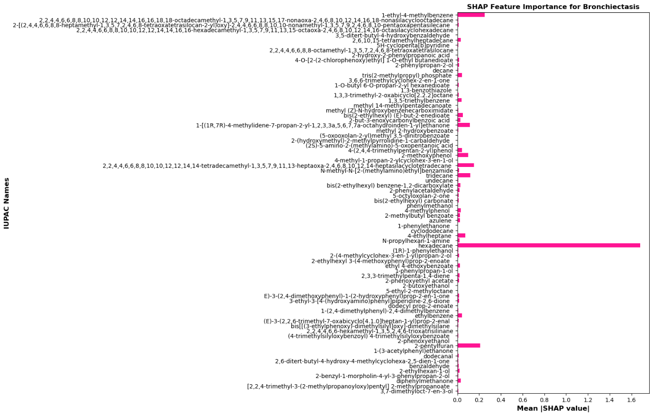
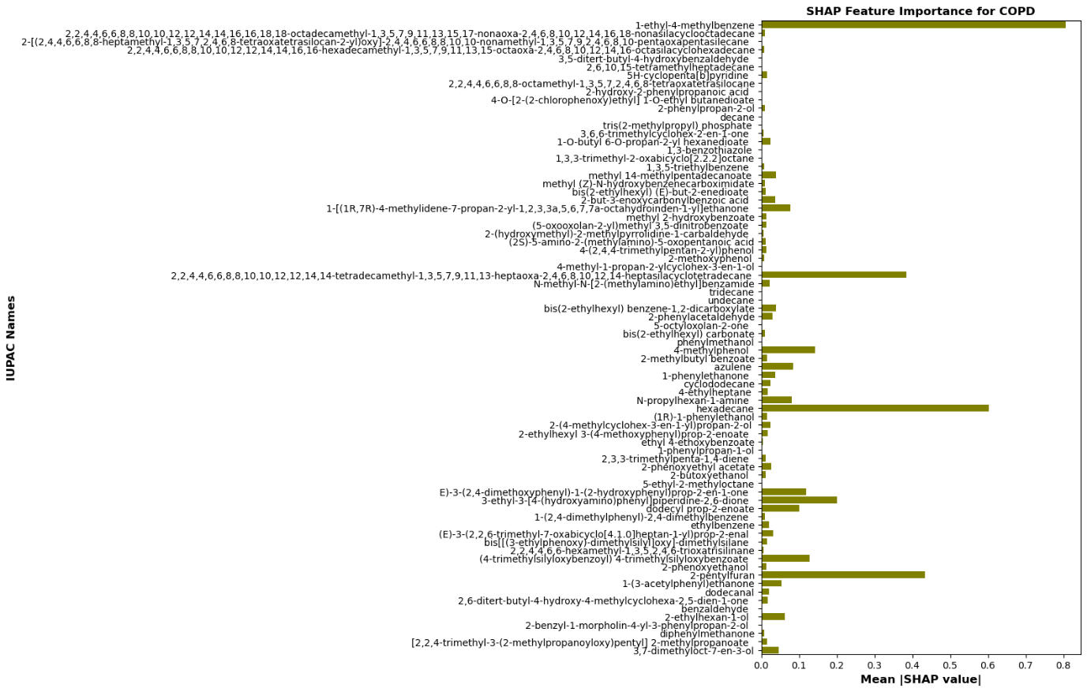

Figure S5. Class-wise SHAP beeswarm plots for asthma, bronchiectasis, and COPD. Each plot displays the 9 most influential VOCs for that disease, along with the summed contribution of all remaining 67 VOCs. VOCs are identified by their IUPAC names on the y-axis. Each point corresponds to one patient sample, with horizontal position indicating the SHAP value (impact on model output). Positive SHAP values indicate that a VOC increases the likelihood of the disease prediction, whereas negative values decrease it. Color represents the relative feature value for that sample (red = high, blue = low).

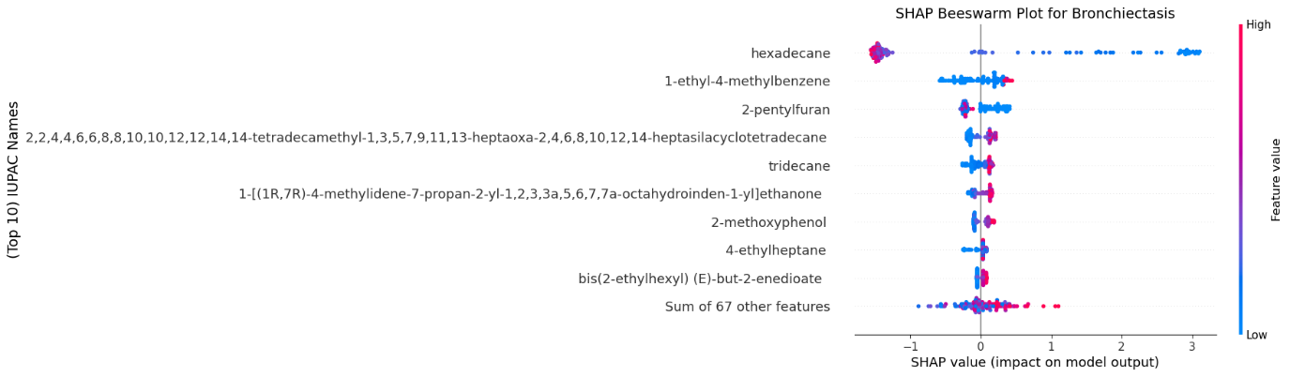

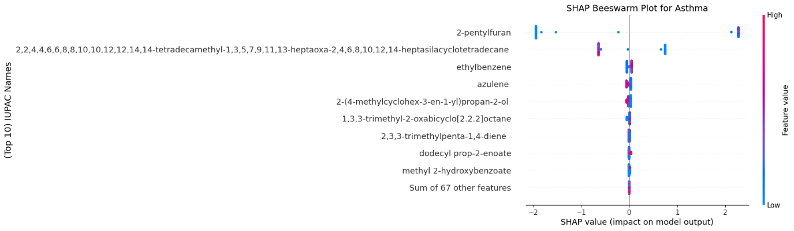

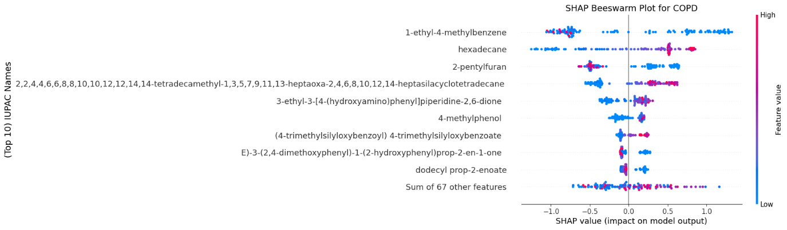

Table S1. Bootstrap-estimated classification performance with 95% confidence intervals for seven machine learning models. (Values are presented as mean estimates followed by the 95% confidence interval in parentheses, obtained from 1,000 bootstrap resamples of the refitted model predictions.)
Models | Accuracy (%) | AUC | Precision | Sensitivity | F1-score
KNN | 56.46  (40.91 ~ 70.27) | 0.742  (0.630 ~ 0.842) | 0.547  (0.391 ~ 0.695) | 0.541  (0.390 ~ 0.677) | 0.526  (0.375 ~ 0.665)
LR | 83.01  (70.72 ~ 93.33) | 0.930  (0.858 ~ 0.989) | 0.815  (0.687 ~ 0.926) | 0.812  (0.683 ~ 0.929) | 0.805  (0.671 ~ 0.922)
NB | 78.29  (66.67 ~ 88.89) | 0.896  (0.817 ~ 0.960) | 0.758  (0.626 ~ 0.879) | 0.750  (0.638 ~ 0.871) | 0.738  (0.611 ~ 0.860)
DT | 89.69  (79.55 ~ 97.87) | 0.916  (0.836 ~ 0.984) | 0.883  (0.765 ~ 0.976) | 0.880  (0.765 ~ 0.978) | 0.875  (0.761 ~ 0.975)
SVM | 80.56  (67.33 ~ 91.49) | 0.923  (0.841 ~ 0.983) | 0.789  (0.651 ~ 0.909) | 0.784  (0.644 ~ 0.901) | 0.777  (0.639 ~ 0.899)
RF | 90.54  (80.00 ~ 97.92) | 0.979  (0.931 ~ 0.999) | 0.896  (0.787 ~ 0.978) | 0.893  (0.778 ~ 0.978) | 0.886  (0.766 ~ 0.975)
XGBoost | 93.06  (83.99 ~ 100.00) | 0.991  (0.967 ~ 1.000) | 0.924  (0.833 ~ 1.000) | 0.921  (0.823 ~ 1.000) | 0.917  (0.813 ~ 1.000)

Table S2. The common PubChem CID and IUPAC Name lists for each disease used in this study are provided below.
PubChem CID | IUPAC Name
17100 | 2-(4-methylcyclohex-3-en-1-yl)propan-2-ol
6429350 | 1-[(1R,7R)-4-methylidene-7-propan-2-yl-1,2,3,3a,5,6,7,7a-octahydroinden-1-yl]ethanone
16821 | 5-octyloxolan-2-one
136569 | 2,3,3-trimethylpenta-1,4-diene
146102 | 2,6-ditert-butyl-4-hydroxy-4-methylcyclohexa-2,5-dien-1-one
29996 | N-propylhexan-1-amine
7720 | 2-ethylhexan-1-ol
13596727 | 2-but-3-enoxycarbonylbenzoic acid
551986 | 2-[(2,4,4,6,6,8,8-heptamethyl-1,3,5,7,2,4,6,8-tetraoxatetrasilocan-2-yl)oxy]-2,4,4,6,6,8,8,10,10-nonamethyl-1,3,5,7,9,2,4,6,8,10-pentaoxapentasilecane
23284 | [2,2,4-trimethyl-3-(2-methylpropanoyloxy)pentyl] 2-methylpropanoate
520958 | 1-(2,4-dimethylphenyl)-2,4-dimethylbenzene
6041429 | E)-3-(2,4-dimethoxyphenyl)-1-(2-hydroxyphenyl)prop-2-en-1-one
91742720 | bis[[(3-ethylphenoxy)-dimethylsilyl]oxy]-dimethylsilane
5370325 | bis(2-ethylhexyl) (E)-but-2-enedioate
574439 | 2-(hydroxymethyl)-2-methylpyrrolidine-1-carbaldehyde
567717 | 2-benzyl-1-morpholin-4-yl-3-phenylpropan-2-ol
5370158 | (E)-3-(2,2,6-trimethyl-7-oxabicyclo[4.1.0]heptan-1-yl)prop-2-enal
21630 | 2-ethylhexyl 3-(4-methoxyphenyl)prop-2-enoate
137353 | 3-ethyl-3-[4-(hydroxyamino)phenyl]piperidine-2,6-dione
558880 | (5-oxooxolan-2-yl)methyl 3,5-dinitrobenzoate
73219 | 3,5-ditert-butyl-4-hydroxybenzaldehyde
141033 | 3,6,6-trimethylcyclohex-2-en-1-one
91731726 | (4-trimethylsilyloxybenzoyl) 4-trimethylsilyloxybenzoate
575987 | 5H-cyclopenta[b]pyridine
7410 | 1-phenylethanone
91713521 | 1-O-butyl 6-O-propan-2-yl hexanedioate
1303 | 2-hydroxy-2-phenylpropanoic acid
9231 | azulene
240 | benzaldehyde
7602 | 1,3,5-triethylbenzene
12160 | 1-ethyl-4-methylbenzene
998 | 2-phenylacetaldehyde
12053 | 2-phenylpropan-2-ol
7147 | 1-phenylpropan-1-ol
637516 | (1R)-1-phenylethanol
103653 | 2-methylbutyl benzoate
90232 | ethyl 4-ethoxybenzoate
3102 | diphenylmethanone
Table S2. The common PubChem CID and IUPAC Name lists for each disease used in this study are provided below. (continued)
PubChem CID | IUPAC Name
7222 | 1,3-benzothiazole
244 | phenylmethanol
8343 | bis(2-ethylhexyl) benzene-1,2-dicarboxylate
85781 | bis(2-ethylhexyl) carbonate
9268 | cyclododecane
7874 | 2,2,4,4,6,6,8,8,10,10,12,12,14,14-tetradecamethyl-1,3,5,7,9,11,13-heptaoxa-2,4,6,8,10,12,14-heptasilacyclotetradecane
11170 | 2,2,4,4,6,6,8,8,10,10,12,12,14,14,16,16-hexadecamethyl-1,3,5,7,9,11,13,15-octaoxa-2,4,6,8,10,12,14,16-octasilacyclohexadecane
11169 | 2,2,4,4,6,6,8,8-octamethyl-1,3,5,7,2,4,6,8-tetraoxatetrasilocane
10914 | 2,2,4,4,6,6-hexamethyl-1,3,5,2,4,6-trioxatrisilinane
15600 | decane
8194 | dodecanal
75084 | dodecyl prop-2-enoate
8133 | 2-butoxyethanol
31236 | 2-phenoxyethanol
22568 | 2-phenoxyethyl acetate
23229 | 1-(3-acetylphenyl)ethanone
7500 | ethylbenzene
2758 | 1,3,3-trimethyl-2-oxabicyclo[2.2.2]octane
19602 | 2-pentylfuran
160669 | (2S)-5-amino-2-(methylamino)-5-oxopentanoic acid
41209 | 2,6,10,15-tetramethylheptadecane
16663 | 4-ethylheptane
11006 | hexadecane
557859 | 3,7-dimethyloct-7-en-3-ol
4133 | methyl 2-hydroxybenzoate
13544681 | N-methyl-N-[2-(methylamino)ethyl]benzamide
537332 | 5-ethyl-2-methyloctane
9602988 | methyl (Z)-N-hydroxybenzenecarboximidate
2879 | 4-methylphenol
21205 | methyl 14-methylpentadecanoate
460 | 2-methoxyphenol
8814 | 4-(2,4,4-trimethylpentan-2-yl)phenol
91726212 | 4-O-[2-(2-chlorophenoxy)ethyl] 1-O-ethyl butanedioate
11230 | 4-methyl-1-propan-2-ylcyclohex-3-en-1-ol
12388 | tridecane
31355 | tris(2-methylpropyl) phosphate
14257 | undecane

