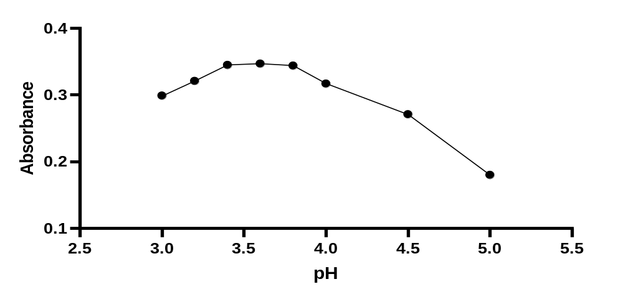

Figure S1: Effect of the pH on the formation of the yielded ion-pair complex of bromhexine (5 µg mL⁻¹) with 0.15% w/v EB.

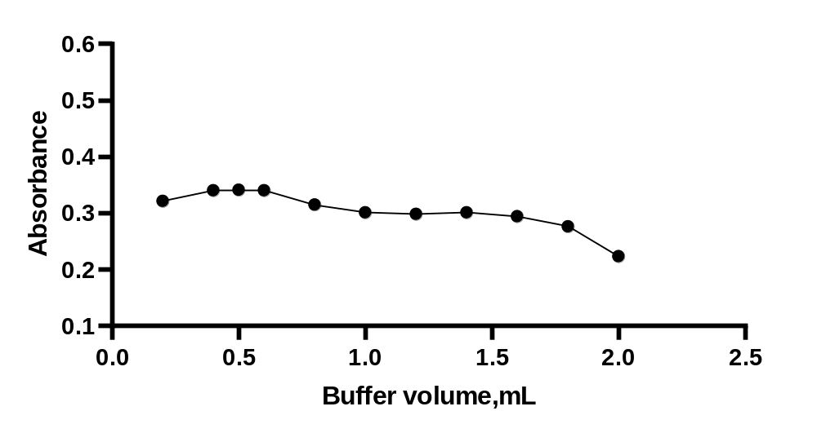
Figure S2: Effect of buffer volume on the formation of the complex of BMH (5 µg mL⁻¹) with 0.15% w/v EB.
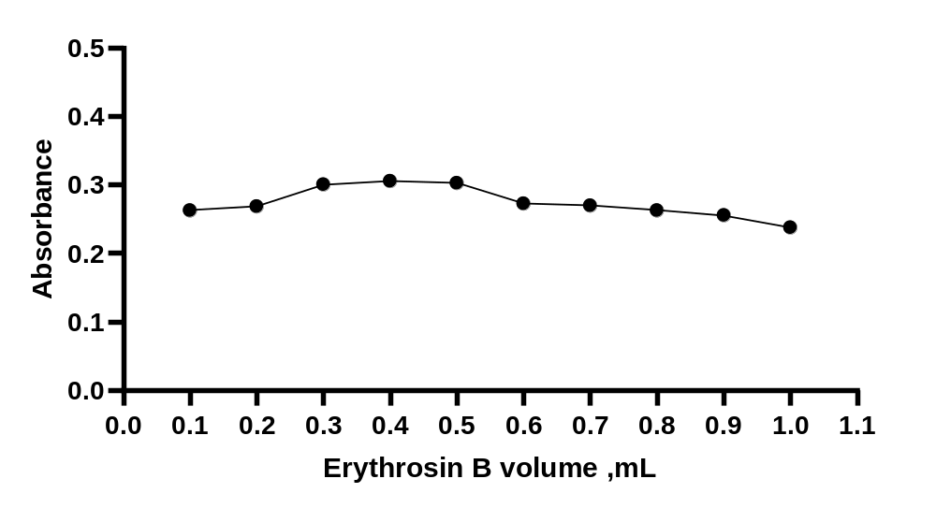

Figure S3: Effect of EB volume on the formation of the complex of BMH (5 µg mL⁻¹) with 0.15% w/v EB.
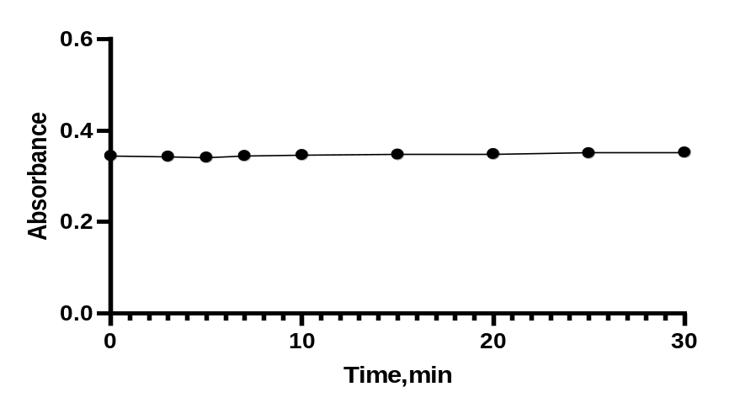

Figure S4: Time influence on the formation of the complex of BMH (5 µg mL⁻¹) with 0.15% w/v EB.
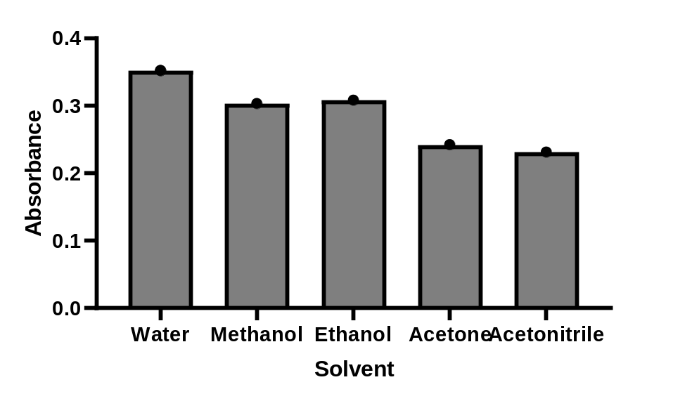
Figure S5: Solvent type influence on the formation of the complex of BMH (5 µg mL⁻¹) with 0.15% w/v EB
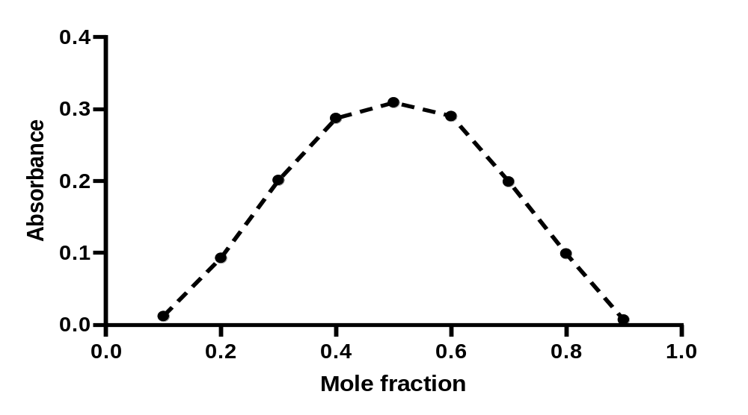

Figure S6: Job's method using 4 ×10⁻⁴ M concentration of BMH.

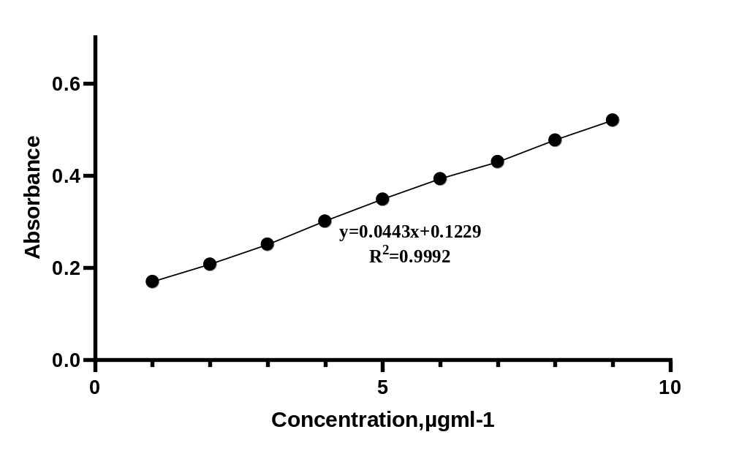
Figure S7: Calibration curve of BMH with 0.15% w/v EB.

MoGAPI AGREE
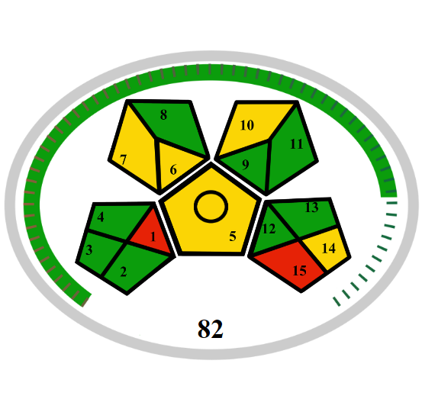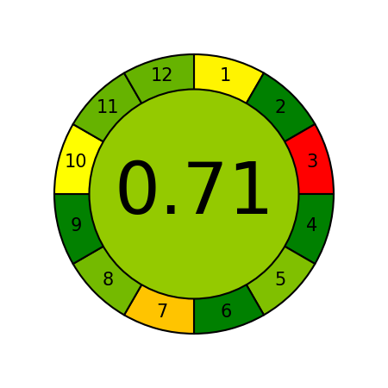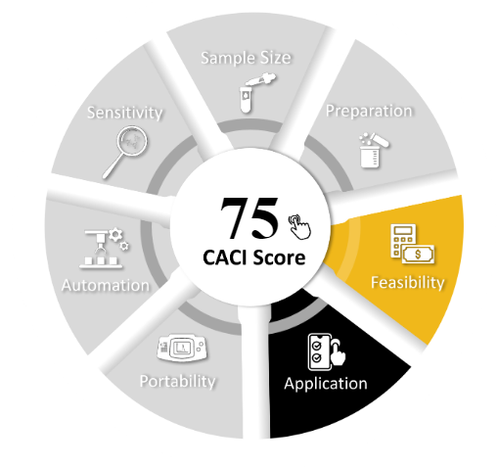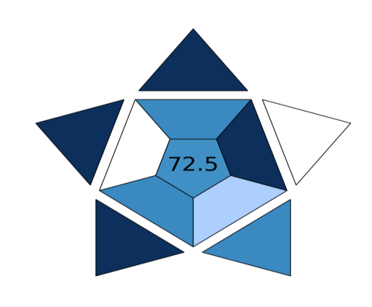
CACI BAGI

Figure S8: Summary of all greenness metrics used and how the method scores

1-GAPI

Reported HPLC  Method^{[2]} | Reported spectrophotometric  method^{[1]} | Proposed approach
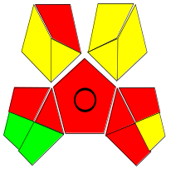 | 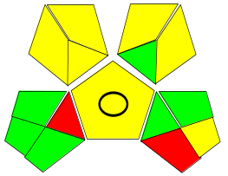 | 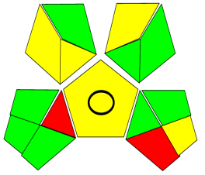 | GAPI

2-White chemistry

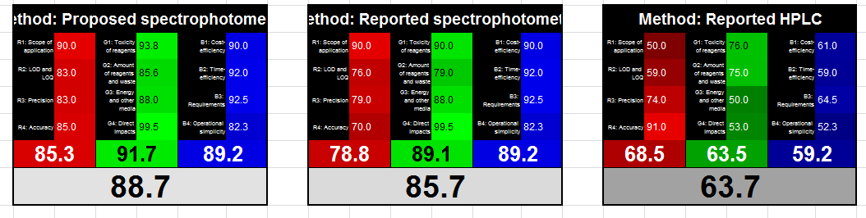

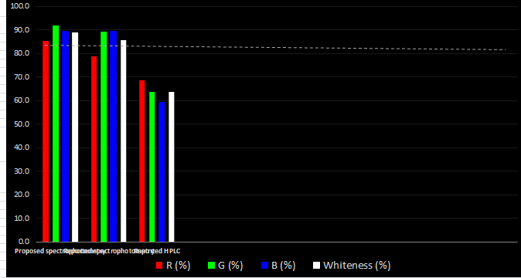

Figure S9: Comparison between proposed method and reported method in greenness (GAPI and White chemistry)
Table S1. Standard addition method for the assay of Bromhexine hydrochloride in its pharmaceutical dosage form using Bisolvon® 8mg tablets

Recovery(%)±RSDª | Found  (µgml⁻¹) | Total  (µgml⁻¹) | Amount added  (µgml⁻¹) | Amount analyzed  (µgml⁻¹)
101.69±1.11 | 1.966 | 2 | 0 | 2
99.14±1.16 | 2.974 | 3 | 1 | 2
100.50±1.69 | 4.020 | 4 | 2 | 2
100.86±1.13 | 5.043 | 5 | 3 | 2
ªThe value is the mean of three determinations

Table S2: Effect of excipients on the determination of drug

Conc. level (µgml⁻¹) | Recovery (%)± RSD* of 4 µg/ml of BMH per µg/ml of excipient added
Glucose | 98.3±1.32
Fructose | 97.9±0.97
Lactose | 99.2±0.75
NaCL | 100.2±1.36
KCL | 98.6±0.84
CaCL₂ | 99.7±1.53
Starch | 98.7±1.18
*Mean of three determinations

Table S3: Comparison between the proposed method and reported methods:

Reported HPLC  Method^{[2]} | Reported spectrophotometric  method^{[1]} | Proposed approach | Point of comparison
4.00-40.00 | 10-200 | 1-9 | Linear range (µg mL⁻¹)
1.24 | 0.408 | 0.199 | LOD
3.82 | 1.394 | 0.605 | LOQ
Time-consuming. | Time saving | Time saving | Time
*Needs relatively expensive and sophisticated instruments  *Needs extremely-cost detectors | Low cost | Low cost | Cost

Reported spectrophotometric  method^{[3]} |  |  | Point of comparison
Method C | Method B | Method A | Point of comparison
10-50 | 4-36 | 8-44 | Linear range (µg mL⁻¹)
0.8766 | 1.0533 | 0.8005 | LOD
2.6564 | 3.1921 | 2.4260 | LOQ

Reported spectrophotometric  Method^{[4]} |  |  |  |  | Point of comparison
Method E | Method D | Method C | Method B | Method A | Point of comparison
12.5–150 | 5–50 | 2.0–25 | 2.5–25 | 2.5–25 | Linear range (µg mL⁻¹)
11.30 | 3.53 | 2.58 | 1.65 | 2.12 | LOD
34.10 | 10.60 | 7.74 | 4.95 | 6.37 | LOQ

Method ^{[8]} | Method ^{[7]} | Method^{[6]} | Method^{[5]} | Point of comparison
1.5–65.0 | 2-20 | 5- 25 | 2-10 | Linear range (µg mL⁻¹)
- | 0.2011 | 0.1851 | - | LOD
- | 0.6696 | 0.6165 | - | LOQ

References:

[1] S.A. Mohammed, R.F. Almukhtar, Indirect spectrophotometric method for determination of bromhexine-HCL in pharmaceutical preparations, Rafidain Journal of Science, 27 (2018) 116-126
[2] N.S. Abdelwahab, S.M. Adly, N.W. Ali, M.M. Abdelrahman, Development and Validation of Two Novel Chromatographic Methods: HPTLC and HPLC for Determination of Bromhexine Hydrochloride in Presence of Its Two Impurities, Journal of chromatographic science, 59 (2021) 425-431
[3] A. Narayana, C.N. Rao, K. Sivakumar, Spectrophotometric determination of bromhexine using charge transfer complex reaction, Indian Journal of Advances in Chemical Science, 3 (2015) 128-132.
[4] K. Susmitha, M. Thirumalachary, G. Venkateshwarlu, Spectrophotometric Determination of Bromhexine HCl in Pure and Pharmaceutical Forms, International Scholarly Research Notices, 2013 (2013) 861851.
[5] S.V. Rao, I. Rao, T. Reddy, C.S.P. Sastry, Assay of bromhexine hydrochloride in pharmaceutical formulations by extraction spectrophotometry, Indian Journal of Chemical Technology, 12 (2005) 170-174.

[6] K. Siddappa, P. Hanamshetty, Spectrophotometric quantitative determination of bromhexine hydrochloride in bulk and pharmaceutical dosage form using p-nitrobenzaldehyde reagent, International Journal of Pharmaceutical Sciences Review and Research, 39 (2016) 260-265
[7]P. Hanamshetty, Spectrophotometric Quantitative Determination of Bromhexine Hydrochloride in Bulk and Pharmaceutical Dosage Form Using PDEAB Reagent, Chemical Science Transactions, (2016), 5(3), 611-618.
[8] B. Gala, G.-H. A., D. and Pérez-Bendito, Direct Kinetic Determination of Bromhexine Hydrochloride in Pharmaceutical Formulations, Analytical Letters, 26 (1993) 2607-2617.

