Article title: Arterial Flow Volume Measurement using Signal Intensity Gradient Versus Phase Contrast

Journal: Scientific Reports

Author names: Chan-Hyuk Lee, MD, PhD¹; Sang Hyuk Lee, PhD²; Hyo-Sung Kwak, MD, PhD³; Robert S. Rosenson, MD⁴; Seul-Ki Jeong, MD, PhD⁵; Keun-Hwa Jung, MD, PhD⁶

¹Department of Neurology, Ulsan University Hospital, University of Ulsan College of Medicine, Ulsan, Republic of Korea
²Virtual Engineering Research Center, Korea Institute of Machinery and Materials, Daejeon, Republic of Korea
³Department of Radiology and Research Institute of Clinical Medicine of Jeonbuk National University, Biomedical Research Institute of Jeonbuk National University Hospital, Jeonju, Republic of Korea
⁴Fuster Heart Hospital, Icahn School of Medicine at Mount Sinai, New York, NY, USA
⁵Institute for Blood Flow & Metabolism Research, MediIMG, Inc, Seoul National University Bundang Hospital, Seongnam, Republic of Korea
⁶Department of Neurology, Seoul National University Hospital, Seoul National University College of Medicine, Seoul, Republic of Korea

Address for correspondence:

Seul-Ki Jeong, MD, PhD
Institute for Blood Flow & Metabolism Research, MediIMG, Inc, Healthcare Innovation Park, Seoul National University Bundang Hospital 172, Dolma-ro, Bundang-gu, Seongnam-si, Gyeonggi-do 13605 Republic of Korea
Tel: +82-2-4861617, Fax: +82-2-64996448, email: skijeong@gmail.com
or
Keun-Hwa Jung, MD, PhD
Department of Neurology, Seoul National University College of Medicine and Hospital
101, Daehak-ro, Jongno-gu, Seoul 03080, Republic of Korea
Tel: +82-2-20724901, Fax: +82-2-36727553, email: jungkh@gmail.com

Table S1 Demographics of study participants
Number | 25
Age, y | 63.3 ± 11.5
Body mass index, kg/m² | 23.1 ± 3.4
Women, % | 36.0
Systolic blood pressure, mmHg | 138.6 ± 19.3
Diastolic blood pressure, mmHg | 79.3 ± 12.7
Heart rate, /min | 78.2 ± 10.2
Blood urea nitrogen, mg/dL | 14.6 ± 3.9
Creatinine, mg/dL | 0.8 ± 0.2
Hematocrit, % | 39.9 ± 4.9
Total cholesterol, mg/dL | 160.4 ± 33.1
HbA1c, % | 5.9 ± 0.7
Mean ± SD or proportions are shown.

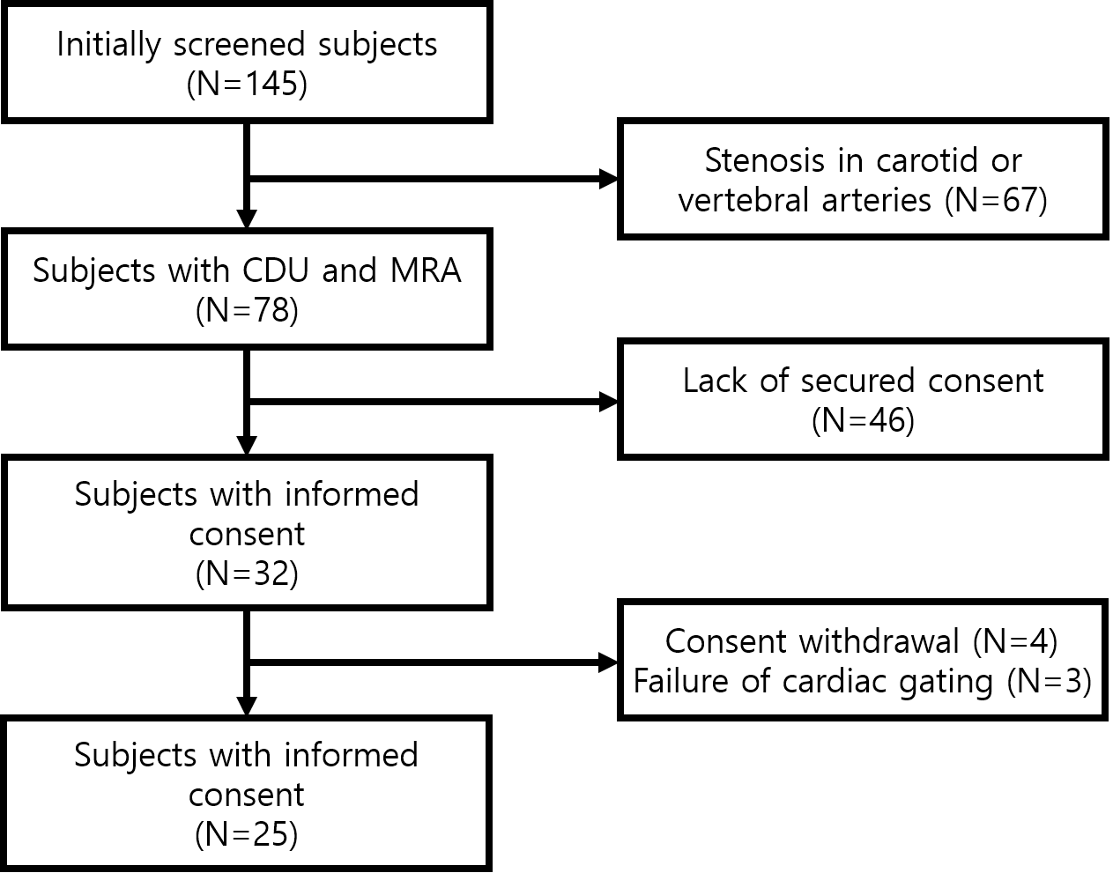
Fig S1 Flow chart of study population

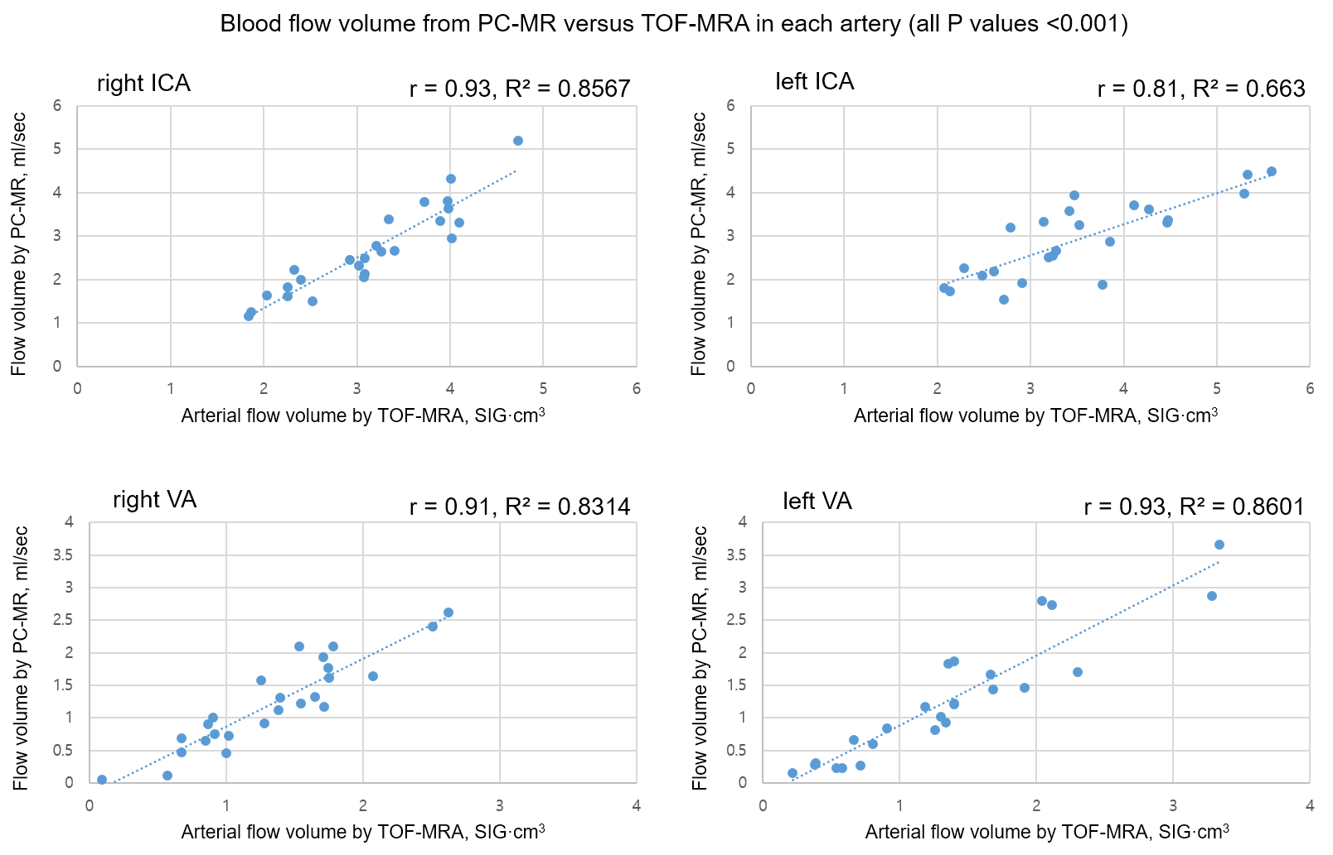 Fig S2 Flow analysis with PC-MR and TOF-MRA for internal carotid (ICA) and vertebral arteries (VA). The very low flow values were observed in the vertebral arteries, which was primarily attributed to asymmetric atrophy of a unilateral VA.
PC-MR: phase-contrast magnetic resonance, TOF-MRA: time-of-flight magnetic resonance angiography.

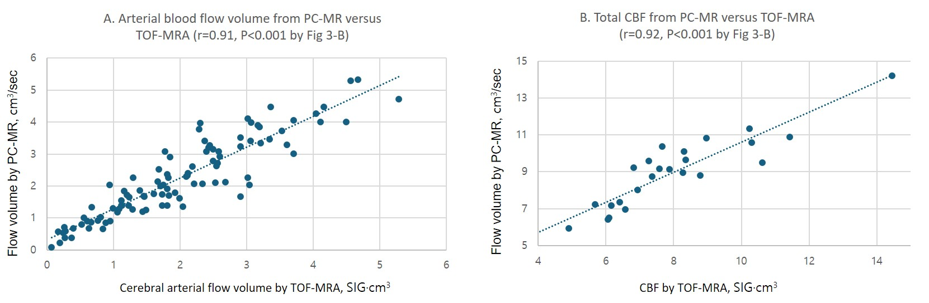 Fig S3 Flow analysis with PC-MR and TOF-MRA (short-segment method) for ICAs and VAs. A. Correlation between arterial blood flow volumes measured by PC-MR and TOF-MRA. B. Correlation of total cerebral blood flow measured by PC-MR and TOF-MRA.

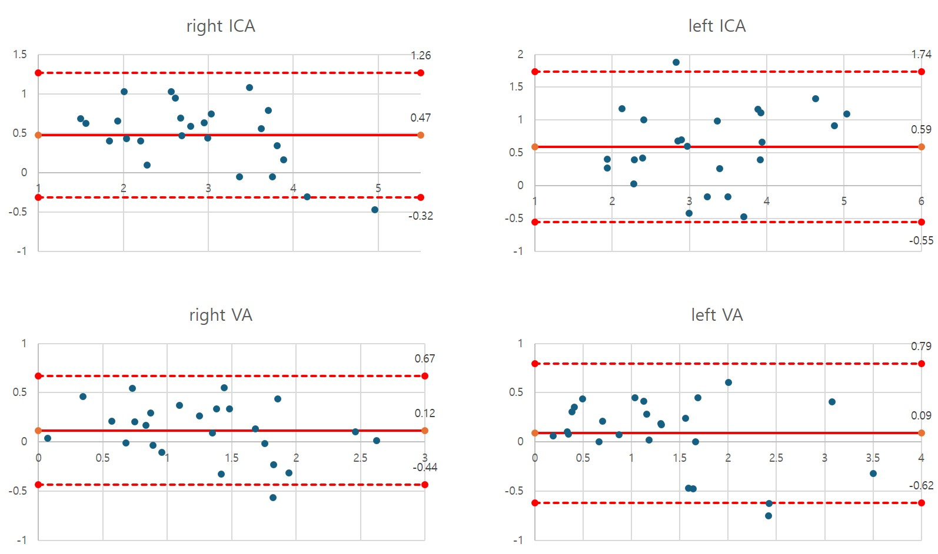
Fig S4 Agreement in blood flow volume measurements between PC-MR and TOF-MRA (long segment) in ICAs and VAs. The Bland-Altman plots display the mean differences, as well as the upper and lower limits of agreement.

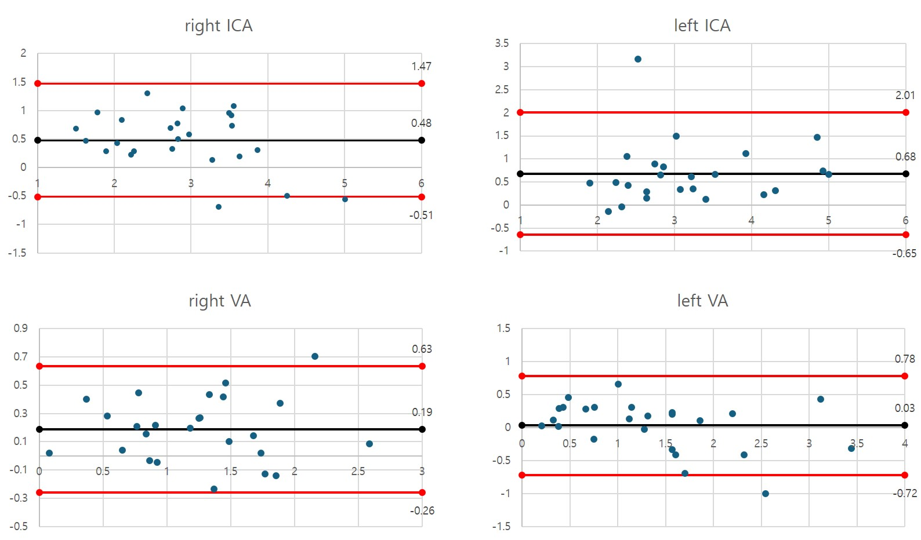
Fig S5 Agreement in blood flow volume measurements between PC-MR and TOF-MRA (short segment) for ICAs and VAs. Bland-Altman plots illustrate the mean differences, as well as the upper and lower limits of agreement.

