Table S1. In-silico assessment of the homogeneity of human antibodies specific for coronavirus receptors in cattle
Receptor | Antibody | NCBI accession number |  | Protein immunogen on human sequence | Per. Ident
Receptor | Antibody | Bos taurus | Homosapiens | Protein immunogen on human sequence | Per. Ident
ACE2ª | sc-390851 | NP_001019673.2 | Q9BYF1.2 | 631-805 | 74.71%
TMPRSS2^{b} | sc-515727 | NP_001075054.1 | O15393.3 | 296-345 | 81.25%
APN^{c} | sc-166105 | NP_001068612.1 | P15144.4 | 668-967 | 78.45%
CEACAM1^{d} | sc-166453 | NP_991357.1 | P13688.2 | 391-526 | 56.52%
ª ACE2- angiotensin-converting enzyme 2; ^{b} TMPRSS2- transmembrane protease serine 2; ^{c} APN- aminopeptidase N: ^{d} CEACAM1- carcinoembryonic antigen-related cell adhesion molecule 1.

Quantitative PCR
The constitutive mRNA levels of ACE2, CEACAM, DPP4, and APN in selected tissues were determined by qPCR. Snap-frozen bovine tissues were homogenized in TRIzol reagent (Thermo Fisher Scientific, Waltham, MA, USA) using 2.8 mm ceramic beads (Omni). Homogenates were subjected to chloroform phase separation, and total RNA was extracted from the clear aqueous phase following the manufacturer’s instructions (QIAGEN, Germantown, MD, USA). Total RNA concentration and purity were evaluated using NanoDrop one microvolume UV-Vis spectrophotometer (Thermo Fisher Scientific). Samples with A260/280 between 1.96 and 2.05 were used for reverse transcription (100 ng/µL total RNA) using a qScript XLT cDNA SuperMix (Quantabio, Beverly, MA, USA). qPCR reactions were performed using 1.0 ng/μL of cDNA, 1x PowerUp SYBR Green Master Mix (Thermofisher Scientific), and 500 nM of bovine-specific primers (Table S2) in an QuantStudio 7 Pro Real-time PCR system under these conditions: 50 °C for 2 min and 95 °C for 2 min holding; 40 cycles, 95 °C for 15 s denaturation and 60 °C for 1 min amplification; final melting curve analysis was performed at 95 °C for 15 s, 60 °C for 1 min and 95 °C for 15 s. qPCR reactions were performed in triplicate, including no-template controls. Amplification efficiencies beyond the range (1.90–2.2) and samples with multiple melting peaks, were discarded.
Table S2. List of primers designed for this study.
Gene of interest | Sequence (5'-3') | GeneBank accession
ACE2ª | F- GCTACAGAAGAGAGAAGAATCCAGACA | NM_001024502.4
 | R- AAAGACGGTGGCCAAGCA
TMPRSS2^{b} | F- CGCCTCGACACCTGTCATCTA | NM_001081585.1
 | R- GCACAGGGCTTTCTTAGTCTTTGA
APN/ANPEP^{c} | F- CCAGAAGCACTTCCTCCTTGA | NM_001075144.1
 | R- TGGGAACAATCCACAGATAGTTGA
DPP4^{d} | F- CCTGCCTGCAGCCCTTTAT | NM_174039.3
 | R- CACAAGGCGCTTCCAAGTTT
CEACAM1e | F- CCACTGCCCAGCTCACTATTG | NM_205788.1
 | R- GTGGGCAAGCAGAAGAACATC
ª ACE2- angiotensin-converting enzyme 2; ^{b} TMPRSS2- transmembrane protease serine 2; ^{c} APN- aminopeptidase N: ^{d} DPP4; dipeptidyl peptidase 4; ^{e} CEACAM1- carcinoembryonic antigen-related cell adhesion molecule 1.

Immunohistochemistry
Protein expression was assessed in paraffin-embedded tissue sections (4 μm) by IHC using primary antibodies against the different receptors (Figure S1). ImmPRESS VR anti-mouse IgG HRP-conjugated polymer detection kit (Vector Laboratories Inc., Burlingame, CA, USA) was used for secondary antibody staining following the manufacturer’s instructions. Deparaffinized sections were heat retrieved (96 °C/30 min) using citrate buffer (Millipore-Sigma, Burlington, MA, USA) and washed in tris-buffered saline containing 0.1% Tween 20 (TBST) (Millipore-Sigma, Burlington, MA, USA). After blocking with animal-free buffer (Vector Laboratories) for 30 min, sections were incubated overnight with the corresponding primary antibody at 4 °C. The sections were then treated with 0.3% hydrogen peroxide for 30 min, followed by incubation with the secondary antibody for 60 min. Chromogenic detection of sections was performed using ImmPACT DAB EqV peroxidase substrate solution (Vector Laboratories) and hematoxylin, followed by mounting in Tissue-Tek Glas mounting medium (Sakura Finetek Inc, Torrance, CA, USA).
Table S3.
Coronavirus receptor gene expression qPCR in bovine respiratory and intestinal tissue.
Tissue | Animal | ACE2ª | TMPRSS2^{b} | APN/ANPEP^{c} | DPP4^{d} | CEACAM1e
Trachea | 1 | 34.21 | 34.18 | 34.57 | 33.80 | 31.17
Trachea | 2 | 33.93 | 31.27 | 33.34 | 32.68 | 30.56
Trachea | 3 | 33.34 | 32.53 | 32.84 | 33.06 | 30.37
Lung | 1 | 35.36 | 34.11 | 32.86 | 34.62 | 31.41
Lung | 2 | 34.95 | 35.67 | 33.45 | 34.43 | 31.98
Lung | 3 | 34.50 | 3476 | 32.78 | 34.37 | 30.80
Ileum | 1 | 34.74 | 35.49 | 32.93 | 33.65 | 31.64
Ileum | 2 | 34.55 | >40.0 | 34.69 | 35.00 | 31.60
Ileum | 3 | 34.54 | >40.0 | 34.40 | 34.94 | 27.91
Colon | 1 | 31.47 | 31.71 | 34.86 | 31.75 | 28.25
Colon | 2 | 31.84 | 34.24 | 32.95 | 32.20 | 29.14
Colon | 3 | 33.22 | 34.14 | 34.77 | 33.01 | 30.56

ª ACE2- angiotensin-converting enzyme 2; ^{b} TMPRSS2- transmembrane protease serine 2; ^{c} APN- aminopeptidase N: ^{d} DPP4; dipeptidyl peptidase 4; ^{e} CEACAM1- carcinoembryonic antigen-related cell adhesion molecule 1.

Figure S1. Immunohistochemical characterization of ACE2 (A), TMPRSS2 (B), APN (C), DPP4 (D), and CEACAM1 (E) in bovine kidney. The secondary antibody (F) and blank (G) staining control. Scale bar = 100 μm; images taken at 200x magnification.

Performance metrics of PixF to ImageJ
The envisioned use case for the PixF tool is primarily the ease of use over the web. So, the user can run their image multiple times using the Graphical Interface hosted on agrivax.onrender.com, or programmatically through the GitHub package, varying different Color-distance values. PixF is explicitly designed for a different user base and purpose. It does not claim to outperform ImageJ or replace its rich plugin ecosystem, but it fills a usability gap. Many biologists are deterred by ImageJ's steep learning curve and complex installation or scripting requirements. PixF's advantage lies in accessibility and speed, offering real-time pixel-level fluorescence summaries directly in the browser. Its interface prioritizes ease-of-use, enabling non-specialists to quickly obtain essential quantification and spatial information. The manuscript does not frame PixF as a more advanced analytical engine but as a time-saving alternative for researchers who need rapid insights rather than exhaustive annotation. In this way, it complements—not competes with—platforms like ImageJ.
Performance metrics of PixF with respect to ImageJ for a publicly available benchmark database of 283 neuronal brain slice images released along with their ground truth labels (detailed in Supplementary Figure S2). The dataset was reported by: Hitrec, T., Luppi, M., Bastianini, S., Squarcio, F., Berteotti, C., Martire, V.L., Martelli, D., Occhinegro, A., Tupone, D., Zoccoli, G. and Amici, R., 2019. Neural control of fasting-induced torpor in mice. Scientific reports, 9(1), pp.1-12 ⁶³. This dataset is available through – https://www.kaggle.com/datasets/nbroad/fluorescent-neuronal-cells/data
For instance, quantification of normalized #ffd700 color intensities across all 283 images was done side-by-side using ImageJ and PixF against ground truth labels. ImageJ showed an R2-value of 0.91, while PixF was at 0.88 (Figure S2A). PixF was two orders of magnitude faster than ImageJ for an image-by-image analysis (Figure S2B). However, PixF's DeckCrop module can programmatically take in all 283 images at once and output a similar performance under 15 seconds. The web version of PixF allows users to upload up to a 100-image deck. We have added this analysis to the supplementary material of the updated manuscript.
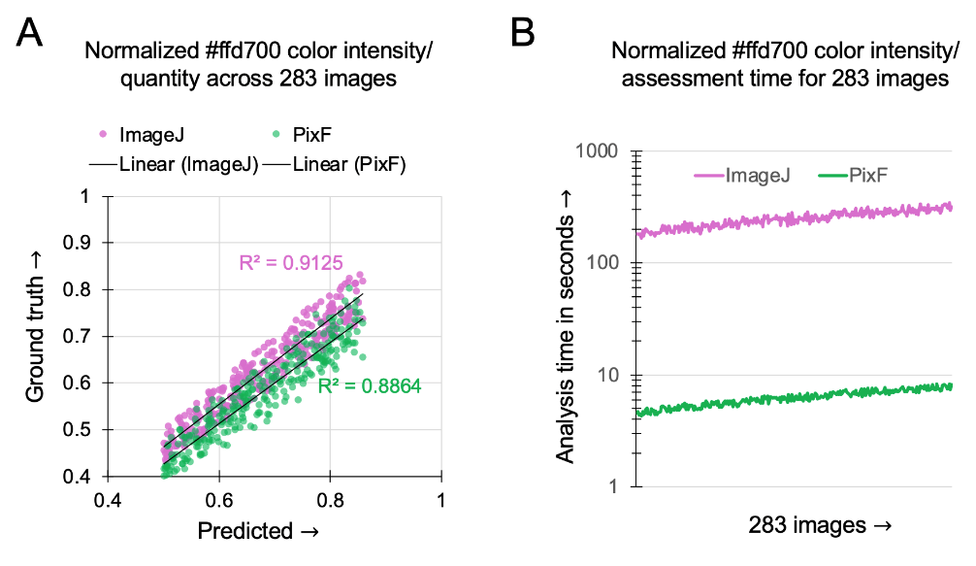
Figure S2. The precision and recall values for PixF for measuring the fluorescence intensities (such as for color #ffd700) on the Color-distance value that the user puts in PixF prior to calculation. Programmatically, it is possible to play around with several values between 0 to 100 to identify what value yields the best precision, accuracy, recall, and F1-score. On the 283 image dataset, we identified that a Color-distance value between 45 to 65 yielded the highest performance for PixF.
An automated sampling of Color-distance values were compared with 21 unique user tests, where each of the users were asked to report the cumulative fluorescence levels (of both #3a1f00 and #ffd700) on randomly chosen, 30 unique images from this dataset. Users had complete freedom to choose whatever Color-distance value they deemed appropriate. The precision, accuracy, recall, and F1 scores from all experiments have been summarized below. Based on ground truth labels, any pixel with a normalized intensity >0.2 (on a scale of 0-1) for each color was considered positive data, and lower than or equal to 0.2 was negative.

Table S4. Statistics from soft benchmarking of PixF for this study
Aspects | Color #3a1f00 | Color #ffd700
Blinded 21-user test across 30 randomly chosen images for each user
Mean Color-distance chosen | $\text{53 }\text{∓}$4 | $$\text{47 }\text{∓}\text{ 2}$$
Precision | 0.801$\text{∓}$ 0.11 | 0.750$\text{∓}$ 0.16
Accuracy | 0.942 $\text{∓}$0.07 | 0.960 $\text{∓}$0.12
Recall | 0.667$\text{∓}$ 0.06 | 0.643$\text{∓}$ 0.08
F1-score | 0.727 $\text{∓}$0.22 | 0.692 $\text{∓}$0.18
Computationally performed exhaustive random sampling.
Optimal Color-distance iteratively identified | $$\text{58 }\text{∓}\text{ 2}$$ | $$\text{55 }\text{∓}\text{ 3}$$
Precision | 0.857 | 0.769
Accuracy | 0.950 | 0.950
Recall | 0.600 | 0.833
F1-score | 0.705 | 0.800

Note:
PixF does not claim to perform advanced spectral unmixing or artifact deconvolution beyond what standard imaging hardware and acquisition settings enable. Instead, it minimizes the impact of bleed-through and non-specific fluorescence through its multi-channel thresholding and channel-specific intensity normalization features, which are designed to highlight high-confidence signals over background. The goal is not to eliminate these artefacts as an imaging tool would, but rather to filter them out computationally during quantification without requiring manual ROI annotation or pre-processing. While a formal quantitative comparison is future work, PixF's advantage lies in delivering reproducible and interpretable pixel-level summaries under standardized settings, making it highly effective for consistent analysis across large datasets—especially when image acquisition parameters are controlled. In contrast to traditional methods, which often require expert tuning or manual correction, PixF's strength is in rapid and standardized handling, not in deep artifact correction.
Head-to-head analysis (Supplementary Figure S3) with ImageJ in terms of processing speed differences and quantitative accuracy was performed, and the MultiCrop module of PixF was re-optimized to make it parallelized and faster. The new run times on the 283 benchmark image dataset are reported. We also report the pairwise similarity of these images in the dataset, showing reasonable variability across these images. We used the Structural Similarity Index Measure (SSIM) from skimage.metrics.ssim for the pairwise image comparisons. The process was implemented in Python and executed in a Colab environment.

Figure S3. Performance evaluation and benchmarking of PixF. (A) MultiCrop runtime comparison before and after PixF optimization across 10 representative image datasets (x-axis labels). Optimized PixF shows >96% reduction in runtime across all datasets. (B) DeckCrop runtime consistency across 100 benchmarking images for two representative fluorescence colors (#3a1f00 and #ffd700), demonstrating stable per-image performance under varying conditions. (C) Heatmap of pairwise similarity scores (0–1) between 100 benchmarking images used in the runtime tests, revealing structural diversity in the dataset and validating the robustness of PixF across heterogeneous inputs.

