Supplementary Discussion
for
Investigating Microstructural and Mechanical Properties Evolution in Biomedical AZ31 Magnesium Alloy under Different Casting Conditions

Gunvanta Dhanuskar ª, Abhaykumar Kuthe ª, Dheeraj Bhiogade ª, Bhupesh Sarode ^{a,} and Ashutosh Bagde ^{b,*}
ª Visvesvaraya National Institute of Technology, Nagpur, Maharashtra, 440010, India
^{b} Datta Meghe Institute of Higher Education and Research, Wardha, Maharashtra, 442005, India.

Supplementary Discussion
S1. Materials
Fig. S1 presents the X-ray diffraction (XRD) patterns of AZ31 magnesium alloy samples subjected to eight different experimental casting conditions (Exp-1 to Exp-8), highlighting the evolution of phase composition under varying furnace and atmospheric parameters. The observed diffraction peaks correspond to α-Mg, β-Mg₁₇Al₁₂, Al₈Mn₅, and MgO (oxidation product). In Exp-1 to Exp-4, the dominant presence of MgO and diminished α-Mg and β-Mg₁₇Al₁₂ peaks indicates severe oxidation due to uncontrolled environments, with residues likely originating from surface-oxidized or partially sublimated metal. Exp-5 to Exp-7 show a gradual increase in β-Mg₁₇Al₁₂ and Al₈Mn₅ peak intensities, corresponding to partially melted samples with incomplete phase development, corroborating the macrographic evidence in Fig. 5(e–g). Notably, Exp-8 reveals strong and distinct peaks of α-Mg, β-Mg₁₇Al₁₂, and Al₈Mn₅ with minimal MgO, indicating successful casting under argon-assisted resistance furnace conditions. This confirms complete solidification and proper phase formation in Exp-8, making it suitable for direct comparison with the rolled AZ31 sheet (raw material) in subsequent structural and mechanical analyses (Fig. 13, Table 3). The progression of phase formation across experiments underscores the importance of a protective atmosphere and thermal control during AZ31 casting in suppressing oxidation and promoting the desired intermetallic phase distribution, which is crucial for biomedical applications.

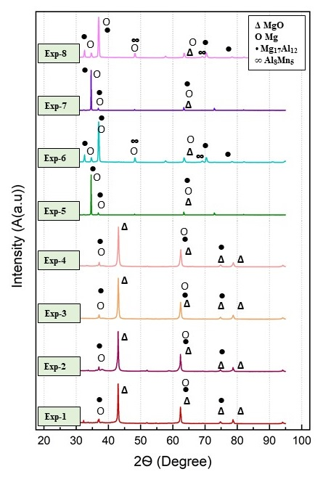
Fig. S1. XRD profiles of AZ31 magnesium alloy processed under eight experimental casting conditions (Exp-1 to Exp-8).

