Table of contents
- ¹HNMR of 3a in DMSO-d⁶………………………………………………..…………..S1
- ¹³CNMR of 3a in DMSO-d⁶………………………………………..……..……………S2
- ¹HNMR of 3b in DMSO-d⁶………………………………………………..…………..S3
- ¹³CNMR of 3b in DMSO-d⁶………………..………………………………..…………..S4
- ¹HNMR of 3c in DMSO-d⁶………………………………………………..…………..S5
- ¹³CNMR of 3c in DMSO-d⁶………………...……………………………..…………..S6
- ¹HNMR of 3d in DMSO-d⁶……………………………………....………..…………..S7
- ¹³CNMR of 3d in DMSO-d⁶…………………….…………..……………..…………..S8
- ¹HNMR of 3e in DMSO-d⁶………………………………………………..…………..S9
- ¹³CNMR of 3e in DMSO-d⁶…………………………………………...…..…………S10
- ¹HNMR of 3f in DMSO-d⁶………………………………………………..…………S11
- ¹³CNMR of 3f in DMSO-d⁶………………………………………………..………...S12
- ¹HNMR of 3g in DMSO-d⁶………………………………………………..………..S13
- ¹³CNMR of 3g in DMSO-d⁶………………………………………………..………..S14
- ¹HNMR of 3h in DMSO-d⁶………………………………………………..………..S15
- ¹³CNMR of 3h in DMSO-d⁶………………………………………………..………..S16
- ¹HNMR of 3i in DMSO-d⁶………………………………………………..………..S17
- ¹³CNMR of 3i in DMSO-d⁶………………………………………………..………..S18
- ¹HNMR of 3j in DMSO-d⁶……………..…………………………………..………..S19
- ¹³CNMR of 3j in DMSO-d⁶…………….…………………………………..………..S20
- ¹HNMR of 3k in DMSO-d⁶…………….…………………………………..………..S21
- ¹³CNMR of 3k in DMSO-d⁶……………..…………………………………..………..S22
- ¹HNMR of 3l in DMSO-d⁶…………………………………………………..………..S23
- ¹³CNMR of 3l in DMSO-d⁶…………………………………………………..………..S24
- ¹HNMR of 3m in DMSO-d⁶…………………………………………………..………..S25
- ¹³CNMR of 3m in DMSO-d⁶……………..…………………………………..………..S26
- HRMS of 3a……………………………………………………………………………S27
- HRMS of 3b……………………………………………………………………………S28
- HRMS of 3c……………………………………………………………………………S29
- HRMS of 3d……………………………………………………………………………S30
- HRMS of 3e……………………………………………………………………………S31
- HRMS of 3f……………………………………………………………………………S32
- HRMS of 3g……………………………………………………………………………S33
- HRMS of 3h……………………………………………………………………………S34
- HRMS of 3i……………………………………………………………………………S35
- HRMS of 3j……………………………………………………………………………S36
- HRMS of 3k……………………………………………………………………………S37
- HRMS of 3l……………….…………………………………………………………S38
- HRMS of 3m…………………………………………………………………………S39
- HRMS of 3a……………………………………………………………………………S40
- HRMS of 3b……………………………………………………………………………S41
- HRMS of 3c……………………………………………………………………………S42
- HRMS of 3d……………………………………………………………………………S43
- HRMS of 3e……………………………………………………………………………S44
- HRMS of 3f……………………………………………………………………………S45
- HRMS of 3g……………………………………………………………………………S46
- HRMS of 3h……………………………………………………………………………S47
- HRMS of 3i……………………………………………………………………………S48
- HRMS of 3j……………………………………………………………………………S49
- HRMS of 3k……………………………………………………………………………50
- HRMS of 3l……………………………………………………………………………S51
- HRMS of 3m…………………………………………………………………………S52

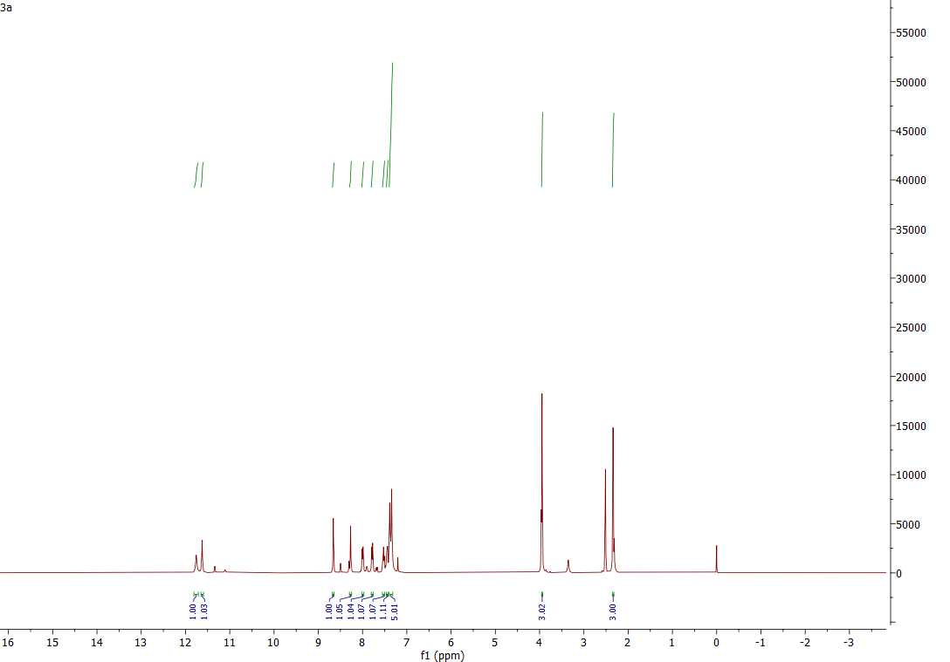
SI-1: ¹HNMR of 3a in DMSO-d⁶
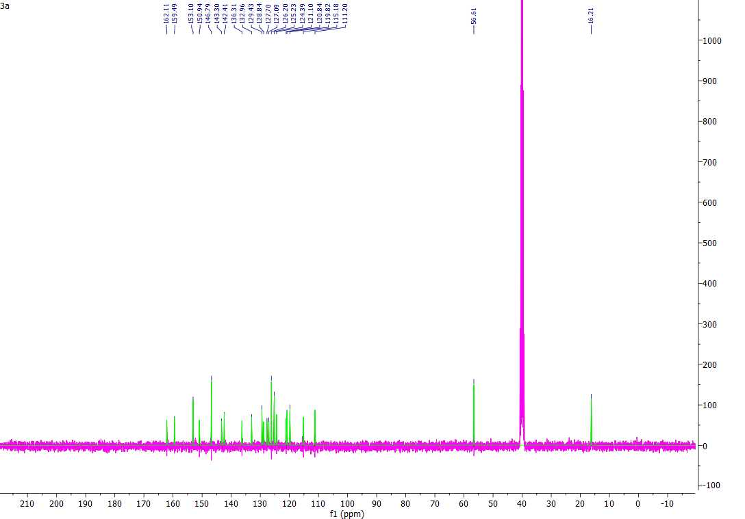
SI-2: ¹³CNMR of 3a in DMSO-d⁶

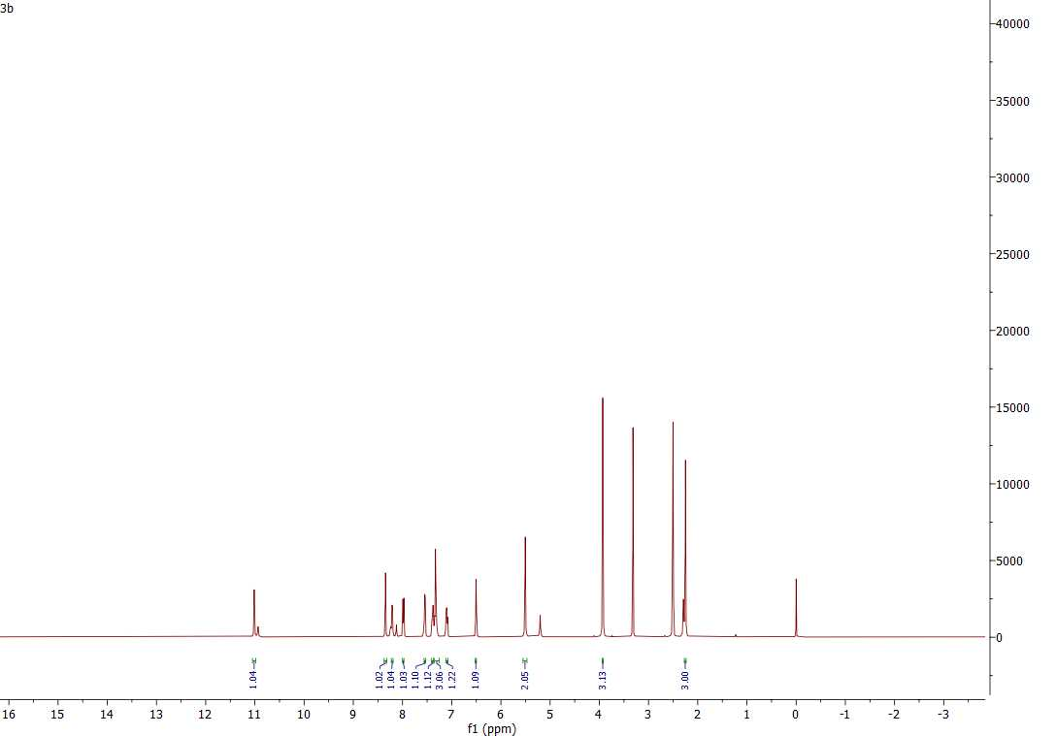
SI-3: ¹HNMR of 3b in DMSO-d⁶

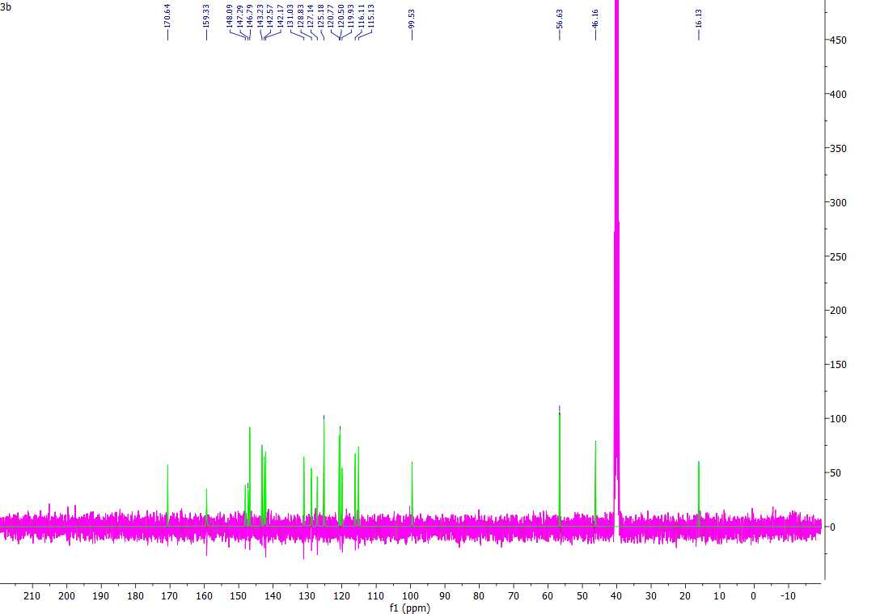
SI-4: ¹³CNMR of 3b in DMSO-d⁶

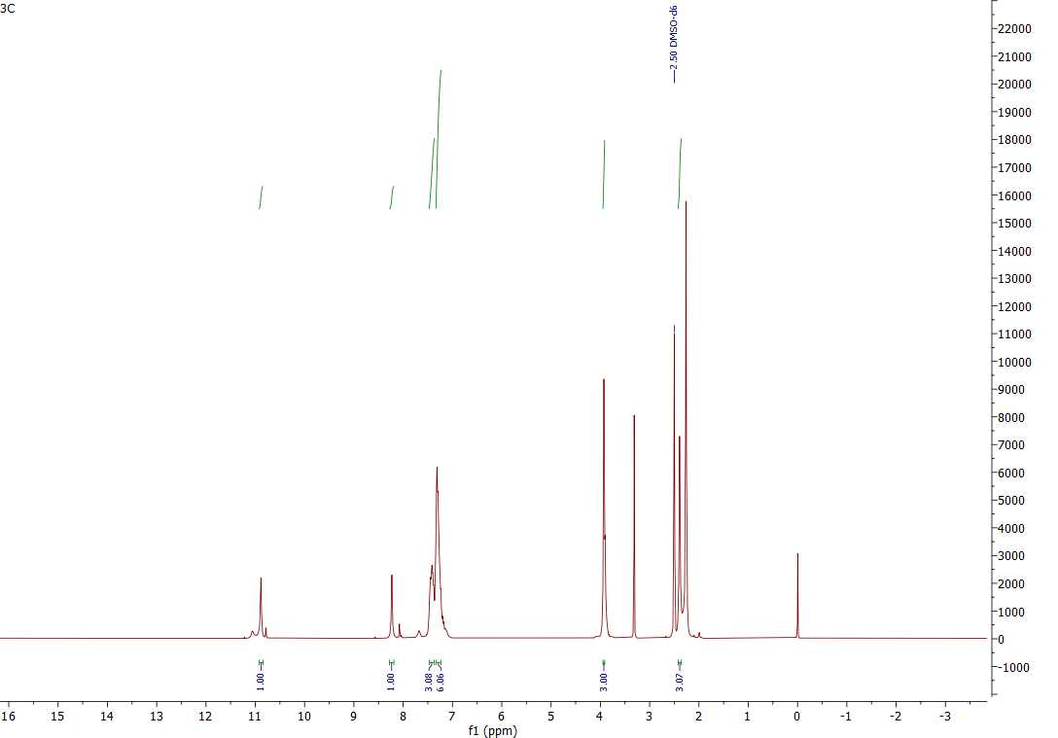
SI-5: ¹HNMR of 3c in DMSO-d⁶

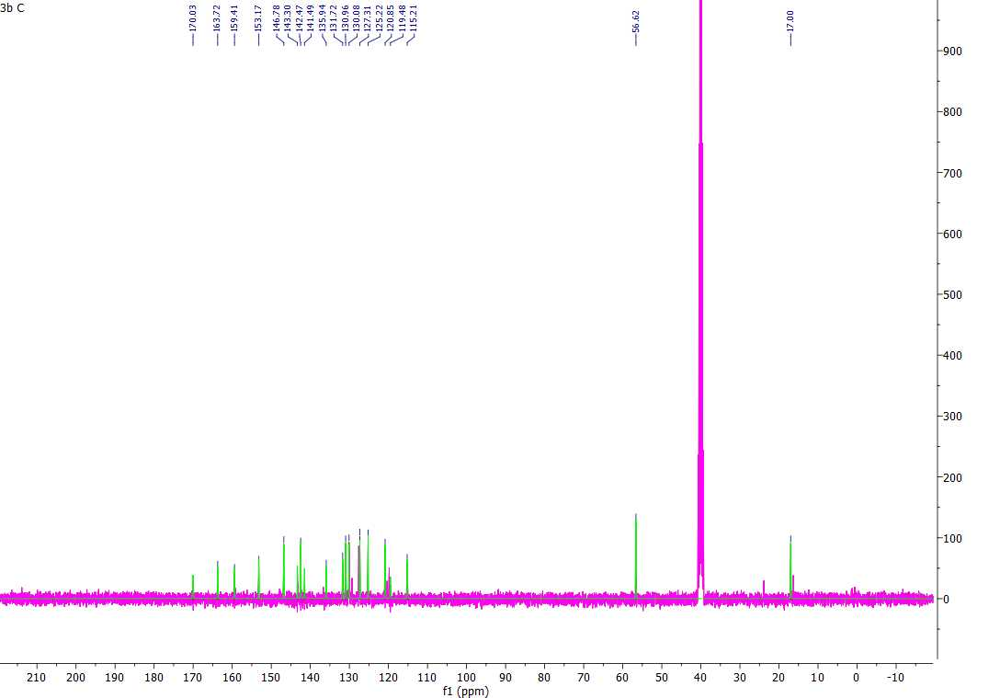
SI-6: ¹³CNMR of 3c in DMSO-d⁶

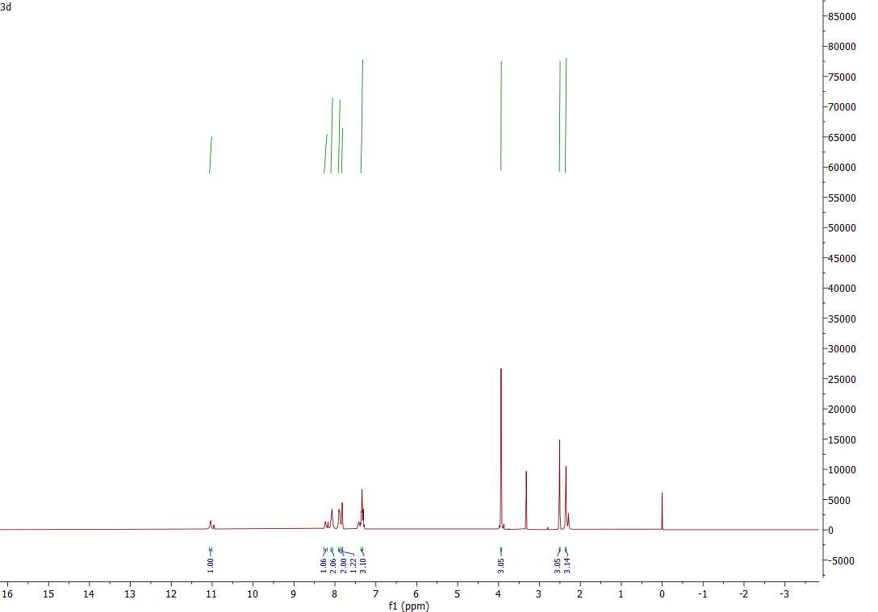
SI-7: ¹HNMR of 3d in DMSO-d⁶

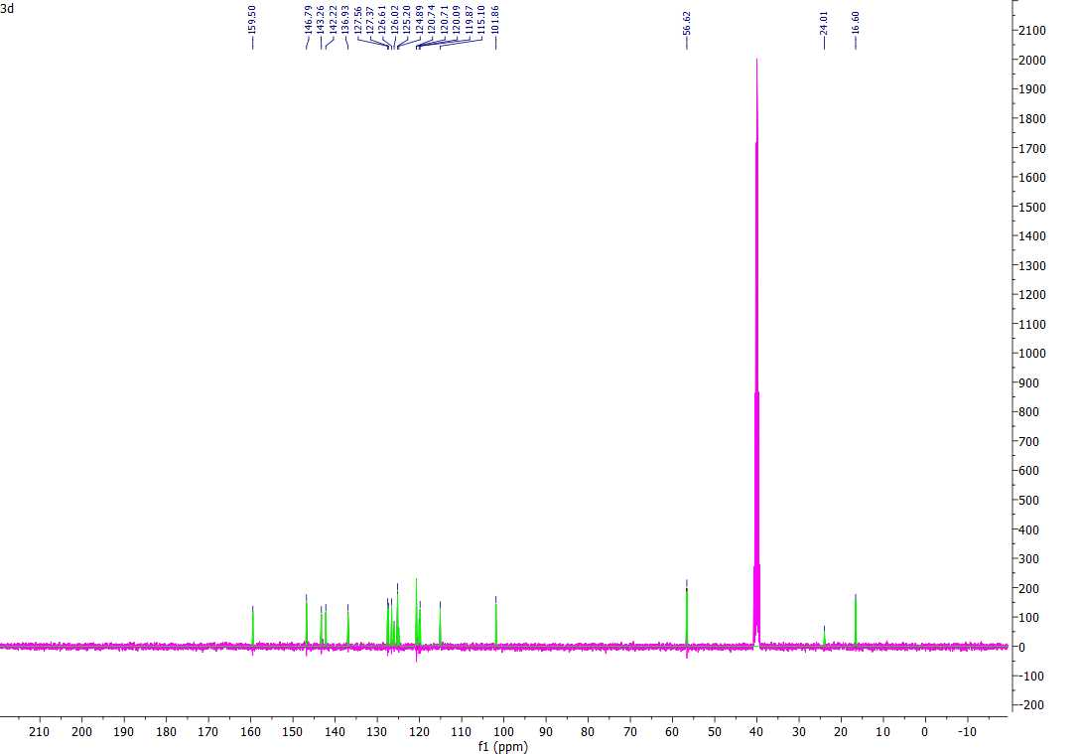
SI-8: ¹³CNMR of 3d in DMSO-d⁶

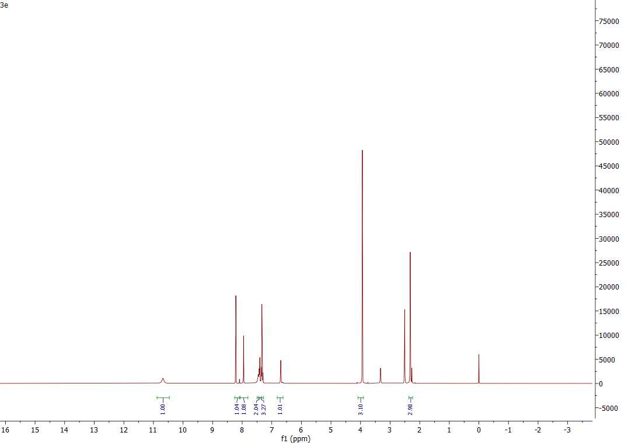
SI-9: ¹HNMR of 3e in DMSO-d⁶

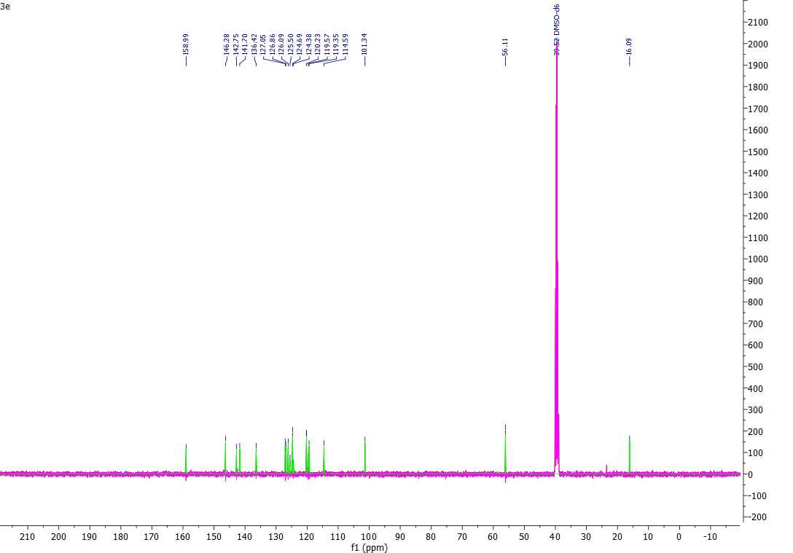
SI-10: ¹³CNMR of 3e in DMSO-d⁶

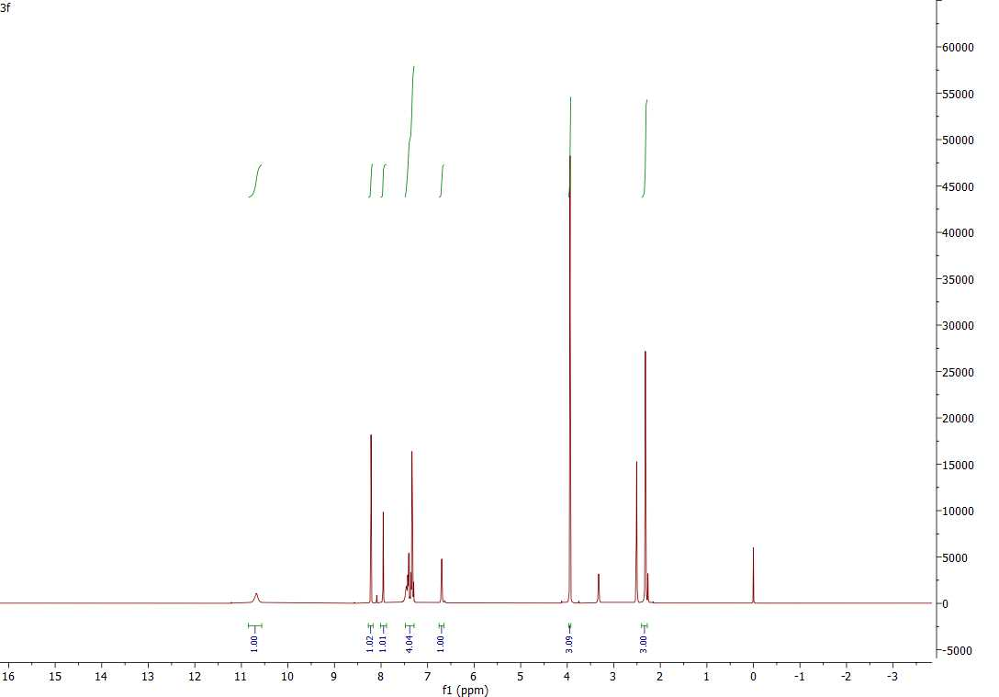
SI-11: ¹HNMR of 3f in DMSO-d⁶

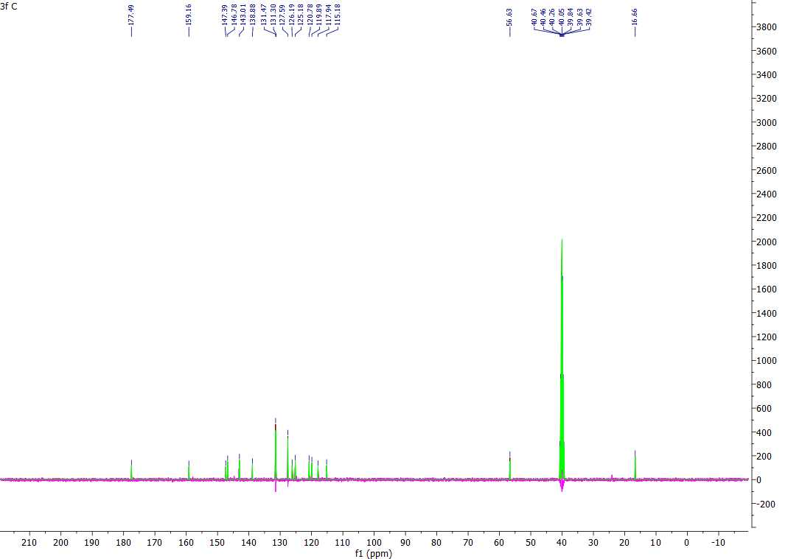
SI-12: ¹³CNMR of 3f in DMSO-d⁶

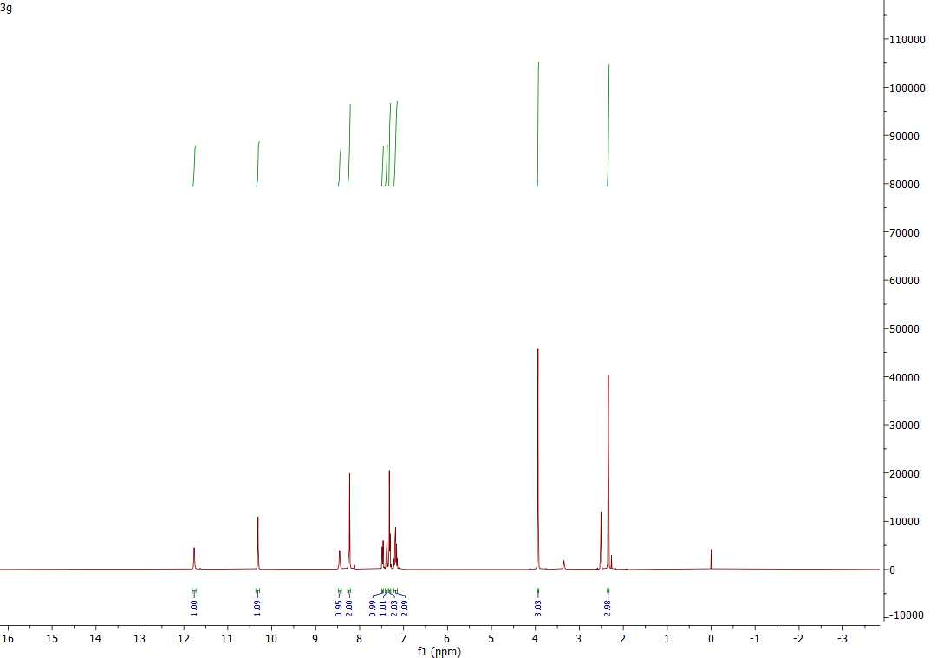
SI-13: ¹HNMR of 3g in DMSO-d⁶

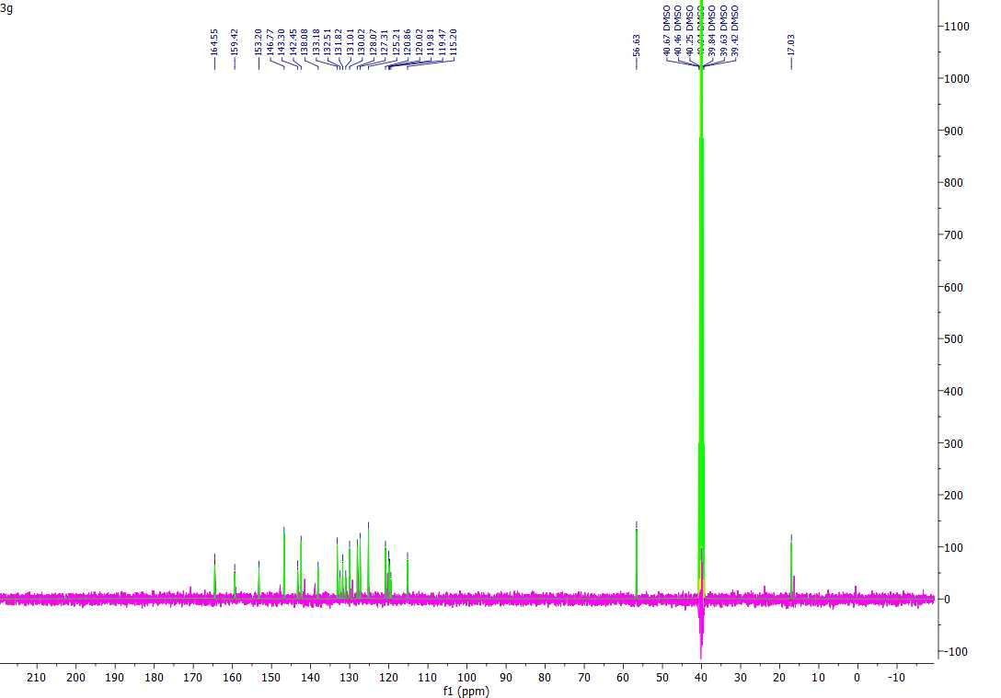
SI-14: ¹³CNMR of 3g in DMSO-d⁶

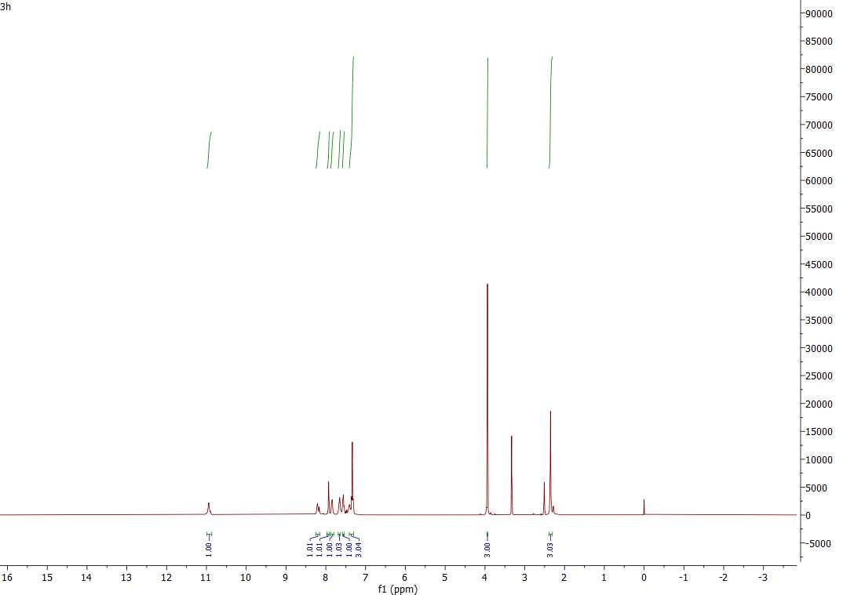
SI-15: ¹HNMR of 3h in DMSO-d⁶

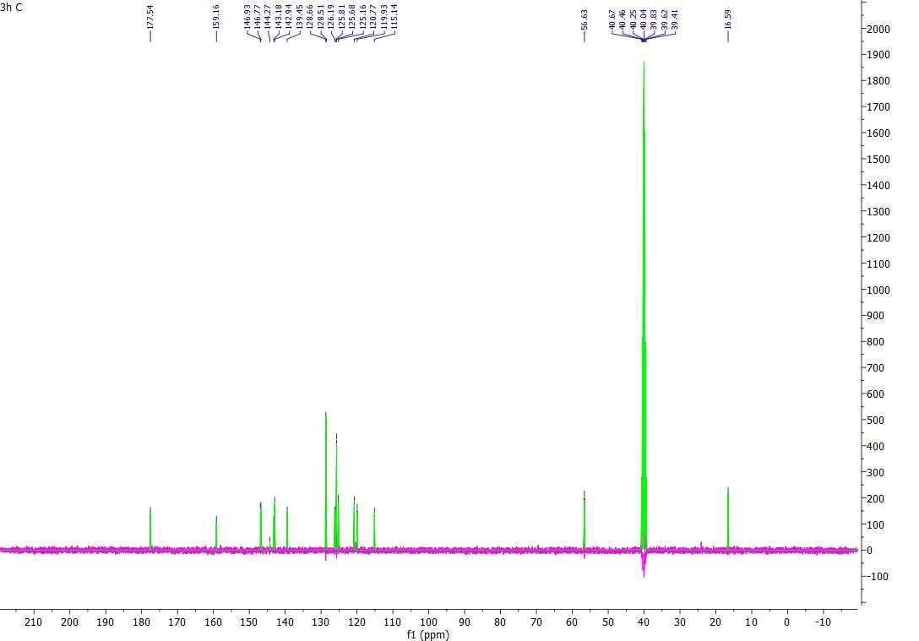
SI-16: ¹³CNMR of 3h in DMSO-d⁶

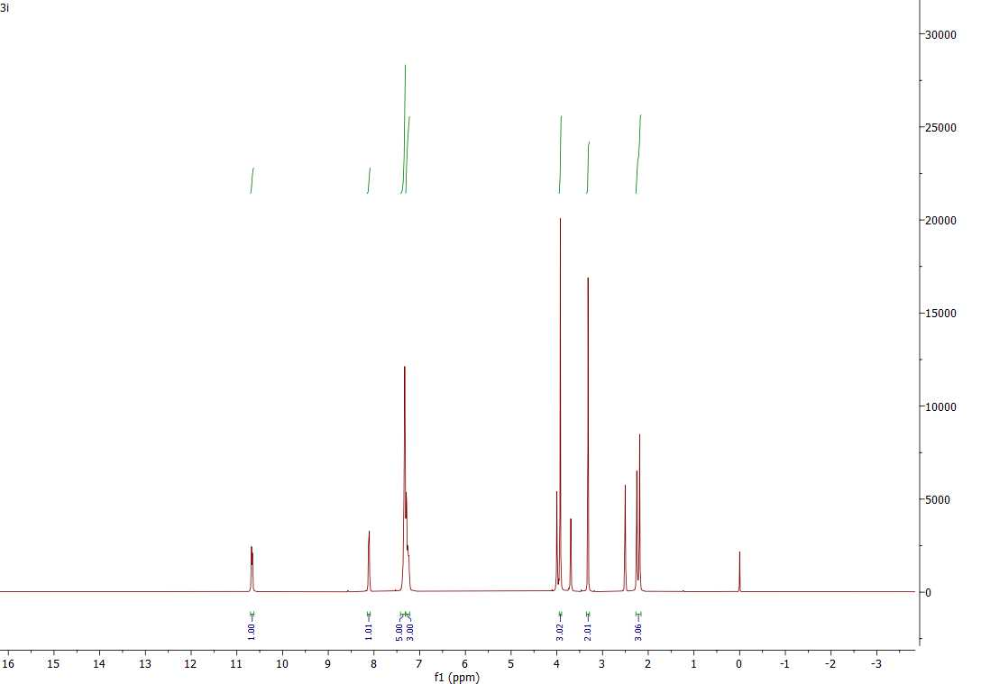
SI-17: ¹HNMR of 3i in DMSO-d⁶

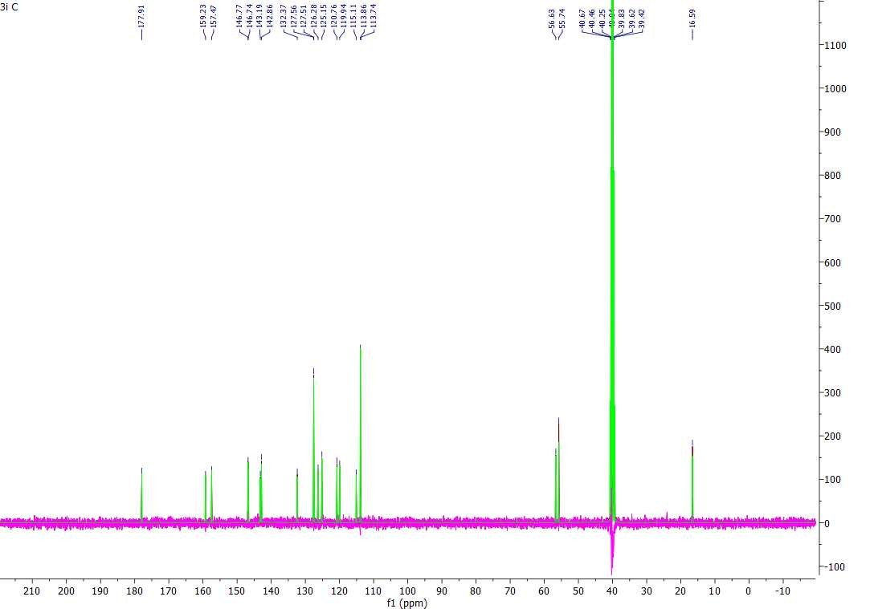
SI-18: ¹³CNMR of 3i in DMSO-d⁶

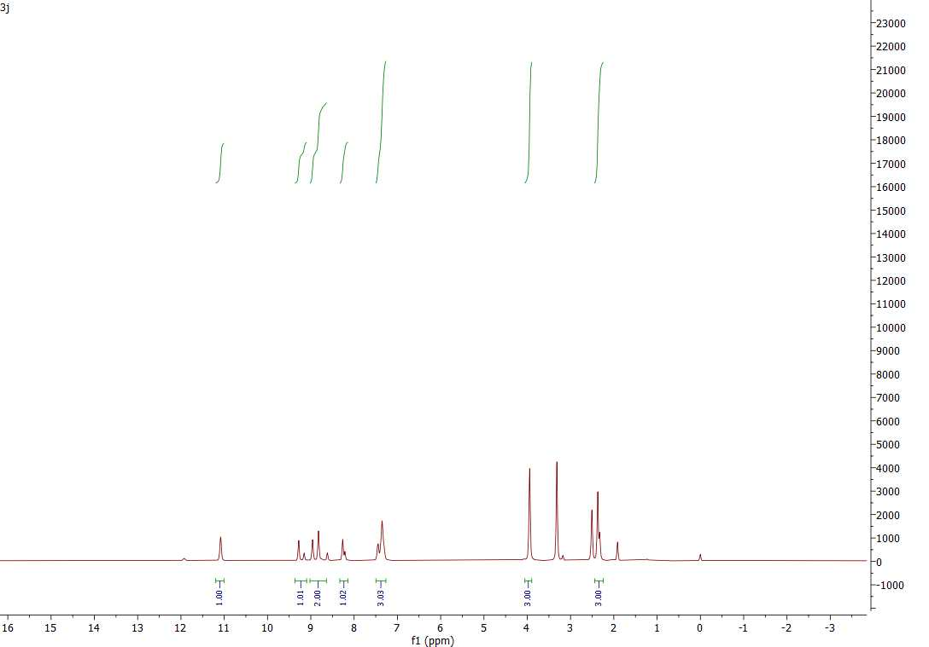
SI-19: ¹HNMR of 3j in DMSO-d⁶

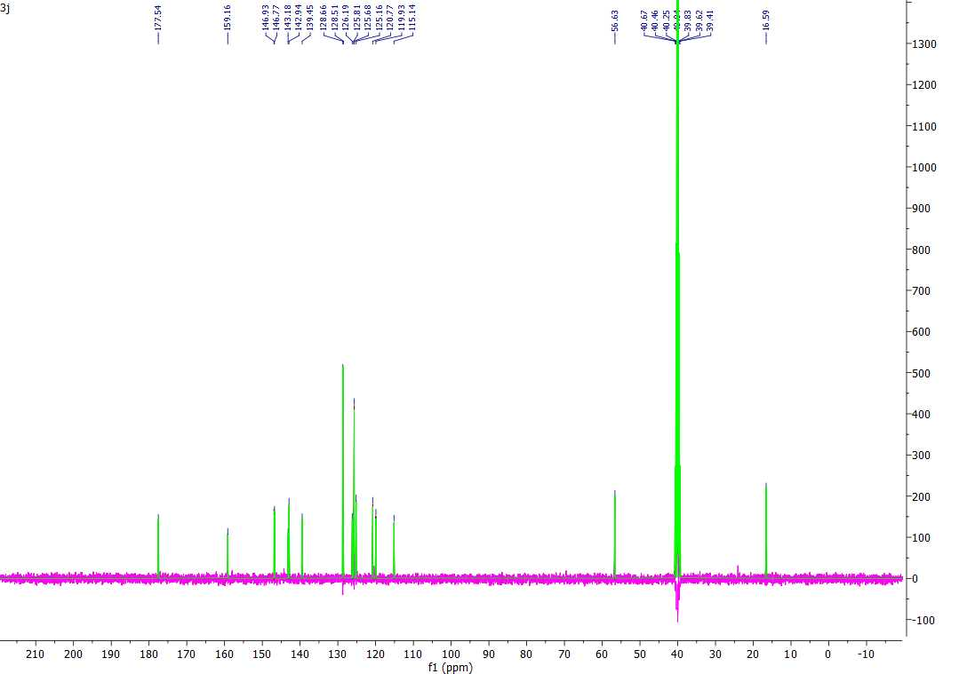
SI-20: ¹³CNMR of 3j in DMSO-d⁶

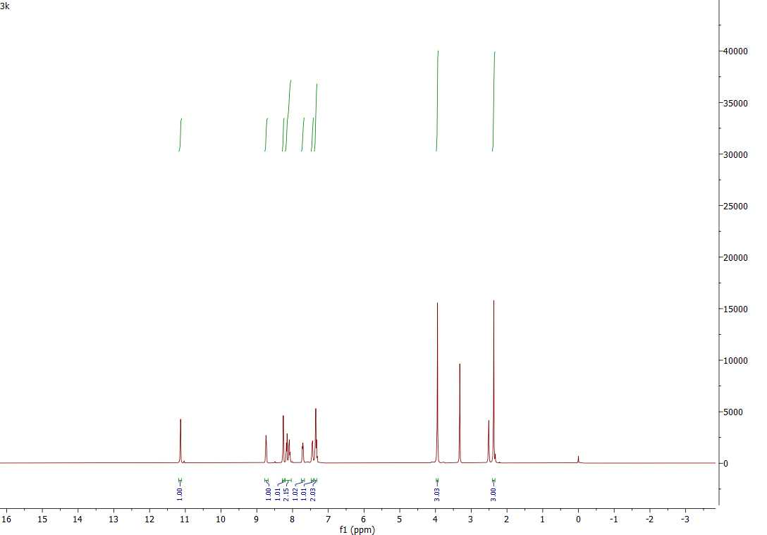
SI-21: ¹HNMR of 3k in DMSO-d⁶

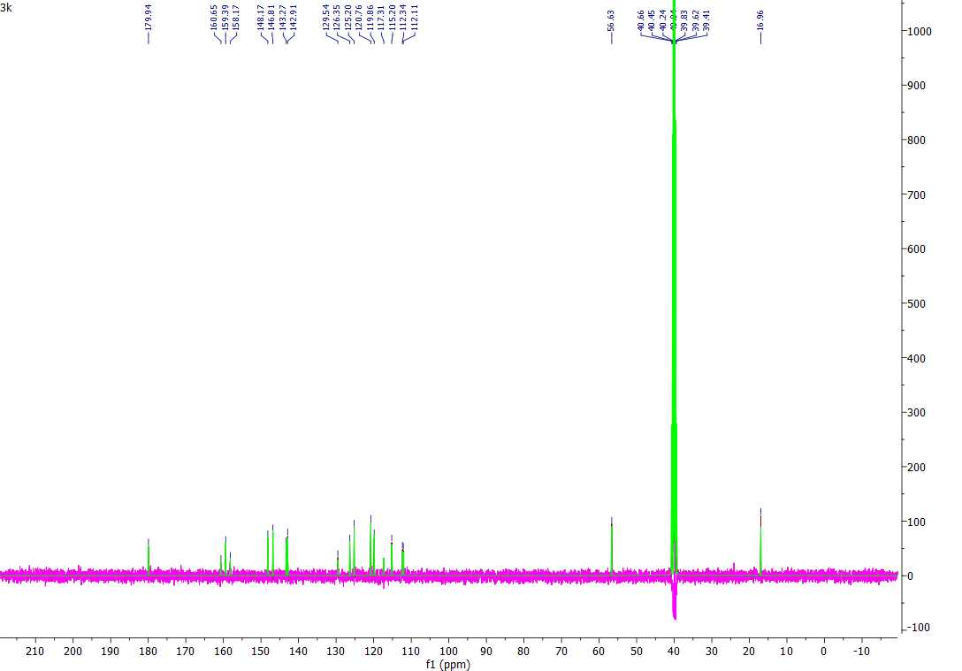
SI-22: ¹³CNMR of 3k in DMSO-d⁶

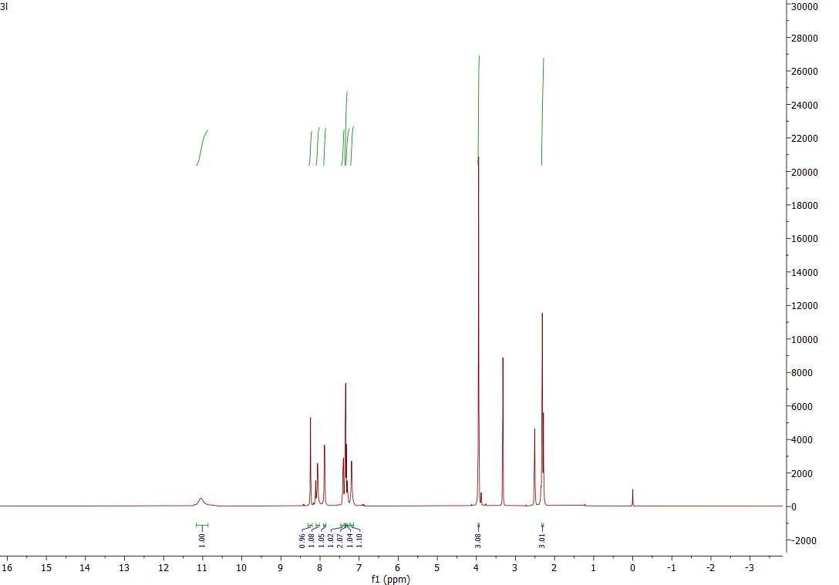
SI-23: ¹HNMR of 3l in DMSO-d⁶

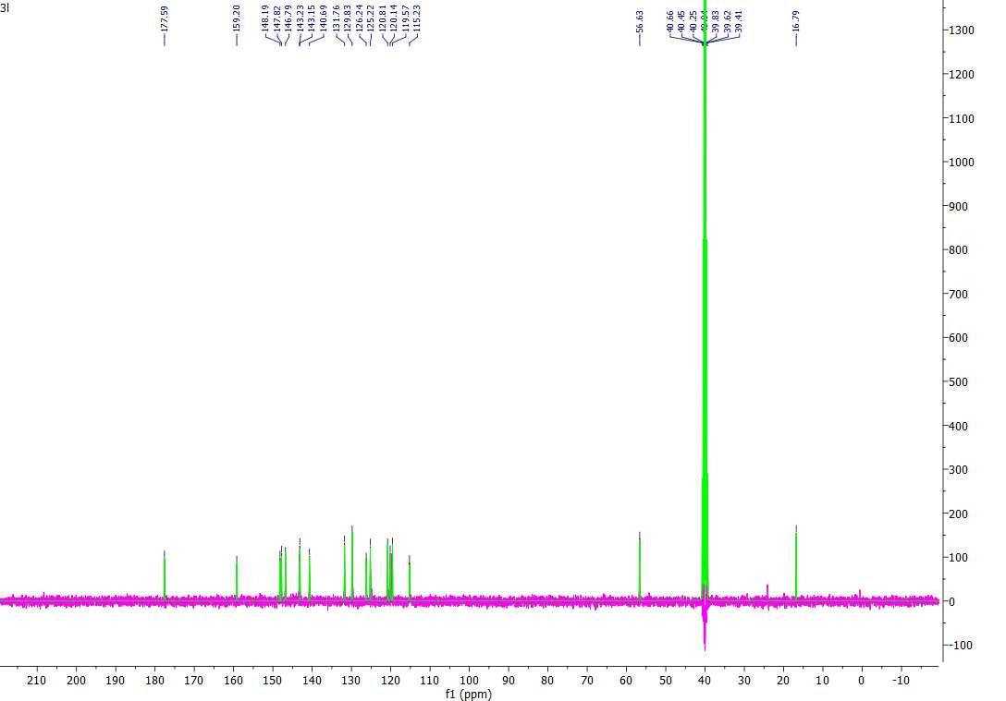
SI-24: ¹³CNMR of 3l in DMSO-d⁶

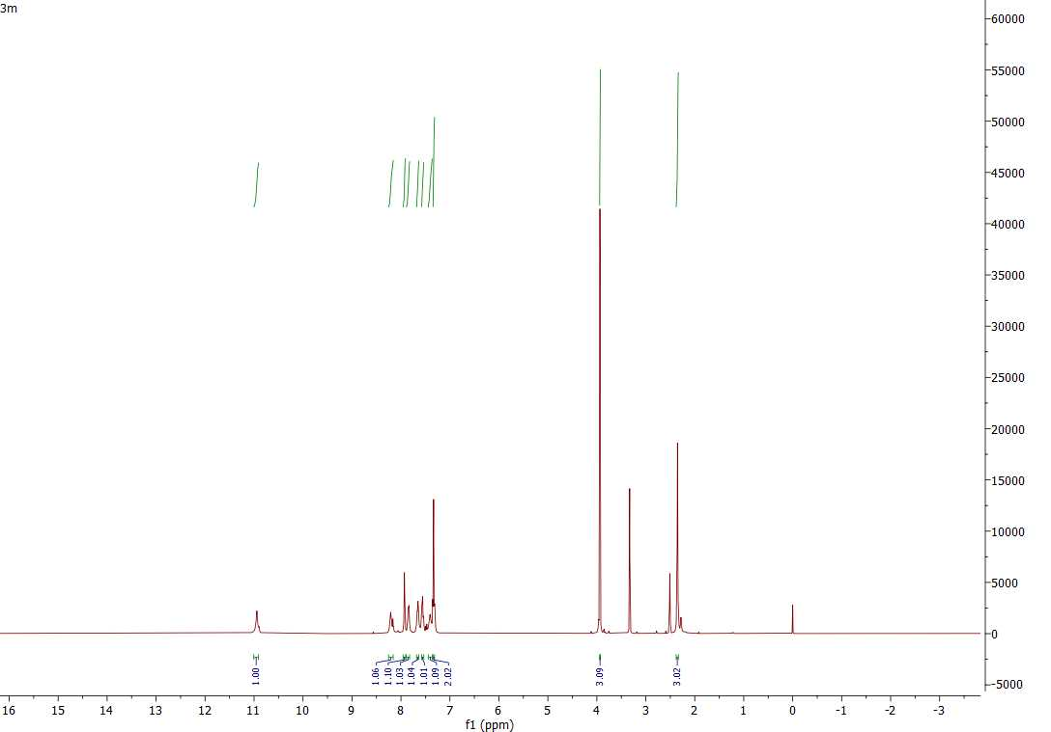
SI-25: ¹HNMR of 3m in DMSO-d⁶

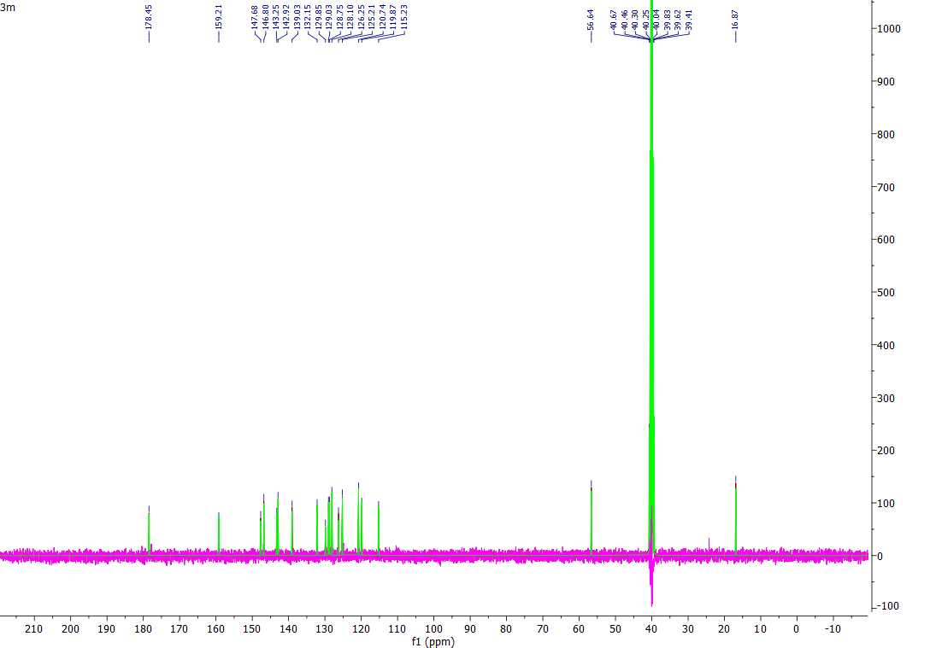
SI-26: ¹³CNMR of 3m in DMSO-d⁶
SI-27: HRMR of 3a
SI-28: HRMR of 3b
SI-29: HRMR of 3c

SI-30: HRMR of 3d

SI-31: HRMR of 3e

SI-32: HRMR of 3f
SI-33: HRMR of 3g

SI-34: HRMR of 3h

SI-35: HRMR of 3i

SI-36: HRMR of 3j

SI-37: HRMR of 3k

SI-38: HRMR of 3l

SI-39: HRMR of 3m

SI-40: HPLC of 3a

SI-41: HPLC of 3b

SI-42: HPLC of 3c
SI-43: HPLC of 3d

SI-44: HPLC of 3e
SI-45: HPLC of 3f

SI-46: HPLC of 3g
SI-47: HPLC of 3h

SI-48: HPLC of 3i
SI-49: HPLC of 3j

SI-50: HPLC of 3k
SI-51: HPLC of 3l

SI-52: HPLC of 3m

