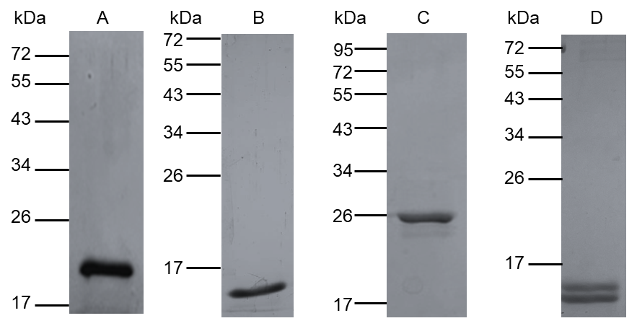
Supplementary figure 1: Purified rBlo t allergens (A: rBlo t 2, theoretical Mw 14.5 kDa; B: rBlo t 5, theoretical Mw 13.9 kDa; C: rBlo t 7, theoretical Mw 21.2 kDa; D: rBlo t 21, theoretical Mw 13.2 kDa).

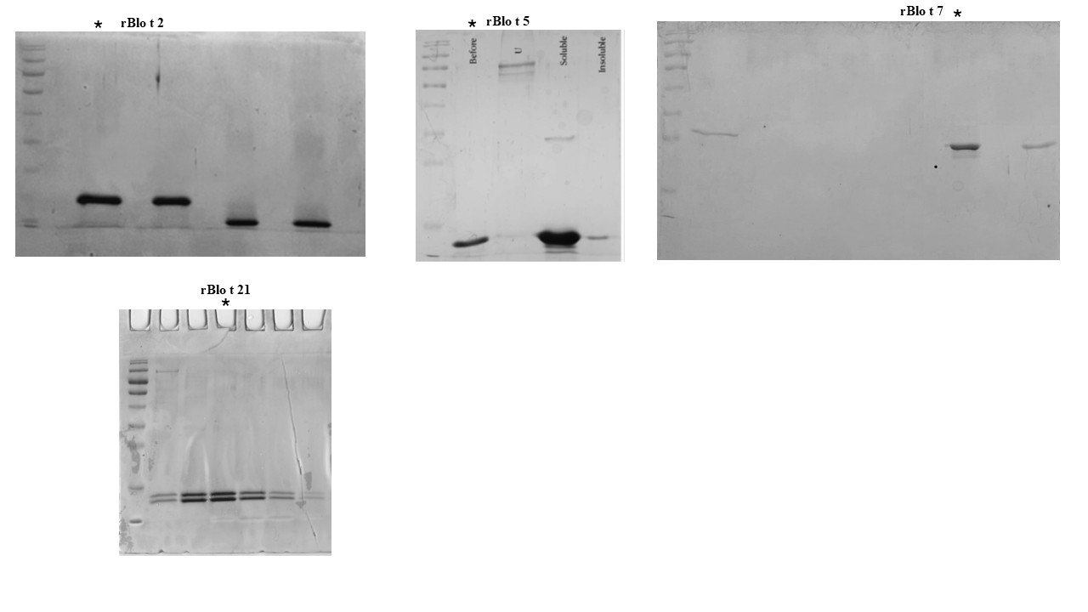

Supplementary figure 2: Full SDS-PAGE gel for the characterization of purified recombinant rBlo t 2, rBlo t 5, rBlo t 7, and rBlo t 21. The lanes used to create Supplementary Figure 1 are labeled with a *.

Supplementary Table 1: Distribution of ImmunoCAP grade classifications among the allergic population from different cohorts
 | No and percentage of occurrence
ImmunoCAP grade classification | Total population (N=329) | HKL (N=87) | HSAAS (N=93) | HRPZ II (N=79) | UniSZA (N=70)
Class 1 (0.35-0.60) | 21 (6.4%) | 7 (8%) | 4 (4.3%) | 4 (5.1%) | 6 (8.6%)
Class 2 (>0.70-3.5) | 42 (12.8%) | 11 (12.6%) | 11 (11.8%) | 8 (10.1%) | 12 (17.1%)
Class 3 (>3.5-17.5) | 59 (17.9%) | 19 (21.8%) | 18 (19.4%) | 12 (15.2%) | 10 (14.3%)
Class 4 (>17.5-50) | 42 (12.8%) | 13 (14.9%) | 12 (12.9%) | 7 (8.9%) | 10 (14.3%)
Class 5 (>50-100) | 12 (3.6%) | 3 (3.4%) | 5 (5.4%) | 2 (2.5%) | 2 (2.9%)
Class 6 (>100) | 4 (1.2%) | 1 (1.1%) | 2 (2.2%) |  | 1 (1.4%)
Negative (<0.35) | 149 (45.3%) | 33 (37.9%) | 41 (44.1%0 | 46 (58.2%) | 29 (41.4%)

Supplementary table 2: Estimated regression coefficients and corresponding odds ratio for relationship between SPT and ImmunoCAP
 |  |  |  | 95% CI |  | P value
 | Variables | Estimate (B) | OR (Exp B) | Lower | Upper
Threshold | Mild sensitization (3-5mm) | 0.370 | 2.718 | 0.051 | 0.690 | 0.023
 | Moderate sensitization  (6-10mm) | 1.353 | 3.869 | 1.002 | 1.704 | <.001
 | Severe sensitization (>11mm) | 3.560 | 35.163 | 3.008 | 4.112 | <.001
ImmunoCAP Class | Class 1 (0.35-0.60) | 1.354 | 3.87 | 0.507 | 2.201 | 0.002
 | Class 2 (>0.70-3.5) | 1.064 | 2.90 | 0.426 | 1.703 | 0.001
 | Class 3 (>3.5-17.5) | 0.915 | 2.50 | 0.350 | 1.481 | 0.002
 | Class 4 (>17.5-50) | 1.292 | 3.64 | 0.650 | 1.933 | <.001
 | Class 5 (>50-100) | 1.701 | 5.48 | 0.605 | 2.796 | 0.002
 | Class 6 (>100) | 2.457 | 11.66 | 0.577 | 4.336 | 0.010

Supplementary table 3: Association between rBlo t allergens sensitization and allergic diseases (n=329) [OR (95%CI)].
Variables |  | Blo t |  |  | rBlo t 2 |  |  |  | rBlo t 5 |  |  |  | rBlo t 7 |  |  |  | rBlo t 21
Variables | OR | 95% CI |  | P value | OR | 95% CI |  | p value | OR | 95% CI |  | p value | OR | 95% CI |  | p value | OR | 95% CI |  | p value
Variables |  | Lower | Upper |  |  | Lower | Upper |  |  | Lower | Upper |  |  | Lower | Upper |  |  | Lower | Upper
AA | 9.442E+9 | 1.615E+7 | 5.519E+10 | <0.001 | 2.48E+07 | 1.10E+07 | 5.61E+07 | <0.001 | 2.81E+07 | 1.10E+07 | 6.19E+07 | <0.001 | 3.88E+07 | 1.76E+07 | 8.52E+07 | <0.001 | 2.73E+07 | 1.20E+07 | 6.20E+07 | <0.001
AR | 4.343E+9 | 2.669E+8 | 7.066E_10 | <0.001 | 1.73E+07 | 8.96E+06 | 3.34E+07 | <0.001 | 2.32E+07 | 8.96E+06 | 4.32E+07 | <0.001 | 2.76E+07 | 1.49E+07 | 5.11E+07 | <0.001 | 1.64E+07 | 8.42E+06 | 3.20E+07 | <0.001
ARC | 6.853E+9 | 1.145E+7 | 4.102E+10 | <0.001 | 1.46E+07 | 6.67E+06 | 3.17E+07 | <0.001 | 2.32E+07 | 6.67E+06 | 4.81E+07 | <0.001 | 2.26E+07 | 1.10E+07 | 4.64E+07 | <0.001 | 1.58E+07 | 7.21E+06 | 3.44E+07 | <0.001
AD | 2.469E+9 | 1.465E+8 | 4.162E+10 | <0.001 | 1.50E+07 | 1.50E+07 | 1.50E+07 | <0.001 | 1.79E+07 | 1.50E+07 | 1.79E+07 | <0.001 | 2.02E+07 | 2.02E+07 | 2.02E+07 | <0.001 | 1.38E+07 | 1.38E+07 | 1.38E+07 | <0.001

