0
10
20
30
40
50
60
70
80
90
100
0
50
100
150
200
250
300
350
400
450
HCT
Concentration of Bee venom in
µg/mL
%Viability
IC50 : 16.29µg/ml
R% : 1.66
Supplementary Figure 1. Cytotoxic activity of bee venom against the HCT cell line. Data points represent mean values from three independent trials (n=3)

0
10
20
30
40
50
60
70
80
90
100
0
20
40
60
80
100
120
140
HCT
IC50 : 6.74 µg/ml
R% : 2.23
Concentration of Thymoquinone
in
µg/mL
%Viability
Supplementary Figure 2. Cytotoxic activity of thymoquinone against HCT cell lines. Data points represent mean values from three independent trials (n=3)

0
10
20
30
40
50
60
70
80
90
100
110
0
2
4
6
8
10
12
14
16
18
20
22
24
HCT
%Viability
Bee venom
concentration
in
combination in
µg/mL
IC50 : 5.7 µg/ml
Supplementary Figure 3. Cytotoxic activity of the combination of BV with a fixed TQ concentration against HCT cell lines. Data points represent mean values from three independent trials (n=3)

0
10
20
30
40
50
60
70
80
90
100
110
0
1
2
3
4
5
6
7
8
9
10
HCT
%Viability
Thymoquinone concentration
in
combination in
µg/mL
IC50 : 1.865 µg/ml
Supplementary Figure 4. Cytotoxic activity of the combination of TQ with a fixed BV concentration against HCT cell lines. Data points represent mean values from three independent trials (n=3)

0
10
20
30
40
50
60
70
80
90
100
0
50
100
150
200
250
300
350
400
450
HELA
Concentration of Bee venom in
µg/mL
IC50 : 9.96 µg/ml
R% : 1.32
%Viability
Supplementary Figure 5. Cytotoxic activity of bee venom against HeLa cell lines. Data points represent mean values from three independent trials (n=3)

0
10
20
30
40
50
60
70
80
90
100
0
20
40
60
80
100
120
140
HELA
IC50 : 3.26 µg/ml
R% : 2.47
Concentration of Thymoquinone in
µg/mL
%Viability
Supplementary Figure 6. Cytotoxic activity of thymoquinone against HeLa cell lines. Data points represent mean values from three independent trials (n=3)

0
10
20
30
40
50
60
70
80
90
100
110
0
0.5
1
1.5
2
2.5
3
3.5
4
4.5
5
HELA
%Viability
Thymoquinone concentration
in
combination in
µg/mL
IC50
:
0.86µg/ml
Supplementary Figure 7. Cytotoxic activity of the combination of TQ with a fixed BV concentration against HeLa cell lines. Data points represent mean values from three independent trials (n=3)

0
10
20
30
40
50
60
70
80
90
100
110
0
1
2
3
4
5
6
7
8
9
10
11
HELA
Bee venom
concentration
in
combination in
µg/mL
%Viability
IC50 : 4.55 µg/ml
Supplementary Figure 8. Cytotoxic activity of the combination of BV with a fixed TQ concentration against HeLa cell lines. Data points represent mean values from three independent trials (n=3)

0
10
20
30
40
50
60
70
80
90
100
110
0
100
200
300
400
500
MCF
-
7
Concentration of Bee venom in
µg/mL
%Viability
IC50
22.18 µg/ml
:
R% : 1.54
Supplementary Figure 9. Cytotoxic activity of bee venom against MCF-7 cell lines. Data points represent mean values from three independent trials (n=3)

0
10
20
30
40
50
60
70
80
90
100
0
20
40
60
80
100
120
140
MCF
-
7
Concentration of Thymoquinone in
µg/mL
%Viability
IC50 : 5.58 µg/ml
R% : 1.34
Supplementary Figure 10. Cytotoxic activity of thymoquinone against MCF-7 cell lines. Data points represent mean values from three independent trials (n=3)

0
10
20
30
40
50
60
70
80
90
100
110
0
2
4
6
8
10
12
14
16
18
20
22
24
MCF
-
7
%Viability
Bee venom
concentration
in
combination
in
µg/mL
IC50 : 8.3 µg/ml
Supplementary Figure 11. Cytotoxic activity of the combination of BV with a fixed TQ concentration against MCF-7cell lines. Data points represent mean values from three independent trials (n=3)

0
10
20
30
40
50
60
70
80
90
100
110
0
2
4
6
8
10
MCF
-
7
%Viability
Thymoquinone concentration
in
combination
in
µg/mL
IC50 : 2.73 µg/mL
Supplementary Figure 12. Cytotoxic activity of the combination of TQ with a fixed BV concentration against MCF-7 cell lines. Data points represent mean values from three independent trials (n=3)

0
10
20
30
40
50
60
70
80
90
100
0
50
100
150
200
250
300
350
400
450
HSF
Concentration of Bee venom in
µg/mL
%Viability
IC50
20.21 µg/ml
:
R% : 1.13
Supplementary Figure 13. Cytotoxic activity of bee venom against HSF cell lines. Data points represent mean values from three independent trials (n=3)

0
10
20
30
40
50
60
70
80
90
100
0
20
40
60
80
100
120
140
HSF
Concentration of Thymoquinone in
µg/mL
%Viability
IC50
:
7.1 µg/ml
Supplementary Figure 14. Cytotoxic activity of the thymoquinone against HSF cell lines. Data points represent mean values from three independent trials (n=3)

0
10
20
30
40
50
60
70
80
90
100
110
0
2
4
6
8
10
12
14
16
18
20
22
24
HSF
%Viability
Bee venom
concentration
in
combination
in
µg/mL
IC50
6.4 µg/mL
:
Supplementary Figure 15. Cytotoxic activity of the combination of BV with a fixed TQ concentration against HSF cell lines. Data points represent mean values from three independent trials (n=3)

0
10
20
30
40
50
60
70
80
90
100
110
0
2
4
6
8
10
HSF
%Viability
Thymoquinone concentration
in
combination
in
µg/mL
IC50 : 2.1 µg/mL
Supplementary Figure 16. Cytotoxic activity of the combination of TQ with a fixed BV concentration against HSF cell lines. Data points represent mean values from three independent trials (n=3)

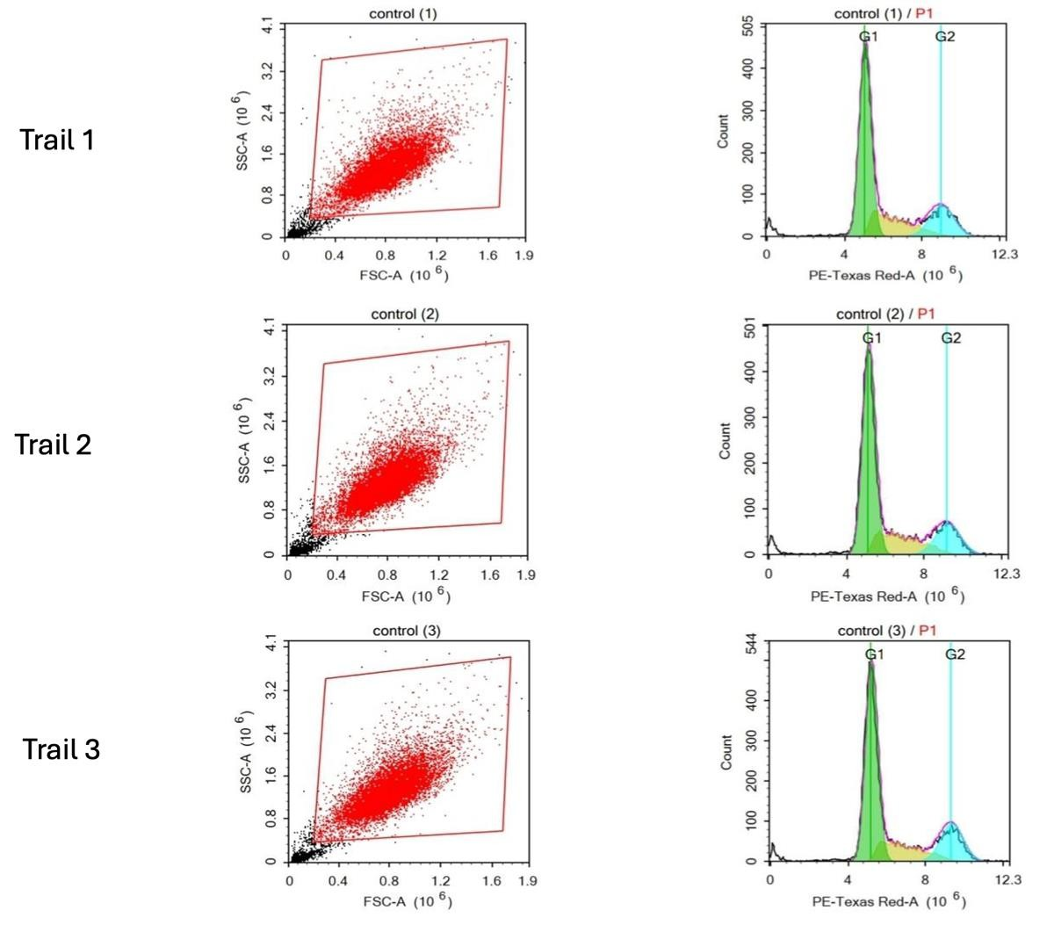
Supplementary Figure 17. Representative flow cytometry dot plots and histograms from three independent trials showing analysis of the cell cycle in control HeLa cells. Forward scatter (FSC-A) versus side scatter (SSC-A) plots (left) were used for cell population gating, and PE-Texas Red-A histograms (right) display DNA content distribution.
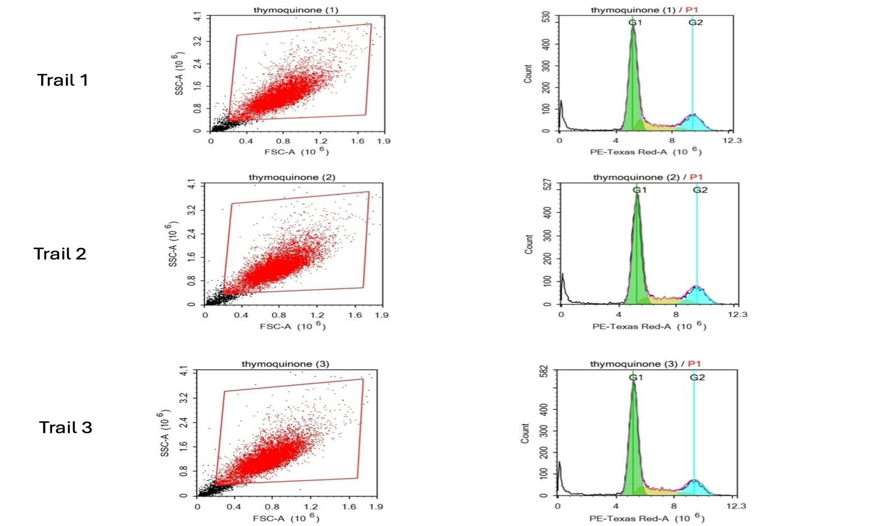
Supplementary Figure 18. Representative flow cytometry dot plots and histograms from three independent trials showing analysis of the cell cycle in HeLa cells treated with thymoquinone. Forward scatter (FSC-A) versus side scatter (SSC-A) plots (left) were used for cell population gating, and PE-Texas Red-A histograms (right) display DNA content distribution.

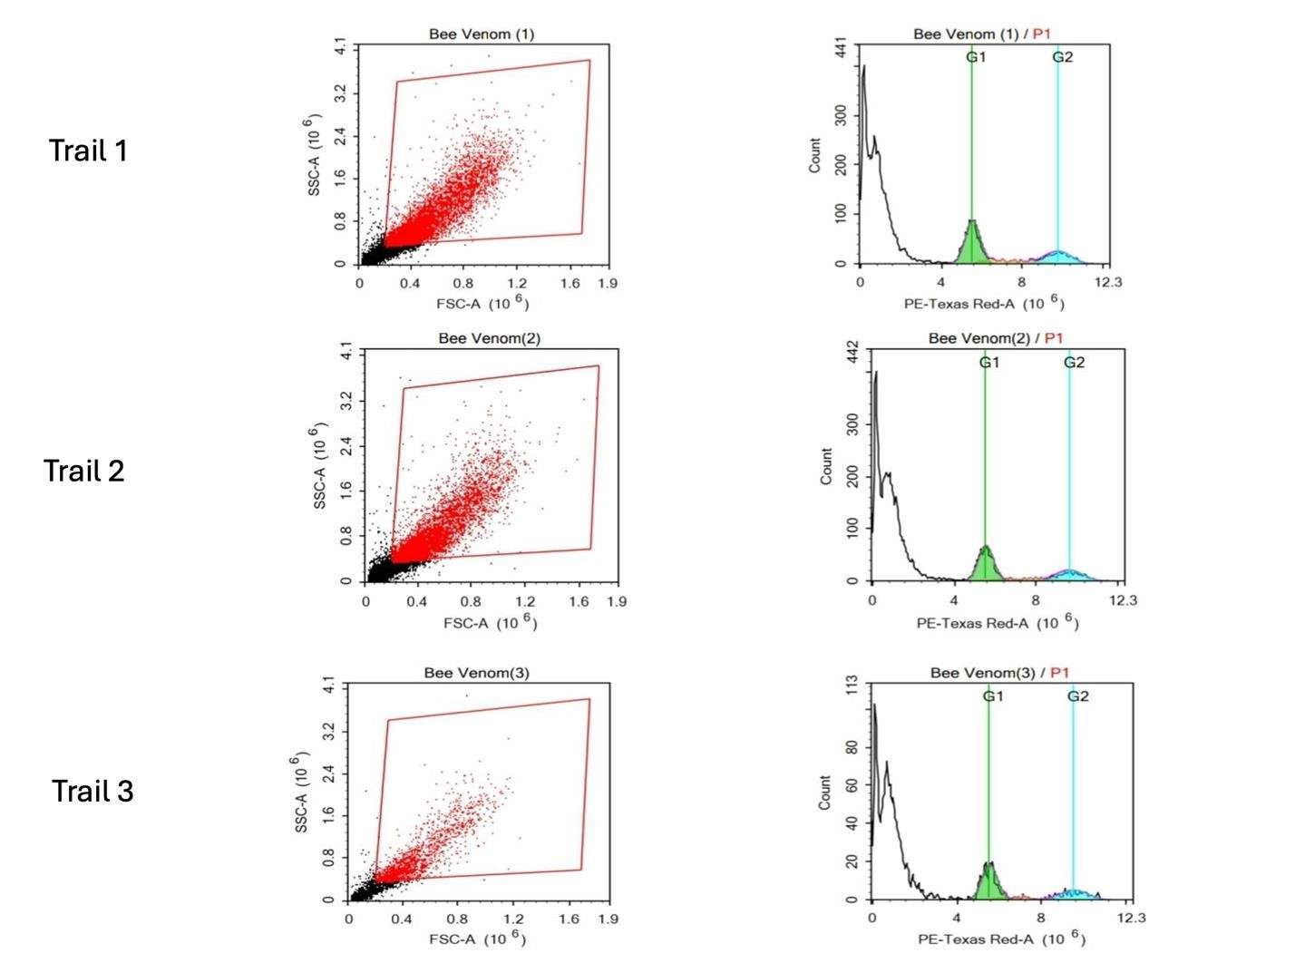
Supplementary Figure 19. Representative flow cytometry dot plots and histograms from three independent trials showing analysis of the cell cycle in HeLa cells treated with bee venom. Forward scatter (FSC-A) versus side scatter (SSC-A) plots (left) were used for cell population gating, and PE-Texas Red-A histograms (right) display DNA content distribution.

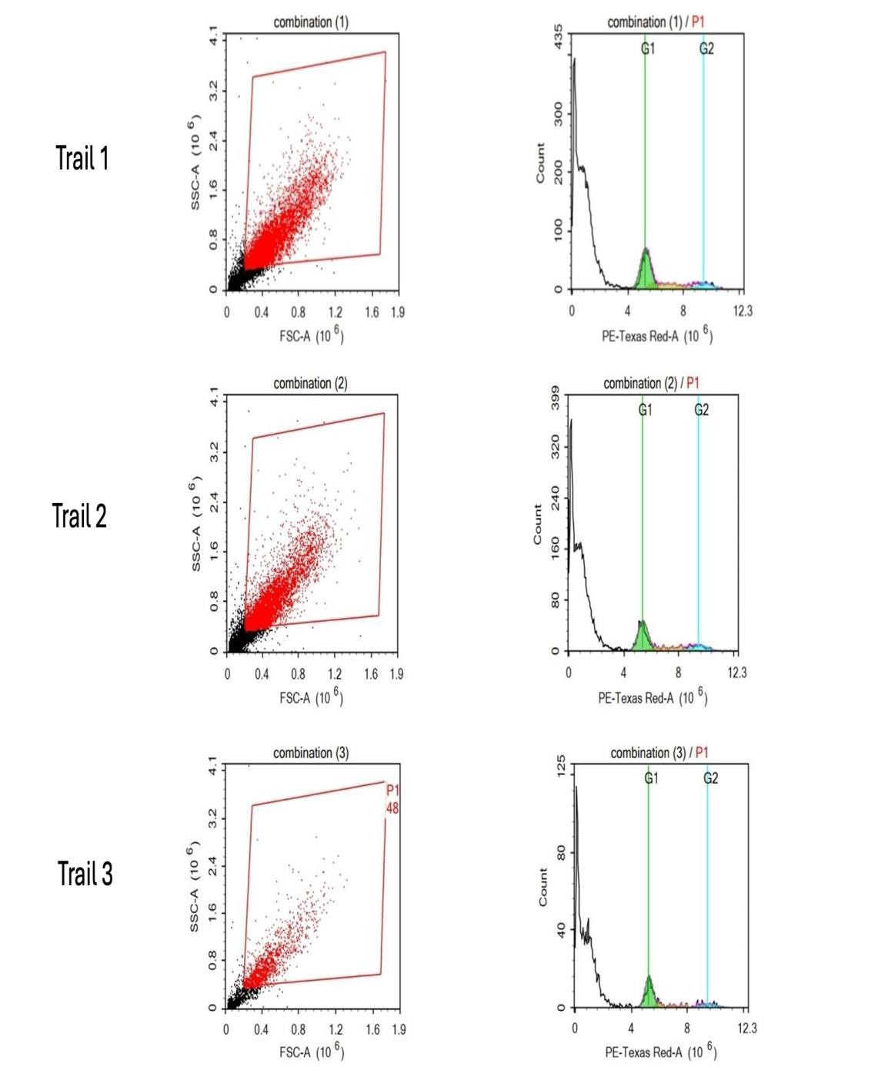
Supplementary Figure 20. Representative flow cytometry dot plots and histograms from three independent trials showing analysis of the cell cycle in HeLa cells treated with the combination. Forward scatter (FSC-A) versus side scatter (SSC-A) plots (left) were used for cell population gating, and PE-Texas Red-A histograms (right) display DNA content distribution.

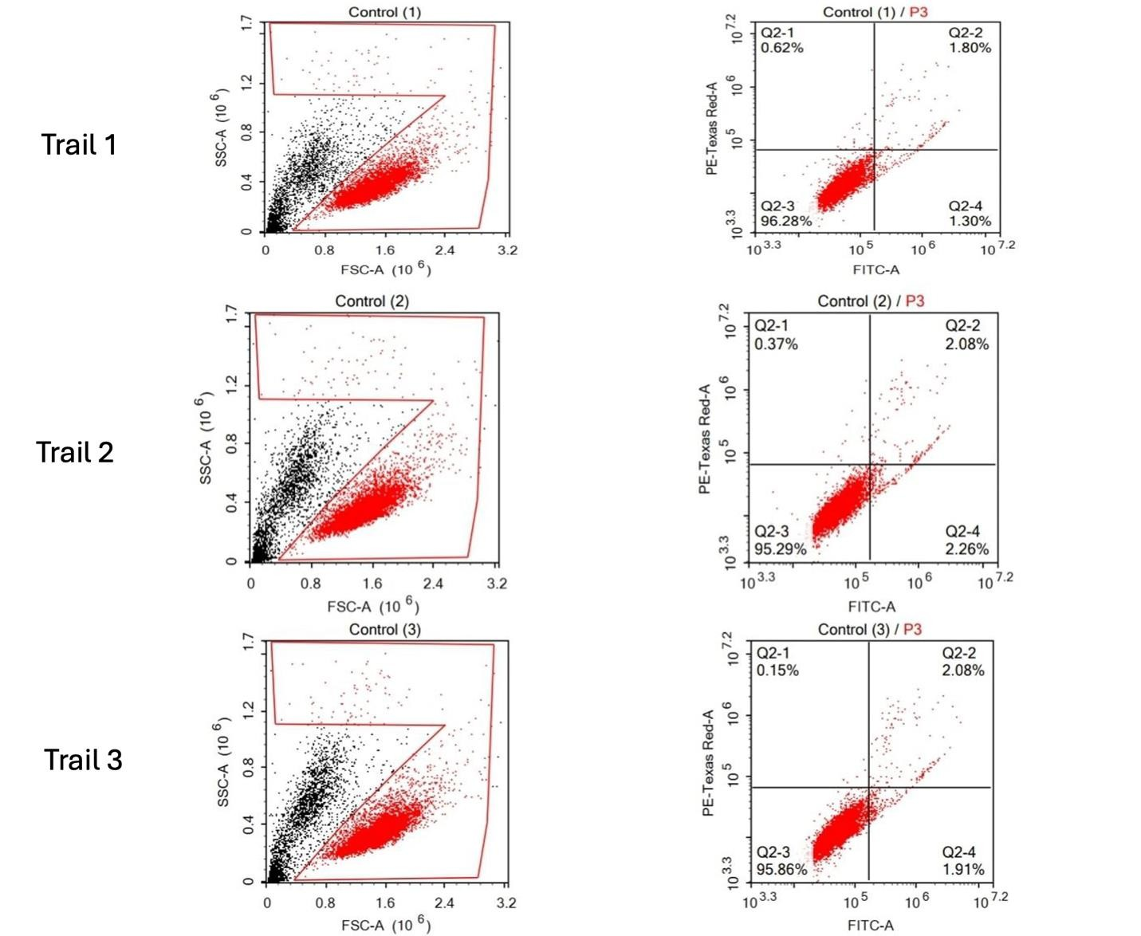
Supplementary Figure 21. Representative flow cytometry dot plots showing apoptosis analysis of control HeLa cells in three independent trials. For each trial, forward scatter (FSC-A) versus side scatter (SSC-A) plots (left) were used to gate the main cell population, while Annexin V–FITC versus PI (FITC-A vs PI-A) plots (right) show the distribution of viable, early apoptotic, late apoptotic, and necrotic cells.

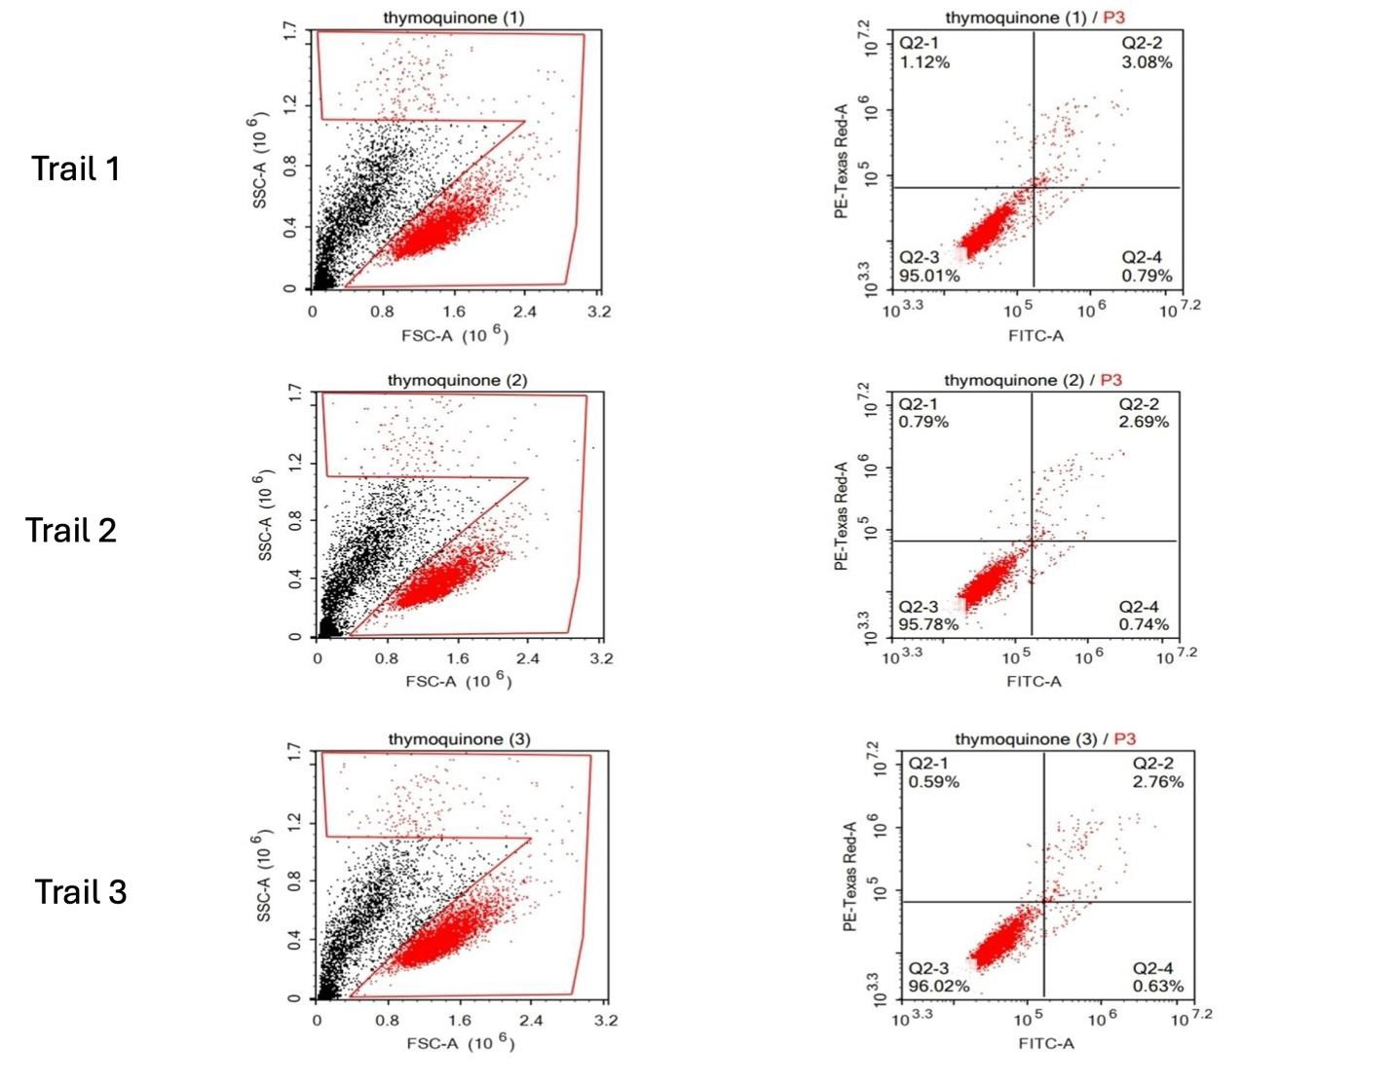Supplementary Figure 22. Representative flow cytometry dot plots showing apoptosis analysis of HeLa cells treated with thymoquinone in three independent trials. For each trial, forward scatter (FSC-A) versus side scatter (SSC-A) plots (left) were used to gate the main cell population, while Annexin V–FITC versus PI (FITC-A vs PI-A) plots (right) show the distribution of viable, early apoptotic, late apoptotic, and necrotic cells.

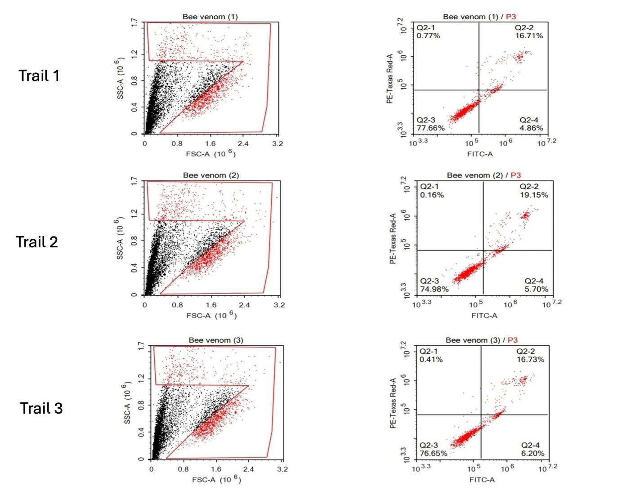
Supplementary Figure 23. Representative flow cytometry dot plots showing apoptosis analysis of HeLa cells treated with bee venom in three independent trials. For each trial, forward scatter (FSC-A) versus side scatter (SSC-A) plots (left) were used to gate the main cell population, while Annexin V–FITC versus PI (FITC-A vs PI-A) plots (right) show the distribution of viable, early apoptotic, late apoptotic, and necrotic cells.
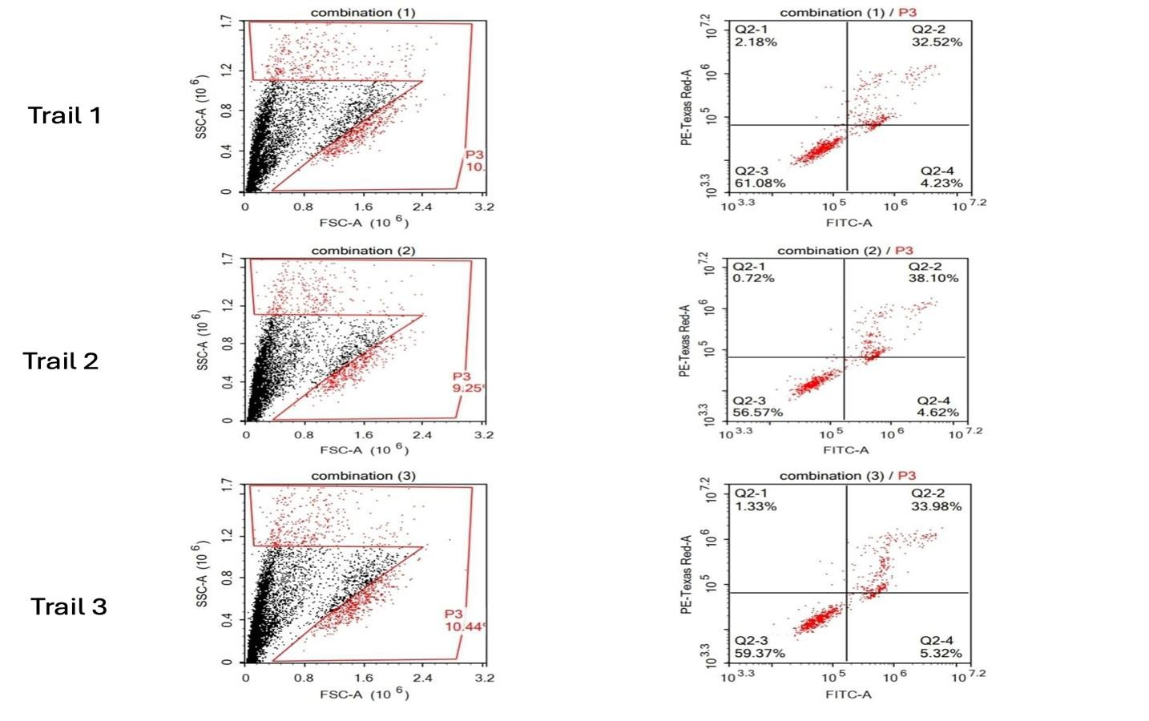
Supplementary Figure 24. Representative flow cytometry dot plots showing apoptosis analysis of HeLa cells treated with the combination in three independent trials. For each trial, forward scatter (FSC-A) versus side scatter (SSC-A) plots (left) were used to gate the main cell population, while Annexin V–FITC versus PI (FITC-A vs PI-A) plots (right) show the distribution of viable, early apoptotic, late apoptotic, and necrotic cells.

