sFigure 1: LASSO regression results
A,the LASSO regression path plot showing the evolution of regression coefficients as the regularization parameter log(λ) increases. Each curve represents the coefficient path for a specific feature, with coefficients shrinking and eventually becoming zero as log(λ) increases, indicating feature selection. B, Plot of binomial deviance (cross-validation error) versus the regularization parameter λ for Lasso regression. The curve shows the model's performance during cross-validation, where the binomial deviance is minimized at an optimal value of λ. At λ corresponding to the minimum deviance plus one standard error (λmin + 1se), the model exhibits similar performance while including fewer variables, making it useful for feature selection

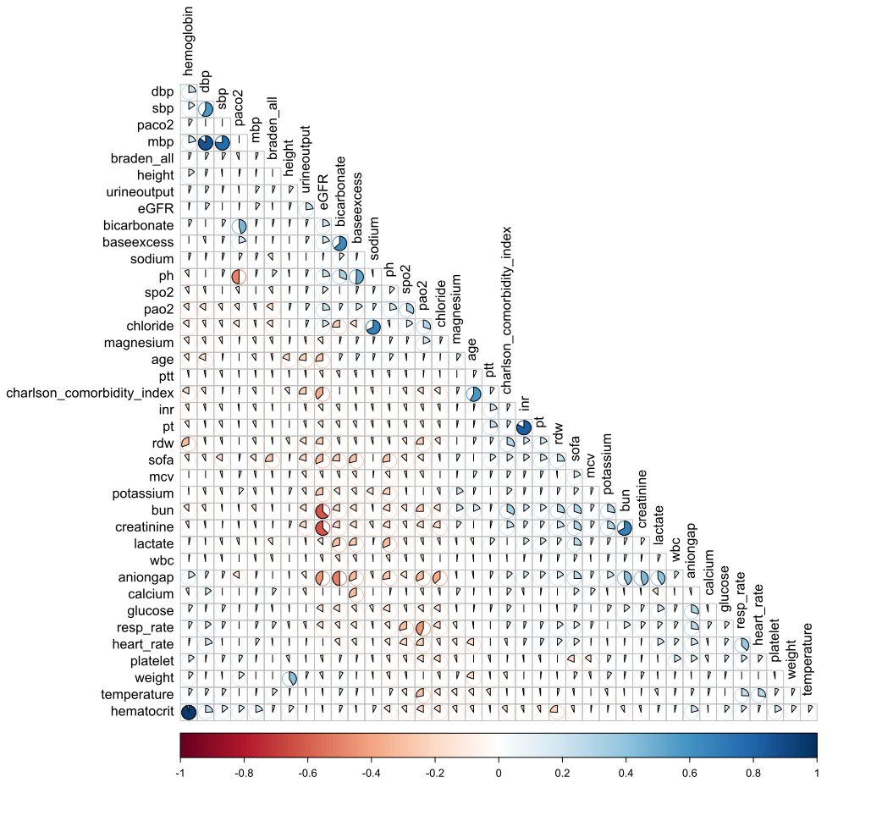
sFigure 2: The heatmap of the correlation between continuous variables across all extracted variables.

sFigure 3: Receiver Operating Characteristic (ROC) curves for the XGBoost model on internal training and test sets.
Category | Score 1 | Score 2 | Score 3 | Score 4
Sensory Perception | Completely limited (unable to feel pressure changes or pain) | Very limited (able to feel some discomfort but cannot protect self) | Slightly limited (able to feel discomfort, but may not be able to react appropriately) | No impairment (responds to verbal commands; has intact sensory perception)
Moisture | Constantly moist (always wet) | Very moist (frequent dampness) | Occasionally moist (moist in certain situations) | Rarely moist (skin remains generally dry; changes in linens only cause occasional dampness)
Activity | Bedfast (confined to bed) | Very limited (confined to bed or chair most of the time) | Walks occasionally (able to sit up, but not able to walk) | Walks frequently (independent ambulation outside the room at least twice a day and moves at least once every two hours)
Mobility | Completely immobile (cannot move or change position) | Very limited (extremely difficult to move) | Slightly limited (can change position with some help) | No limitations (makes major position changes independently and frequently)
Nutrition | Very poor (extremely inadequate intake) | Inadequate (poor food intake) | Adequate (can take food, but might be inconsistent) | Excellent (eats most of every meal; never refuses food; eats a total of four or more servings of protein per day)
Friction and Shear | High (high risk of friction or shear) | Moderate (some friction or shear risks) | Mild (some friction, but less risk of shear) | None (moves in bed and in chair independently and smoothly without sliding)
sTable 1: The Braden Score is a widely used tool for assessing a patient's risk of developing pressure ulcers (also known as bedsores or decubitus ulcers). It evaluates the patient's risk based on six categories, and a score is given for each category. The total score ranges from 6 to 23, with lower scores indicating a higher risk for pressure ulcers.

sTable 2: The VIF results of logistic model adjusted by full-variable
Variable | GVIF | Df | GVIF^(1/(2*Df))
Braden all | 1.15512568074173 | 1 | 1.07476773339254
Age | 1.55708686301333 | 1 | 1.24783286661849
Gender | 1.88106964985298 | 1 | 1.3715209257802
Height | 2.05929751887291 | 1 | 1.43502526767751
Weight | 1.3666984528652 | 1 | 1.16905878931096
Ethnicity | 1.13545189047434 | 4 | 1.01600557783409
Admission type | 1.29852921092914 | 3 | 1.04450042401191
Diabetes | 1.20031588558136 | 1 | 1.09558928690516
SOFA | 1.71874997389129 | 1 | 1.31101105025522
Renal disease | 1.53414969374772 | 1 | 1.23860796612476
Temperature | 1.12136640128254 | 1 | 1.05894589157451
Charlson_comorbidity_index | 1.87884562970977 | 1 | 1.37070989990945
Lactate | 1.49806998696111 | 1 | 1.22395669325394
Creatinine | 1.80216658849889 | 1 | 1.34244798353563
RDW | 1.29872737091403 | 1 | 1.13961720367588
Resp_rate | 1.22811112483578 | 1 | 1.10820175276697
Calcium | 1.33444884957542 | 1 | 1.1551834700927
GCS | 1.03555906912919 | 1 | 1.01762422786075
SpO2 | 1.08766899724473 | 1 | 1.04291370555992
Hematocrit | 1.2656233373601 | 1 | 1.12499926104869
Aniongap | 1.91741392026274 | 1 | 1.38470716047211
Chloride | 1.19886264525034 | 1 | 1.09492586290138
INR | 1.08812240024587 | 1 | 1.04313105612184
MCV | 1.09359846407942 | 1 | 1.04575258263101
WBC | 1.04367353541423 | 1 | 1.02160341395976
PTT | 1.0822902343063 | 1 | 1.04033179049104
PaO2 | 1.30461160848884 | 1 | 1.14219595888308
platelet | 1.22120199802005 | 1 | 1.10508008669962
SBP | 1.09800057002845 | 1 | 1.04785522379213
24-hour urine output | 1.2062873985216 | 1 | 1.0983111574238

 | Overall | Test | Train | p
N | 37981 | 7597 | 30384 | 0.157
Age (year) | 68.00 [56.00, 78.00] | 67.00 [56.00, 78.00] | 68.00 [56.00, 78.00] | 0.765
Male | 22783 (60.0) | 4569 (60.1) | 18214 (59.9) | 0.976
Height (cm) | 169.41 (10.66) | 169.41 (10.71) | 169.41 (10.65) | 0.677
Weight (kg) | 80.00 [67.70, 95.00] | 80.00 [67.40, 95.30] | 80.00 [67.70, 95.00] | 0.495
Ethnicity (%) |  |  |  | 0.835
Asian | 960 ( 2.5) | 195 ( 2.6) | 765 ( 2.5)
Black | 2806 ( 7.4) | 566 ( 7.5) | 2240 ( 7.4)
Hispanic | 1144 ( 3.0) | 242 ( 3.2) | 902 ( 3.0)
Other | 7323 (19.3) | 1477 (19.4) | 5846 (19.2)
White | 25748 (67.8) | 5117 (67.4) | 20631 (67.9)
Frst careunit (%) |  |  |  | 0.924
CCU | 13008 (34.2) | 2605 (34.3) | 10403 (34.2)
CSRU | 3553 ( 9.4) | 715 ( 9.4) | 2838 ( 9.3)
Med-Surg_ICU | 4044 (10.6) | 793 (10.4) | 3251 (10.7)
MICU | 8517 (22.4) | 1709 (22.5) | 6808 (22.4)
SICU | 4730 (12.5) | 966 (12.7) | 3764 (12.4)
TSICU | 4129 (10.9) | 809 (10.6) | 3320 (10.9)
Admission type (%) |  |  |  | 0.881
elective | 3683 ( 9.7) | 740 ( 9.7) | 2943 ( 9.7)
emergency | 21448 (56.5) | 4275 (56.3) | 17173 (56.5)
observation | 2701 ( 7.1) | 556 ( 7.3) | 2145 ( 7.1)
urgent | 10149 (26.7) | 2026 (26.7) | 8123 (26.7)
Heart rate (beats/ minute) | 88.03 (19.19) | 88.09 (19.26) |  | 0.789
Respiration rate (beats/minute) | 18.73 (5.63) | 18.74 (5.61) | 88.02 (19.17) | 0.902
Temperature (℃)) | 36.56 (0.96) | 36.56 (0.95) | 18.73 (5.63) | 0.623
SBP (mmHg) | 117.00 [105.00, 133.00] | 117.00 [105.00, 133.00] | 36.55 (0.97) | 0.469
MBP (mmHg) | 81.17 (15.94) | 81.10 (15.98) | 118.00 [105.00, 133.00] | 0.641
DBP (mmHg) | 64.24 (15.13) | 64.16 (15.20) | 81.19 (15.93) | 0.608
Anion gap (mEg/L) | 14.75 (4.56) | 14.78 (4.62) | 64.26 (15.11) | 0.549
Bicarbonate (mEq/L) | 22.82 (4.62) | 22.78 (4.61) | 14.74 (4.54) | 0.413
pH | 7.37 (0.09) | 7.37 (0.09) | 22.83 (4.63) | 0.332
Base excess (mEq/L) | 0.12 (4.63) | 0.08 (4.68) | 7.37 (0.09) | 0.38
PaO2 (mmHg) | 152.00 [77.00, 319.00] | 152.00 [77.00, 318.00] | 0.13 (4.62) | 0.488
SpO2 (%) | 99.00 [96.00, 100.00] | 99.00 [96.00, 100.00] | 152.00 [77.00, 319.00] | 0.938
PaCO2 (mmHg) | 42.33 (11.65) | 42.33 (11.69) | 99.00 [96.00, 100.00] | 0.997
Sodium (mEq/L) | 138.47 (5.05) | 138.51 (5.12) | 42.33 (11.64) | 0.506
Calcium (mEq/L) | 7.80 [1.19, 8.50] | 7.80 [1.19, 8.50] | 138.46 (5.03) | 0.42
Chloride (mEq/L) | 104.83 (6.63) | 104.86 (6.68) | 7.80 [1.19, 8.50] | 0.569
Magnesium (mEq/L) | 2.00 [1.70, 2.30] | 2.00 [1.70, 2.30] | 104.82 (6.62) | 0.611
Glucose (mg/dL) | 128.00 [106.00, 163.00] | 128.00 [105.50, 161.00] | 2.00 [1.70, 2.30] | 0.085
Creatinine (mg/dL) | 1.00 [0.80, 1.50] | 1.00 [0.80, 1.50] | 128.00 [106.00, 164.00] | 0.229
eGFR (mL/min/1.73m²) | 75.23 (40.26) | 74.78 (40.01) | 1.00 [0.70, 1.50] | 0.279
24-hour urine output (ml) | 1655.00 [1029.00, 2495.00] | 1660.00 [1020.00, 2497.00] | 75.34 (40.32) | 0.784
BUN (mg/dL) | 19.00 [14.00, 31.00] | 20.00 [14.00, 31.50] | 1650.00 [1031.00, 2495.00] | 0.749
Hematocrit (%) | 32.32 (6.67) | 32.34 (6.64) | 19.00 [14.00, 31.00] | 0.814
WBC (K/uL) | 11.30 [8.10, 15.60] | 11.30 [8.00, 15.60] | 32.32 (6.68) | 0.745
Hemoglobin (g/dL) | 10.77 (2.27) | 10.77 (2.25) | 11.30 [8.10, 15.60] | 0.845
Platelet (K/uL) | 179.00 [128.00, 248.00] | 178.00 [127.00, 248.00] | 10.77 (2.27) | 0.375
MCV (fL) | 90.96 (6.99) | 90.98 (7.12) | 180.00 [128.00, 247.50] | 0.871
RDW (%) | 14.30 [13.30, 15.70] | 14.30 [13.40, 15.80] | 90.96 (6.95) | 0.055
INT | 1.30 [1.10, 1.60] | 1.30 [1.10, 1.60] | 14.30 [13.30, 15.70] | 0.408
PT (seconds) | 14.40 [12.90, 16.60] | 14.40 [12.90, 16.60] | 1.30 [1.10, 1.60] | 0.583
PTT (seconds) | 31.10 [27.10, 38.80] | 31.20 [27.10, 39.10] | 14.40 [12.90, 16.60] | 0.168
Hypertension | 17340 (45.7) | 3422 (45.0) | 31.10 [27.10, 38.70] | 0.238
Coronary artery disease | 10907 (28.7) | 2154 (28.4) | 13918 (45.8) | 0.442
Myocardial infarction | 7412 (19.5) | 1504 (19.8) | 8753 (28.8) | 0.498
Congestive heart failure | 11510 (30.3) | 2299 (30.3) | 5908 (19.4) | 0.939
Cerebrovascular disease | 6092 (16.0) | 1204 (15.8) | 9211 (30.3) | 0.624
Liver disease (%) | 5317 (14.0) | 1049 (13.8) | 4888 (16.1) | 0.604
Chronic Pulmonary disease (%) | 8864 (23.3) | 1761 (23.2) | 4268 (14.0) | 0.728
Diabetes (%) | 11223 (29.5) | 2198 (28.9) | 7103 (23.4) | 0.193
Renal disease (%) | 6804 (17.9) | 1393 (18.3) | 9025 (29.7) | 0.461
Braden nutrition | 2.00 [2.00, 3.00] | 2.00 [2.00, 3.00] | 15.16 (2.69) | 0.211
Braden mobility | 2.00 [2.00, 3.00] | 2.00 [2.00, 3.00] | 2.00 [2.00, 3.00] | 0.943
Braden activity | 1.00 [1.00, 1.00] | 1.00 [1.00, 1.00] | 2.00 [2.00, 3.00] | 0.693
Braden friction | 2.00 [2.00, 3.00] | 2.00 [2.00, 3.00] | 1.00 [1.00, 1.00] | 0.659
Braden moisture | 4.00 [3.00, 4.00] | 4.00 [3.00, 4.00] | 2.00 [2.00, 3.00] | 0.859
Braden sensory perception | 3.00 [2.00, 3.00] | 3.00 [2.00, 3.00] | 4.00 [3.00, 4.00] | 0.589
SOFA | 5.00 [4.00, 8.00] | 5.00 [4.00, 8.00] | 3.00 [2.00, 3.00] | 0.935
Charlson comorbidity index | 5.00 [4.00, 7.00] | 5.00 [4.00, 7.00] | 5.00 [4.00, 8.00] | 0.278
GCS | 15.00 [15.00, 15.00] | 15.00 [15.00, 15.00] | 5.00 [4.00, 7.00] | 0.688
Death in ICU (%) | 3265 ( 8.6) | 676 ( 8.9) | 15.00 [15.00, 15.00] | 0.305
Death in hospital(%) | 4811 (12.7) | 981 (12.9) | 2589 ( 8.5) | 0.483
Length of stay in ICU | 5.13 (6.61) | 5.13 (6.57) | 3830 (12.6) | 0.987
Length of stay in hospital | 12.23 (12.48) | 12.18 (12.35) | 12.18 (12.35) | 0.698
sTable 3: Baseline characteristics of the training and test sets
Braden risk stratification: Low risk (Braden 19-23), Moderate risk (13-18), High risk (6-12). Abbreviations: CCU, cardiac care unit; CSRU, cardiac surgical care unit; Med-Surg_ICU, Medical-Surgical Intensive Care Unit; MICU, medical intensive care unit; SICU, surgical intensive care unit; TSICU, trauma surgical intensive care unit; SBP, systolic blood pressure. MBP, mean blood pressure; DBP, diastolic blood pressure; PaO₂, partial pressure of oxygen; SpO₂, peripheral capillary oxygen saturation; SpCO₂, peripheral capillary carbon dioxide saturation; PaCO₂, partial pressure of carbon dioxide; eGFR, estimated glomerular filtration rate; BUN, blood urea nitrogen. WBC, white blood cell; MCV, mean corpuscular volume; RDW, red cell distribution width; INR, international normalized ratio; PT, prothrombin time; PTT, partial thromboplastin time; SOFA, sequential organ failure assessment; GCS, Glasgow coma scale.

