Supplemental Figure 1 – Kaplan-Meier curves for out-of-hospital survival in the studied population.
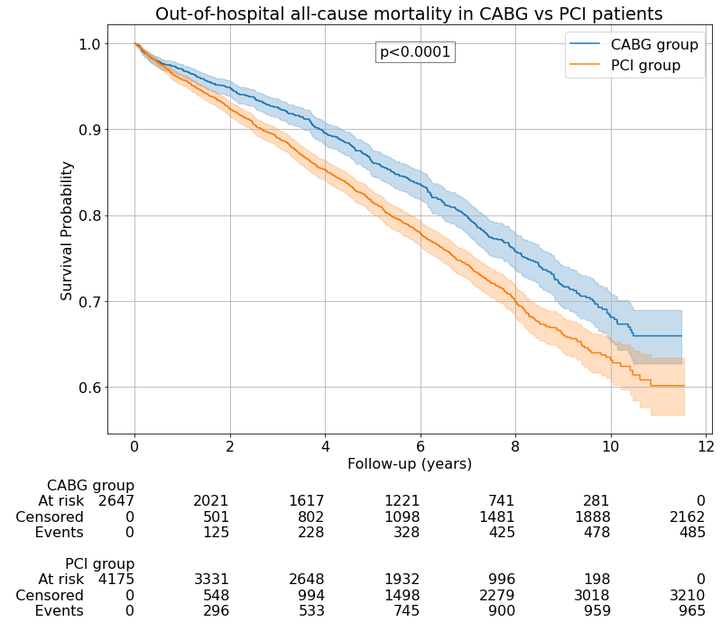 | 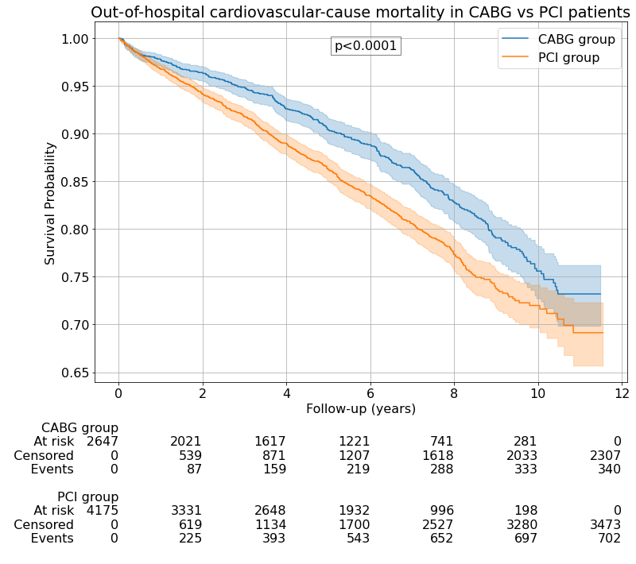
CABG – coronary artery bypass graft surgery; PCI – percutaneous coronary intervention.

Supplemental Figure 2 – Multivariate Cox regression analysis of out-of-hospital survival.
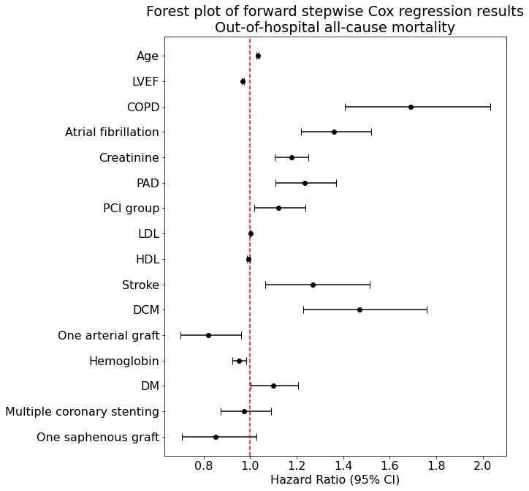 | 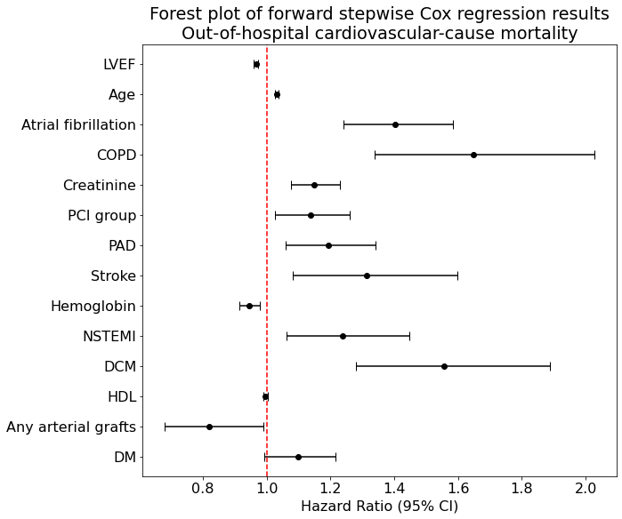
COPD – chronic obstructive pulmonary disease; DCM – dilated cardiomyopathy; DES – drug-eluting stent; DM – diabetes mellitus; HDL – high-density lipoprotein; LDL – low-density lipoprotein; LVEF – left ventricular ejection fraction; NSTEMI – non-ST-elevation myocardial infarction at presentation; PAD – peripheral artery disease.

Supplemental Figure 3 – Performance metrics for the multivariate Cox models in predicting out-of-hospital survival.
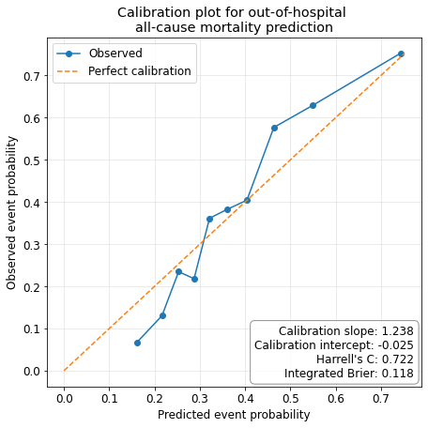 | 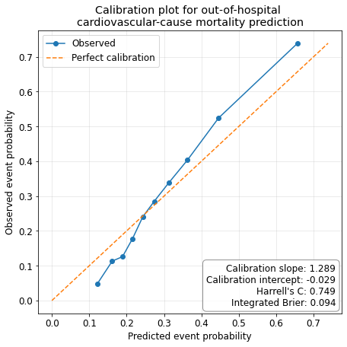

Supplemental Table 1 – Impact of clinical parameters on out-of-hospital patient survival.
Parameter | Out-of-hospital all-cause death |  | Out-of-hospital cardiovascular-cause death
Parameter | HR | p value | HR | p value
Age (years) | 1.06 (1.06-1.07) | <0.0001 | 1.07 (1.06-1.08) | <0.0001
Male sex | 0.96 (0.85-1.07) | 0.44 | 0.9 (0.78-1.03) | 0.12
Treated by CABG | 0.76 (0.68-0.85) | <0.0001 | 0.73 (0.64-0.83) | <0.0001
Treated by PCI | 1.3 (1.16-1.45) | <0.0001 | 1.36 (1.19-1.54) | <0.0001
Hypercholesterolemia | 0.72 (0.65-0.8) | <0.0001 | 0.7 (0.62-0.79) | <0.0001
Diabetes mellitus | 1.28 (1.15-1.43) | <0.0001 | 1.32 (1.16-1.51) | <0.0001
HBP | 1.01 (0.87-1.17) | 0.88 | 1.01 (0.85-1.2) | 0.90
Atrial fibrillation | 2.05 (1.81-2.32) | <0.0001 | 2.28 (1.98-2.63) | <0.0001
CKD | 2.74 (2.32-3.23) | <0.0001 | 2.96 (2.45-3.58) | <0.0001
History of stroke | 1.73 (1.42-2.1) | <0.0001 | 1.87 (1.5-2.35) | <0.0001
History of MI | 1.33 (1.2-1.48) | <0.0001 | 1.44 (1.28-1.63) | <0.0001
LBBB | 1.73 (1.31-2.27) | 0.0001 | 2.0 (1.48-2.7) | <0.0001
PAD | 1.46 (1.29-1.65) | <0.0001 | 1.43 (1.23-1.65) | <0.0001
Smoker | 0.87 (0.77-0.99) | 0.0324 | 0.82 (0.7-0.96) | 0.0108
COPD | 2.67 (2.2-3.25) | <0.0001 | 2.8 (2.24-3.51) | <0.0001
DCM | 3.18 (2.67-3.79) | <0.0001 | 3.69 (3.04-4.48) | <0.0001
NSTEMI * | 1.54 (1.31-1.81) | <0.0001 | 1.75 (1.46-2.1) | <0.0001
Creatinine (mg/dl) | 1.32 (1.22-1.42) | <0.0001 | 1.32 (1.21-1.44) | <0.0001
Hemoglobin(×103/µL) | 0.84 (0.81-0.87) | <0.0001 | 0.86 (0.82-0.89) | <0.0001
Platelets (×103/µL) | 1.0 (1.0-1.0) | 0.38 | 1.0 (1.0-1.0) | 0.75
Leucocytes (×103/µL) | 1.05 (1.03-1.07) | <0.0001 | 1.03 (1.0-1.06) | 0.07
HDL-c (mg/dl) | 0.99 (0.98-1.0) | 0.0032 | 0.99 (0.98-1.0) | 0.12
LDL-c (mg/dl) | 1.0 (1.0-1.0) | 0.94 | 1.0 (1.0-1.0) | 0.83
Triglyceride (mg/dl) | 1.0 (1.0-1.0) | 0.51 | 1.0 (1.0-1.0) | 0.33
Cholesterol (mg/dl) | 1.0 (1.0-1.0) | 0.64 | 1.0 (1.0-1.0) | 0.87
LVEF (%) | 0.95 (0.94-0.95) | <0.0001 | 0.94 (0.93-0.95) | <0.0001
Cost (x1000 €) | 1.0 (1.0-1.0) | 0.14 | 1.0 (1.0-1.0) | 0.20
ICU stay (days) | 1.01 (0.98-1.04) | 0.38 | 1.02 (0.98-1.05) | 0.33
Hospitalization days | 1.02 (1.01-1.03) | <0.0001 | 1.02 (1.01-1.03) | <0.0001
CABG – coronary artery bypass grafting surgery; CAD – coronary artery disease; CKD – chronic kidney disease; COPD – chronic obstructive pulmonary disease; DCM -dilated cardiomyopathy; HBP – high blood pressure; HR – hazard ratio; ICU – intensive care unit; LBBB – left bundle branch block; MI – myocardial infarction; NSTEMI – non-ST-elevation myocardial infarction; PAD – peripheral artery disease; PCI – percutaneous coronary intervention. *NSTEMI at presentation.

Supplemental Table 2 – Complete procedural characteristics of the two groups.
Parameter | Out-of-hospital all-cause death |  |  | Out-of-hospital cardiovascular-cause death
Parameter | Number | HR | p value | HR | p value
CABG patients (n=2647)
1 vein graft | 468 (17.68%) | 0.73 (0.57-0.94) | 0.01 | 0.78 (0.58-1.05) | 0.10
2 vein grafts | 1267 (47.87%) | 1.05 (0.88-1.25) | 0.61 | 0.97 (0.79-1.2) | 0.81
3 vein grafts | 697 (26.33%) | 1.39 (1.15-1.69) | 0.0007 | 1.36 (1.08-1.71) | 0.009
≥4 vein grafts | 39 (1.47%) | 0.86 (0.43-1.72) | 0.67 | 0.93 (0.41-2.07) | 0.85
1 arterial graft | 760 (28.71%) | 0.53 (0.42-0.67) | <0.0001 | 0.54 (0.41-0.71) | <0.0001
≥2 arterial grafts | 25 (0.94%) | 1.45 (0.69-3.06) | 0.33 | 1.76 (0.78-3.94) | 0.17
Total vein grafts | 1.98 ± 0.88 | 1.23 (1.11-1.36) | <0.0001 | 1.17 (1.04-1.32) | 0.008
Total arterial grafts | 0.31 ± 0.48 | 0.6 (0.49-0.74) | <0.0001 | 0.63 (0.49-0.81) | 0.0002
Total grafts | 2.29 ± 0.76 | 1.11 (0.99-1.24) | 0.08 | 1.05 (0.92-1.2) | 0.45
Only venous graft | 1861 (70.31%) | 1.8 (1.44-2.24) | <0.0001 | 1.74 (1.34-2.26) | <0.0001
Only arterial graft | 181 (6.84%) | 0.61 (0.41-0.91) | 0.01 | 0.77 (0.5-1.18) | 0.23
Combined grafts | 604 (22.82%) | 0.59 (0.46-0.76) | <0.0001 | 0.56 (0.41-0.75) | 0.0002
PCI patients (n=4175)
Single stent in a single coronary | 2501 (59.90%) | 0.8 (0.7-0.91) | 0.0005 | 0.8 (0.69-0.93) | 0.003
Multiple stents in a single coronary | 1283 (30.73%) | 1.09 (0.95-1.25) | 0.21 | 1.14 (0.97-1.34) | 0.10
Multiple stents in multiple coronaries | 444 (10.63%) | 1.46 (1.21-1.76) | 0.0001 | 1.34 (1.07-1.68) | 0.01
Number of stents | 1.43 ± 0.55 | 1.2 (1.07-1.34) | 0.001 | 1.21 (1.06-1.37) | 0.005
BMS – bare metal stent; CABG – coronary artery bypass grafting surgery; DES – drug-eluting stent; HR – hazard ratio; PCI – percutaneous coronary intervention.

