Appendix A. Supplementary data

Discovery and Characterization of An Enantioselective Family VIII Esterase from Effluent Treatment Plant Sludge Metagenome

Manish Kumar Yadav^{a,b,$}, Ravi Ranjan^{a,#}, Pratima Vermaª and Rakesh Sharma^{a,b *}
a: CSIR-Institute of Genomics and Integrative Biology, Council of Scientific and Industrial Research, Mathura Road, New Delhi-110025, India.
b: Academy of Scientific and Innovative Research (AcSIR), Ghaziabad- 201002, India.

Supplementary Table 1: Comparison of chiral selectivity of purified esterases for methyl mandelate.
Lipase/esterase | Formulation used | Reaction type | Product | ee % | Substrate Conc. | E value | Reference
EstN3 (Current study) | Purified enzyme | Hydrolysis | S-MA | 96.26% | 50 mM | 93 | Current study
Pseudomonas sp. ECU1011 | Whole-cell | Deacylation | S-MA | 98.1% | 20 mM | E > 200 | Ju et al., 2010
Lipase (Candida rugosa) | Encapsulated within a sol-gel | Hydrolysis | R-MA | > 98% | 20 mM | 193 | Zheng et al., 2016
Lipase AFL67 (Aspergillus fumigatus) | Whole-cell | Deacylation | S-MA | 91.9 % | 5 mM | 64 | Shangguan et al., 2012
Lipase (CALB) (Candida antarctica) | Immobilized | Aminolysis | R-MA | 99% | 20 mM | >300 | Muller et al., 2020
Lipase (Burkholderia ambifaria YCJ01) | Powder preparation | Transesterification | S-MA | 99.9% | 30 mM | - | Yao et al., 2013
Lipase (Pseudomonas stutzeri LC2-8) | Powder preparation | Transesterification | R-MA | 99% | 180 mM | - | Muller et al., 2020
Lipase (Pseudomonas sp.) | Immobilized | Asymmetric amidation | S-MA | 99% | 50 mM | >200 | Yildirim and tukel, 2014
Lipase (Geotrichum candidum) | Immobilized | Hydrolysis | R-MA | 99% | 10 mM | >200 | Morais et al., 2018
Lipase (Burkholderia sp. GXU56) | Immobilized | Hydrolysis | R-MA | 98.5% | 25 mM | >230 | Palomo et al., 2002
Lipase (Novozym 435) | Immobilized | Hydrolysis | R-MA | 78% | 5 mM | >10 | Yadav and Sivakumar, 2004
Esterase BSE04211 (Metagenome) | Crude enzyme | Hydrolysis | S-MA | 99% | 10 mM | - | Liang et al., 2016
DAEst6 (Dactylosporangium aurantiacum subsp) | Crude enzyme | Hydrolysis | R-MA | 99% | 10 mM | >200 | Deng et al., 2016
Esterase rPPE01 (Pseudomonas putida ECU1011) | Lyophilized cells | Deacetylation | S-MA | 99% | 100 mM | >200 | Ma et al., 2013

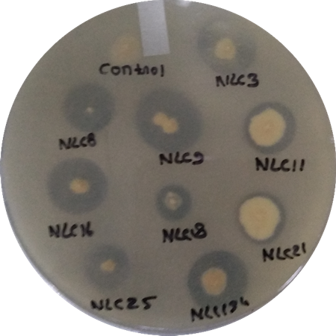
Supplementary Figure 1. Tributyrin Hydrolysis Assay: Activity was observed after three incubation days at 37 °C on 1 % tributyrin-containing plates. EstN3 was identified from clone NLC3.
Supplementary Figure 2. SDS- PAGE of Ni-NTA column chromatography purified EstN3: SDS-PAGE analysis of purified EstN3: EstN3 (cloned in pET28a) was overexpressed in E. coli BL21 (DE3) cells and purified using Ni-NTA affinity chromatography. Lane 1: Protein Marker, Lane 2: Cell lysate of E. coli BL21 (DE3) carrying empty pET28a. Lane 3: Cell lysate of E. coli BL21 (DE3) overexpressed EstN3 (in pET28a). Lane 4: pass through of column. Lane 5: Purified EstN3.

