Supplementary Figures
Supplementary Figures: Symptom networks and centrality plots
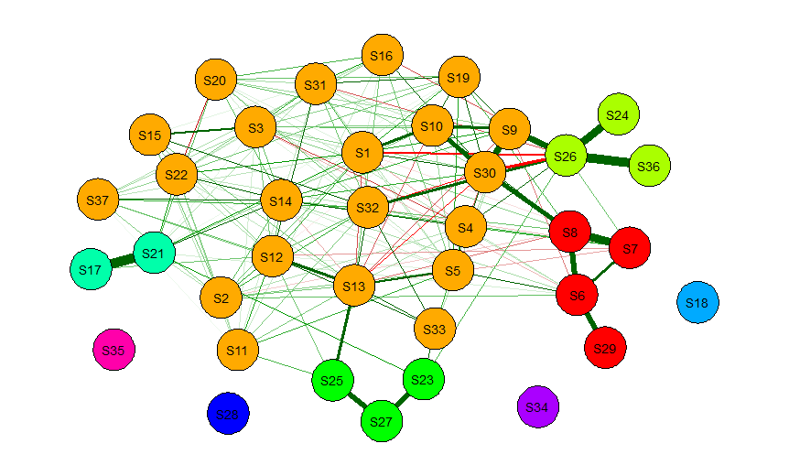
Supplementary Figure S1. Symptom network for Period 1 (last month before death).
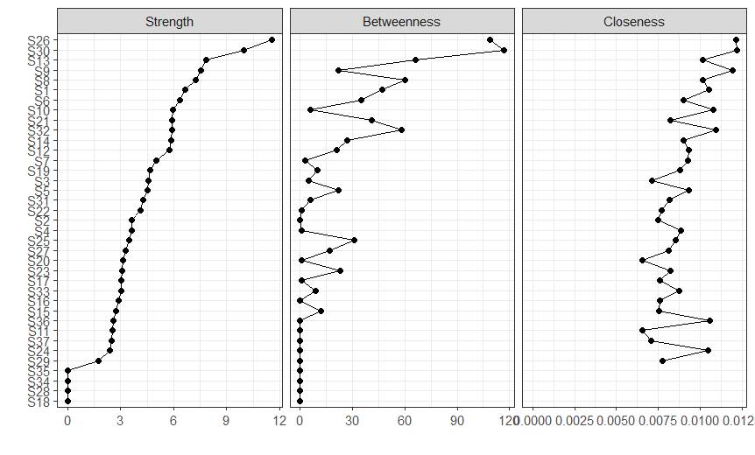
Supplementary Figure S2. Centrality plot for Period 1 (last month before death).
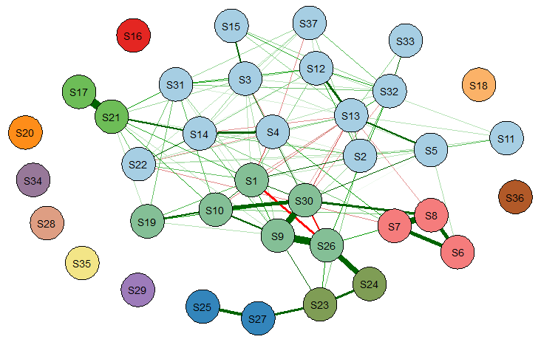
Supplementary Figure S3. Symptom network for Period 2 (1 to 2 months before death).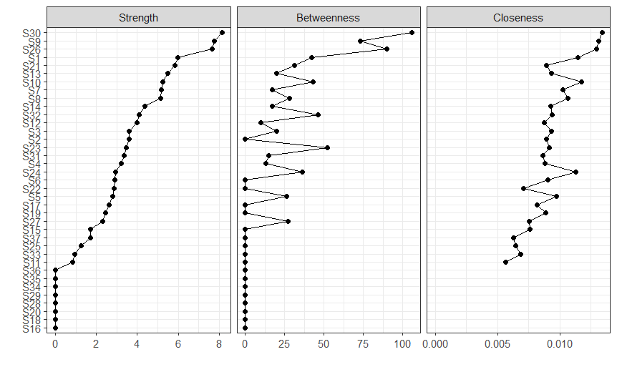
Supplementary Figure S4. Centrality plot for Period 2 (1 to 2 months before death).

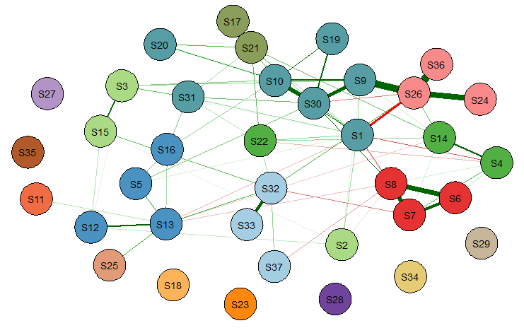
Supplementary Figure S5. Symptom network for Period 3 (2 to 3 months before death).
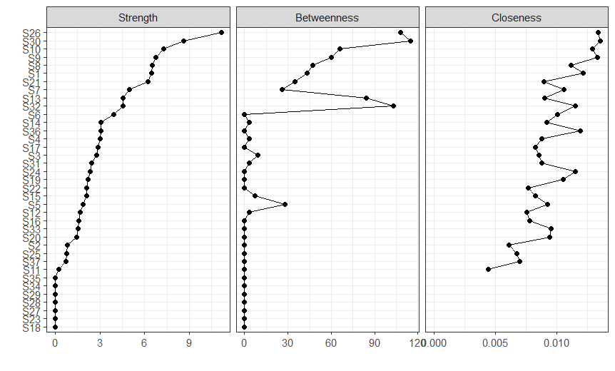
Supplementary Figure S6. Centrality plot for Period 3 (2 to 3 months before death).
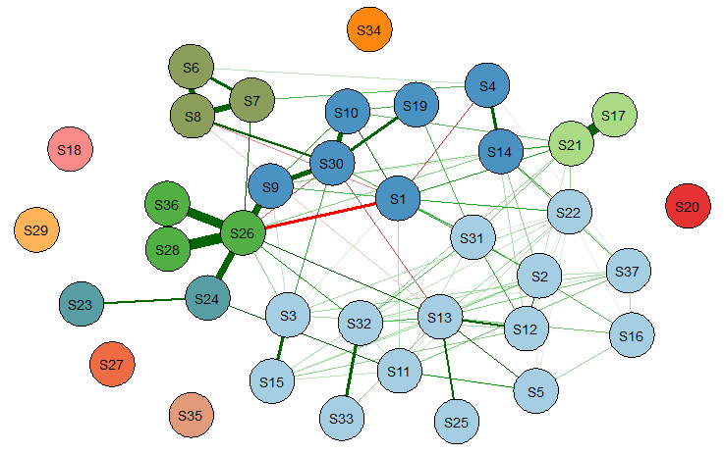
Supplementary Figure S7. Symptom network for Period 4 (3 to 6 months before death).

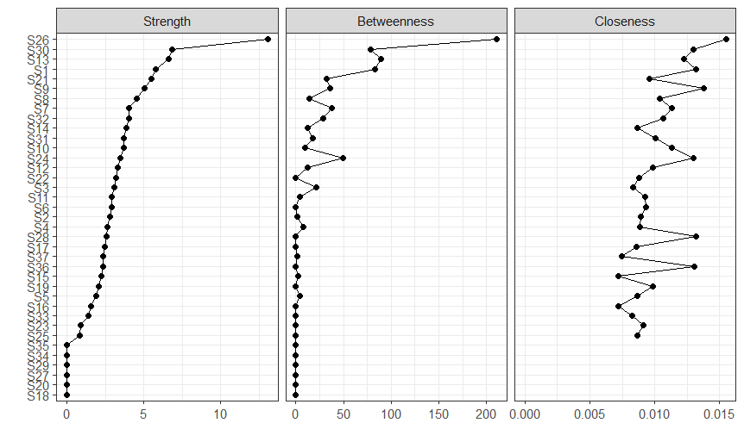
Supplementary Figure S8. Centrality plot for Period 4 (3 to 6 months before death).
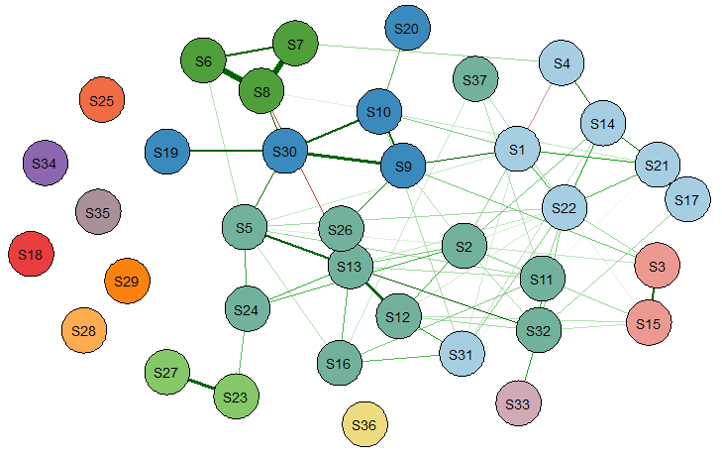
Supplementary Figure S9. Symptom network for Period 5 (6 to 12 months before death).

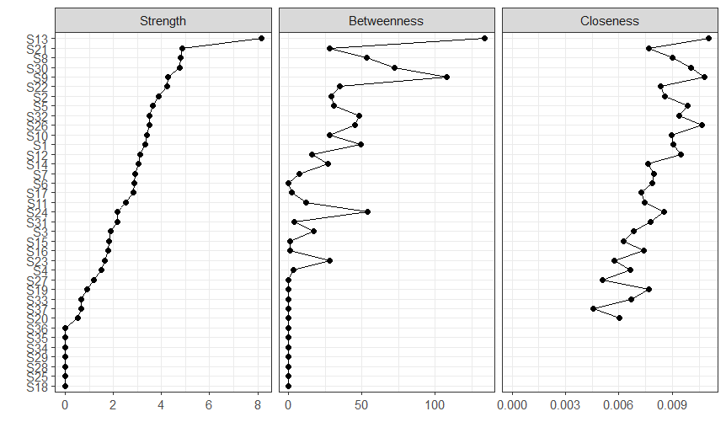
Supplementary Figure S10. Centrality plot for Period 5 (6 to 12 months before death).

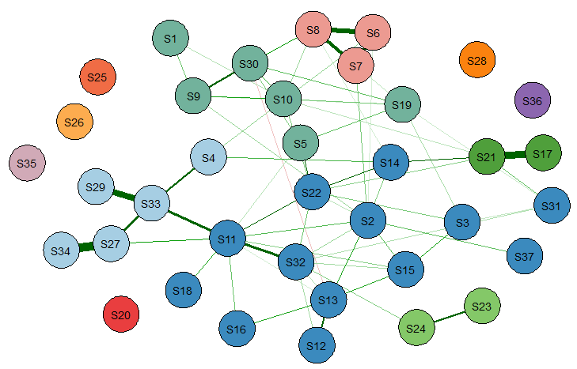
Supplementary Figure S11. Symptom network for Period 6 (more than 12 months before death).

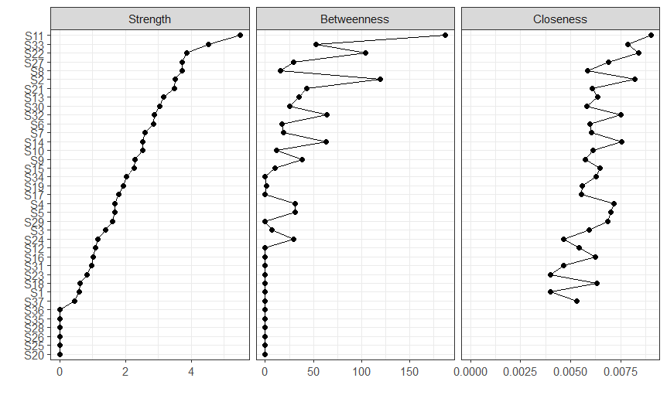
Supplementary Figure S12. Centrality plot for Period 6 (more than 12 months before death).
Supplementary Figures: the results of the edge-weight accuracy test
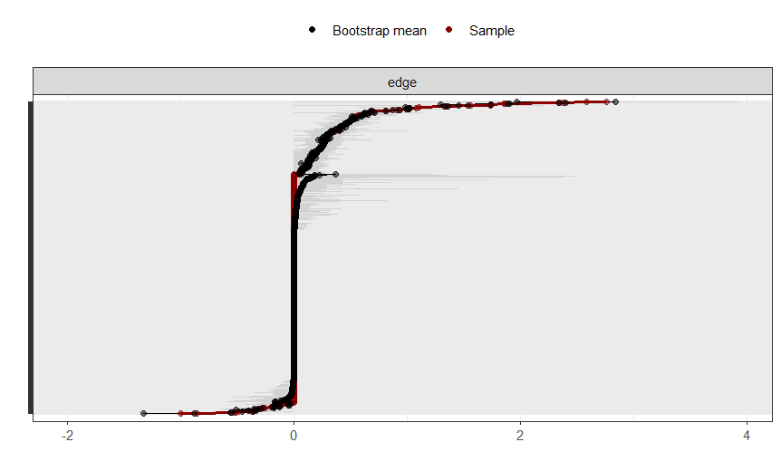
Supplementary Figure S13. Bootstrap analysis of edge-weight accuracy for Period 1.

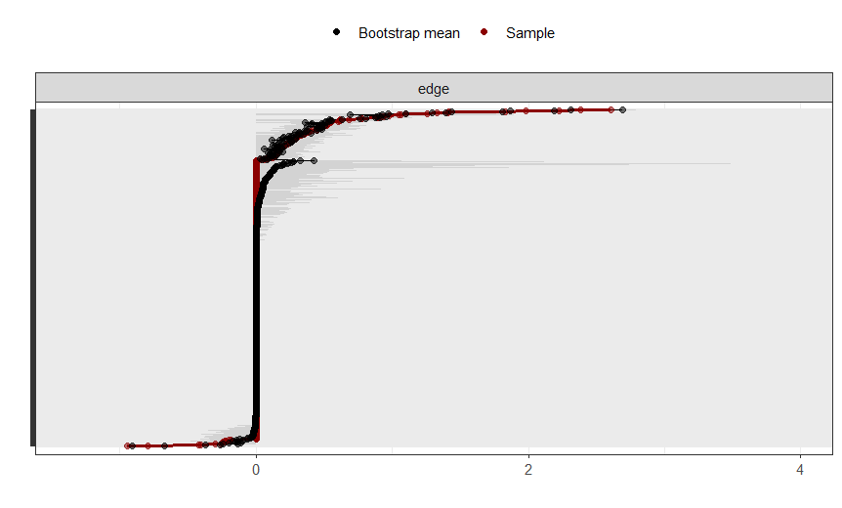
Supplementary Figure S14. Bootstrap analysis of edge-weight accuracy for Period 2.
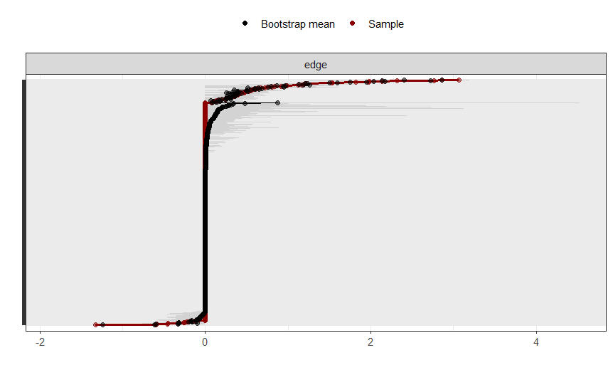
Supplementary Figure S15. Bootstrap analysis of edge-weight accuracy for Period 3.

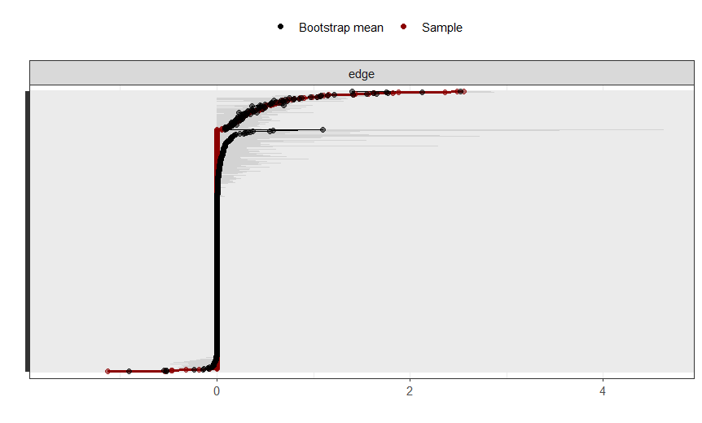
Supplementary Figure S16. Bootstrap analysis of edge-weight accuracy for Period 4.

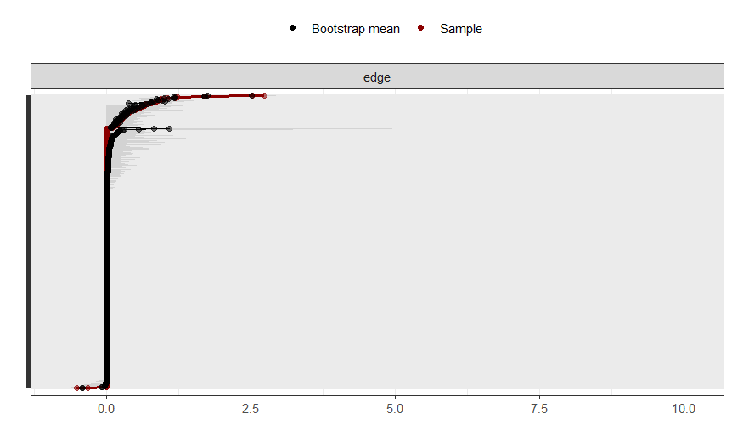
Supplementary Figure S17. Bootstrap analysis of edge-weight accuracy for Period 5.
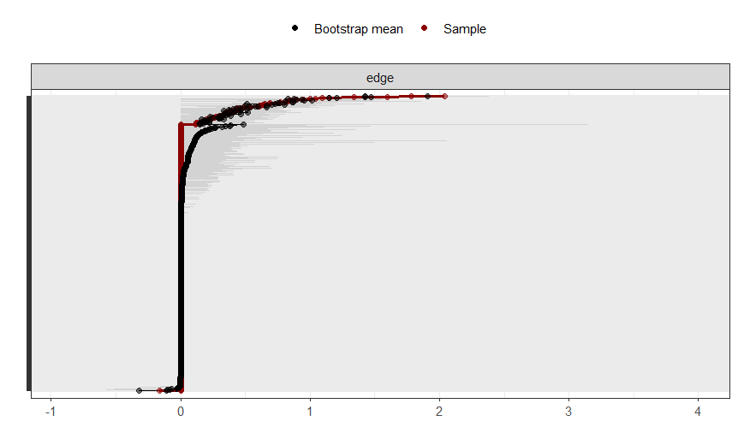
Supplementary Figure S18. Bootstrap analysis of edge-weight accuracy for Period 6.

Supplementary Figures: The results of centrality stabilities
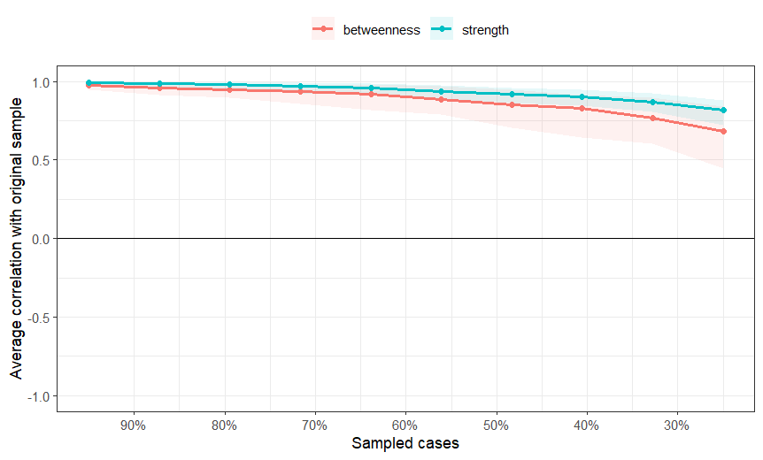
Supplementary Figure S19. Case-dropping bootstrap analysis of centrality stability for Period 1 (last month before death).
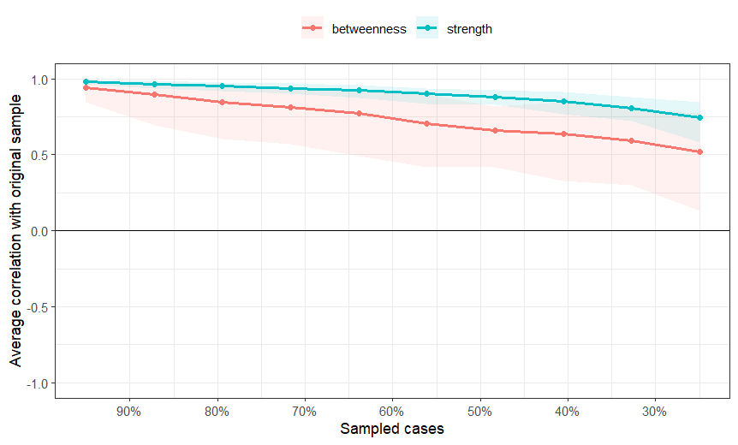
Supplementary Figure S20. Case-dropping bootstrap analysis of centrality stability for Period 2 (1 to 2 months before death).
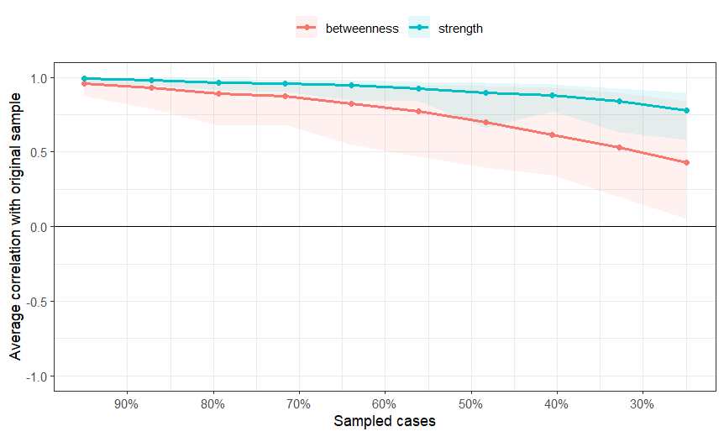
Supplementary Figure S21. Case-dropping bootstrap analysis of centrality stability for Period 3 (2 to 3 months before death).
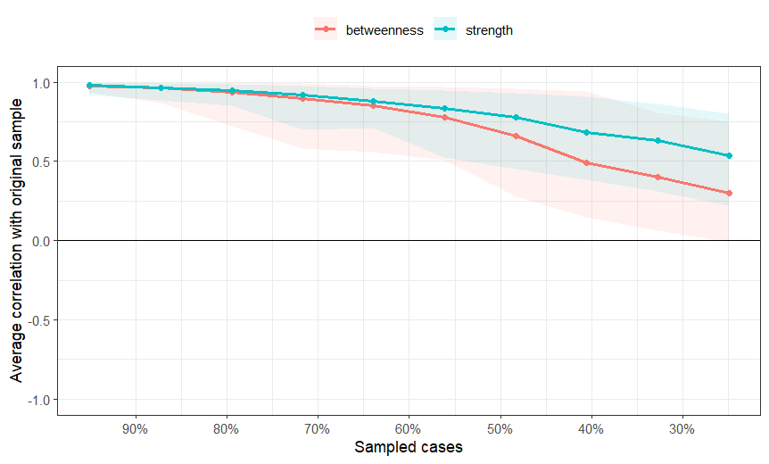
Supplementary Figure S22. Case-dropping bootstrap analysis of centrality stability for Period 4 (3 to 6 months before death).
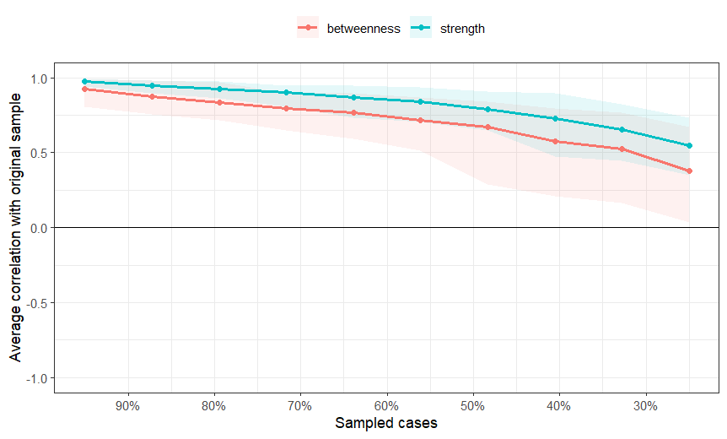
Supplementary Figure S23. Case-dropping bootstrap analysis of centrality stability for Period 5 (6 to 12 months before death).
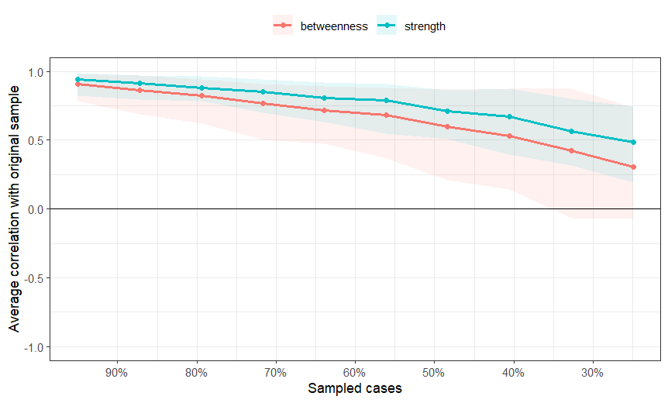
Supplementary Figure S24. Case-dropping bootstrap analysis of centrality stability for Period 6 (more than 12 months before death).

