Supplementary Material

Supplementary material to Teran, Yee-Rendon, Sosa-Arámbula, De La Herrán-Arita & Woods (submitted) “Home Lighting, Blue-Light Filtering, and Their Effects on Melatonin Suppression”

Calculation of the figures of merit used in the calculation of circadian illuminance (CIL) and the melatonin suppression value (MSV)
The MSV was calculated using the luminous efficacy of radiation (LER) and circadian efficiency of radiation (CER) which determine the relative photopic and circadian efficiency, respectively, of the source plus and filter. We used two types of parameters to evaluate the effect of radiation on the visual and circadian systems. The circadian illuminance (CIL) help us to quantify the effects of light on the circadian clock, this parameter weights the effect of the wavelengths on the circadian clock such as the photopic (visual) illuminance (PIL) weights the effect of visible light. The circadian action factor (CAF) refers to the biological action per unit of visual response. Different CAF values are advisable depending on the time of day: high CAF during daytime and low CAF during nighttime.
The circadian illuminance (CIL_{i,j}) of lamp i and filter j was calculated as the product of the circadian action factor (CAF_{i,j}) [37] and the photopic illuminance (PIL_{i,j}) [38] :
${CIL}_{i,j}={CAF}_{i,j}×{PIL}_{i,j}$, [blm/m²] (S1),
where blm denotes a bio-lumen. CAF and PIL are calculated using the measured spectral irradiances of the lamps as described above. PIL can be obtained through the relationship:
${PIL}_{i,j}=683\int_{380}^{780}{\left(I_{c,i}\left(λ\right) T_{j}\left(λ\right)\right) V\left(λ\right) dλ}$. [lm/m²] (S2).
Here, $I_{c,i}\left(λ\right)={Φ_{c,i}\left(λ\right)}/{A_{p}}, Φ_{c}\left(λ\right)$ is the flux or power at the cornea of lamp i, $A_{p}$ the pupil area, and T_{j}(λ) the transmittance of filter j, and V(λ) is the human photopic luminous efficiency function. For calculations of lamps alone (no filter),T_{j}(λ)=1. The constant 683 came from the definition of a lumen. A lumen is equal to 1/683 Watts at 540 THz (approximately a wavelength of 555 nm, the peak of the luminous efficiency function).

CAF is defined by the ratio:
${CAF}_{i,j}={CER}_{i,j}/{LER}_{i,j}$, [blm/lm] (S3),
where the luminous efficacy of radiation (LER) and the circadian efficiency of radiation (CER) can be calculated by means of the following expressions:
${LER}_{i,j}=683\int_{380}^{780}{I_{c,i}\left(λ\right) T_{j}\left(λ\right) V\left(λ\right) dλ}/\int_{380}^{780}{I_{c,i}\left(λ\right) T_{j}\left(λ\right) dλ}$, [lm/W] (S4),
and
${CER}_{i,j}=683\int_{380}^{780}{I_{c,i}\left(λ\right) T_{j}\left(λ\right) C\left(λ\right) dλ}/\int_{380}^{780}{I_{c,i}\left(λ\right) T_{j}\left(λ\right) dλ}$, [blm/W] (S5),
where the circadian luminous efficiency function is denoted by $C\left(λ\right)$ [37]. These parameters allow the evaluation of the effect of the incident light on the circadian response of the eye. However, these parameters alone are not sufficient to evaluate the response of the body to the incoming light. Equation (2) in the manuscript describes the relationship CIL and MSV (melanopic suppression value) obtained by fitting previously reported data from human studies of melatonin concentrations in the blood.

Calculation of the error in the Melatonin Suppression Value
Since the $CIL$ is defined by the product of$CAF$ and $PIL$, it can be shown that the propagated error to$MSV$can be calculated as
$\left({δMSV}/{MSV}\right)=\sqrt{{\left[{δCAF}/{CAF}\right]}^{2}+{\left[{δPIL}/{PIL}\right]}^{2}}$. (S6).

Normalisation of the Melatonin Suppression Value
The normalized photopic illuminance was defined as
${PIL}_{i, j}^{(N)}=683\int_{380}^{780}{I_{c,i}^{(N)}\left(λ\right) T_{j}\left(λ\right) V\left(λ\right) dλ}$, [lm/m²] (S7),
and, the normalized circadian illuminance was
${CIL}_{i, j}^{(N)}={CAF}_{i,j}×{PIL}_{i, j}^{(N)}$. [blm/m²] (S8).
We should note that the circadian action factor is not affected by the normalization, ${CAF}^{(N)}=CAF$.
The factor $γ$ can be calculated in terms of an arbitrary source. We chose a source of a 75 W incandescent lamp at 2 m, with an illuminance of ${PIL}_{75W}=40 lx$ [28]. Thus, from equation (A7), the photopic illuminance can be written as
${PIL}_{75W}=\left[\frac{γ}{I_{inc}^{(vis)}}\right]683\int_{380}^{780}{I_{c,i}\left(λ\right) T_{j}\left(λ\right) V\left(λ\right) dλ}$, [lm/m²] (S9),
where $I_{c,i}\left(λ\right)$ represented the spectral irradiance of the light source, here an incandescent lamp need to define $I_{inc}^{(vis)}.$Then, solving for the factor $γ$, we obtain
$γ=\frac{{PIL}_{75W}}{{PIL}_{Inc}}I_{Inc}^{(vis)}. \left[\frac{W}{m^{2}}\right]$ (S10),
where ${PIL}_{Inc}$ represents the photopic illuminance of one of the incandescent lamps.
The normalized photopic illuminance of the lamps, see equation (S7), can written in terms of the reference photopic illuminance using equations (S2) and (S10), as:
${PIL}_{x}^{(n)}={PIL}^{(75w)}\left[{{PIL}^{(x)}}/{{PIL}^{(Inc)}}\right]\left[{I_{Inc}^{(vis)}}/{I_{x}^{(vis)}}\right]$ [lx] (S11),
where $x=$ cool-LED, cool-CFL, warm-LED, etc. For instance, the normalized photopic illuminance of the cool-LED lamps can be calculated from equation (S11) and the median value of the PIL for cool-LED lamps from Table S6 to obtain ${PIL}_{cool-LED}^{(n)}=40\left[54.7/23.9\right]×\left[0.1/0.2\right]=56.8 lx$.

Table S1. All the (fixed correlated colour temperature: CCT) lamps measured in this study grouped by technology and CCT category (warm or cool white light) for the compact fluorescent (CFL) and Light-emitting diode (LED) lamps.
Manufacturer | LED |  | CFL |  | Incandescent
 | Warm | Cool | Warm | Cool
Argos | - | 9403014 (12W) | - | 8900010 (11W); 8900030 (15W);8900050 (25W), | 8900810 (40W); 8900810 (40W); 8900810 (40W); 8900810 (25W)
Aski | - | - | - | Aski | -
Etko | - | - | - | Etko | -
Filsh | - | - | - | - | filsh100w
Fulgore | - | - | Fulgore-25W | Fulgore-15W | -
General Electric | - | - | - | - | general.electric-40w
Great value | GVT-LED-12W-30 | GVT-LED-12W-65 | GVASP-C-23W | GVASP-23W | -
Line starlux | - | - | - | - | Lw 100
Osram | A60 9W/830 | A60 9w/865 | Dulux value El Twist 15W/827 | Dulux value El Twist 15W/865 | P45 40 125 E26 Clear decorative incandescent lamp; osram-60w
Philips | Ess ledbulb 8-60W E27 3000K 1PF; Ess ledbulb 12-100W E27 3000K 1PF; 13A19/LED/830/FR/P/ND 1BC MX; ledbulb 4W E27 3000K 100-240VG16.5 MX | Ess ledbulb 8-60W E27 6500K 1PF/6 MX; 13A19/LED/865/FR/P/ND 1BC/6 MX;ledbulb 4W E27 6500K 100-240VG16.5 MX; philiphs-4.5W | - | Mini Twister 13W | P45 Claro (40W)
Red dot | - | - | - | ETWFL 54; ETWFL 59; ETWFL 60; | -
Saglite | A19 9W 30K | A21 E26 65K; A19 E26 65K | - | - | -
Tecnolite | NUNKI A19-LED/007/30;HIDRUS I A19-LED/010/30;LUMIA I A19-LED/012/30; TITANIUM V A19-LED/005/30 | NUKI A19-LED/007/65; HIDRUS I A19-LED/010/65; LUMIA I A19-LED/012/65;TITANIUM V A19-LED/005/65 | - | Hel-15W/27-T2 | -

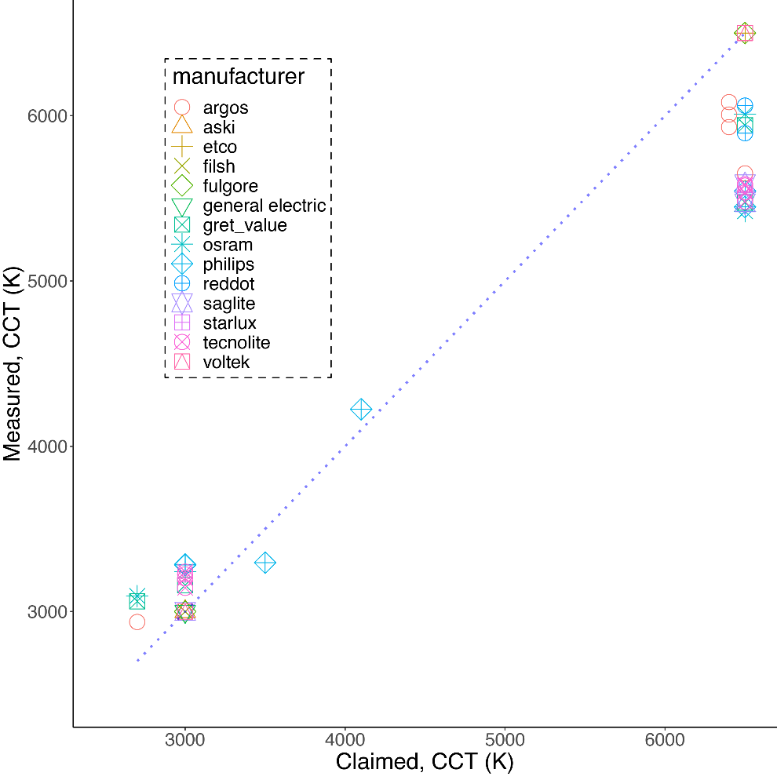
Figure S1. Correlated color temperature (CCT) of the lamps claimed versus measured. Dotted line represents equality.

Table S2. Wattage, equivalent wattage (as reported by the manufacturer) and luminous flux claimed for the lamps. Values are the median with the range in parentheses.
Lamp category | Wattage(W) | Equivalent wattage(W) | Lumen(lx)
Cool-LED | 11(4/15) | 75(40/120) | 820(350/1,310)
Warm-LED | 10(4/15) | 60(10/100) | 900(350/1,310)
Cool-CFL | 15(11/25) | 59.5(54/120) | 845.5(365/1,571)
Warm-CFL | 15(5/25) | 60(40/100) | 800(365/1,675)
Incandescent | 40(40/100) | 40(40/100) | 365(365/2,200)

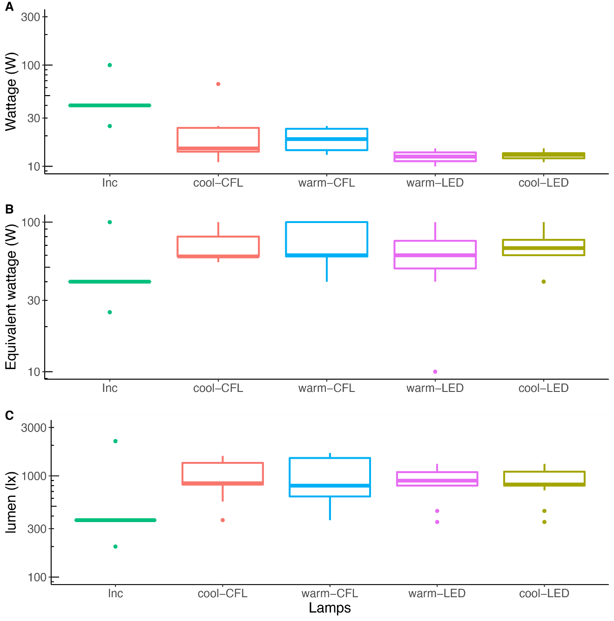
Figure S2. Wattage(A), equivalent wattage (B) and lumens(C) claimed by the lamps: cool-LED (olive-green), warm-LED (pink), cool-CFL (orange), warm-CFL (blue), and Incandescent (green). Please see Table S2 for related values.

Table S3. Normalized figures of merit and melatonin suppression values of the median lamp of each category. Range shown in parentheses.
Lamp | LER  (lm/W) | CER  (lm/w) | CAF  (-) | PIL^{(n)}  (lx) | CIL^{(n)}  (blx) | MSV^{(n)}  (%)
cool-LED | 299.3 ( 292.3/ 303.2) | 204.9 ( 201.3/ 208.5) | 0.7 ( 0.7/ 0.7) | 57.8 ( 27.2/ 146.2) | 39.6 ( 18.2/ 104.2) | 15.3 ( 4.3/ 50.3)
warm-LED | 297.0 ( 290.6/ 299.2) | 95.9 ( 80.9/ 103.3) | 0.3 ( 0.3/ 0.4) | 58.1 ( 27.4/ 151.9) | 18.6 ( 9.4/ 48.6) | 4.5 ( 1.4/ 20.6)
cool-CFL | 297.0 ( 253.6/ 316.2) | 204.2 ( 146.2/ 215.8) | 0.7 ( 0.5/ 0.8) | 57.5 ( 27.8/ 149.2) | 39.4 ( 18.0/ 108.8) | 15.2 ( 4.3/ 52.2)
warm-CFL | 328.1 ( 307.7/ 336.3) | 78.0 ( 72.4/ 82.4) | 0.2 ( 0.2/ 0.3) | 67.6 ( 31.5/ 175.7) | 15.8 ( 7.4/ 40.7) | 3.4 ( 0.9/ 15.9)
Incandescent | 110.9 ( 102.6/ 123.4) | 31.7 ( 23.9/ 41.4) | 0.3 ( 0.2/ 0.3) | 40.2 ( 17.9/ 107.4) | 10.9 ( 4.6/ 36.0) | 1.8 ( 0.4/ 13.2)
LER= Luminous efficiency of radiation; CER=circadian luminous efficiency of radiation; CAF=circadian action factor; PIL^{(n)}=normalized phototopic illuminance; CIL^{(n)}=normalized circadian illuminance; MSV^{(n)}=normalized melatonin suppression values.

Table S4. Absolute (without normalization) figures of merit and melatonin suppression values of the median lamp of each category. Range shown in parentheses.
Lamp | LER  (lm/W) | CER  (lm/w) | CAF  (-) | PIL  (lx) | CIL  (blx) | MSV  (%) | I^{(vis)} [W/m²]
cool-LED | 299.3 ( 292.3/ 303.2) | 204.9 ( 201.3/ 208.5) | 0.7 ( 0.7/ 0.7) | 57.5 ( 27.2/ 102.2) | 39.6 ( 19.0/ 70.8) | 15.3 ( 4.7/ 33.7) | 0.2 ( 0.1/ 0.3)
warm-LED | 297.0 ( 290.6/ 299.2) | 95.9 ( 80.9/ 103.3) | 0.3 ( 0.3/ 0.4) | 59.2 ( 25.6/ 111.8) | 18.6 ( 6.9/ 37.0) | 4.5 ( 0.8/ 13.8) | 0.2 ( 0.1/ 0.4)
cool-CFL | 297.0 ( 253.6/ 316.2) | 204.2 ( 146.2/ 215.8) | 0.7 ( 0.5/ 0.8) | 33.6 ( 15.5/ 46.6) | 22.9 ( 10.0/ 32.0) | 6.4 ( 1.5/ 11.0) | 0.1 ( 0.0/ 0.1)
warm-CFL | 328.1 ( 253.6/ 316.2) | 78.0 ( 80.9/ 215.8) | 0.2 ( 0.3/ 0.8) | 34.5 ( 15.5/ 111.8) | 8.4 ( 6.9/ 63.9) | 1.1 ( 0.8/ 50.0) | 0.1 ( 0.0/ 0.4)
Incandescent | 110.9 ( 102.6/ 123.4) | 31.7 ( 23.9/ 41.4) | 0.3 ( 0.2/ 0.3) | 23.9 ( 10.6/ 63.8) | 6.5 ( 2.8/ 21.4) | 0.7 ( 0.2/ 5.7) | 0.1 ( 0.1/ 0.3)
LER= Luminous efficiency of radiation; CER=circadian luminous efficiency of radiation; CAF=circadian action factor; PIL=phototopic illuminance; CIL=circadian illuminance; MSV=melatonin suppression value; I^{(vis)}= area under the curve in the visible range of the lamp’s irradiance.

Table S5. Figures of Merit and melatonin suppression values (MSV) of the circadian (tunable) lamps as a function of the correlated color temperature (CCT); See Figure 1F.
Circadian lamp | LER  (lm/W) | CER  (lm/w) | CAF  (-) | PIL  (lx) | CIL  (blx) | MSV  (%) | CCT  (K)
Estevez | 298.53 | 80.84 | 0.27 | 46.97 | 12.72 | 2.33 | 2972
Estevez | 297.77 | 97.61 | 0.33 | 46.68 | 15.30 | 3.21 | 3201
Estevez | 297.39 | 112.00 | 0.38 | 47.26 | 17.80 | 4.16 | 3423
Estevez | 297.08 | 122.42 | 0.41 | 47.43 | 19.54 | 4.88 | 3597
Estevez | 296.76 | 138.76 | 0.47 | 47.46 | 22.19 | 6.04 | 3895
Estevez | 296.51 | 147.12 | 0.50 | 47.13 | 23.38 | 6.59 | 4058
Estevez | 296.30 | 163.02 | 0.55 | 46.72 | 25.71 | 7.71 | 4393
Estevez | 296.13 | 174.59 | 0.59 | 45.91 | 27.07 | 8.39 | 4656
Estevez | 296.11 | 190.97 | 0.64 | 44.52 | 28.71 | 9.24 | 5054
Estevez | 296.20 | 206.33 | 0.70 | 42.86 | 29.85 | 9.84 | 5456
Estevez | 296.38 | 216.77 | 0.73 | 41.87 | 30.62 | 10.25 | 5745
Philips hue-color | 283.26 | 50.03 | 0.18 | 16.48 | 2.91 | 0.17 | 2161
Philips hue-color | 282.02 | 71.29 | 0.25 | 27.74 | 7.01 | 0.82 | 2559
Philips hue-color | 282.02 | 71.29 | 0.25 | 27.74 | 7.01 | 0.82 | 2828
Philips hue-color | 284.58 | 80.18 | 0.28 | 30.69 | 8.65 | 1.18 | 3035
Philips hue-color | 294.38 | 99.14 | 0.34 | 34.27 | 11.54 | 1.97 | 3366
Philips hue-color | 303.36 | 117.77 | 0.39 | 37.44 | 14.53 | 2.94 | 3674
Philips hue-color | 307.10 | 139.04 | 0.45 | 37.48 | 16.97 | 3.83 | 4043
Philips hue-color | 299.73 | 167.48 | 0.56 | 31.36 | 17.53 | 4.05 | 4647
Philips hue-color | 292.73 | 190.37 | 0.65 | 26.95 | 17.53 | 4.05 | 5214
Philips hue-color | 288.50 | 202.63 | 0.70 | 24.79 | 17.41 | 4.01 | 5561
Philips: Scene-switching | 251.89 | 47.89 | 0.19 | 2.65 | 0.50 | 0.01 | 2200
Philips: Scene-switching | 290.08 | 78.39 | 0.27 | 15.66 | 4.23 | 0.33 | 2700
Philips: Scene-switching | 305.42 | 172.64 | 0.57 | 14.90 | 8.42 | 1.13 | 5000
Wiz | 312.30 | 100.80 | 0.32 | 44.40 | 14.49 | 2.68 | 2800
Wiz | 311.70 | 107.80 | 0.34 | 44.14 | 15.37 | 3.07 | 3000
Wiz | 312.97 | 83.23 | 0.27 | 43.83 | 11.65 | 3.46 | 3200
Wiz | 309.76 | 123.21 | 0.40 | 43.66 | 17.37 | 3.99 | 3400
Wiz | 309.31 | 127.94 | 0.41 | 43.53 | 18.01 | 4.24 | 3600
Wiz | 308.86 | 133.75 | 0.43 | 42.99 | 18.62 | 4.49 | 3800
Wiz | 308.04 | 144.39 | 0.47 | 42.51 | 19.93 | 5.04 | 4000
Wiz | 307.64 | 149.27 | 0.49 | 42.41 | 20.58 | 5.32 | 4200
Wiz | 306.99 | 157.11 | 0.51 | 42.40 | 21.70 | 5.82 | 4400
Wiz | 306.54 | 163.17 | 0.53 | 41.96 | 22.34 | 6.11 | 4600
Wiz | 305.93 | 171.34 | 0.56 | 41.84 | 23.43 | 6.62 | 4800
Wiz | 305.45 | 177.61 | 0.58 | 41.79 | 24.30 | 7.03 | 5000
LER= Luminous efficiency of radiation; CER=circadian luminous efficiency of radiation; CAF=circadian action factor; PIL=phototopic illuminance; CIL=circadian illuminance; MSV=melatonin suppression value; CCT=correlated color temperature.

Table S6. Figures of Merit, and normalized melatonin suppression values (MSV) of the lamp categories weighted by the transmittance of the blue-light-filter (BLF) lenses, with no lens and clear lens provided as control conditions.
Lamp | Lens | LER  (lm/W) | CER  (lm/w) | CAF  (-) | PIL^{(n)}  (lx) | CIL^{(n)}  (blx) | MSV^{(n)}  (%)
cool-LED | No lens | 299.85 | 204.57 | 0.68 | 58.05 | 39.61 | 15.29
 | clear | 300.85 | 201.51 | 0.67 | 53.19 | 35.63 | 13.01
 | Seto | 300.11 | 203.46 | 0.68 | 55.63 | 37.71 | 14.20
 | Vaccutek | 306.15 | 196.32 | 0.64 | 56.42 | 36.18 | 13.32
 | Essilor | 306.83 | 193.82 | 0.63 | 57.82 | 36.53 | 13.52
 | Zeiss | 306.98 | 195.02 | 0.64 | 57.58 | 36.58 | 13.55
 | CGID | 310.69 | 184.84 | 0.59 | 53.78 | 31.99 | 10.99
 | Spektrum | 318.80 | 171.95 | 0.54 | 53.57 | 28.90 | 9.33
 | Swanwick | 315.77 | 10.75 | 0.03 | 49.52 | 1.69 | 0.07
 | THL Sleep | 320.84 | 19.27 | 0.06 | 45.89 | 2.76 | 0.16
warm-LED | No lens | 296.81 | 94.07 | 0.32 | 58.80 | 18.64 | 4.47
 | clear | 295.45 | 95.51 | 0.32 | 53.60 | 17.33 | 3.97
 | Seto | 292.98 | 96.20 | 0.33 | 55.81 | 18.33 | 4.37
 | Vaccutek | 295.68 | 93.13 | 0.31 | 56.01 | 17.64 | 4.10
 | Essilor | 297.78 | 91.93 | 0.31 | 57.56 | 17.77 | 4.15
 | Zeiss | 298.45 | 92.61 | 0.31 | 57.44 | 17.82 | 4.17
 | CGID | 297.30 | 86.50 | 0.29 | 52.82 | 15.37 | 3.23
 | Spektrum | 300.53 | 80.57 | 0.27 | 51.78 | 13.88 | 2.71
 | Swanwick | 267.04 | 5.49 | 0.02 | 42.16 | 0.87 | 0.02
 | THL Sleep | 269.36 | 9.30 | 0.03 | 38.88 | 1.34 | 0.04
cool-CFL | No lens | 297.61 | 205.26 | 0.69 | 58.66 | 40.46 | 15.79
 | clear | 301.24 | 202.58 | 0.67 | 54.00 | 36.31 | 13.39
 | Seto | 311.69 | 205.27 | 0.66 | 58.46 | 38.50 | 14.65
 | Vaccutek | 319.85 | 196.74 | 0.62 | 59.70 | 36.72 | 13.63
 | Essilor | 310.44 | 195.46 | 0.63 | 59.27 | 37.32 | 13.97
 | Zeiss | 310.65 | 196.80 | 0.63 | 58.96 | 37.35 | 13.99
 | CGID | 322.58 | 187.26 | 0.58 | 56.52 | 32.81 | 11.43
 | Spektrum | 330.60 | 174.80 | 0.53 | 56.28 | 29.76 | 9.78
 | Swanwick | 319.59 | 14.37 | 0.04 | 51.72 | 2.32 | 0.12
 | THL Sleep | 330.58 | 23.62 | 0.07 | 48.70 | 3.48 | 0.24
warm-CFL | No lens | 326.85 | 76.06 | 0.23 | 67.08 | 15.61 | 3.32
 | clear | 328.60 | 74.71 | 0.23 | 61.43 | 13.97 | 2.74
 | Seto | 335.24 | 73.05 | 0.22 | 65.66 | 14.31 | 2.86
 | Vaccutek | 338.78 | 69.48 | 0.21 | 66.01 | 13.54 | 2.60
 | Essilor | 333.31 | 71.72 | 0.22 | 66.25 | 14.26 | 2.84
 | Zeiss | 334.05 | 72.18 | 0.22 | 66.12 | 14.29 | 2.85
 | CGID | 338.21 | 66.90 | 0.20 | 61.78 | 12.22 | 2.17
 | Spektrum | 340.64 | 62.71 | 0.18 | 60.40 | 11.12 | 1.84
 | Swanwick | 293.69 | 7.50 | 0.03 | 48.67 | 1.24 | 0.04
 | THL Sleep | 299.70 | 11.54 | 0.04 | 45.37 | 1.75 | 0.07
Incandescent | No lens | 109.67 | 30.21 | 0.28 | 40.00 | 11.02 | 1.81
 | clear | 109.18 | 29.54 | 0.27 | 36.37 | 9.84 | 1.49
 | Seto | 108.70 | 29.24 | 0.27 | 37.78 | 10.16 | 1.57
 | Vaccutek | 109.12 | 28.32 | 0.26 | 37.86 | 9.83 | 1.48
 | Essilor | 110.99 | 28.87 | 0.26 | 38.96 | 10.13 | 1.57
 | Zeiss | 110.81 | 28.96 | 0.26 | 39.11 | 10.22 | 1.59
 | CGID | 108.75 | 26.34 | 0.24 | 35.56 | 8.61 | 1.18
 | Prospek | 109.56 | 24.90 | 0.23 | 34.69 | 7.89 | 1.01
 | Swanwick | 80.27 | 1.53 | 0.02 | 25.31 | 0.48 | 0.01
 | THL Sleep | 80.18 | 2.60 | 0.03 | 23.36 | 0.76 | 0.02
LER= Luminous efficiency of radiation; CER=circadian luminous efficiency of radiation; CAF=circadian action factor; PIL^{(n)}=normalized phototopic illuminance; CIL^{(n)}=normalized circadian illuminance; MSV^{(n)}=normalized melatonin suppression value

Table S7. Equivalent α-optic illuminance of the lamp categories weighted by the transmittance of the blue-light-filter (BLF) lenses, with no lens and clear lens provided as control conditions.
 |  | erythropic | chloropic | rhodopic | melanopic | cyanopic | photopic | m_lux
LED cool | No lens | 11.20 | 10.80 | 9.56 | 8.65 | 7.66 | 11.70 | 46.73
 | clear | 10.38 | 9.99 | 8.81 | 7.95 | 6.94 | 10.84 | 42.93
 | Seto | 10.07 | 9.72 | 8.64 | 7.85 | 6.77 | 10.51 | 42.39
 | Vaccutek | 10.61 | 10.19 | 8.90 | 7.96 | 6.44 | 11.11 | 42.98
 | Essilor | 10.69 | 10.24 | 8.89 | 7.90 | 6.44 | 11.20 | 42.66
 | Zeiss | 10.61 | 10.21 | 8.91 | 7.96 | 6.60 | 11.12 | 42.99
 | CGID | 9.78 | 9.25 | 7.87 | 6.89 | 5.39 | 10.24 | 37.22
 | Spektrum | 9.46 | 8.87 | 7.34 | 6.28 | 4.45 | 9.95 | 33.91
 | Swanwick | 5.55 | 3.53 | 1.18 | 0.42 | 0.02 | 5.41 | 2.27
 | THL Sleep | 5.23 | 3.53 | 1.43 | 0.64 | 0.02 | 5.19 | 3.44
LED warm | No lens | 12.00 | 9.48 | 6.38 | 5.02 | 3.00 | 12.08 | 27.12
 | clear | 11.14 | 8.78 | 5.89 | 4.62 | 2.73 | 11.21 | 24.97
 | Seto | 10.82 | 8.52 | 5.76 | 4.56 | 2.67 | 10.87 | 24.61
 | Vaccutek | 11.43 | 8.98 | 5.99 | 4.67 | 2.57 | 11.50 | 25.20
 | Essilor | 11.51 | 9.04 | 6.00 | 4.64 | 2.55 | 11.59 | 25.07
 | Zeiss | 11.41 | 8.99 | 6.00 | 4.66 | 2.61 | 11.49 | 25.18
 | CGID | 10.64 | 8.25 | 5.35 | 4.08 | 2.15 | 10.69 | 22.02
 | Spektrum | 10.36 | 7.98 | 5.06 | 3.77 | 1.79 | 10.42 | 20.35
 | Swanwick | 7.58 | 4.25 | 1.16 | 0.36 | 0.01 | 7.08 | 1.97
 | THL Sleep | 6.96 | 4.05 | 1.30 | 0.50 | 0.01 | 6.57 | 2.71
CFL-cool | No lens | 6.15 | 5.94 | 5.30 | 4.62 | 4.49 | 6.50 | 24.95
 | clear | 5.70 | 5.49 | 4.89 | 4.24 | 4.06 | 6.03 | 22.91
 | Seto | 5.53 | 5.32 | 4.75 | 4.14 | 3.71 | 5.84 | 22.38
 | Vaccutek | 5.83 | 5.59 | 4.90 | 4.19 | 3.43 | 6.18 | 22.62
 | Essilor | 5.88 | 5.63 | 4.93 | 4.21 | 3.70 | 6.23 | 22.72
 | Zeiss | 5.84 | 5.62 | 4.95 | 4.24 | 3.81 | 6.19 | 22.92
 | CGID | 5.38 | 5.09 | 4.36 | 3.66 | 2.94 | 5.70 | 19.74
 | Spektrum | 5.19 | 4.86 | 4.07 | 3.33 | 2.43 | 5.52 | 17.99
 | Swanwick | 2.91 | 1.75 | 0.63 | 0.25 | 0.01 | 2.78 | 1.38
 | THL Sleep | 2.79 | 1.85 | 0.80 | 0.38 | 0.01 | 2.75 | 2.03
CFL-warm | No lens | 5.97 | 4.55 | 2.84 | 1.86 | 1.16 | 6.09 | 10.04
 | clear | 5.54 | 4.22 | 2.63 | 1.71 | 1.07 | 5.65 | 9.25
 | Seto | 5.37 | 4.08 | 2.54 | 1.66 | 0.96 | 5.47 | 8.95
 | Vaccutek | 5.69 | 4.31 | 2.66 | 1.71 | 0.88 | 5.81 | 9.22
 | Essilor | 5.73 | 4.35 | 2.69 | 1.73 | 0.97 | 5.85 | 9.34
 | Zeiss | 5.68 | 4.33 | 2.69 | 1.74 | 1.00 | 5.80 | 9.37
 | CGID | 5.31 | 3.99 | 2.42 | 1.52 | 0.76 | 5.41 | 8.22
 | Spektrum | 5.16 | 3.86 | 2.30 | 1.42 | 0.62 | 5.26 | 7.69
 | Swanwick | 3.75 | 1.97 | 0.55 | 0.20 | 0.00 | 3.43 | 1.08
 | THL Sleep | 3.49 | 1.95 | 0.65 | 0.27 | 0.00 | 3.25 | 1.45
Incandescent | No lens | 5.89 | 4.45 | 3.03 | 2.35 | 1.09 | 5.85 | 12.71
 | clear | 5.47 | 4.12 | 2.80 | 2.17 | 0.99 | 5.43 | 11.71
 | Seto | 5.32 | 3.99 | 2.73 | 2.13 | 0.90 | 5.27 | 11.49
 | Vaccutek | 5.62 | 4.21 | 2.85 | 2.19 | 0.86 | 5.57 | 11.81
 | Essilor | 5.65 | 4.25 | 2.86 | 2.19 | 0.92 | 5.61 | 11.81
 | Zeiss | 5.60 | 4.21 | 2.86 | 2.20 | 0.94 | 5.56 | 11.86
 | CGID | 5.23 | 3.87 | 2.54 | 1.92 | 0.73 | 5.18 | 10.36
 | Spektrum | 5.09 | 3.74 | 2.42 | 1.79 | 0.62 | 5.05 | 9.66
 | Swanwick | 3.77 | 1.93 | 0.53 | 0.17 | 0.00 | 3.44 | 0.93
 | THL Sleep | 3.46 | 1.86 | 0.60 | 0.24 | 0.01 | 3.20 | 1.31

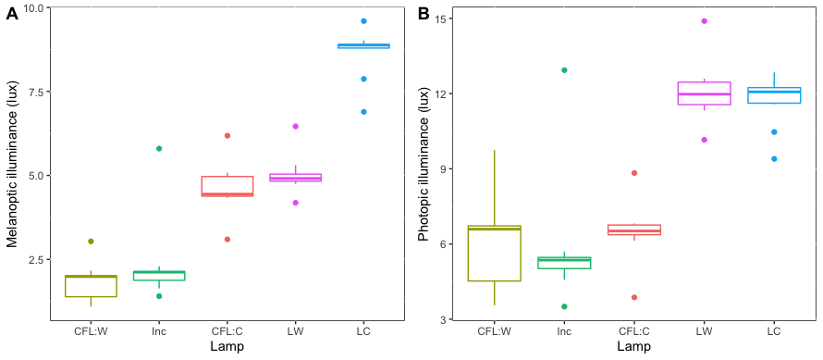
Figure S3. Equivalent α-opic illuminance: melanopic (A) and photopic (B) illuminance by lamp group.

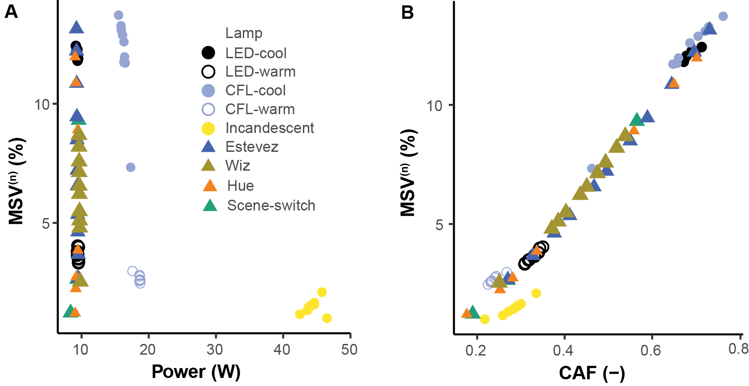
Figure S4. Normalized melatonin suppression value (MSV^{(n)}) as function of the power (A) and the circadian action factor (B) of the standard and tunable lamps.

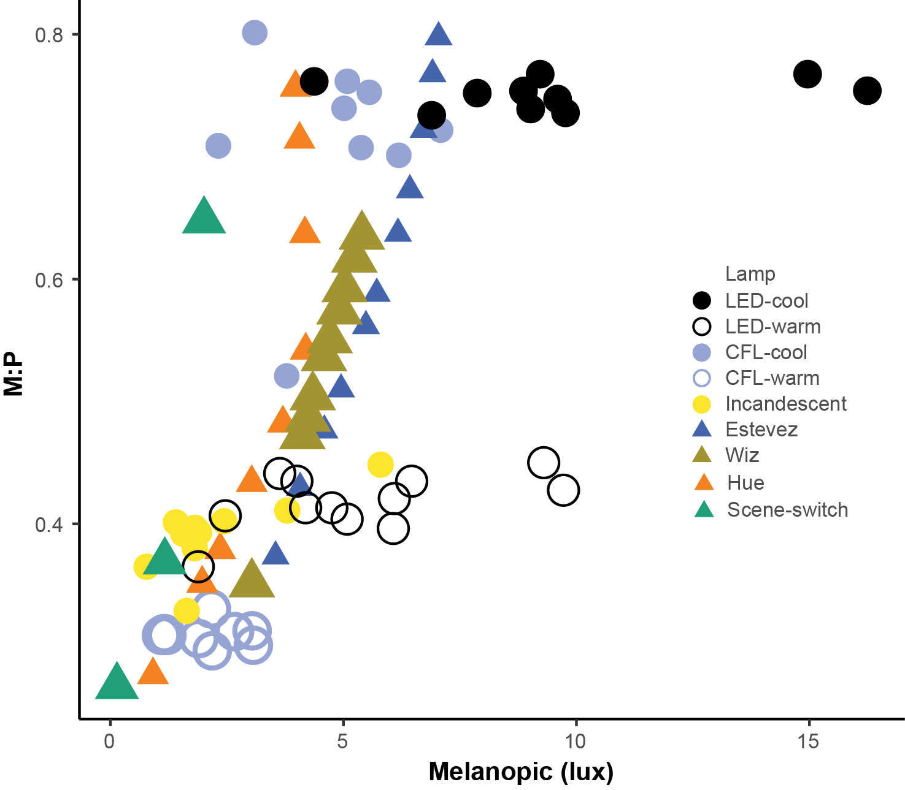
Figure S5. Melanopic to photopic illuminance (M:P) ratio as a function of the melanopic illuminance.

Table S8. Blue-light hazard efficiency of radiation $η_{B}$ and the blue light weighted radiance illuminance $L_{B}$ of the conventional lamps.
Lamp | $$η_{B}$$ | $L_{B}$ (W m-2 sr-1 nm-1)
CFL-cool | 0.19869219 | 734.209299
CFL-warm | 0.07039614 | 233.91332
LED cool | 0.17129749 | 1283.49176
LED warm | 0.06595435 | 517.33289
Incandescent | 0.03796294 | 189.156387

Table S9. Blue-light hazard efficiency of radiation $η_{B}$ and the blue light weighted radiance
illuminance $L_{B}$ of the (tunable) lamps.
Lamp | CCT | $$η_{B}$$ | $L_{B}$ (W m-2 sr-1 nm-1)
Estevez | 2700 | 0.04504263 | 256390.292
 | 3600 | 0.0739821 | 426971.808
 | 4600 | 0.09979858 | 581831.548
 | 5500 | 0.12360984 | 712956.981
 | 6500 | 0.17686172 | 920799.057
Philips:hue-color | 2000 | 0.01945771 | 40986.4964
 | 3100 | 0.04141497 | 145493.781
 | 4200 | 0.06612056 | 276992.328
 | 5300 | 0.10289442 | 457673.245
 | 6500 | 0.17196379 | 542101.156
Wiz | 2000 | 0.01945771 | 40986.4964
 | 3100 | 0.04141497 | 145493.781
 | 4200 | 0.06612056 | 276992.328
 | 5300 | 0.10289442 | 457673.245
 | 6500 | 0.17196379 | 542101.156
Philips:scene-switching | 2200 | 0.13410687 | 240374.159
 | 2700 | 0.0303534 | 11125.6469
 | 5000 | 0.04565782 | 88365.869

Table S10. Blue-light hazard efficiency of radiation $η_{B}$ and the blue light weighted radiance illuminance $L_{B}$ of the conventional lamps weighted by the transmittance of the blue-light-filter (BLF) lenses, with no lens and clear lens provided as control conditions.
Lamp | BLF | $$η_{B}$$ | $L_{B}$ (W m-2 sr-1 nm-1)
CFL-cool | CGID | 0.1565707 | 482.9661174
 | Healthlist | 0.00463204 | 7.357474154
 | Prospek | 0.13829157 | 403.1574921
 | Swanwick | 0.00345969 | 5.849832518
 | Clear lenses | 0.19483222 | 664.2536711
 | Crizal | 0.1565707 | 482.9661174
 | Anti Blu-Ray | 0.18405114 | 597.6951464
 | 1.6 UV Blue light | 0.16819144 | 563.9216165
 | BlueProtect | 0.18325085 | 627.4735138
CFL-warm | CGID | 0.04875676 | 142.037065
 | Healthlist | 0.00200817 | 4.162883259
 | Prospek | 0.04176716 | 117.2280953
 | Swanwick | 0.00154604 | 3.493331511
 | Clear lenses | 0.06844906 | 210.8800823
 | Crizal | 0.04875676 | 142.037065
 | Anti Blu-Ray | 0.05966368 | 176.3621388
 | 1.6 UV Blue light | 0.05316914 | 164.7090745
 | BlueProtect | 0.06276407 | 195.9401084
LED-cool | CGID | 0.14410016 | 930.1272131
 | Healthlist | 0.0040101 | 13.97049221
 | Prospek | 0.12740675 | 779.1216824
 | Swanwick | 0.002941 | 11.04153994
 | Clear lenses | 0.16829894 | 1166.121335
 | Crizal | 0.14410016 | 930.1272131
 | Anti Blu-Ray | 0.16837636 | 1142.278815
 | 1.6 UV Blue light | 0.15679058 | 1103.183195
 | BlueProtect | 0.16031314 | 1122.607003
LED-warm | CGID | 0.05429183 | 380.1622727
 | Healthlist | 0.00181822 | 9.168927898
 | Prospek | 0.04798208 | 323.8867304
 | Swanwick | 0.0013047 | 7.213657885
 | Clear lenses | 0.06465476 | 470.8109415
 | Crizal | 0.05429183 | 380.1622727
 | Anti Blu-Ray | 0.06439035 | 460.8125222
 | 1.6 UV Blue light | 0.05990595 | 449.1374228
 | BlueProtect | 0.06176221 | 456.8584041
Incandescent | CGID | 0.02778417 | 124.432786
 | Healthlist | 0.0010715 | 3.887493549
 | Prospek | 0.02494468 | 108.3080139
 | Swanwick | 0.00072665 | 2.878694136
 | Clear lenses | 0.0370653 | 171.6036352
 | Crizal | 0.02778417 | 124.432786
 | Anti Blu-Ray | 0.03291503 | 150.173814
 | 1.6 UV Blue light | 0.03008213 | 143.9209675
 | BlueProtect | 0.03506523 | 164.0622968

Table S11. Blue-light hazard efficiency of radiation $η_{B}$ and the blue light weighted radiance illuminance $L_{B}$ of the (tunable) lamps weighted by the transmittance of the blue-light-filter (BLF) lenses, with no lens and clear lens provided as control conditions.
Lamp | CCT | Filter | $$η_{B}$$ | $L_{B}$ (W m⁻²sr⁻¹nm⁻¹)
Estevez | 2700 | CGID | 0.03776932 | 193285.907
 |  | Healthlist | 0.00157467 | 6033.40221
 |  | Prospek | 0.03374103 | 166958.447
 |  | Swanwick | 0.00110409 | 4648.20679
 |  | Clear lenses | 0.04421259 | 233821.397
 |  | Crizal | 0.03776932 | 193285.907
 |  | Anti Blu-Ray | 0.04448768 | 231522.315
 |  | 1.6 UV Blue light | 0.0417338 | 227988.355
 |  | BlueProtect | 0.04257737 | 229050.244
 | 3600 | CGID | 0.06225864 | 320136.505
 |  | Healthlist | 0.00199916 | 7202.64553
 |  | Prospek | 0.05530359 | 273703.147
 |  | Swanwick | 0.00140305 | 5537.76958
 |  | Clear lenses | 0.07262319 | 389002.421
 |  | Crizal | 0.06225864 | 320136.505
 |  | Anti Blu-Ray | 0.07337075 | 386669.81
 |  | 1.6 UV Blue light | 0.06871994 | 379169.12
 |  | BlueProtect | 0.06975467 | 379616.225
 | 4600 | CGID | 0.08418852 | 433734.578
 |  | Healthlist | 0.00242462 | 8224.11035
 |  | Prospek | 0.07466336 | 368694.339
 |  | Swanwick | 0.00171222 | 6342.97402
 |  | Clear lenses | 0.09799359 | 529746.539
 |  | Crizal | 0.08418852 | 433734.578
 |  | Anti Blu-Ray | 0.09899223 | 526301.504
 |  | 1.6 UV Blue light | 0.09264032 | 514429.219
 |  | BlueProtect | 0.09396179 | 515475.714
 | 5500 | CGID | 0.10457065 | 528884.679
 |  | Healthlist | 0.00287011 | 8990.49704
 |  | Prospek | 0.09276091 | 447942.535
 |  | Swanwick | 0.0020404 | 6958.02683
 |  | Clear lenses | 0.12142363 | 648834.418
 |  | Crizal | 0.10457065 | 528884.679
 |  | Anti Blu-Ray | 0.1225495 | 643673.769
 |  | 1.6 UV Blue light | 0.1146617 | 627602.103
 |  | BlueProtect | 0.11631282 | 630016.94
 | 6500 | CGID | 0.15096925 | 677055.468
 |  | Healthlist | 0.00413846 | 9840.66688
 |  | Prospek | 0.13440497 | 570439.356
 |  | Swanwick | 0.0029949 | 7680.745
 |  | Clear lenses | 0.17394805 | 837370.973
 |  | Crizal | 0.15096925 | 677055.468
 |  | Anti Blu-Ray | 0.17519978 | 827583.263
 |  | 1.6 UV Blue light | 0.16408683 | 803584.772
 |  | BlueProtect | 0.16648835 | 810275.507
Philips:hue-color | 2000 | CGID | 0.01599115 | 30606.3068
 |  | Healthlist | 0.00099772 | 1542.46226
 |  | Prospek | 0.01435241 | 26643.2759
 |  | Swanwick | 0.00065785 | 1120.70122
 |  | Clear lenses | 0.0190799 | 37396.1744
 |  | Crizal | 0.01599115 | 30606.3068
 |  | Anti Blu-Ray | 0.01880089 | 36295.4213
 |  | 1.6 UV Blue light | 0.0176106 | 35744.0159
 |  | BlueProtect | 0.01830925 | 36551.964
 | 3100 | CGID | 0.03414596 | 108077.255
 |  | Healthlist | 0.00139611 | 3382.36425
 |  | Prospek | 0.03012266 | 92240.4158
 |  | Swanwick | 0.00099605 | 2649.78521
 |  | Clear lenses | 0.04058434 | 132505.378
 |  | Crizal | 0.03414596 | 108077.255
 |  | Anti Blu-Ray | 0.04057813 | 130476.316
 |  | 1.6 UV Blue light | 0.03779837 | 127584.902
 |  | BlueProtect | 0.03881141 | 128827.085
 | 4200 | CGID | 0.0549631 | 205659.53
 |  | Healthlist | 0.00186158 | 4980.5923
 |  | Prospek | 0.04838647 | 174496.623
 |  | Swanwick | 0.00134758 | 3946.92116
 |  | Clear lenses | 0.06483245 | 252142.878
 |  | Crizal | 0.0549631 | 205659.53
 |  | Anti Blu-Ray | 0.06523224 | 249562.456
 |  | 1.6 UV Blue light | 0.06077121 | 243607.098
 |  | BlueProtect | 0.06196578 | 244832.131
 | 5300 | CGID | 0.08634934 | 338954.774
 |  | Healthlist | 0.00255457 | 6497.3371
 |  | Prospek | 0.07607896 | 286119.297
 |  | Swanwick | 0.00187068 | 5186.18953
 |  | Clear lenses | 0.10098345 | 416409.391
 |  | Crizal | 0.08634934 | 338954.774
 |  | Anti Blu-Ray | 0.10198369 | 413116.487
 |  | 1.6 UV Blue light | 0.09510012 | 402399.315
 |  | BlueProtect | 0.09646119 | 403634.475
 | 6500 | CGID | 0.14597406 | 397844.166
 |  | Healthlist | 0.00374823 | 5612.4205
 |  | Prospek | 0.12865519 | 332069.499
 |  | Swanwick | 0.00282057 | 4549.21658
 |  | Clear lenses | 0.16896017 | 492684.803
 |  | Crizal | 0.14597406 | 397844.166
 |  | Anti Blu-Ray | 0.17065981 | 488952.195
 |  | 1.6 UV Blue light | 0.15937613 | 473725.384
 |  | BlueProtect | 0.16119765 | 475059.651
Wiz | 2000 | CGID | 0.01599115 | 30606.3068
 |  | Healthlist | 0.00099772 | 1542.46226
 |  | Prospek | 0.01435241 | 26643.2759
 |  | Swanwick | 0.00065785 | 1120.70122
 |  | Clear lenses | 0.0190799 | 37396.1744
 |  | Crizal | 0.01599115 | 30606.3068
 |  | Anti Blu-Ray | 0.01880089 | 36295.4213
 |  | 1.6 UV Blue light | 0.0176106 | 35744.0159
 |  | BlueProtect | 0.01830925 | 36551.964
 | 3100 | CGID | 0.03414596 | 108077.255
 |  | Healthlist | 0.00139611 | 3382.36425
 |  | Prospek | 0.03012266 | 92240.4158
 |  | Swanwick | 0.00099605 | 2649.78521
 |  | Clear lenses | 0.04058434 | 132505.378
 |  | Crizal | 0.03414596 | 108077.255
 |  | Anti Blu-Ray | 0.04057813 | 130476.316
 |  | 1.6 UV Blue light | 0.03779837 | 127584.902
 |  | BlueProtect | 0.03881141 | 128827.085
 | 4200 | CGID | 0.0549631 | 205659.53
 |  | Healthlist | 0.00186158 | 4980.5923
 |  | Prospek | 0.04838647 | 174496.623
 |  | Swanwick | 0.00134758 | 3946.92116
 |  | Clear lenses | 0.06483245 | 252142.878
 |  | Crizal | 0.0549631 | 205659.53
 |  | Anti Blu-Ray | 0.06523224 | 249562.456
 |  | 1.6 UV Blue light | 0.06077121 | 243607.098
 |  | BlueProtect | 0.06196578 | 244832.131
 | 5300 | CGID | 0.08634934 | 338954.774
 |  | Healthlist | 0.00255457 | 6497.3371
 |  | Prospek | 0.07607896 | 286119.297
 |  | Swanwick | 0.00187068 | 5186.18953
 |  | Clear lenses | 0.10098345 | 416409.391
 |  | Crizal | 0.08634934 | 338954.774
 |  | Anti Blu-Ray | 0.10198369 | 413116.487
 |  | 1.6 UV Blue light | 0.09510012 | 402399.315
 |  | BlueProtect | 0.09646119 | 403634.475
 | 6500 | CGID | 0.14597406 | 397844.166
 |  | Healthlist | 0.00374823 | 5612.4205
 |  | Prospek | 0.12865519 | 332069.499
 |  | Swanwick | 0.00282057 | 4549.21658
 |  | Clear lenses | 0.16896017 | 492684.803
 |  | Crizal | 0.14597406 | 397844.166
 |  | Anti Blu-Ray | 0.17065981 | 488952.195
 |  | 1.6 UV Blue light | 0.15937613 | 473725.384
 |  | BlueProtect | 0.16119765 | 475059.651
Philips:scene-switching | 2200 | CGID | 0.11325799 | 177325.147
 |  | Healthlist | 0.00316569 | 2961.1252
 |  | Prospek | 0.10013186 | 149425.998
 |  | Swanwick | 0.00230425 | 2340.14219
 |  | Clear lenses | 0.13172746 | 218643.595
 |  | Crizal | 0.11325799 | 177325.147
 |  | Anti Blu-Ray | 0.13290454 | 216576.905
 |  | 1.6 UV Blue light | 0.12414208 | 210668.821
 |  | BlueProtect | 0.1258738 | 211697.318
 | 2700 | CGID | 0.02460833 | 8173.19602
 |  | Healthlist | 0.0009943 | 269.28148
 |  | Prospek | 0.02166608 | 6978.2101
 |  | Swanwick | 0.00075422 | 224.978353
 |  | Clear lenses | 0.02971066 | 10126.6894
 |  | Crizal | 0.02460833 | 8173.19602
 |  | Anti Blu-Ray | 0.02935844 | 9878.11887
 |  | 1.6 UV Blue light | 0.02724439 | 9626.90178
 |  | BlueProtect | 0.02838898 | 9825.03985
 | 5000 | CGID | 0.03817018 | 66436.8269
 |  | Healthlist | 0.00152615 | 2001.12977
 |  | Prospek | 0.03398364 | 57194.7939
 |  | Swanwick | 0.0010868 | 1565.34607
 |  | Clear lenses | 0.0448002 | 80559.0161
 |  | Crizal | 0.03817018 | 66436.8269
 |  | Anti Blu-Ray | 0.04505297 | 79760.3671
 |  | 1.6 UV Blue light | 0.0422142 | 78440.7574
 |  | BlueProtect | 0.04309399 | 78791.4591

