A Novel Four-Serum Marker Model for Early Detection and Therapeutic Monitoring of Breast Cancer
Shang Chen^{1,2}, Jianling Zeng³, Ke Gong³, Yaru Liu^{2,4}, Shoubin Long², Li Han^{1,*}, Dixian Luo^{2,5,*}
¹Hunan Provincial University Key Laboratory of the Fundamental and Clinical Research on Functional Nucleic Acid, Hunan Provincial Key Laboratory of the Research and Development of Novel Pharmaceutical Preparations, Changsha Medical University, Changsha, 410219, P. R. China.
²Laboratory Medicine Centre, Shenzhen Nanshan People's Hospital, Shenzhen University, Shenzhen, 518052, P. R. China.
³Translational Medicine Institute, The First People's Hospital of Chenzhou, University of South China, Hengyang, 423000, P. R. China.
⁴School of Basic Medical Sciences, Ningxia Medical University, Yinchuan, 750004, P. R. China.
⁵ Medical Laboratory Center, Shenzhen Luohu Hospital Group Luohu People's Hospital, The third Affiliated Hospital of Shenzhen University, Shenzhen 518001, P. R. China.
* Corresponding e-mail: 524675905@qq.com (L.H.), luo_dixian@email.szu.edu.cn (D.L.)

Supplementary Figures

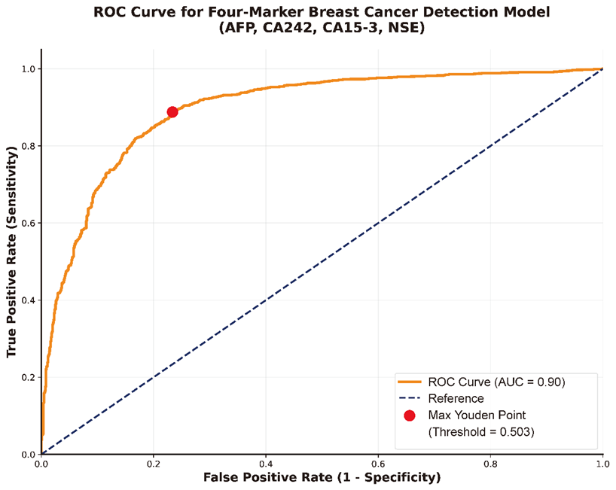
Supplementary Figure 1. Receiver operating characteristic (ROC) curve for the four-marker model with Youden Index point indicated on curve with a red spot.

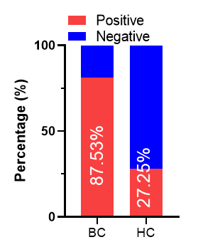
Supplementary Figure 2. Proportion of high-risk individuals identified by the 4-serum biomarker model in breast cancer (BC) patients and healthy controls (HC) within the validation cohort.

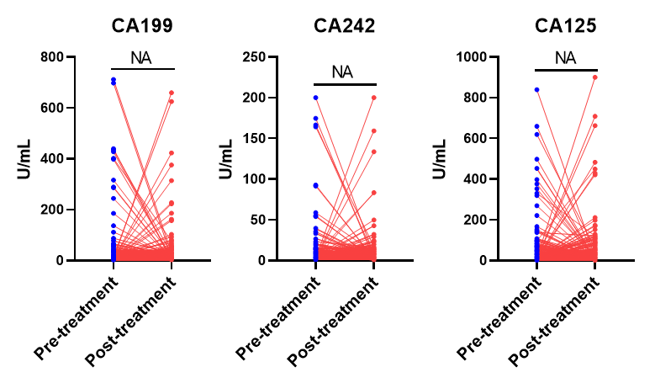
Supplementary Figure 3. Evaluation of the 4-serum biomarker model before and after treatment in 692 breast cancer patients. Comparison of serum levels of CA199, CA242, and CA125 before and after treatment in breast cancer patients (paired t-test).

Supplementary Table S1. Multicollinearity assessment in the 4-marker model

Predictors | Tolerance | Variance Inflation Factor
AFP | 0.845 | 1.184
CA242 | 0.755 | 1.324
CA15-3 | 0.813 | 1.230
NSE | 0.868 | 1.152
Tolerance and variation inflation factors were used to evaluate the multicollinearity of multivariate models

Supplementary Table S2 Serum tumor marker levels in breast cancer patients before and after treatment

Biomarkers | Test time | NED  n = 120 | S/PD  n = 237 | DP/R  n = 335
CEA (ng/mL) | pre-treatment | 2.69 ± 6.66 | 2.64 ± 2.73 | 3.73 ± 10.77
 | post-treatment | 1.64 ± 2.09* | 2.44 ± 7.85 | 4.67 ± 15.48*
AFP (ng/L) | pre-treatment | 2.63 ± 3.36 | 2.69 ± 3.20 | 3.03 ± 6.22
 | post-treatment | 1.96 ± 1.84* | 2.40 ± 3.59* | 4.19 ± 5.00*
CA199 (U/mL) | pre-treatment | 12.34 ± 14.87 | 15.75 ± 40.76 | 18.35 ± 58.41
 | post-treatment | 9.47 ± 7.23** | 15.89 ± 37.42 | 20.67 ± 89.60
CA242 (U/mL) | pre-treatment | 5.19 ± 7.14 | 6.06 ± 4.58 | 7.49 ± 14.76
 | post-treatment | 3.74 ± 2.57* | 5.32 ± 8.55* | 7.83 ± 8.97
CA15-3 (U/mL) | pre-treatment | 19.82 ± 26.91 | 21.48 ± 28.52 | 23.72 ± 8.84
 | post-treatment | 17.52 ± 23.25* | 20.31 ± 26.87* | 34.84 ± 126.68**
CA125 (U/mL) | pre-treatment | 15.46 ± 27.47 | 19.47 ± 54.88 | 25.86 ± 73.62
 | post-treatment | 13.01 ± 20.90* | 18.85 ± 49.75* | 27.42 ± 76.65
FER (µg/L) | pre-treatment | 152.91 ± 152.39 | 156.84 ± 143.67 | 154.20 ± 122.09
 | post-treatment | 112.37 ± 116.86** | 137.97 ± 129.38* | 166.21 ± 155.60*
NSE (ng/mL) | pre-treatment | 4.65 ± 4.08 | 3.77 ± 2.58 | 4.05 ± 9.41
 | post-treatment | 3.24 ± 1.66* | 3.16 ± 1.93* | 4.83 ± 7.91*
NED, no evidence of disease; S/PD, stable/persistent disease; DP/R, disease progression/recurrence. *p<0.05, **p<0.01, ***p<0.001

