Appendices

Appendix 1: Frequency (percentage) of positive responses to the Nordic Questionnaire items (indicating the presence of musculoskeletal disorder symptoms) among office workers
Body Regions | Have you ever been hospitalized because of the trouble? | Have you ever had to change jobs or duties (even temporarily) because of the trouble? | Have you trouble (ache, pain or discomfort) at any time during the last month (4 weeks)? | Have you trouble (ache, pain or discomfort) at any time during the last 12 months? | During the last 12 months have you at any time:
 |  |  |  |  | been prevented from doing your normal work (at home or away from home) because of the trouble? | seen a doctor, physiotherapist, chiropractor or other such person because of the trouble? | taken medication because of the trouble? | taken sick leave from work/studies because of the trouble?
Neck | 5 (5.10) | 3 (3.00) | 58 (58.60) | 42 (42.40) | 14 (14.10) | 19 (19.20) | 19 (19.20) | 5 (5.10)
Shoulders | 0 (0.00) | 0 (0.00) | 34 (34.30) | 25 (25.30) | 7 (7.10) | 12 (12.10) | 12 (12.10) | 2 (2.00)
Upper back | 0 (0.00) | 0 (0.00) | 21 (21.20) | 5 (5.10) | 3 (3.00) | 3 (3.00) | 3 (3.00) | 2 (2.00)
Elbows | 0 (0.00) | 0 (0.00) | 16 (16.20) | 11 (11.10) | 3 (3.00) | 4 (4.00) | 4 (4.00) | 1 (1.00)
Wrists/Hands | 0 (0.00) | 0 (0.00) | 5 (5.10) | 17 (17.20) | 3 (3.00) | 3 (3.00) | 3 (3.00) | 2 (2.00)
Low back | 14 (14.10) | 7 (7.10) | 52 (52.50) | 43 (43.40) | 18 (18.20) | 20 (20.20) | 20 (20.20) | 14 (14.10)
Hips/Thighs | 0 (0.00) | 0 (0.00) | 7 (7.10) | 6 (6.10) | 3 (3.00) | 3 (3.00) | 3 (3.00) | 2 (2.00)
Knees | 8 (8.10) | 3 (3.00) | 37 (37.40) | 27 (27.30) | 8 (8.10) | 18 (18.20) | 18 (18.20) | 8 (8.10)
Ankles/Feet | 0 (0.00) | 0 (0.00) | 15 (15.20) | 11 (11.10) | 4 (4.00) | 7 (7.10) | 7 (7.10) | 1 (1.00)

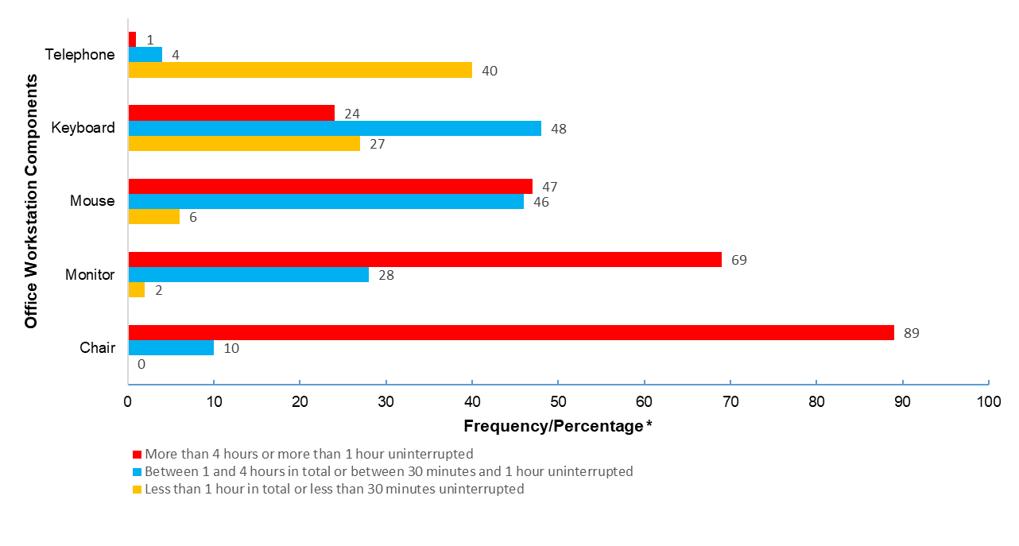
Appendix 2: Frequency/percentage of time duration of use for each component of the office workstation among studied administrative staff (n=99)
*Due to the sample size being close to 100, the frequency is approximately equal to the percentage value

