Supplemental material

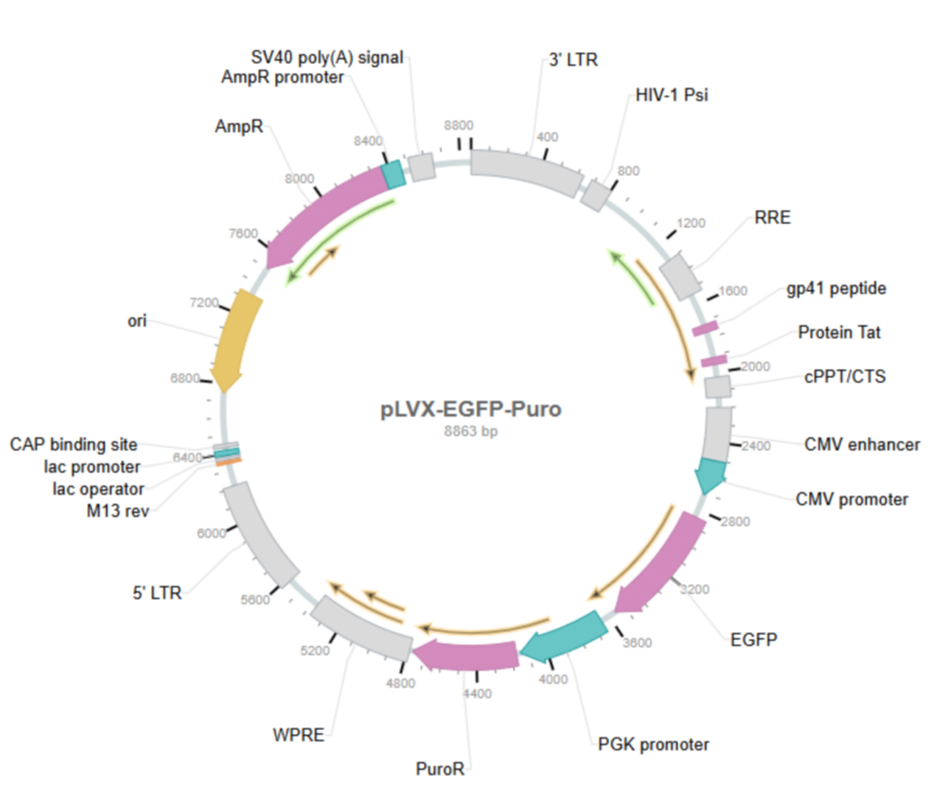

S-Figure1. The lentiviral vector structures used to construct overexpressing AFP.

