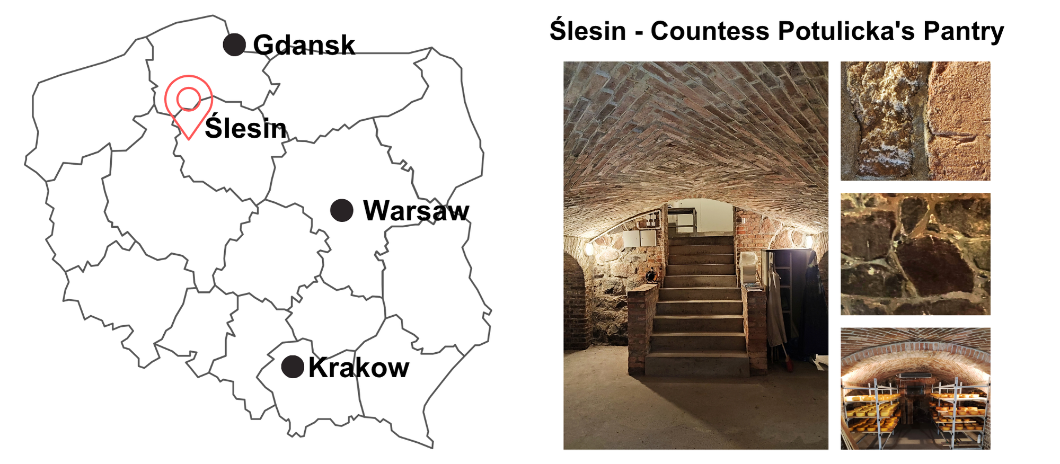
Fig. S1. Geographic location of Ślesin (Kuyavian-Pomeranian Voivodeship, Poland), where the long-ripened cheese cellar of Countess Potulicka’s Pantry is located, and representative photographs of the ripening room interior and close-up views of the stone and brick building materials used in its construction.

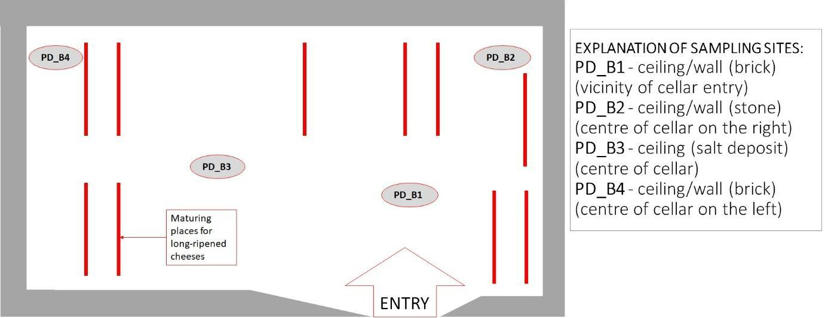
Fig. S2. Scheme of cheese ripening room with location of sampling location (PD_B1, PD_B2, PD_B3, PD_B4)

Table S1. Sequences information from four biofilm samples, analyzed in triplicate.
sample | input | filtered | denoised | merged | non-chimeric
PD_B1_1 | 149955 | 144316 | 141877 | 134009 | 124764
PD_B1_2 | 146986 | 138801 | 136356 | 128007 | 117952
PD_B1_3 | 149493 | 141383 | 139099 | 131223 | 121999
PD_B2_1 | 146585 | 137710 | 133442 | 124182 | 107659
PD_B2_2 | 134525 | 125746 | 121576 | 112960 | 97788
PD_B2_3 | 142752 | 136001 | 135431 | 133970 | 118219
PD_B3_1 | 146093 | 139133 | 138483 | 136780 | 118545
PD_B3_2 | 148452 | 142044 | 141299 | 139508 | 120274
PD_B3_3 | 140385 | 134499 | 133448 | 130783 | 107366
PD_B4_1 | 152988 | 145048 | 143840 | 140656 | 113405
PD_B4_2 | 139908 | 131066 | 129899 | 127118 | 105013
PD_B4_3 | 141521 | 134858 | 129979 | 120769 | 107872

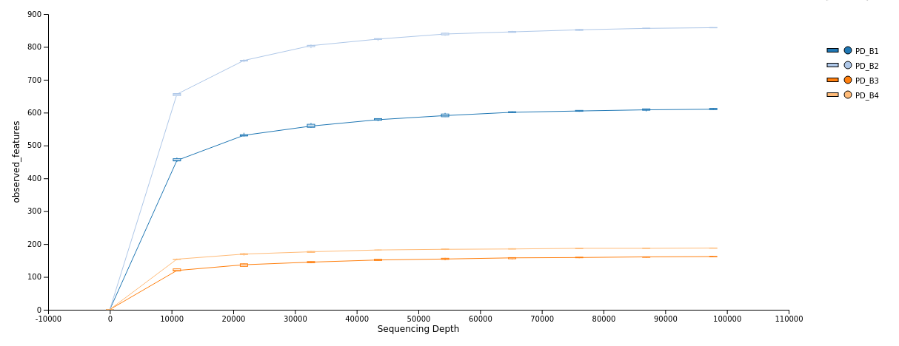
Fig.S3. Rarefaction curves based on 16S rRNA gene sequences (V4–V6 region) from four biofilm samples, analyzed in triplicate.
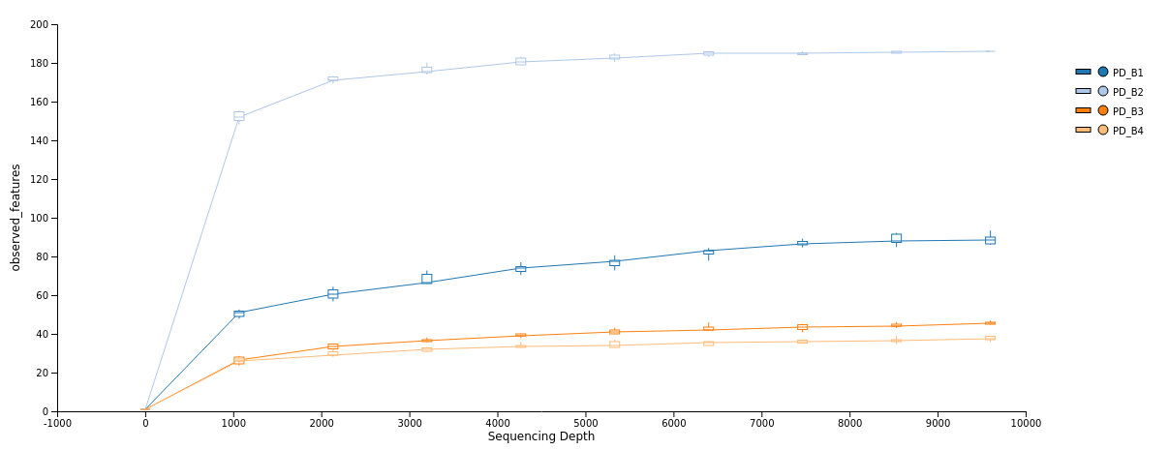
Fig.S4. Rarefaction curves based on ITS region sequences from four biofilm samples, analyzed in triplicate.

Table S2. Relative abundance (%) of bacterial taxa (phylum to genus level) representing the microbial community identified in the biofilm samples (Excel appendix).
Table S3. Relative abundance (%) of fungal taxa (phylum to genus level) representing the microbial community identified in the biofilm samples (Excel appendix).
Table S4. Taxonomy of bacterial and fungal ASVs used for the construction of ecological networks. (Excel appendix).

