Suppl. File 6: This file contains a figure of the motif composition for the sample HG002, the input motifs with corresponding color/letter code, newly detected sequences and a detailed description of how to use the workflow for other VNTRs.
Article title: Analysis of clinically relevant large tandem repeats using nanopore sequencing
Authors: Silvia Madritsch, David Horner, Tamara Löwenstern, Nadja Brait, Vivienne Arnold, Andrea Wenzel, Denisa Weis, Markus Hengstschläger, Franco Laccone
Corresponding Author: Silvia Madritsch (silvia.madritsch@meduniwien.ac.at) Institute of Medical Genetics, Center for Pathobiochemistry and Genetics, Medical University of Vienna, Vienna, Austria
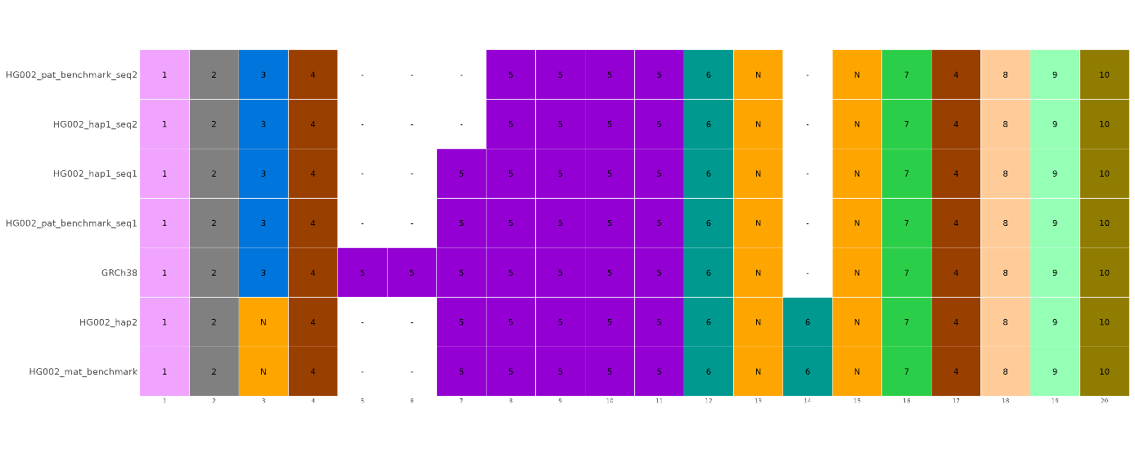
Motif composition of the VNTR in the CEL gene for sample HG002, comparing WGS sequencing analysis, benchmark haplotypes and the reference genome. In the paternal allele of HG002, the CEL VNTR is present twice with differing motif composition. Each row shows the sequence of repeat motifs for a specific dataset (maternal/paternal benchmarks, WGS haplotypes and the GRCh38 reference). Individual repeat motifs are represented by colored boxes. White boxes signify a gap (a missing motif) at that position. The numbers along the horizontal axis (1-20) denote the sequential position of each motif in the VNTR. The actual DNA sequences for each motif type (color and internal number combination) are shown below (the first and last are the boundary sequences) and represent all CEL VNTR sequences shown in Higuchi et al., 2002 publication. Motifs not presented in that publication are indicated in orange with an N.

Input motifs and corresponding color/letter code:
1 TATCTGGCGCTGCCCACAGTGACCGACCAG
2 GAGGCCACCCCTGTGCCCCCCACAGGGGACTCC
3 GAGGCCACTCCCGTGCCCCCCACGGGTGACTCC
4 GAGACCGCCCCCGTGCCGCCCACGGGTGACTCC
5 GGGGCCCCCCCCGTGCCGCCCACGGGTGACTCC
6 GGCGCCCCCCCCGTGCCGCCCACGGGTGACGCC
7 GGGGCCCCCCCCGTGACCCCCACGGGTGACTCC
8 GGGGCCCCCCCTGTGCCCCCCACGGGTGACTCT
9 GAGGCTGCCCCTGTGCCCCCCACAGATGACTCC
10 AAGGAAGCTCAGATGCCTGCAGTCATTAGGTTTTAG
Sequences not provided as input motifs (Higuchi et al., 2002), so called new sequences (N), can be extracted from the new_and_lof_seqs.xlsx output file:
N GGGCCCCCCCCCGTGCCGCCCACGGGTGACTCC hap1_seq1, hap1_seq2, hap2 (Repeat 13), hap2 (Repeat 15)
N GGCGCCCCCCCCGTGCCGCCCACGGGTGACTCC hap1_seq1, hap1_seq2 (Repeat 15)
N GAGGCCACTCCTGTGCCCCCCACGGGTGACTCC hap2 (Repeat 3)

How to use the workflow for other VNTRs:

- Search for known motif sequences for the VNTR (e.g. for CEL, publication Higuchi et al. 2002, DOI: 10.1007/s100380200027, Fig. 1), another option would be to use motifs from VAMOS (https://github.com/ChaissonLab/vamos/archive/refs/tags/vamos-v1.1.0.zip).
- Retrieve start and ending coordinates of your VNTR for your desired reference genome (hg38 or chm13) e.g. by using a genome browser like IGV. Search for the gene and then copy your motif sequence into the Tool “BLAT” (in the Tools tab) and extract the corresponding coordinates. Alternatively one can use the Tool “find Motifs” to produce a visual representation of the matches.
- To establish the boundary sequences, you can use the first and last motif (if they are usually the same in all individuals) or check the sequence before and after the VNTR in a genome browser. You can also plot a reference database (e.g. gnomAD) to retrieve frequencies of known SNPs. Boundary sequences should not contain any common SNPs. The workflow allows a maximum of one mismatch in the boundary sequence to correctly extract the VNTR in your consensus sequences.
- Once the motifs and the boundary sequences have been defined one can create the MOTIFS_FILE needed as input. The first column are the motif sequences, the second column are the assigned characters and the third column are colors in quoted in hexadecimal format (also color names, without quotes, readable by ggplot2 are possible). The file needs to be tab delimited and should be saved in lib directory.
- Get information for other input parameters: Give an approximate number for the average PCR product size (VNTR_ASSEMBLY_SIZE) and for the minimal PCR product size (VNTR_MIN_PRODUCT_SIZE). Both parameters are only relevant in PCR mode (e.g. filtering very small sequences (noise), canu assembly …). Also give the size of one repeat unit (VNTR_REPEAT_SIZE) and the coordinates for your desired reference genome. In WGS-mode the region of VNTR_COORDINATES_HG38 and VNTR_COORDINATES_CHM13, respectively, can be larger, but not excessively so, than the actual VNTR.
- Usage for the CEL VNTR: VNTR_pipeline -i <input_folder containing HG002_CEL_WGS.fastq> -o <output_folder> -r hg38 -p wgs VNTR_BOUNDARY_SEQUENCE_LEFT=TATCTGGCGCTGCCCACAGTGACCGACCAG VNTR_BOUNDARY_SEQUENCE_RIGHT=AAGGAAGCTCAGATGCCTGCAGTCATTAGGTTTTAG VNTR_ASSEMBLY_SIZE=560 VNTR_MIN_PRODUCT_SIZE=200 VNTR_REPEAT_SIZE=33 VNTR_COORDINATES_HG38=chr9:133071168-133071728 VNTR_MOTIFS=motifs_cel_with_char_scheme.txt (VNTR_ALL=Y)
- The VNTR alignment figure (best_trviz_fig.png) is in the *_results folder. The sequence and position of all new sequences is in the motifs_distribution.xlsx file. Other important output files are described in Suppl. File 1.
- For Quality Control, check the output files sequence_distribution.xlsx and the mapping of the uncorrected haplotype assigned reads to the final consensus sequence in the assembly_mapping folder.
By adding the option VNTR_ALL=Y, all assembled variants within the given boundary sequences of one haplotype are visualized.
- For validation, benchmarking and/or reference sequences can be included in the figure output. Therefore copy the *haplotype*best_hit.fasta results and your benchmarking fasta (extracted for the VNTR, change the name of the fasta to *best_hit.fasta) into one folder and start the command again adding the option ALL_FIGURES=Y

