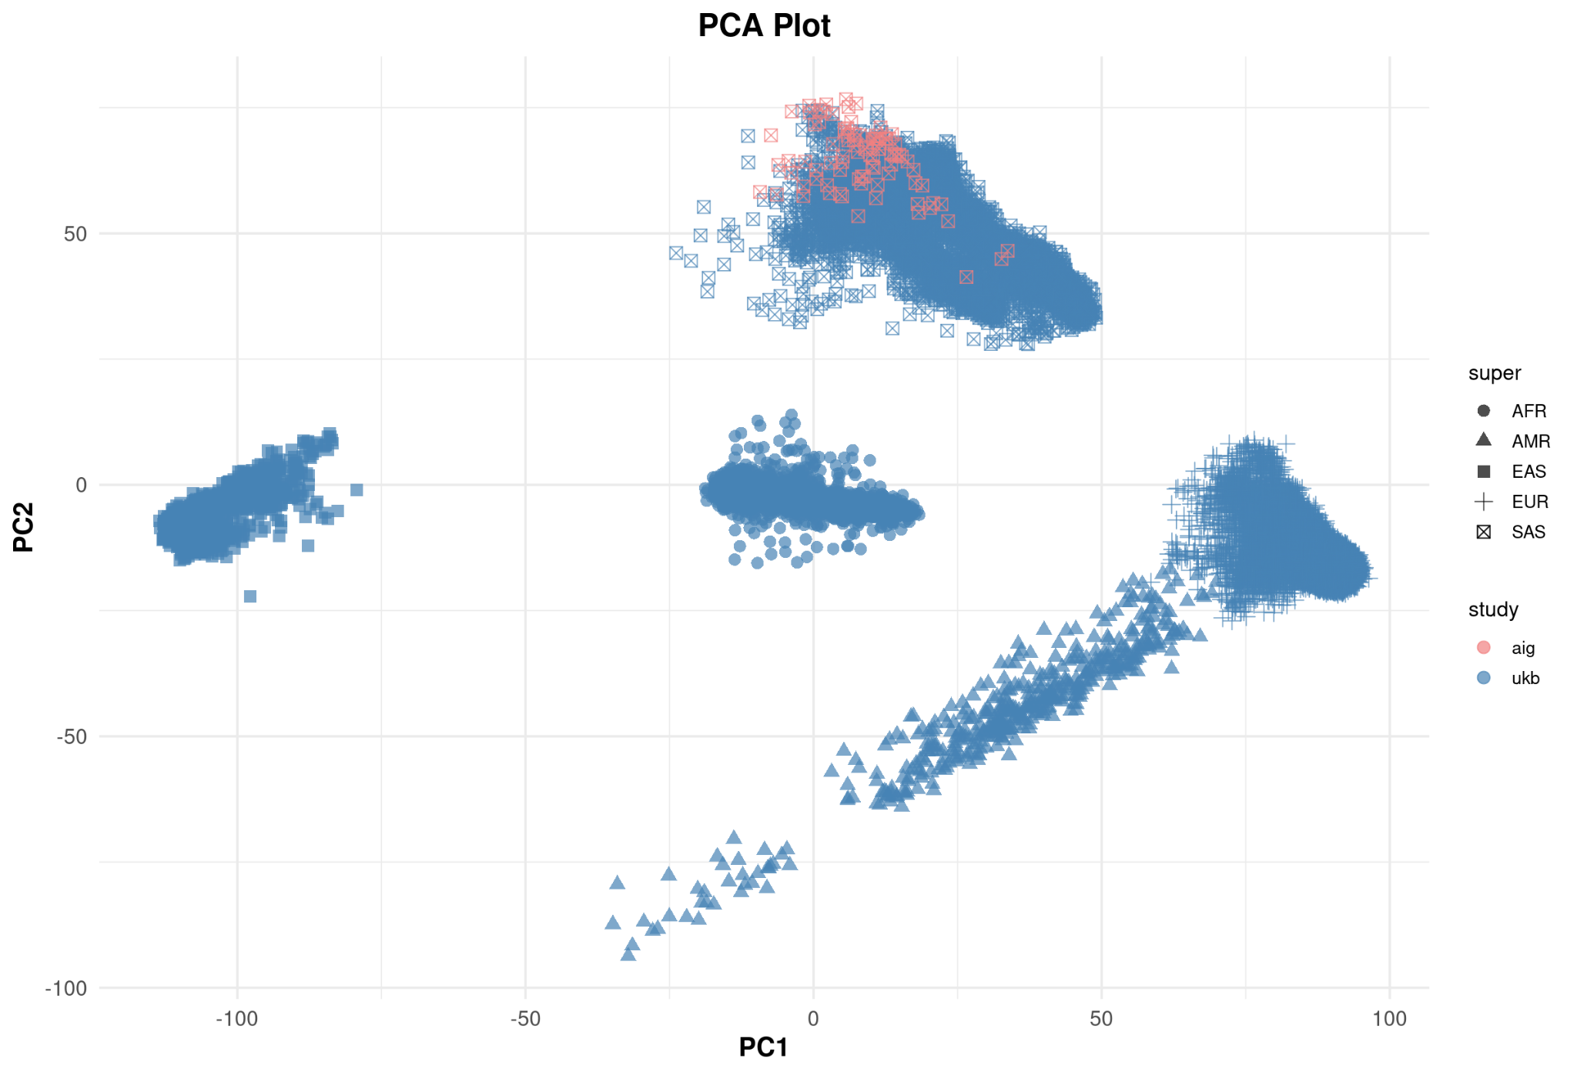
Supplementary figure 1: The principal components analysis of W-AIG and UK Biobank cohort, clustered according to their super populations.
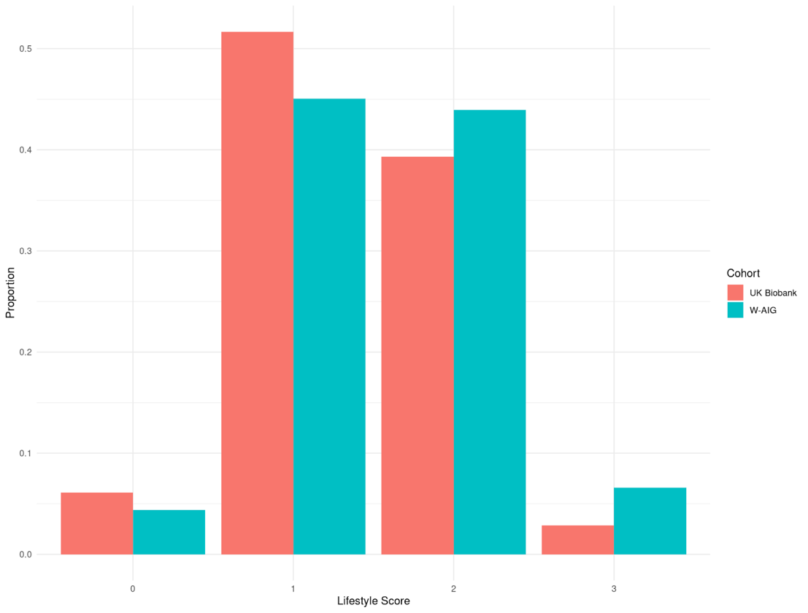
Supplementary figure 2: Distribution of lifestyle score in the UK Biobank and W-AIG cohorts
PRS | Lifestyle | Estimate | 95% CI | P-value | P_FDR | Study
High | Unfavorable | 24.5 | 23.47 – 25.56 | 0.00226 | 0.00897 | AIG
High | Favorable | 3.92 | 3.11 – 4.73 | 0.0921 | 0.19350 | AIG
Low | Unfavorable | 2.78 | 1.99 – 3.57 | 0.196 | 0.281 | AIG
Low | Favorable | Reference |  |  |  | AIG
High | Unfavorable | 3.01 | 2.92 – 3.11 | 4.20E-33 | 8.21e-33 | UK Biobank
High | Favorable | 2.13 | 2.00 – 2.25 | 1.74E-09 | 2.32e-09 | UK Biobank
Low | Unfavorable | 1.19 | 1.12 – 1.26 | 7.42E-02 | 7.42e-02 | UK Biobank
Low | Favorable | Reference |  |  |  | UK Biobank
Supplementary table 1: Logistic Regression Analysis of Polygenic Risk Score (PRS) and Lifestyle on Obesity Risk in AIG and UK Biobank Cohorts

PRS | Lifestyle | Age | Odds ratio | 95% CI | P-value | P_FDR
Low | Favorable | <=50 | 1.26 | 1.01 – 1.51 | 3.52e-01 | 0.4113
Low | Favorable | >60 | Reference
Low | Unfavorable | <=50 | 1.40 | 1.16 – 1.64 | 1.56e-01 | 0.2184
Low | Unfavorable | >60 | 1.12 | 0.96 – 1.28 | 9.00e-01 | 0.900
High | Favorable | <=50 | 1.96 | 1.70 – 2.22 | 9.62e-03 | 0.02060
High | Favorable | >60 | 1.60 | 1.41 – 1.79 | 1.18e-02 | 0.02065
High | Unfavorable | <=50 | 3.17 | 2.93 – 3.41 | 1.38e-06 | 4.83e-06
High | Unfavorable | >60 | 2.48 | 2.31 – 2.65 | 9.80e-08 | 6.86e-07

Supplementary table 2: Age-Stratified Joint Associations of Polygenic Risk Score and Lifestyle with Obesity in the UK Biobank

Polygenic Risk Score (PRS) | Lifestyle | Mean BMI | Standard Deviation (SD) | Study Cohort
High | Favorable | 28.7 | 5.45 | AIG
High | Unfavorable | 33.4 | 4.45 | AIG
Low | Favorable | 23.2 | 3.2 | AIG
Low | Unfavorable | 28.6 | 5.75 | AIG
High | Favorable | 28.8 | 4.97 | UK Biobank
High | Unfavorable | 29.5 | 5.05 | UK Biobank
Low | Favorable | 26.4 | 3.88 | UK Biobank
Low | Unfavorable | 26.7 | 4.08 | UK Biobank

Supplementary table 3: Interaction of Polygenic Risk Score (PRS) and Lifestyle on Mean Body Mass Index (BMI) Across AIG and UK Biobank Cohorts.

