Supplementary Material:
Superficial Temporal Artery and Branches in Thai Cadavers: Anatomical Variations, Ethnic Considerations, and Filler Injection Safety
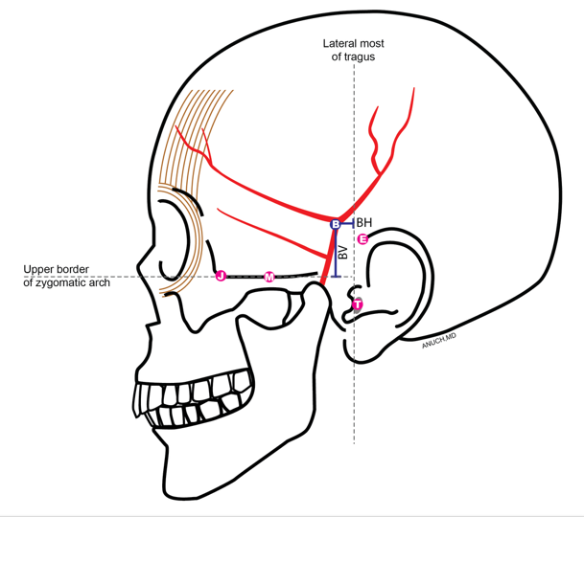
J point (J) = jugale, M point (M) = The midpoint of the upper zygomatic arch, E point (E) = Crus of the helix , T point (T) = Lateral most of the tragus.
Plane BV, defined as the vertical distance from the upper border of the zygomatic arch, and Plane BH, defined as the horizontal distance from the lateral border of the tragus.

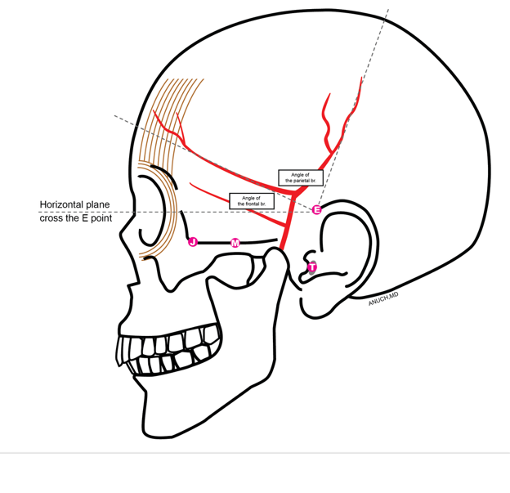The angles of the frontal and parietal branches relative to Plane BH.
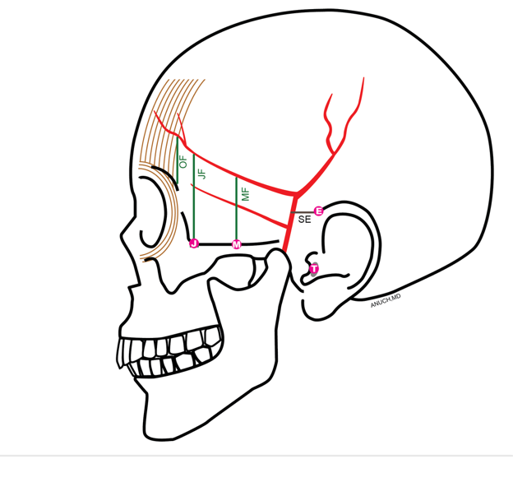
MF = Mid-upper border of zygomatic arch to the frontal branch
JF = Jugale to frontal branch
OF = Lateral of the orbital brim to frontal branch

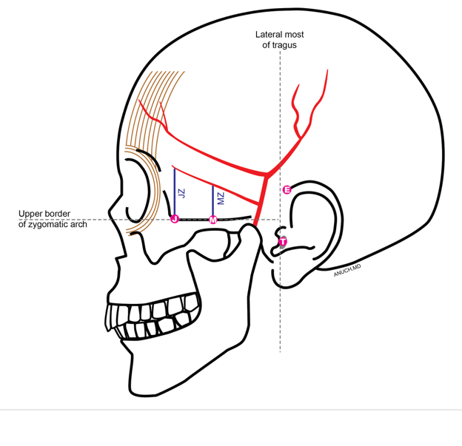
Mz = Mid-upper border of zygomatic arch to the ZOA branch
JZ = Mid-upper border of zygomatic arch to the ZOA branch

 |  | Sex
Variable | Overall (N = 20)¹ | Male (n = 14)¹ | Female (n = 6)¹ | P-value²
Age at death (y) | 76 ± 16 [39, 97] | 72 ± 17 [39, 93] | 85 ± 12 [71, 97] | 0.074
Superficial temporal artery (mm) | 3.29 ± 1.08 [2.09, 6.36] | 3.40 ± 1.26 [2.09, 6.36] | 3.00 ± 0.33 [2.46, 3.36] | 0.299
Frontal branch (mm) | 2.59 ± 0.78 [1.03, 4.11] | 2.61 ± 0.90 [1.03, 4.11] | 2.52 ± 0.43 [1.89, 3.12] | 0.756
Parietal branch | 2.51 ± 1.09 [1.09, 5.71] | 2.84 ± 1.08 [1.61, 5.71] | 1.73 ± 0.67 [1.09, 2.89] | 0.013
Zygomatico-orbital branch | 1.24 ± 0.46 [0.58, 2.25] | 1.27 ± 0.55 [0.58, 2.25] | 1.16 ± 0.24 [0.92, 1.55] | 0.552
SE | 18.0 ± 4.4 [9.5, 29.0] | 17.1 ± 3.6 [9.5, 22.1] | 21.7 ± 6.3 [17.8, 29.0] | 0.340
BV | 30 ± 11 [7, 44] | 31 ± 8 [14, 40] | 26 ± 17 [7, 44] | 0.553
BH | 22.4 ± 6.6 [11.7, 37.2] | 21.7 ± 5.5 [13.4, 31.8] | 24.2 ± 9.6 [11.7, 37.2] | 0.602
MF | 35.7 ± 7.5 [25.9, 47.0] | 37.6 ± 6.7 [27.4, 46.7] | 31.2 ± 7.9 [25.9, 47.0] | 0.116
JF | 43.9 ± 6.3 [34.1, 58.3] | 44.3 ± 7.2 [34.1, 58.3] | 43.0 ± 4.0 [37.6, 48.0] | 0.628
OF | 38 ± 16 [14, 77] | 34 ± 13 [14, 56] | 47 ± 19 [26, 77] | 0.173
MZ | 14.3 ± 7.6 [1.3, 26.2] | 14.7 ± 8.1 [1.3, 25.5] | 13.5 ± 7.2 [7.1, 26.2] | 0.770
JZ | 19 ± 9 [6, 35] | 19 ± 12 [6, 35] | 20 ± 5 [17, 28] | 0.821
STAL | 34 ± 15 [7, 72] | 37 ± 14 [17, 72] | 28 ± 15 [7, 44] | 0.321
F angle | 21 ± 10 [0, 40] | 24 ± 10 [7, 40] | 16 ± 9 [0, 25] | 0.119
P angle | 70 ± 16 [45, 104] | 73 ± 16 [48, 104] | 60 ± 12 [45, 75] | 0.067
Bifurcation Type |  |  |  | 0.521
a | 18 (90%) | 13 (93%) | 5 (83%)
b | 1 (5.0%) | 0 (0%) | 1 (17%)
c | 1 (5.0%) | 1 (7.1%) | 0 (0%)
ZOA number | 19 (95%) | 13 (93%) | 6 (100%) | 1.00
¹Mean ± SD [Min, Max]; n (%)
²Welch Two Sample t-test; Fisher's exact test

