Appendix
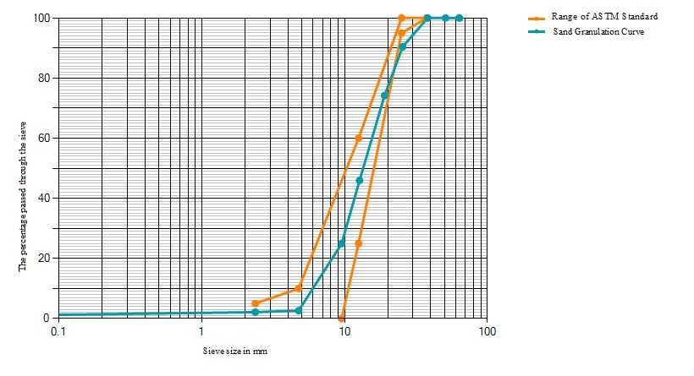
S.F.1. Sand granulation curve – comparison of the sand's particle size distribution with ASTM standard limits for concrete suitability
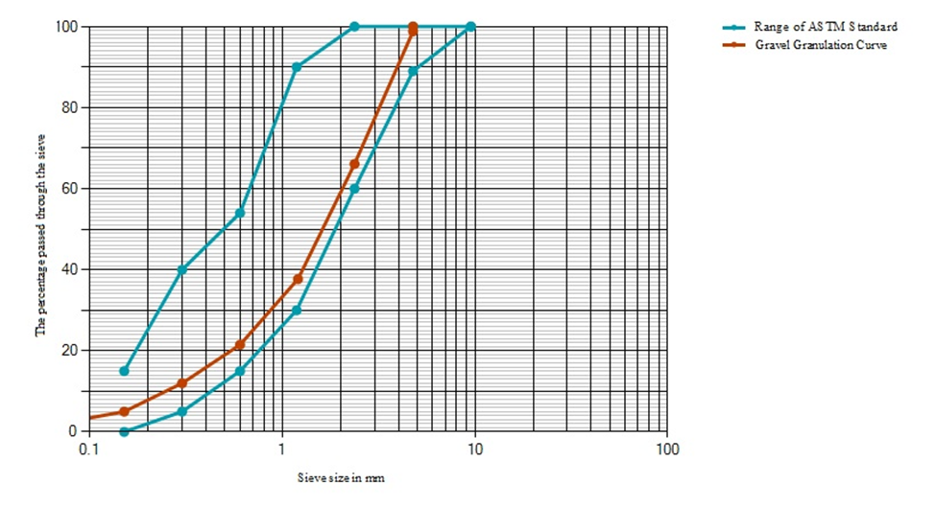
S.F.2. Gravel granulation curve – comparison of the gravel's particle size distribution with ASTM standard limits, indicating compliance for suitability in concrete production

