Application of poly(acrylamide/styrenesulfonic acid) hydrogel as highly effective adsorbent in recovery and reuse of chromium
Abdalla M. Khedr, Ashraf A. Lotfalla(✉), Kazuhiro Hara, Satoru Yoshiokaand Mohamed Gaber
Supplementary materials
Table S1 shows the amount of Cr(III) adsorbed after each time interval for each prepared poly(AAm/Sty) hydrogel
and the molar ratios of each monomer with 0.133wt% crosslinker
 | Total Molar Conc. | AAm%  (mol%)  Sty%  (mol%) |  | Molar Ratio  (AAm:SA)M | Gel | Time(hours)
 |  |  |  |  |  | 0.17 | 0.33 | 0.5 | 1 | 2 | 3 | 4 | 5 | 24
AdsorbedCr(III) (mg/g) | 0.7M | 86 | 14 | 0.6:0.1 | G1 | 2.4 | 1.70 | 1.69 | 2.10 | 2.45 | 2.33 | 2.52 | 2.48 | 2.35
AdsorbedCr(III) (mg/g) | 0.7M | 71 | 29 | 0.5:0.2 | G2 | 1.79 | 2.21 | 2.54 | 2.16 | 2.25 | 2.43 | 2.42 | 2.30 | 2.88
AdsorbedCr(III) (mg/g) | 0.7M | 57 | 43 | 0.4:0.3 | G3 | 0.90 | 133 | 1.40 | 1.81 | 3.14 | 3.27 | 3.21 | 3.11 | 3.27
AdsorbedCr(III) (mg/g) | 1.4M | 85.7 | 14.3 | 1.2:0.2 | G4 | 1.83 | 1.90 | 1.85 | 1.43 | 2.28 | 1.98 | 2.54 | 2.46 | 2.68
AdsorbedCr(III) (mg/g) | 1.4M | 71.7 | 28.6 | 1.0:0.4 | G5 | 1.85 | 1.96 | 2.03 | 1.59 | 2.06 | 2.38 | 2.14 | 2.42 | 2.69
AdsorbedCr(III) (mg/g) |  | 57 | 43 | 0.8:0.6 | G6 | 1.65 | 1.81 | 1.56 | 1.80 | 1.82 | 2.40 | 2.53 | 2.32 | 2.70
AdsorbedCr(III) (mg/g) | 2.1M | 85.7 | 14.3 | 1.8:0.3 | G7 | 1.79 | 1.60 | 2.06 | 1.88 | 1.86 | 2.43 | 2.53 | 2.30 | 2.18
AdsorbedCr(III) (mg/g) | 2.1M | 71.4 | 28.6 | 1.5:0.6 | G8 | 1.33 | 1.89 | 1.73 | 1.45 | 2.13 | 2.03 | 2.39 | 2.19 | 2.25
AdsorbedCr(III) (mg/g) | 2.1M | 57 | 43 | 1.2:0.9 | G9 | 1.43 | 1.73 | 1.75 | 1.93 | 1.66 | 2.15 | 2.21 | 2.41 | 2.62
AdsorbedCr(III) (mg/g) | 2.8M | 85.7 | 14.3 | 2.4:0.4 | G10 | 1.49 | 1.41 | 1.81 | 1.85 | 1.74 | 2.38 | 2.19 | 2.40 | 2.50
AdsorbedCr(III) (mg/g) | 2.8M | 71.4 | 28.6 | 2.0:0.8 | G11 | 1.60 | 1.67 | 1.73 | 1.99 | 2.13 | 2.24 | 2.42 | 2.51 | 2.59
AdsorbedCr(III) (mg/g) | 2.8M | 57 | 43 | 1.6:1.2 | G12 | 1.66 | 1.68 | 1.66 | 1.74 | 2.00 | 2.14 | 2.30 | 2.39 | 2.83

Table S2 The important assigned bands in the FTIR spectra of the monomers used (AAm, Sty, and MBA), poly(AAm/Sty) hydrogels (G1–G12) and Cr-poly(AAm/Sty) metal complex (CG1–CG12)
Compound | Wavenumber cm⁻¹
Compound | ʋ _{NH2} | ʋ _{NH} | ʋ _{C = C} | ʋ _{C = O} | ʋ _{CH2, CH} | ʋ _{C-SO3} | ʋ _{S = O} | ʋ _{(C -C)Ar} | ʋ _{Aromatic skeletal} | ʋ _{M → O}
AAm | 3351 | --- | 3107 | 1675 | --- | --- | --- | --- | --- | ---
Sty | --- | --- | 3087 | --- | --- | 690 | 1188,1132 | 1630 | 1400 | ---
MBA | --- | 3308 | 3101 | 1660 | 2956 | --- | --- | --- | --- | ---
G1 | 3440 | 3203 | --- | 1668 | 2939,2862 | 682 | 1197,1120 | 1602 | 1413 | ---
CG1 | 3433 | 3190 | --- | 1668 | 2935,2796 | 622 | 1195,1122 | 1608 | 1427 | 522
G2 | 3440 | 3192 | --- | 1668 | 2927,2856 | 682 | 1195,1120 | 1606 | 1412 | ---
CG2 | 3421 | 3195 | --- | 1670 | 3933,2796 | 619 | 1191,1118 | 1606 | 1421 | 526
G3 | 3438 | 3200 | --- | 1668 | 2937,2860 | 688 | 1195,1126 | 1606 | 1413 | ---
CG3 | 3427 | 3197 | --- | 1668 | 2947,2794 | 611 | 1186,1120 | 1610 | 1425 | 524
G4 | 3440 | 3194 | --- | 1668 | 2931,2854 | 688 | 1193,1126 | 1602 | 1409 | ---
CG4 | 3433 | 3197 | --- | 1666 | 2941,2790 | 628 | 1184,1122 | 1604 | 1425 | 518
G5 | 3446 | 3200 | --- | 1668 | 2931,2866 | 684 | 1195,1124 | 1608 | 1411 | ---
CG5 | 3437 | 3195 | --- | 1670 | 2930,2781 | 617 | 1184,1118 | 1604 | 1423 | 528
G6 | 3438 | 3213 | --- | 1668 | 2929,2858 | 682 | 1195,1122 | 1602 | 1414 | ---
CG6 | 3429 | 3197 | --- | 1668 | 2937,2783 | 611 | 1195,1114 | 1602 | 1421 | 522
G7 | 3435 | 3201 | --- | 1670 | 2933,2860 | 682 | 1193,1128 | 1608 | 1409 | ---
CG7 | 3435 | 3195 | --- | 1670 | 2931,2796 | 621 | 1193,1120 | 1606 | 1423 | 524
G8 | 3442 | 3203 | --- | 1668 | 2929,2858 | 688 | 1195,1122 | 1602 | 1413 | ---
CG8 | 3431 | 3190 | --- | 1668 | 2931,2798 | 617 | 1197,1116 | 1608 | 1421 | 528
G9 | 3448 | 3201 | --- | 1670 | 2925,2862 | 684 | 1197,1120 | 1604 | 1413 | ---
CG9 | 3427 | 3190 | --- | 1668 | 2935,2788 | 615 | 1195,1116 | 1608 | 1423 | 526
G10 | 3429 | 3194 | --- | 1670 | 2933,2862 | 688 | 1190,1118 | 1612 | 1413 | ---
CG10 | 3440 | 3190 | --- | 1668 | 2937,2794 | 624 | 1190,1116 | 1606 | 1423 | 520
G11 | 3431 | 3195 | --- | 1670 | 2937,2860 | 682 | 1199,1128 | 1606 | 1409 | ---
CG11 | 3427 | 3195 | --- | 1669 | 2935,2780 | 615 | 1193,1120 | 1610 | 1425 | 524
G12 | 3440 | 3200 | --- | 1670 | 2931,2864 | 686 | 1199,1124 | 1604 | 1411 | ---
CG12 | 3437 | 3190 | --- | 1668 | 2935,2790 | 609 | 1195,1124 | 1608 | 1423 | 526

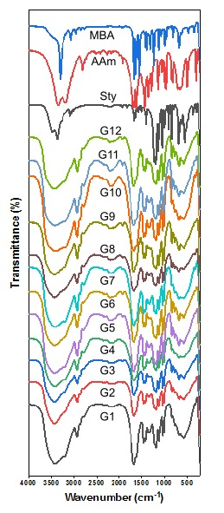
Fig. S1. FTIR spectra for monomers (AAm, MBA, Sty) and synthesized hydrogels (G1-G12)
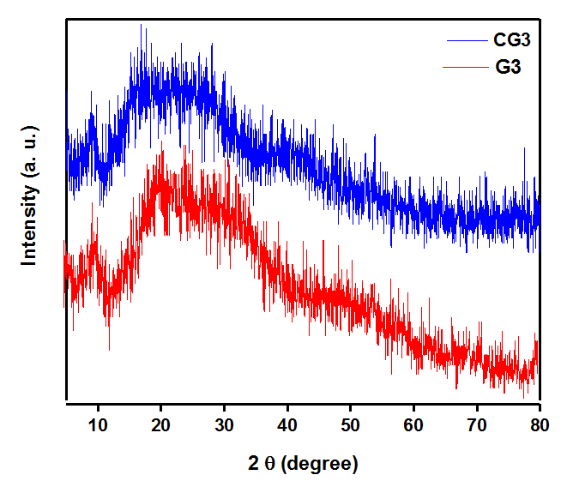
Fig. S2. XRD diffraction pattern of hydrogel (G3) and Cr(III)-hydrogel complex (CG3)

