Supplementary data
Figure S1. Body weight(g) of rats in both groups after the DHEA or sesame oil treatment.
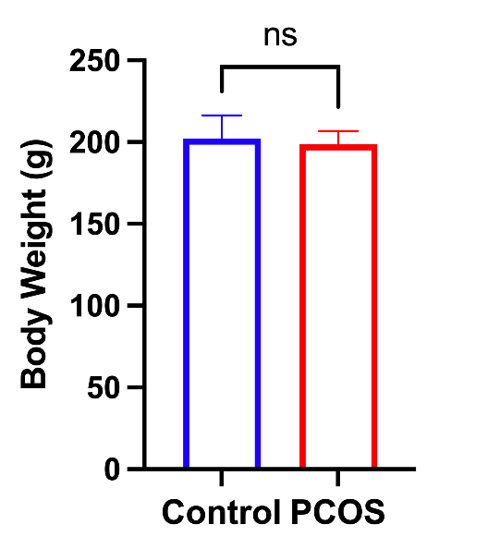

Figure S2. Successful establishment of PCOS rat models induced by subcutaneous DHEA injection
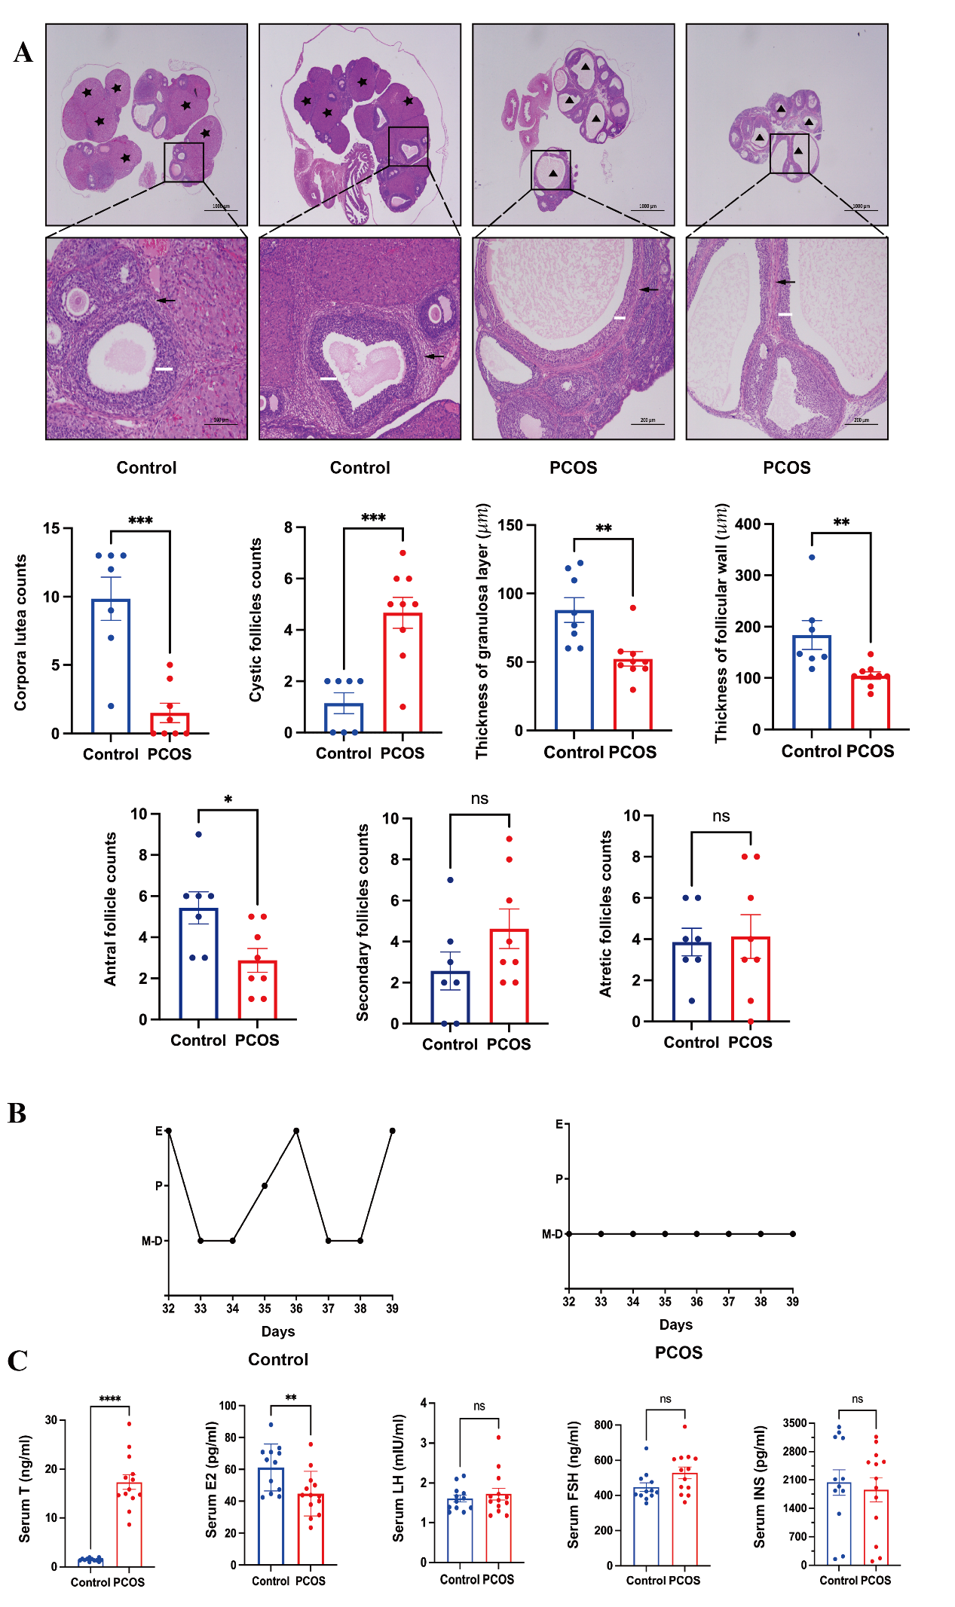
(a) Hematoxylin and eosin (H&E) staining of rat ovaries from Control and PCOS group. Measurement of average number of cystic follicles/corpora lute and the thickness of granulosa cell layer/ theca cell layer. Black asterisk indicates corpora lutea. Black triangle indicates cystic follicles. White line shows the granulosa cell layer thickness, Black arrow shows the theca cell layer thickness. Scale bar, 1000μm, 200μm, 100μm.
(b) The stage of estrous cyclicity determined by microscopic analysis of the predominant cell type in vaginal smears. P, pro-estrus; E, estrus; M, metestrus; D, diestrus.
(c) Serum levels of follicle stimulating hormone (FSH), luteinizing hormone (LH), testosterone (T), insulin (INS) and estradiol (E2). All data are presented as the mean ± SEM. *p < 0.05, **p < 0.01, ***p < 0.001, ****p < 0.0001, NS, nonsignificant. Student's t test.

Figure S3.Venn diagram illustrating the quantity and distribution of Amplicon Sequence Variants (ASVs) in the gut microbiota of both groups.
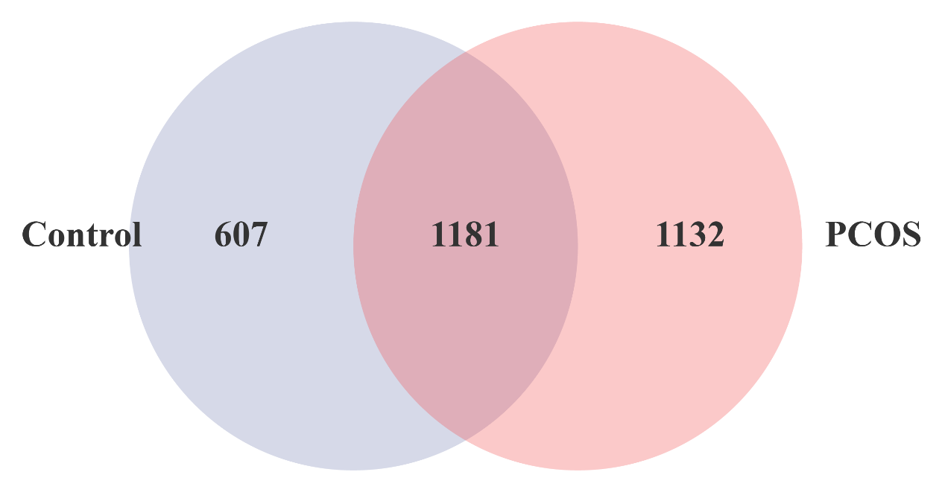The bubble representing the number of ASVs in the gut microbiota from the Control group is highlighted in purple on the left (n=1688), while the bubble representing the number of ASVs from the PCOS group are represented in pink on the right (n=2313). The overlapping portion signifies the number of common ASVs shared by both groups (in the middle, n=1181).

Figure S4. Heatmaps depicting the correlations between metabolites in the fecal, cecum, serum, and ovarian metabolomes for both the PCOS and Control groups
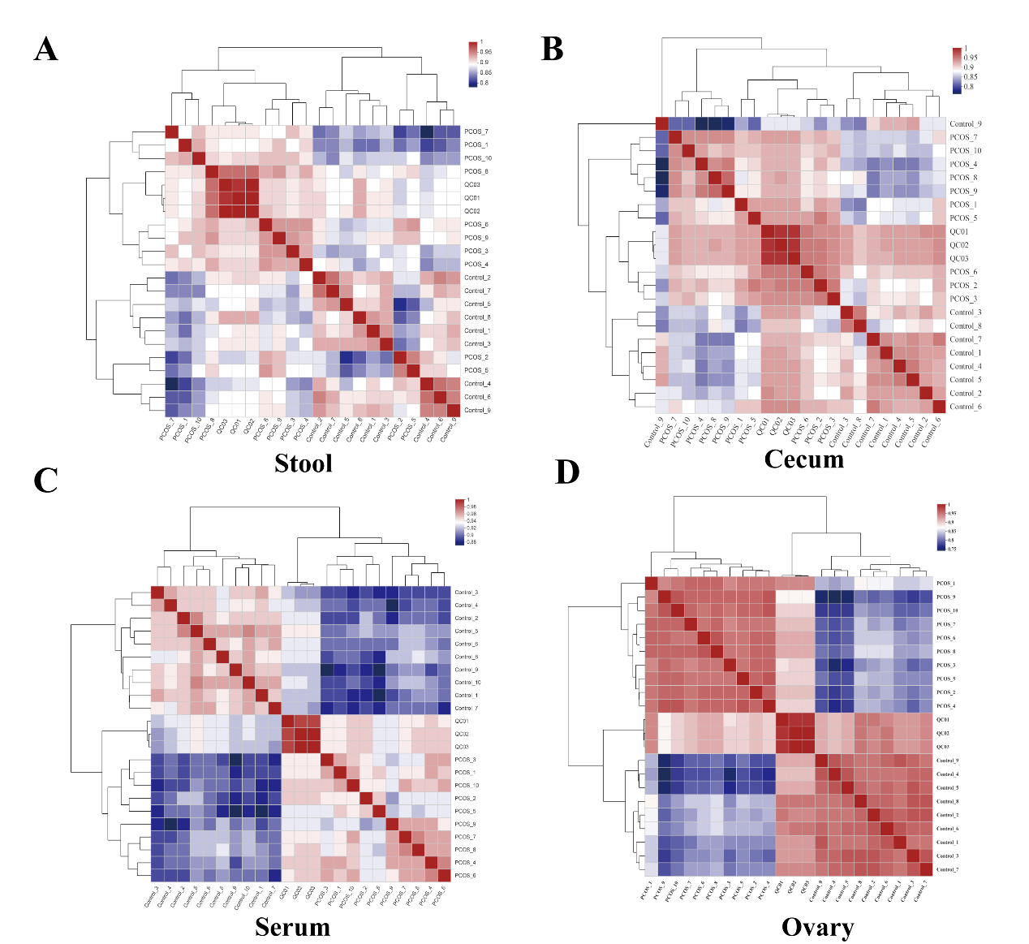
Correlation heatmaps between metabolites in the fecal (a), cecum (b), serum (c), and ovarian (d) metabolomes for both the PCOS and Control groups. Each square represents the Spearman correlation coefficient between the metabolic phenotypes of the corresponding column and row. The ordering of metabolic phenotypes is based on hierarchical clustering, utilizing the distance function defined as 1-correlation. For cluster analysis, the dissimilarity index is applied to arrange different seed phenotypes according to their similarity. Self-correlations are presented in red.

Figure S5. Distinct disparities in fecal, cecum, serum, and ovarian metabolomes between the PCOS and control groups.
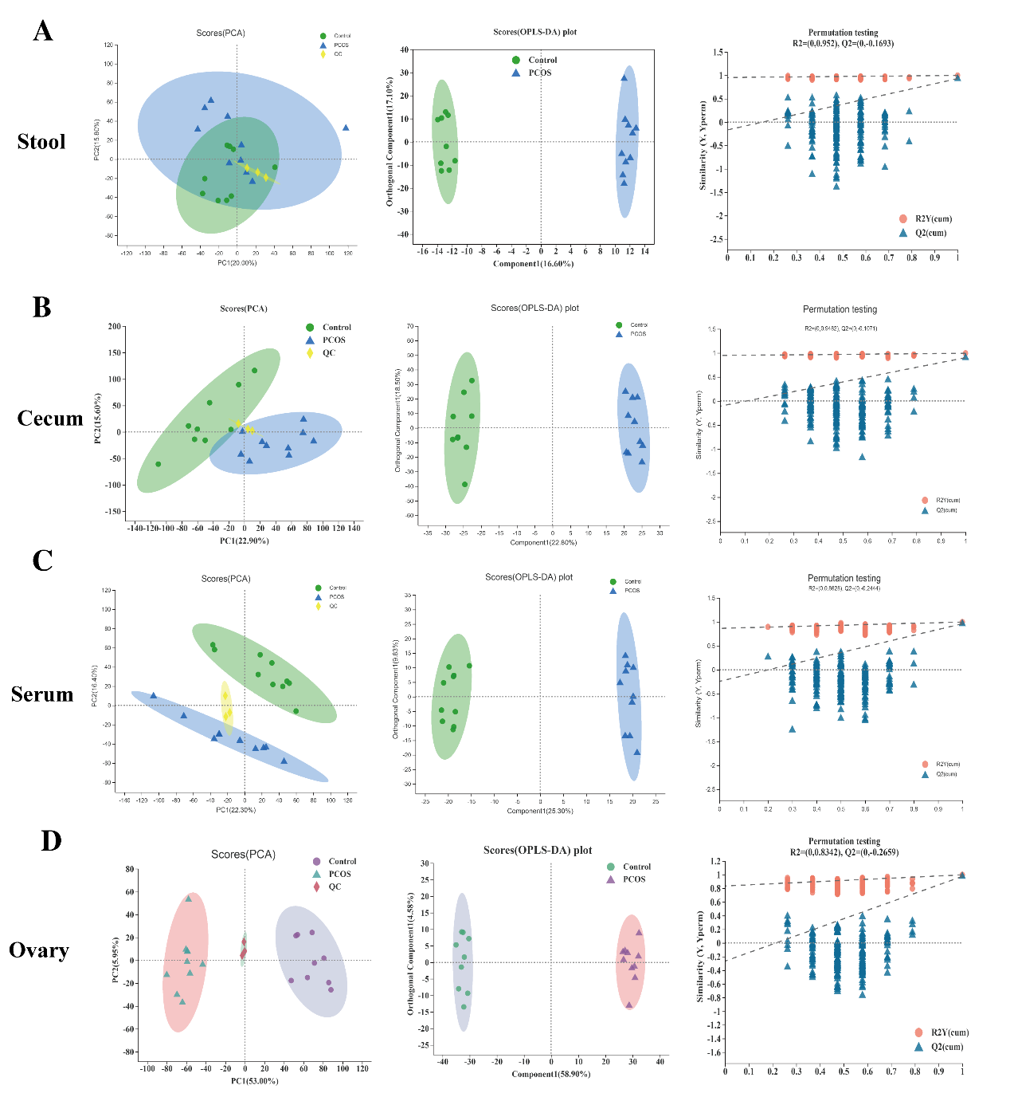
Principal component analysis (PCA, left), Orthogonal partial least-squares discriminant analysis (OPLS-DA, middle), and Permutation testing (right) of the fecal (A), cecum (B), serum (C), and ovarian (D) metabolomes in the PCOS and Control groups.
Figure S6. Pearson correlation heatmap of ovarian, serum, cecum, and fecal differential metabolites and levels of serum PCOS-related hormones
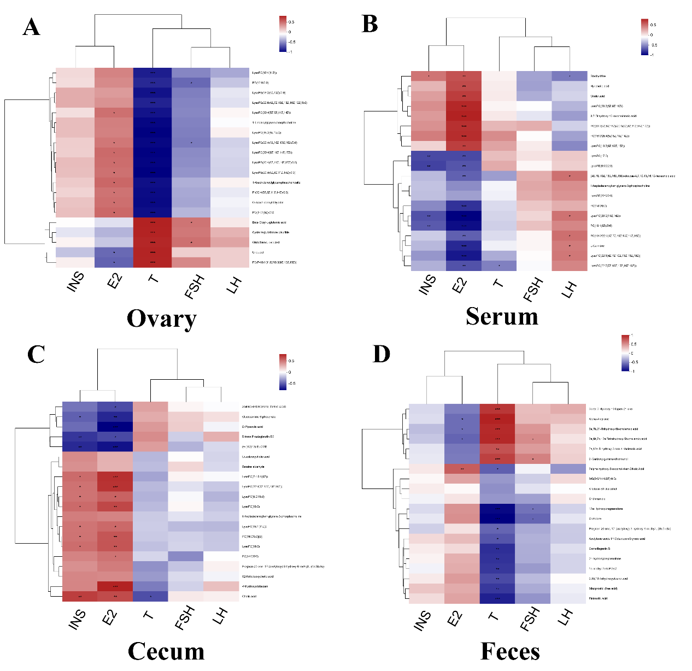
A. Pearson correlation heatmap of ovarian differential metabolites and levels of INS, E₂, T, FSH and LH..
B. Pearson correlation heatmap of serum differential metabolites and levels of INS, E₂, T, FSH and LH.
C. Pearson correlation heatmap of cecum differential metabolites and levels of INS, E₂, T, FSH and LH.
D. Pearson correlation heatmap of fecal differential metabolites and levels of INS, E₂, T, FSH and LH.
Abbreviations: INS, insulin; E_{2,} estrogen; T, testosterone; FSH, follicle stimulating hormone; LH luteinizing hormone

Table S1. Sequences of primers used in this study.
Primers (Rat) | Sequences (5＇→3＇)
Occludin | Forward CGGCAAAGTGAATGGCAAGA
 | Reverse TCATCCACGGACAAGGTCAGAG
TJP-1 | Forward CGGGCTACCTTATTGAATGTCC
TJP-1 | Reverse GAGCGAACTGAATGGTCTGATG
CLDN2 | Forward CTCGCTGGCCTGCATTATCT  Reverse AAAGACTCCACCCACTACAGCCA
CLDN3 | Forward TATCCTACTGGCAGCCTTCGG  Reverse CACGTACAACCCAGTTCCCATCT
GAPDH | Forward CTGGAGAAACCTGCCAAGTATG  Reverse GGTGGAAGAATGGGAGTTGCT
Cyp4f17 | Forward ATGACAACTACTGCCGTCTCCG
Cyp4f17 | ReverseGGTAGAAGATCCCAATCCAACAGAG
Cyp4b1 | Forward CCTGAGCACCAGCAGCTATGT
Cyp4b1 | ReverseACGAAGGTGACTGGCTTGTTGA
Cyp17a1 | Forward GCTAATCTGTCAGGAAGCCAAGT
Cyp17a1 | ReverseAAAGGTCTTTATGGCGGTCAGTT
Star | Forward TGGCTGGAAGTCCCTCAAAG
Star | ReverseGGCTGGCGAACTCTATCTGG
3β-HSD | ForwardCCTTCGTCTACAGCAGCTCAACA
3β-HSD | ReverseCACTACCTTCTCGGCCATCCTTA
β-actin | ForwardTGCTATGTTGCCCTAGACTTCG
β-actin | ReverseGTTGGCATAGAGGTCTTTACGG

