Supplementary Material
Supplementary Fig.1: The flow diagram of matching
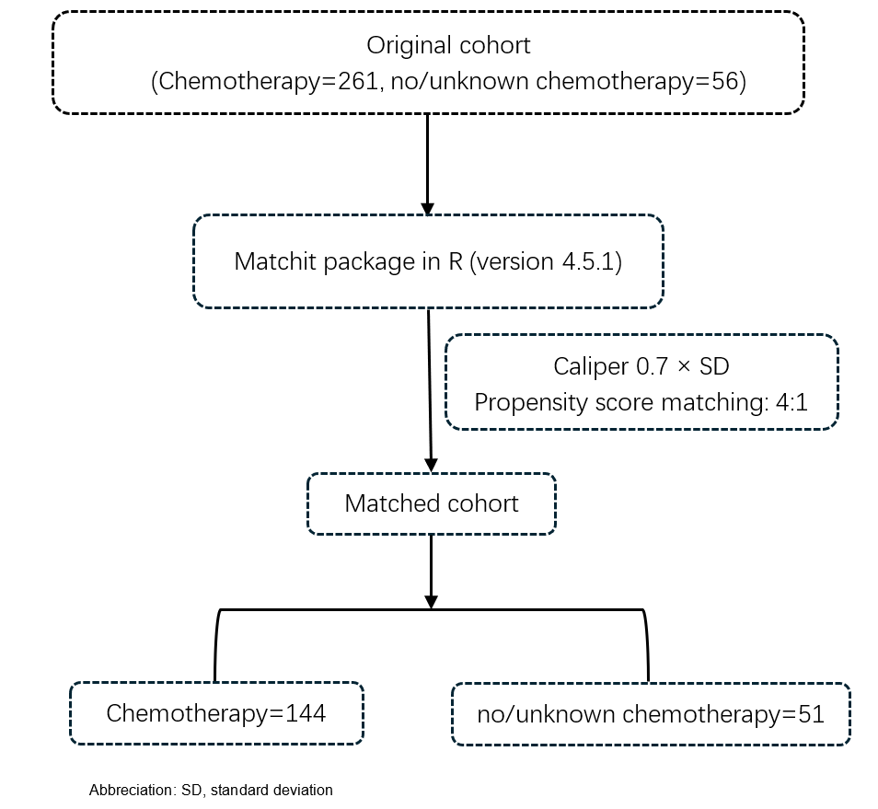

Supplementary Fig.2: The distribution of propensity scores before and after matching
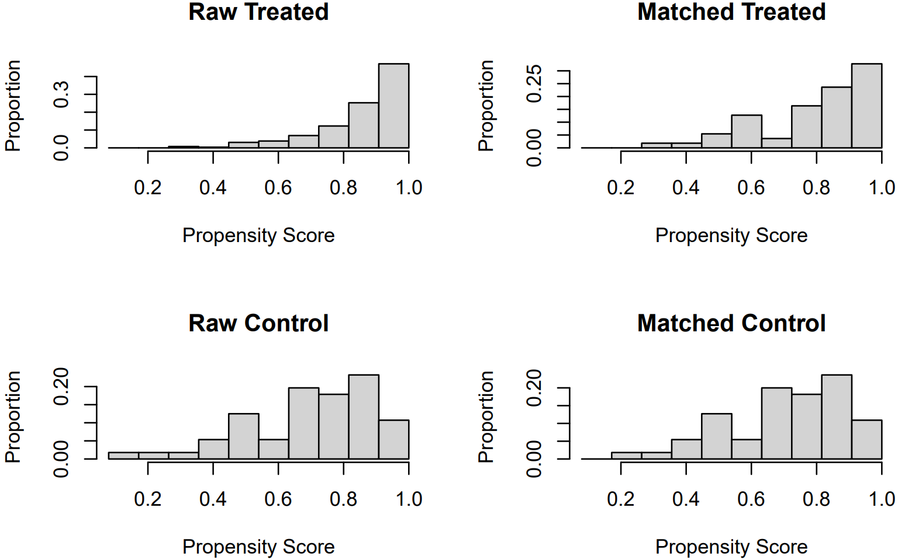
Supplementary Table 1: Detailed scores of prognostic factors in the OS nomograms
Characteristic | OS nomogram | Characteristic | OS nomogram
Stage |  | Radiotherapy
I-II | 35 | No/Unknown | 4
Unknown | 52 | Yes | 35
III-IV | 100 | Chemotherapy
Marital status |  | Yes | 23
Unknown | 0 | No/Unknown | 35
Single | 18 | Age
Married | 19 | <15 | 35
DSW | 35 | 15-42 | 49
 |  | >42 | 80
Abbreciation DSW, divorced&Separated&Widowed

