Supplementary materials
Table S1 Coefficient of determination (R²), root mean square error (RMSE), and percentage bias (BIAS) of model output vs. calibration (calibration phase: 2008-2014, validation phase: 2015-2019)
 | Calibration(2008-2014) | Validation(2015-2019)
Variable | R² | RMSE | BIAS
Temperture(℃) | 0.98|0.97 | 2.19|2.25 | 0.16|0.42
DO(mg O₂/L) | 0.79|0.73 | 1.15|1.37 | 0.10|0.40
Macrophytes Cover(%) | 0.64|0.68 | 16.73|19.58 | 5.74|-0.82
TP(mg P/L) | 0.51|0.70 | 0.06|0.04 | 0.03|0.01
TN(mg N/L) | 0.71|0.62 | 0.88|0.53 | 0.15|-0.14
PO₄(mg P/L) | 0.48|0.86 | 0.01|0.01 | -0.01|-0.01
NO₃(mg N/L) | 0.67|0.84 | 0.45|0.29 | 0.20|0.24
NH₄(mg N/L) | 0.74|0.77 | 0.28|0.16 | 0.13|0.05
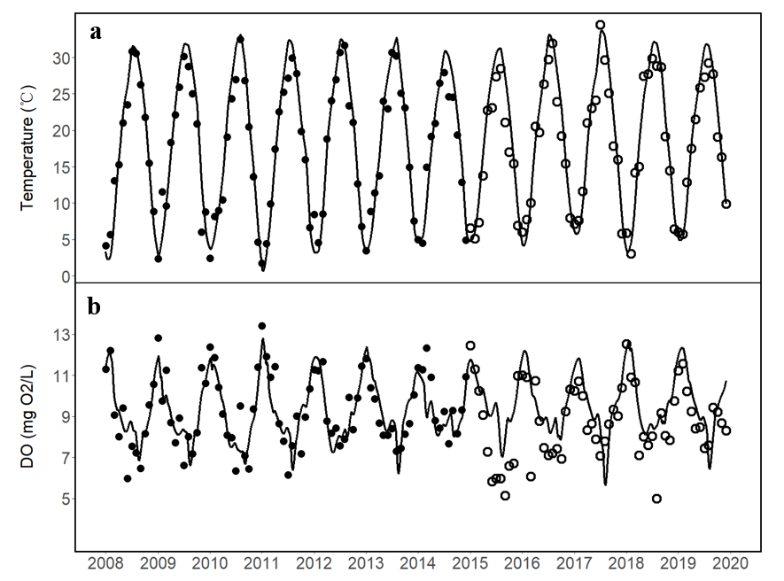
Fig. S1 Model simulated values (black line) and calibration and validation observations (black solid and white hollow dots, respectively) Gray bands represent the uncertainty associated with the 15% error introduced into the indications and observations. (a: TEMP; b: DO)
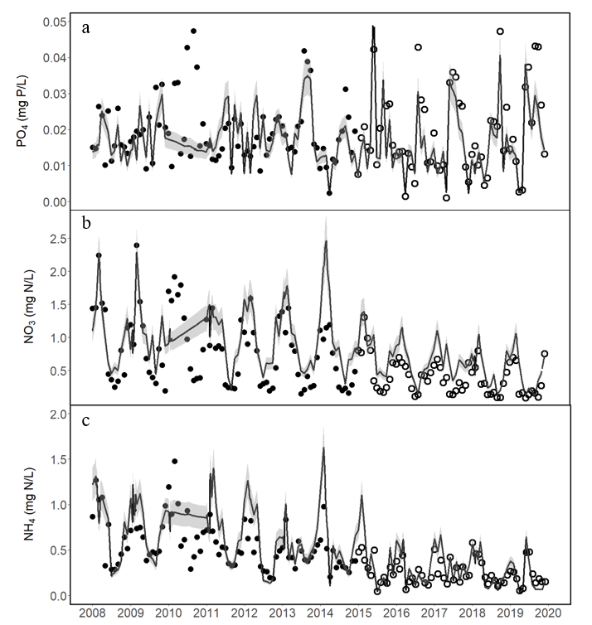
Fig. S2 Model simulated values (black line) and calibration and validation observations (black solid and white hollow dots, respectively) Gray bands represent the uncertainty associated with the 15% error introduced into the indications and observations. (a: PO₄; b: NO₃; c:NH₄)
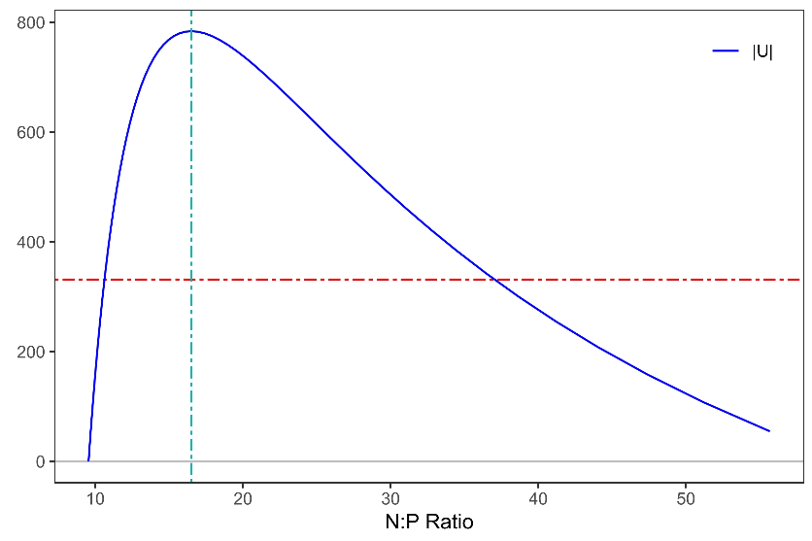
Fig. S3 Scenario-simulated pettitt mutation test for P control inflection point

Table S2 The WET model uses the original values and set values of the parameters.

Paramet | Description | Unit | Parameter Value
Paramet | Description | Unit | Default | Adjusted
Abiotic_Water Module
cThetaAer | temperature coefficient for reaeration | [−] | 1.024 | 1.001
cThetaNitr | temperature coefficient for nitrification | [−] | 1.08 | 1.000
cVSetPOM | maximum settling rate of POM | m·day−1 | −0.25 | −3.9
cVSetIM | maximum settling rate of inorganic matter | m·day−1 | −1.0 | -0.39
hNO3Denit | quadratic half saturation NO₃ conc. for denitrification | mgN·L−1 | 2.0 | 0.31
hO2BOD | half saturation oxygen conc. for BOD | mgO2·L−1 | 1.0 | 2.53
hO2Nitr | half saturation oxygen conc. for nitrification | mgO2·L−1 | 2.0 | 3.0
kNitrW | nitrification rate constant in water | day−1 | 0.1 | 0.04
NO3PerC | denitrified NO₃ per mol C mineralised | mol NO3 | 0.8 | 1.5
O2PerNH4 | used O2 per mol NH4+ nitrified | mol O2 | 2.0 | 2.0
cThetaMinPOMW | temperature coefficient for mineralization from POM to DOM | [−] | 1.07 | 1.05
kDMinPOMW | decomposition constant for POM-DW to DOM-DW | day−1 | 0.01 | 0.0367
kNMinPOMW | decomposition constant for POM-N to DOM-N | day−1 | 0.01 | 0.0238
kPMinPOMW | decomposition constant for POM-P to DOM-P | day−1 | 0.01 | 0.0046
kSiMinPOMW | decomposition constant for POM-Si to DOM-Si | day−1 | 0.01 | 0.01
cThetaMinDOMW | temperature coefficient for DOM mineralization | [−] | 1.07 | 1.058
kDMinDOMW | mineralization constant of dissolved organic DW | day−1 | 0.01 | 0.0658
kNMinDOMW | mineralization constant of dissolved organic N | day−1 | 0.01 | 0.038
kPMinDOMW | mineralization constant of dissolved organic P | day−1 | 0.01 | 0.015
kSiMinDOMW | mineralization constant of dissolved organic Si | day−1 | 0.01 | 0.01
 | Abiotic_Sediment Module
fRefrPOMS | refractory fraction of sediment POM | [−] | 0.15 | 0.13
O2PerNH4 | O2 used per mol NH4+ nitrified | mol | 2.0 | 2.0
kNitrS | nitrification rate constant | day−1 | 1.0 | 1.29
cThetaNitr | temperature coefficient for nitrification | [−] | 1.08 | 1.00
NO3PerC | NO₃ denitrified per mol C mineralised | [−] | 0.8 | 1.5
hNO3Denit | quadratic half-sat. NO₃ conc. for denitrification | mgN·L−1 | 2.0 | 0.316
kPSorp | P sorption rate constant not too high -> model speed | day−1 | 0.05 | 0.045
cRelPAdsD | max. P adsorption per g DW | gP·gD−1 | 3 × 10−5 | 2.04× 10−5
cRelPAdsFe | max. P adsorption per g Fe | gP·gFe−1 | 0.065 | 0.065
fFeDIM | Fe content of inorganic. matter | gFe·Gd−1 | 0.01 | 0.041
fRedMax | max. reduction factor of P adsorption affinity | [−] | 0.9 | 0.9
cKPAdsOx | P adsorption affinity at oxidized conditions | m3·gP−1 | 0.6 | 0.6
coPO4Max | max. SRP conc. in pore water | mgP·L−1 | 1.0 | 0.14
cThetaDif | temperature coefficient for diffusion | [−] | 1.02 | 0.95
kNDifNH4 | molecular NH₄ diffusion constant | m2·day−1 | 0.000112 | 0.000154
cTurbDifNut | bioturbation factor for diffusion | [−] | 5.0 | 25.81
kO2Dif | molecular O₂ diffusion constant | m2·day−1 | 2.6 × 10−5 | 0.00057
cTurbDifO2 | bioturbation factor for diffusion | [−] | 5.0 | 4.68
kDMinHum | maximum decomposition constant of humic material (1D−5) | day−1 | 1 × 10−5 | 2.0159
cThetaMinPOMS | temperature coeff. for sediment mineralization of POM to DOM | [−] | 1.07 | 1.38
kDMinPOMS | mineralization constant in sediment from POM-DW to DOM-DW | day−1 | 0.002 | 0.0152
kNMinPOMS | mineralization constant in sediment from POM-N to DOM-N | day−1 | 0.002 | 0.00087
kPMinPOMS | mineralization constant in sediment from POM-P to DOM-P | day−1 | 0.002 | 0.002
cThetaMinDOMS | exp. temperature constant of sediment mineralization | [−] | 1.07 | 1.06
kDMinDOMS | mineralization constant for sediment dissolved organic matter | day−1 | 0.002 | 0.0025
kNMinDOMS | mineralization constant for sediment dissolved organic N | day−1 | 0.002 | 0.0108
kPMinDOMS | mineralization constant for sediment dissolved organic P | day−1 | 0.002 | 0.0027
kSiMinDOMS | mineralization constant for sediment dissolved organic Si | day−1 | 0.002 | 0.002
kDDifDOM | molecular diffusion constant for dissolved organic matter | m2·day−1 | 0.000112 | 0.00076
kNDifDOM | molecular diffusion constant for dissolved organic N | m2·day−1 | 0.000112 | 0.00051
kPDifDOM | molecular diffusion constant for dissolved organic P | m2·day−1 | 0.000112 | 0.000227
sPAIMS | sediment absorbed phosphate | g·m−2 | 2.0 | 0.288

Auxiliary Module
kVegResus | relative resuspension reduction per gram macrophytes | m2·g DW−1 | 0.01 | 0.05
kTurbFish | relative resuspension by adult fish browsing | g·gfish−1·day−1 | 1.0 | 2.15
cVSedPOM | maximum sedimentation velocity of POM | m·day−1 | 0.25 | 0.5
cVSedDiat | sedimentation velocity of diatoms | m·day−1 | 0.5 | 0.68
cVSedGren | sedimentation velocity of greens | m·day−1 | 0.2 | 0.54
cVSedBlue | sedimentation velocity of blue-greens | m·day−1 | 0.06 | 0.01
crt_shear | critical shear stress | N·m−2 | 0.005 | 0.014
 | Macrophytes Module
cDVegIn | external macrophytes density | g D·m2 | 1.0 | 1.0
kMigrVeg | macrophyte migration rate | day−1 | 0.001 | 0.0004
cMuMaxVeg | maximum growth rate of macrophytes at 20 degrees | day−1 | 0.2 | 0.136
cDCarrVeg | maximum macrophytes standing crop | g DW·m−2 | 400.0 | 250.0
cDayWinVeg | day of the year for the end of growing season | day of the year | 259.0 | 259.0
cTmInitVeg | temperature for onset of initial growth | - C | 9.0 | 10.88
cCovSpVeg | specific cover | Gdw−1·m−2 | 0.5 | 0.2
hLRefVeg | half-saturation for influence of light on macrophytes | W·m−2 PAR | 17.0 | 5.89
fWinVeg | fraction surviving in winter ([−]), default = 0.3 | [−] | 0.3 | 0.295
fSedUptVegMax | maximum sediment fraction of nutrient uptake | [−] | 0.998 | 0.5
cHeightVeg | macrophytes height | m | 1.0 | 0.235
cExtSpVeg | specific extinction of macrophytes | m2·g DW | 0.01 | 0.005
cDVegMin | minimum dry weight of macrophytes in system | g DW·m−2 | 1 × 10−5 | 1 × 10−5
cQ10ProdVeg | temperature quotient of production | [−] | 1.2 | 1.2
cQ10RespVeg | temperature quotient of respiration | [−] | 2.0 | 2.0
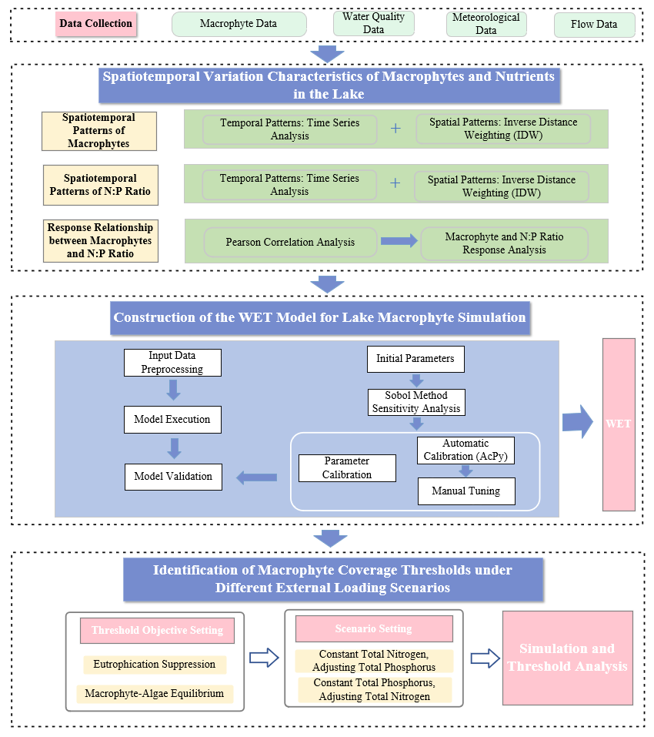
Fig. S4 Research Technology Roadmap

