Supplementary Information

Predicting IgA Nephropathy Progression Through CD8⁺ T-Cell Chromatin Accessibility Analysis

Contents
Supplementary Figure S1. Regulatory network of downstream genes governed by upstream transcription factors enriched in early-stage and late-stage groups. 2
Supplementary Figure S2. Statistical evaluation of the top 10 early-stage group-enriched biomarkers. 4
Supplementary Figure S3. Statistical evaluation of the top 10 late-stage group-enriched biomarkers. 6
Supplementary Figure S4. ATAC-qPCR-based quantification of early-stage group-enriched biomarkers. 7
Supplementary Figure S5. ATAC-qPCR-based quantification of late-stage group-enriched biomarkers 9
Supplementary Table S1. Summary of sample information and ATAC-seq library quality metrics for CD8+ T-cell samples 11
Supplementary Table S2. Differentially accessible regions (DARs) identified in CD8+ T cells from patients with IgA nephropathy. 12
Supplementary Table S3. Covariable-adjusted differentially accessible regions (DARs) between early- and late-stage IgA nephropathy identified in circulating CD8+ T cells 13
Supplementary Table S4. Primer sequences used for ATAC-qPCR analysis 14
Supplementary Table S5. Baseline characteristics of the subjects. 15

Supplementary Figure S1. Regulatory network of downstream genes governed by upstream transcription factors enriched in early-stage and late-stage groups.
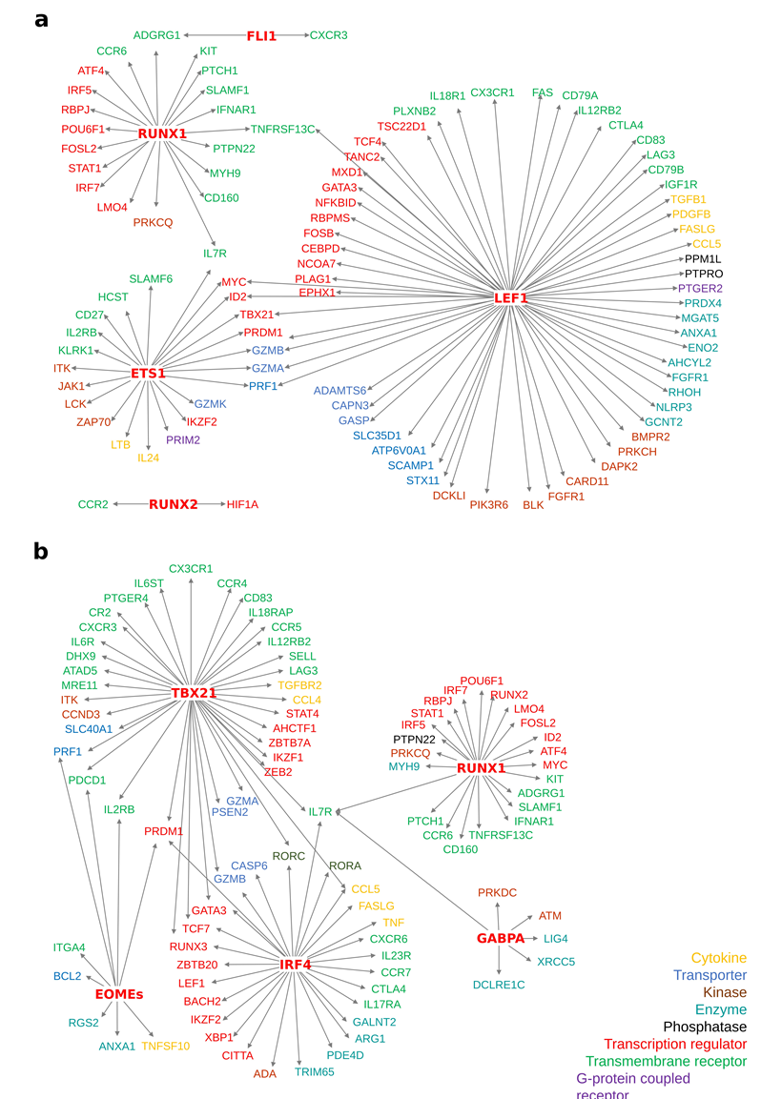
a, b Predicted regulatory networks of downstream genes controlled by the top 5 transcription factors enriched in the early-stage (a) and late-stage (b) groups of CD8⁺ T cells, analyzed using Ingenuity Pathway Analysis (IPA). Downstream genes were categorized by gene families, including transcription regulator (red), transmembrane receptor (green), cytokine (yellow), transporter (light blue), kinase (brown), enzyme (turquoise), phosphatase (black), and G-protein coupled receptor (purple).

Supplementary Figure S2. Statistical evaluation of the top 10 early-stage group-enriched biomarkers.
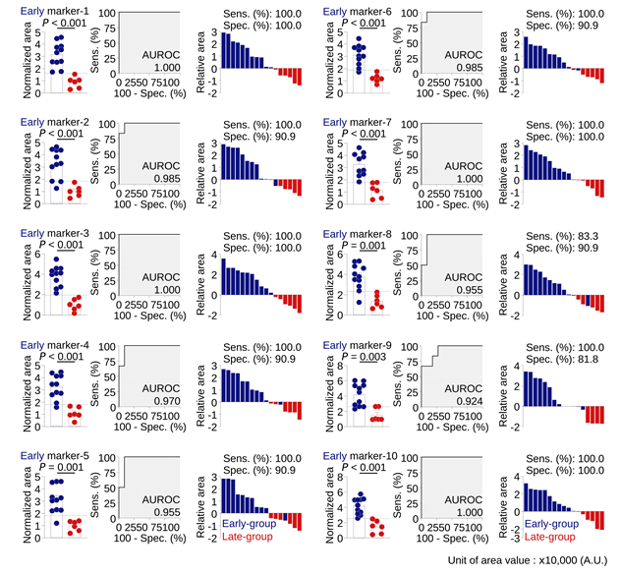Chromatin openness of the top 10 biomarkers enriched in the early-stage group is presented for early-stage (blue) and late-stage (red) groups using normalized area values. Dot plots (left) display individual data points with bars representing the mean ± SEM (early: n = 11, late: n = 6). Statistical significance was determined by Student’s t-test. ROC curves (middle) assess predictive performance, and waterfall plots (right) visualize chromatin openness relative to the cut-off for each biomarker.

Supplementary Figure S3. Statistical evaluation of the top 10 late-stage group-enriched biomarkers.
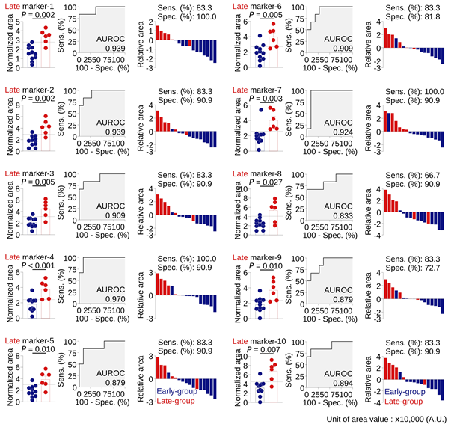
Chromatin openness of the top 10 biomarkers enriched in the late-stage group is shown for early-stage (blue) and late-stage (red) groups using normalized area values. Dot plots (left) display individual values with bars representing the mean ± SEM (early: n = 11, late: n = 6). P-values were calculated using Student’s t-test. ROC curves (middle) illustrate predictive performance, and waterfall plots (right) show individual chromatin openness values compared to the optimal cut-off.
Supplementary Figure S4. ATAC-qPCR-based quantification of early-stage group-enriched biomarkers
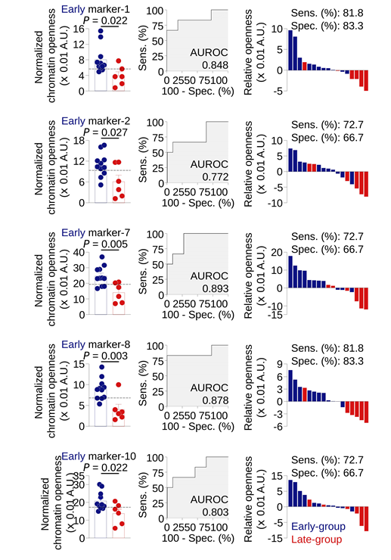
Normalized chromatin openness of the five early-stage group-enriched biomarker was quantified using ATAC-qPCR based on the mean Ct method. Chromatin openness of the five biomarkers enriched in the early-stage group was quantified using ATAC-qPCR the 2^{–Ct} method. Left, dot plots show normalized chromatin openness in early-stage (blue, n = 10) and late-stage (red, n = 6) groups, with the optimized cut-off indicated by a dashed line. Mean values with SEM are shown. Statistical differences were assessed by Student’s t-test. Middle, ROC curves evaluate predictive performance. Right, Waterfall plots display relative openness for individual patients compare to cut-off.

Supplementary Figure S5. ATAC-qPCR-based quantification of late-stage group-enriched biomarkers
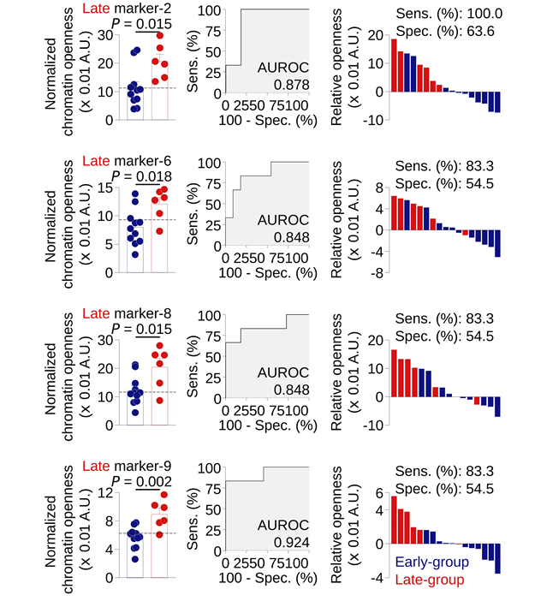
Normalized chromatin openness of four late-stage group-enriched biomarkers was quantified by ATAC-qPCR using the 2^{–Ct} method. Left, Dot plots present normalized chromatin openness in early-stage (blue, n = 10) and late-stage (red, n = 6) groups, with the optimized cut-offs indicated (dashed line). Bars indicate mean ± SEM, and statistical significance was determined using Student’s t-test. Middle, ROC curves assess biomarker prediction accuracy. Right, Waterfall plots visualize individual relative openness across patients compare to cut-off.

Supplementary Table S1. Summary of sample information and ATAC-seq library quality metrics for CD8⁺ T-cell samples
Group-Sample | Gender | Age | Group | PBC1 | PBC2 | NRF | FRiP | TSSE
Early-1 | F | 37 | Early | 0.78 | 4.76 | 0.39 | 0.77 | 13.0
Early-2 | F | 36 | Early | 0.63 | 3.46 | 0.35 | 0.79 | 17.6
Early-3 | M | 37 | Early | 0.80 | 5.15 | 0.52 | 0.60 | 13.5
Early-4 | F | 47 | Early | 0.83 | 6.09 | 0.47 | 0.71 | 13.4
Early-5 | M | 43 | Early | 0.81 | 5.59 | 0.45 | 0.76 | 14.2
Early-6 | F | 64 | Early | 0.79 | 5.08 | 0.47 | 0.67 | 15.9
Early-7 | F | 47 | Early | 0.88 | 9.05 | 0.52 | 0.77 | 19.9
Early-8 | F | 33 | Early | 0.89 | 10.27 | 0.54 | 0.78 | 18.5
Early-9 | M | 45 | Early | 0.89 | 9.33 | 0.76 | 0.34 | 12.5
Early-10 | M | 44 | Early | 0.75 | 4.34 | 0.42 | 0.71 | 12.3
Early-11 | M | 58 | Early | 0.96 | 29.34 | 0.77 | 0.59 | 26.4
Late-1 | M | 45 | Late | 0.73 | 3.84 | 0.37 | 0.77 | 13.0
Late-2 | F | 54 | Late | 0.79 | 4.97 | 0.39 | 0.81 | 15.6
Late-3 | F | 50 | Late | 0.77 | 4.55 | 0.45 | 0.72 | 17.6
Late-4 | F | 50 | Late | 0.88 | 9.41 | 0.51 | 0.81 | 18.4
Late-5 | F | 43 | Late | 0.76 | 4.49 | 0.44 | 0.66 | 11.9
Late-6 | F | 38 | Late | 0.96 | 27.82 | 0.76 | 0.60 | 29.1
PBC: Polymerase chain reaction bottlenecking coefficients
NRF: non-redundant fraction
FRiP: Fraction of reads in peaks
TSSE: Transcription start site enrichment

Supplementary Table S2. Differentially accessible regions (DARs) identified in CD8+ T cells from patients with IgA nephropathy.

Supplementary Table S2.xls

Supplementary Table S3. Covariable-adjusted differentially accessible regions (DARs) between early- and late-stage IgA nephropathy identified in circulating CD8+ T cells.

Supplementary Table S3.xls

Supplementary Table S4. Primer sequences used for ATAC-qPCR analysis.
Marker | Genomic coordinates (hg19) | Sequence (5’ → 3’)
Early-1 | chr4:108957563-108957678 | Forward: CTGCTGCTGTTTGCTTCAGT
Early-1 | chr4:108957563-108957678 | Reverse: GACCCACCCTCCCTCTTGA
Early-2 | chr20:52004930-52005029 | Forward: GGTCCTCTGCCCTCGAGTAAG
Early-2 | chr20:52004930-52005029 | Reverse: TCACCCACCTTCAGTGTTGT
Early-7 | chr16:29838615-29838722 | Forward: CTGTGATGTGGAAAGTGTGCC
Early-7 | chr16:29838615-29838722 | Reverse: TCTGATCGGCTGCTTTCGTG
Early-8 | chr1:49242402-49242505 | Forward: GTTGTCAAAATCCAGCC
Early-8 | chr1:49242402-49242505 | Reverse: CCATGTACGCCTTTGTGCG
Early-10 | chr1:241840643-241840774 | Forward: TCAGTCCCGGGTTAGAAAAGC
Early-10 | chr1:241840643-241840774 | Reverse: CGGCCCAGAAGAAACGGAT
Late-2 | chr20:24089774-24089885 | Forward: CCAGCCTAGTGCAGGAGAAAG
Late-2 | chr20:24089774-24089885 | Reverse: CAAGGTTCTGGTTGGCTCAC
Late-6 | chr1:158948646-158948779 | Forward: ACACATCAGAGCTCCTACTTG
Late-6 | chr1:158948646-158948779 | Reverse: CTCTAAGATGTCTATGAGGGTAGG
Late-8 | chr12:791826-791925 | Forward: CCGCCCTGACTATGCTTCAT
Late-8 | chr12:791826-791925 | Reverse: CTTTTACGTAGCGCAGTGGC
Late-9 | chr11:19302672-19302780 | Forward: GGCTCCCCTTTGCAATTAACAG
Late-9 | chr11:19302672-19302780 | Reverse: AGAGCCCCACATGAGCAACT

Supplementary Table S5. Baseline characteristics of the subjects.
 | Early-stage  (n = 11) | Late-stage  (n = 6) | P-value
age (yr) | 44.0 (37.0–47.0) | 47.5 (43.5–50.0) | 0.391
sex (n, %) | 6 (54.6) | 5 (83.3) | 0.512
duration of biopsy to blood sampling (yr) | 2.4 (1.1–9.6) | 8.1 (3.7–10.4) | 0.301
eGFR at sample (mL/min/1.73m²) | 51.3 (36.9–66.4) | 12.7 (7.9–21.4) | 0.003
eGFR Decline (mL/min/1.73m² per year) | -4.8 (-6.8–-1.0) | -5.4 (-6.5–-3.9) | 0.350
UPCR at sample (g/g) | 1.41 (0.8–2.2) | 2.3 (1.1–3.2) | 1.000
Average UPCR (g/g) | 1.5 (1.0–2.5) | 2.1 (1.2–3.7) | 0.462
percentage of global sclerosis (percent) | 30.3 (16.7–47.8) | 43.5 (28.1–72.4) | 0.208
Oxford classification (MEST-C Score) | 2.0 (1.5–2.5) | 1.8 (1.2–2.0) | 0.326
serum IgA (mg/dL) | 311.0 (253.0–322.5) | 364.5 (341.1–423.3) | 0.006
WBC (10³/μL) | 6.2 (5.8–7.5) | 6.7 (5.5–8.5) | 1.000
hemoglobin (g/dL) | 12.3 (11.8–13.3) | 10.9 (10.3–11.6) | 0.044
total protein (g/dL) | 6.7 (6.7–7.1) | 6.9 (6.7–7.2) | 0.960
albumin (g/dL) | 4.2 (4.1–4.3) | 4.0 (3.9–4.3) | 0.389
calcium (mg/dL) | 9.2 (9.0–9.4) | 8.9 (8.6–9.1) | 0.096
phosphorus (mg/dL) | 3.5 (3.2–3.7) | 4.7 (4.0-5.2) | 0.011
sodium (mmol/dL) | 139.0 (188.0–141.5) | 139.5 (139.0–140.8) | 0.721
potassium (mmol/dL) | 4.6 (4.2–4.9) | 5.6 (5.2–6.1) | 0.018
total CO₂ (mg/dL) | 27.0 (24.8–28.8) | 21.0 (20.0–22.0) | 0.154

The data are presented as n (%) or median (interquartile ranges).
eGFR = estimated glomerular filtration rate, UPCR = urine protein to creatinine ratio, WBC = white blood cell
eGFR decline was calculated by subtracting the final eGFR from the GFR measured at the time of blood sampling, and the difference was divided by the total number of years of follow-up

