Supplementary Material - High genomic structuring in Euterpe precatoria in the Brazilian Amazônia and new implications for restoration and conservation efforts
Ana Flávia Francisconi, Matheus Scaketti, Jonathan Andre Morales Marroquín, Igor Araújo Santos de Carvalho, Gabriela de Oliveira Fornazier, Matheus Sartori Moro, Flaviane Malaquias Costa, David Moreno-Mateos, Roberto de Oliveria Portella, Santiago Linorio Ferreyra Ramos, Doriane Picanço-Rodrigues, Maria Teresa Gomes Lopes & Maria Imaculada Zucchi
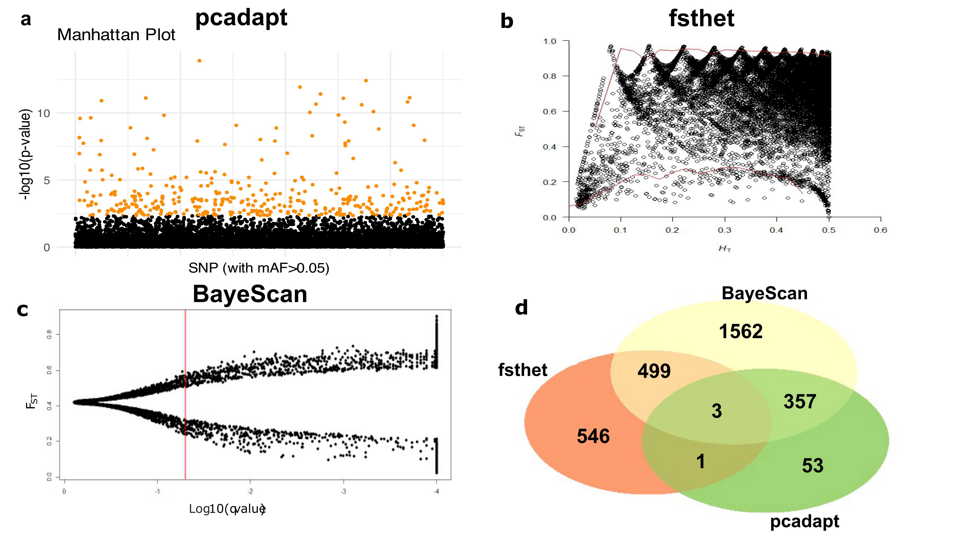
Supplementary Figure S1. Methods applied to detect outlier SNPs. A) The 414 outlier SNPs identified by pcadapt (FDR threshold of q < 0.1), represented by orange points; b) The fsthet method, which detected 1,049 outlier SNPs located outside the red lines representing the upper and lower confidence intervals; c) The 2,421 outlier SNPs identified by BayeScan, positioned to the right of the red threshold line; d) Venn diagram showing the number of unique and shared SNPs under selection among the 309 E. precatoria individuals and 17,514 SNPs analyzed. Note: For fsthet and BayeScan, SNPs were considered outliers when exceeding the respective thresholds indicated by the red lines in panels b and c.

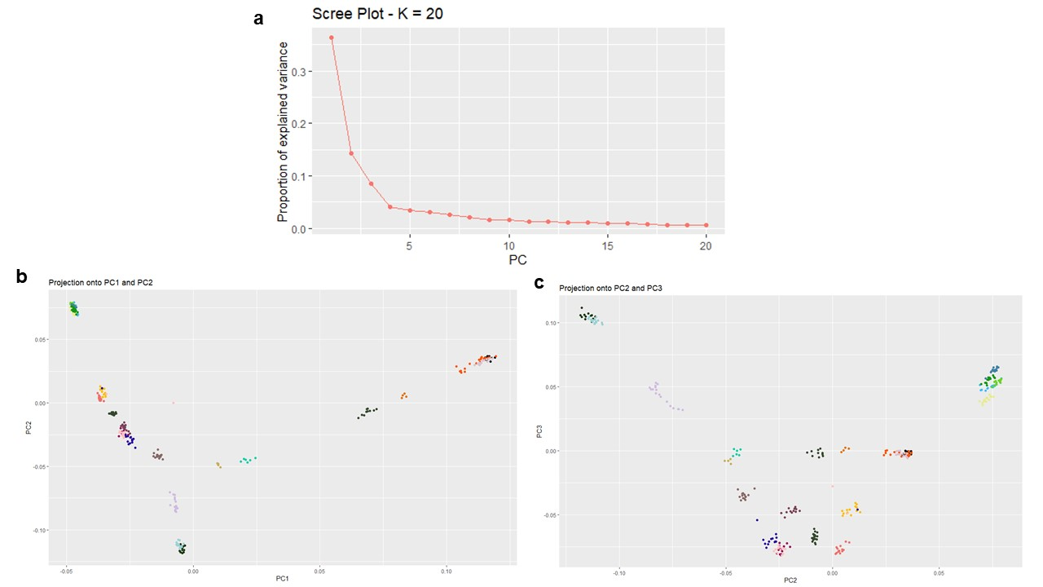

Supplementary Figure S2. Pcadapt method applied to detect putatively outlier SNPs in 309 Euterpe precatoria individuals from the states of Amazonas and Rondônia, based on 17,514 SNPs: A) Scree plot showing the proportion of variance explained by the first 20 principal components (PCs); the number of retained PCs was K = 2; b) Scatter plot of the first two PCs, showing the expected separation among collection sites; c) Scatter plot of PCs three and four, showing random dispersion of individuals among collection sites.

Supplementary Table S1- Outlier loci under selection with BLAST hits in NCBI showing >80% sequence similarity, based on 309 Euterpe precatoria individuals from the states of Amazonas and Rondônia.
Loci | Description | e-Value | Mean  similarity (%)
CLocus_20 | transcriptional corepressor LEUNIG_HOMOLOG isoform X1 | 7.40E-12 | 94.41
CLocus_29 | ubiquitin-conjugating enzyme E2 S | 7.51E-14 | 94.67
CLocus_69 | global transcription factor C | 2.19E-11 | 99.09
CLocus_74 | ATP-citrate synthase beta chain protein 1 | 1.86E-10 | 99.7
CLocus_197 | Non-specific serine/threonine protein kinase protein | 5.00E-08 | 89.53
CLocus_301 | adagio-like protein 1 | 7.43E-13 | 94.84
CLocus_326 | ARM repeat superfamily protein | 1.28E-14 | 97.42
CLocus_361 | isoamylase 3, chloroplastic isoform X1 | 1.71E-09 | 97.29
CLocus_492 | ankyrin repeat-containing protein ITN1 | 4.18E-09 | 95.83
CLocus_515 | Phospholipid-transporting ATPase 3 | 1.09E-13 | 99.24
CLocus_1507 | chaperone protein ClpB3, chloroplastic isoform X1 | 6.43E-11 | 100
CLocus_1658 | importin subunit alpha-1b | 2.50E-13 | 100
CLocus_2041 | Protein suppressor of K(+) transport growth defect 1 | 6.43E-13 | 100
CLocus_2115 | ras-related protein RABA5a | 1.30E-13 | 100
CLocus_2220 | tryptophan aminotransferase-related protein 2-like | 1.36E-09 | 85.45
CLocus_2451 | protein virilizer homolog | 9.68E-15 | 96.36
CLocus_2728 | auxin response factor 2 family protein | 2.06E-12 | 99.69
CLocus_2773 | protein NRT1/ PTR FAMILY 5.2-like | 2.04E-13 | 99.85
CLocus_3018 | vacuolar protein sorting-associated protein 45 homolog | 8.30E-13 | 99.7
CLocus_3200 | DExH-box ATP-dependent RNA helicase DExH6 | 1.33E-11 | 94.23
CLocus_3365 | putative glutamate carboxypeptidase LAMP1 | 4.60E-11 | 97.03
CLocus_3639 | probable folate-biopterin transporter 2 | 9.73E-08 | 91.67
CLocus_3683 | cytochrome P450 86B1-like | 2.06E-14 | 92.12
CLocus_3705 | transformation/transcription domain-associated protein-like | 4.41E-15 | 100
CLocus_3931 | sodium/proton-translocating pyrophosphatase | 9.10E-14 | 100
CLocus_4110 | vacuolar protein sorting-associated protein 32 homolog 2-like isoform X1 | 2.06E-12 | 93.94
CLocus_4730 | probable histidine kinase 5 | 1.90E-11 | 99.09
CLocus_4760 | DNA replication licensing factor MCM6 | 3.38E-09 | 89.22
CLocus_5432 | ABC transporter G family member 36 isoform X1 | 8.09E-07 | 91.04
CLocus_5996 | protein transport protein SEC31 | 4.99E-10 | 94.94
CLocus_6241 | probable zinc metalloprotease EGY2, chloroplastic isoform X1 | 2.57E-11 | 99.7
CLocus_6306 | Glutaredoxin | 2.16E-14 | 98.02
CLocus_6897 | synaptotagmin-2-like isoform X2 | 2.80E-08 | 93.28
CLocus_7045 | BTB/POZ domain-containing protein At5g66560 | 3.83E-13 | 100
CLocus_7189 | putative multidrug resistance protein | 6.85E-13 | 92.89
CLocus_7191 | protein ENHANCED DISEASE RESISTANCE 4 | 7.38E-11 | 95.72
CLocus_7201 | coatomer subunit alpha-1 | 5.83E-14 | 99.55
CLocus_7254 | putative transcription factor PosF21 | 2.16E-12 | 99.85
CLocus_7268 | sugar carrier protein C-like | 8.88E-13 | 92.58
CLocus_7293 | enolase 1, chloroplastic | 2.22E-15 | 99.85
CLocus_7334 | serine threonine-protein kinase | 5.46E-07 | 91.66
CLocus_8048 | homeobox-DDT domain protein RLT3 | 2.69E-16 | 90.07
CLocus_8692 | Receptor-kinase isolog | 4.82E-08 | 93.94
CLocus_9019 | LIMR family protein | 9.27E-07 | 79.06
CLocus_9614 | inositol phosphorylceramide glucuronosyltransferase 1 | 1.81E-09 | 88.32
CLocus_9919 | long chain acyl-CoA synthetase 2 | 1.06E-13 | 98.48
CLocus_9964 | zinc finger protein GIS | 6.02E-11 | 90.86
CLocus_9974 | putative WRKY transcription factor 4 | 1.29E-09 | 87.5
CLocus_10087 | hypothetical protein COCNU_13G006260 | 3.20E-11 | 92.85
CLocus_10292 | probable manganese-transporting ATPase PDR2 | 1.04E-10 | 94.69
CLocus_10429 | protein SGT1 homolog | 1.01E-09 | 92.28
CLocus_10984 | glutamate--cysteine ligase, chloroplastic-like isoform X1 | 3.57E-14 | 97.82
CLocus_11225 | probable folate-biopterin transporter 2 | 1.20E-12 | 100
CLocus_11286 | Receptor kinase-like protein Xa21 | 2.15E-08 | 87.2
CLocus_11441 | beta-adaptin-like protein C | 4.13E-15 | 97.58
CLocus_11671 | sucrose transport protein SUT1-like | 1.41E-08 | 93.75
CLocus_11861 | cycloartenol synthase-like isoform X1 | 9.30E-13 | 98.03
CLocus_12013 | L-type lectin-domain containing receptor kinase SIT2-like | 1.23E-13 | 96.97
CLocus_12173 | pentatricopeptide repeat-containing protein DOT4, chloroplastic-like | 2.69E-10 | 91.81
CLocus_12199 | uncharacterized protein LOC105049106 isoform X2 | 2.22E-11 | 91.67
CLocus_12776 | uncharacterized protein LOC105044622 isoform X1 | 6.59E-10 | 88.43
CLocus_13198 | patatin-like protein 2 | 5.87E-12 | 96.06
CLocus_13389 | BTB/POZ domain and ankyrin repeat-containing protein NPR5-like | 1.40E-11 | 90.22
CLocus_13915 | transcriptional corepressor LEUNIG | 9.40E-17 | 99.85
CLocus_14048 | origin of replication complex subunit 3 isoform X1 | 7.59E-08 | 92.47
CLocus_14326 | TBCC domain-containing protein 1-like | 7.24E-14 | 97.27
CLocus_14418 | Endoglucanase 3 | 1.96E-12 | 97.58
CLocus_14540 | Chlorophyll a-b binding protein 6A, chloroplastic | 9.78E-12 | 99.37
CLocus_14727 | L-type lectin-domain containing receptor kinase IV.2 | 2.47E-10 | 81.63
CLocus_15146 | AChain A, ASPR2 protein | 9.37E-13 | 98.94
CLocus_15241 | histone acetyltransferase HAC1 | 1.56E-12 | 90.57
CLocus_15701 | histone acetyltransferase HAC1 | 3.62E-08 | 88.76
CLocus_16336 | endochitinase EP3-like | 1.15E-12 | 97.42
CLocus_16406 | putative NAD(P)H dehydrogenase (quinone) FQR1-like 1 | 1.30E-13 | 96.82
CLocus_16823 | PH, RCC1 and FYVE domains-containing protein 1 | 2.07E-10 | 90.36
CLocus_17055 | Potassium transporter | 8.47E-12 | 96.97
CLocus_17701 | ubiquitin carboxyl-terminal hydrolase 17 | 2.93E-07 | 83.28
CLocus_18004 | L-type lectin-domain containing receptor kinase IV.1-like | 2.42E-12 | 91.48
CLocus_18135 | methyl-CpG-binding domain-containing protein 2-like | 3.06E-07 | 89.94
CLocus_18184 | exportin-2 | 2.69E-11 | 96.04
CLocus_18658 | putative tripeptidyl-peptidase II | 7.73E-13 | 97.55
CLocus_19011 | homeobox-leucine zipper protein ATHB-13 | 2.19E-14 | 100
CLocus_19030 | protein RDM16-like isoform X1 | 6.95E-12 | 100
CLocus_19142 | serine carboxypeptidase-like 18 | 1.18E-14 | 98.01
CLocus_19204 | RNA-binding protein 48-like isoform X2 | 2.18E-10 | 98.47
CLocus_19991 | putative PH, RCC1 and FYVE domains-containing protein 1 | 2.90E-12 | 97.19
CLocus_20078 | subtilisin-like protease SBT5.6 | 8.62E-12 | 96.25
CLocus_20377 | kinesin-like protein KIN-7A | 4.66E-11 | 97.66
CLocus_20789 | pumilio homolog 1 | 1.55E-11 | 90.48
CLocus_21286 | novel plant SNARE 13-like | 1.45E-11 | 93.33
CLocus_21376 | major facilitator superfamily protein | 2.73E-11 | 99.85
CLocus_22209 | probable methyltransferase PMT20 isoform X1 | 1.95E-14 | 89.68
CLocus_22712 | transcription factor MYBS1 | 7.07E-10 | 93.94
CLocus_22760 | nuclear pore complex protein NUP62 | 2.76E-11 | 88.03
CLocus_23003 | S-formylglutathione hydrolase | 1.04E-10 | 82.86
CLocus_23330 | peptidyl-prolyl cis-trans isomerase CYP71 isoform X2 | 7.45E-14 | 97.73
CLocus_23828 | putative carboxylesterase 18 | 1.75E-11 | 95.66
CLocus_23900 | BEL1-like homeodomain protein 9 | 9.19E-11 | 89.9
CLocus_24143 | protein NEDD1 | 5.68E-11 | 85.48
CLocus_24418 | eukaryotic translation initiation factor 3 subunit A isoform X1 | 3.83E-13 | 100
CLocus_25044 | chloride channel protein CLC-f | 1.75E-13 | 100
CLocus_25622 | UDP-glucose:glycoprotein glucosyltransferase | 2.12E-13 | 99.84
CLocus_25945 | Pyruvate kinase 2 | 1.22E-12 | 99.69
CLocus_26375 | E3 ubiquitin-protein ligase SINA-like 10 | 2.25E-12 | 79.41
CLocus_26490 | wall-associated receptor kinase 5-like | 7.48E-14 | 96.97
CLocus_27373 | probable protein phosphatase 2C 38 | 5.17E-14 | 95.91
CLocus_27525 | probable serine/threonine-protein kinase SIS8 isoform X1 | 6.31E-13 | 96.97
CLocus_27765 | proline--tRNA ligase, chloroplastic/mitochondrial | 1.05E-11 | 96.8
CLocus_28082 | exportin-2 isoform X1 | 7.75E-07 | 91.11
CLocus_28678 | Ferredoxin-dependent glutamate synthase 1, chloroplastic/mitochondrial | 4.20E-16 | 100
CLocus_28728 | UTP:RNA uridylyltransferase 1-like | 7.92E-13 | 90.65
CLocus_30001 | Ubiquitin-conjugating enzyme E2 S | 1.92E-14 | 98.79
CLocus_30072 | transformation/transcription domain-associated protein-like | 2.00E-14 | 98.03
CLocus_31143 | Mitogen-activated protein kinase kinase protein | 6.42E-13 | 100
CLocus_31941 | putative glucose-6-phosphate 1-epimerase | 7.42E-14 | 99.85
CLocus_32662 | molybdopterin biosynthesis protein CNX1 | 5.46E-10 | 96.25
CLocus_32755 | elongation factor 1-alpha | 5.90E-15 | 100
CLocus_33294 | BTB/POZ domain-containing protein NPY4 isoform X1 | 1.39E-07 | 88.89
CLocus_34678 | uncharacterized protein LOC120104602 isoform X3 | 2.25E-08 | 90
CLocus_35196 | uncharacterized protein LOC105057083 isoform X1 | 2.75E-08 | 85.08
CLocus_38077 | far upstream element-binding protein 1-like | 1.25E-12 | 94.54
CLocus_38154 | putative 3,4-dihydroxy-2-butanone kinase | 7.52E-12 | 98.45
CLocus_38580 | root hair specific 17 | 1.98E-10 | 95.43
CLocus_38853 | beta-galactosidase 15-like | 7.37E-12 | 89.24
CLocus_39256 | zinc finger protein-like 1 | 1.49E-09 | 94.67
CLocus_40773 | BEL1-like homeodomain protein 7 | 1.57E-12 | 90.3
CLocus_41033 | Uncharacterized integral membrane protein (DUF2301) | 9.22E-11 | 93.56
CLocus_42402 | putative amino-acid acetyltransferase NAGS1, chloroplastic | 8.28E-09 | 86.72
CLocus_44062 | protein KTI12 homolog isoform X1 | 2.33E-12 | 93.18
CLocus_345518 | 1-deoxy-D-xylulose-5-phosphate synthase 1, chloroplastic-like | 3.33E-14 | 97.88
CLocus_777889 | ABC transporter G family member 42 | 4.28E-13 | 100
CLocus_989714 | 3-ketoacyl-CoA synthase 10 | 1.64E-11 | 93.94

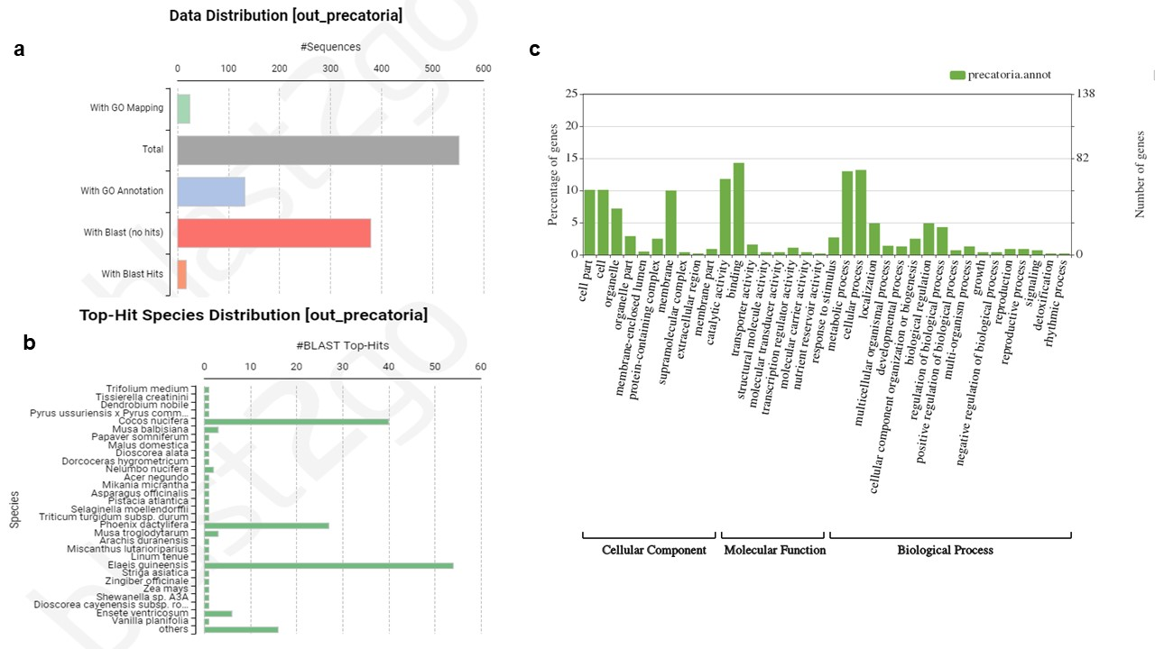
Supplementary Figure S3. Functional annotation results obtained using the Blast2GO program, based on 860 outlier SNPs and 309 Euterpe precatoria individuals from the states of Amazonas and Rondônia. A) Tag distribution of blasted, mapped, and annotated sequences;
b) Top-hit species identified in BLAST results; c) WEGO graph summarizing the Gene Ontology (GO) terms derived from Blast2GO.

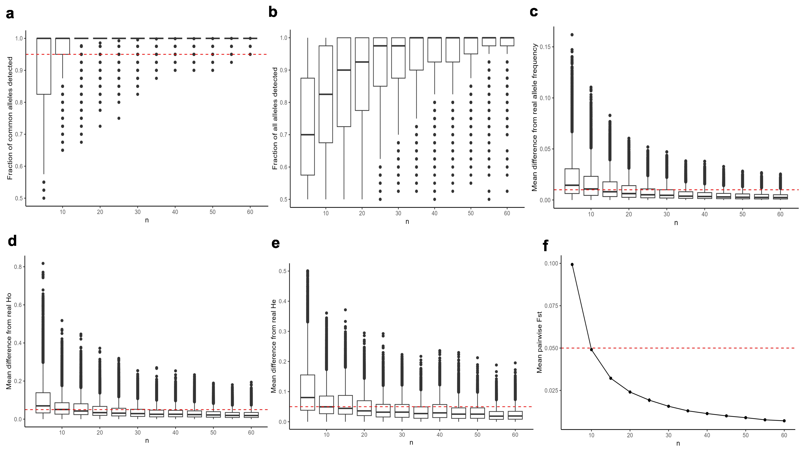
Supplementary Figure S4. Results of SaSii analyses for the 16,654 putatively neutral loci, calculated with a sample size of five, 20 resamplings, a minimum allele frequency of 0.05, and a maximum of 100 individuals per population (stability achieved with 60 individuals).
A) Fraction of common alleles detected; b) Fraction of all alleles detected; c) Mean difference from true allele frequency; d) Mean difference from true H_{O}; e) Mean difference from true H_{E}; f) Mean pairwise F_{ST}. The red line in a indicates the threshold above which 95% of the common alleles are present in the subsamples. The red line in c identifies the threshold below which the mean difference in allele frequencies between the original dataset and the subsample is less than 0.01. In plots d, e, and f, the red line indicates deviations greater than 0.05.

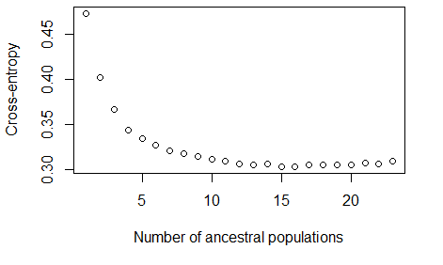
Supplementary Figure S5. Plot of cross-entropy values for different numbers of ancestral populations (K) estimated using sparse non-negative matrix factorization (sNMF), based on 16,654 neutral SNPs from 309 Euterpe precatoria individuals from the states of Amazonas and Rondônia. The plot indicates that the most likely number of ancestral populations is K = 16.

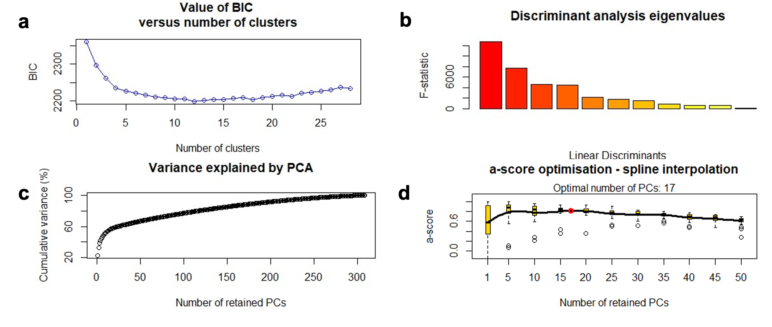
Supplementary Figure S6. Results of the discriminant analysis of principal components (DAPC) using K-means clustering, based on 16,654 neutral SNPs from 309 Euterpe precatoria individuals from the states of Amazonas and Rondônia. A) Bayesian Information Criterion (BIC) indicating K = 12 as the optimal number of clusters; b) Number of retained discriminant functions in the DAPC; c) Number of possible principal components (PCs) in the DAPC; d) Optimal alpha-score identifying the best number of PCs to retain in the analysis.

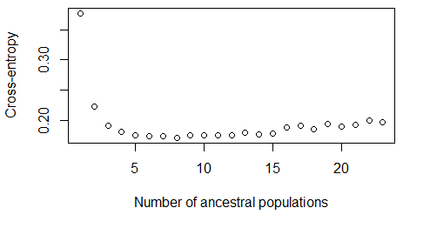

Supplementary Figure S7. Plot of cross-entropy values for different numbers of ancestral populations (K) estimated using sparse non-negative matrix factorization (sNMF), based on 860 outlier SNPs from 309 Euterpe precatoria individuals from the states of Amazonas and Rondônia. The plot indicates that the most likely number of ancestral populations is K = 8.

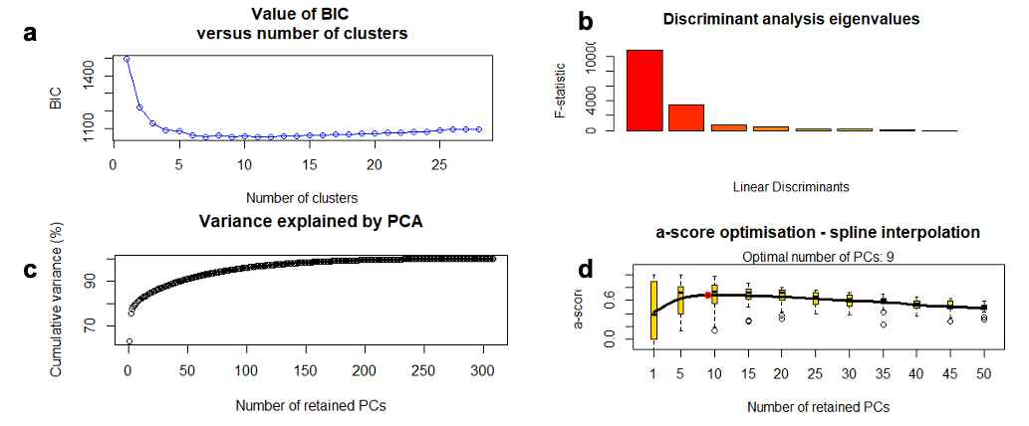
Supplementary Figure S8. Results of the Discriminant Analysis of Principal Components (DAPC) using K-means clustering, based on 860 outlier SNPs from 309 Euterpe precatoria individuals from the states of Amazonas and Rondônia. A) Bayesian Information Criterion (BIC) indicating K = 9 as the optimal number of clusters; b) Number of retained discriminant functions in the DAPC; c) Number of possible principal components (PCs) in the DAPC; d) Bar plot showing the 12 genetic clusters identified by the DAPC with K-means; e) Optimal alpha-score used to determine the best number of PCs to retain in the analysis.

Supplementary Table S2. Extractive production of açaí fruit for each municipality with a collection site in the states of Amazonas (AM) and Rondônia (RO), between 2011 and 2021, including the average production, classified by the respective rivers. Data obtained from the Instituto Brasileiro de Geografia e Estatística (IBGE) – Produção de Extração Vegetal e da Silvicultura (https://sidra.ibge.gov.br/tabela/289).
 |  | Year of extractive production
Colection Sites | River | 2011 | 2012 | 2013 | 2014 | 2015 | 2016 | 2017 | 2018 | 2019 | 2020 | 2021 | Mean
Codajás (AM) | Solimões River | 34,421 | 29,070 | 26,750 | 25,000 | 27,000 | 25,000 | 12,000 | 11,600 | 11,500 | 11,580 | 12,000 | 20,538.27
Itacoatiara (AM) | Amazonas River | 6,804 | 6,920 | 7,544 | 7,500 | 6,500 | 5,300 | 5,000 | 4,320 | 3,500 | 3,375 | 3,150 | 5,446.64
Anori (AM) | Solimões River | 6,302 | 3,520 | 3,225 | 2,446 | 1,800 | 1,500 | 1,657 | 2,000 | 1,900 | 1,800 | 2,200 | 2,577.27
Manicoré (AM) | Madeira River | 2,716 | 2,548 | 2,530 | 2,460 | 2,150 | 2,100 | 2,200 | 2,300 | 2,450 | 2,500 | 2,850 | 2,436.73
Coari (AM) | Solimões River | 3,366 | 2,660 | 2,260 | 1,800 | 1,850 | 1,890 | 1,896 | 1,898 | 1,940 | 2,000 | 2,200 | 2,160
Manacapuru (AM) | Solimões River | 2,816 | 2,237 | 2,200 | 2,600 | 2,600 | - | 52 | 20 | 21 | 181 | 176 | 1,290.3
Parintins (AM) | Amazonas River | 3,240 | 2,618 | 2,858 | 1,304 | 398 | 160 | 140 | 120 | 125 | 130 | 120 | 1,019.36
Borba (AM) | Madeira River | 1,782 | 1,540 | 1,760 | 1,600 | 800 | 500 | 800 | 300 | 320 | 370 | 400 | 924.73
Urucará (AM) | Uatumã River | 1,368 | 610 | 615 | 600 | 600 | 500 | 550 | 560 | 470 | 400 | 335 | 600.73
Itapiranga (AM) | Amazonas River | 855 | 350 | 400 | 400 | 225 | 816 | 720 | 630 | 550 | 500 | 400 | 531.45
Tefé (AM) | Alto Solimões River | 202 | 120 | 516 | 503 | 580 | 600 | 620 | 600 | 540 | 550 | 543 | 488.55
Guajará-Mirim (RO) | Madeira River | 185 | 432 | 442 | 486 | 501 | 500 | 480 | 460 | 519 | 475 | 491 | 451.91
Presidente Figueiredo (AM) | Uatumã River | 84 | 90 | 280 | 277 | 319 | 300 | 350 | 400 | 450 | 430 | 500 | 316.36
Santo Antônio do Içá (AM) | Alto Solimões River | 54 | 92 | 250 | 260 | 220 | 320 | 350 | 350 | 350 | 245 | 140 | 239.18
Fonte Boa (AM) | Alto Solimões River | 567 | 310 | 160 | 180 | 185 | 176 | 170 | 180 | 160 | 161 | 180 | 220.82
Benjamin Constant (AM) | Alto Solimões River | 200 | 220 | 275 | 285 | 285 | 31 | 40 | 45 | 80 | 100 | ... | 156.10
Tabatinga (AM) | Alto Solimões River | 53 | 168 | 160 | 160 | 85 | 100 | 150 | 151 | 151 | 151 | 80 | 128.09
Atalaia do Norte (AM) | Alto Solimões River | 200 | 220 | 168 | 160 | 172 | 45 | 43 | 45 | 90 | 90 | 90 | 120.27
Nova Mamoré (RO) | Madeira River | - | - | 100 | 111 | 115 | 110 | 99 | 94 | 107 | 106 | 103 | 105.00
Porto Velho (RO) | Madeira River | 80 | 84 | 89 | 92 | 97 | 97 | 95 | 87 | 100 | 92 | 96 | 91.73
São Sebastião do Uatumã (AM) | Uatumã River | 120 | 98 | 100 | 80 | 75 | 62 | 68 | 75 | 65 | 68 | 58 | 79.00
São Paulo de Olivença (AM) | Alto Solimões River | 93 | 90 | 90 | 100 | 70 | 32 | 35 | 30 | 42 | 30 | 50 | 60.18
Novo Airão (AM) | Negro River | 50 | 40 | 28 | 28 | 29 | 50 | 45 | 43 | 30 | 40 | 40 | 38.45
 |  |  |  |  |  |  |  |  |  |  |  | Solimões River | 6,641.46
 |  |  |  |  |  |  |  |  |  |  |  | Amazonas River | 2,332.48
 |  |  |  |  |  |  |  |  |  |  |  | Madeira River | 802.02
 |  |  |  |  |  |  |  |  |  |  |  | Uatumã River | 332.03
 |  |  |  |  |  |  |  |  |  |  |  | Alto Solimões River | 201.88
 |  |  |  |  |  |  |  |  |  |  |  | Negro River | 38.45

