Supplementary data:

Supplementary Figure 1.

Protein Target(s) | Sequence (heavy isotope in bold) | Precursor m/z | Product m/z (Collision Energy)
MT1 & MT2 | CAQGCICK | 498.7066++ | 836.4+ (20) | 765.3+ (17) | 637.3+ (17) | 580.3+ (17)
MT1 & MT2 | CAQGCICK | 502.7137++ | 844.4+ (20) | 773.4+ (17) | 645.3+ (17) | 588.3+ (17)
MT3 | GGEAAEAEAEK | 531.2409++ | 818.4+ (18) | 747.4+ (18) | 676.3+ (18) | 347.2+ (27)
MT3 | GGEAAEAEAEK | 535.248++ | 826.4+ (18) | 755.4+ (18) | 684.3+ (18) | 355.2+ (27)
Park7 (DJ-1) | DVVICPDASLEDAK | 766.3691++ | 1105.5+ (25) | 945.5+ (25) | 215.1+ (25) | 314.2+ (25) | 427.3+ (25)
GPX1 | CEVNGAGAHPLFAFLR | 586.9629++ | 863.5+ (16) | 653.4+ (16) | 685.9++ (16) | 628.8++ (16) | 432.3++ (16)
GFAP | DNLAQDLATVR | 608.3200++ | 873.5+ (20) | 802.4+ (20) | 674.4+ (20) | 230.1+ (20) | 343.2+ (20)
GAPDH | GALQNIIPASTGAAK | 706.3988++ | 1042.6+ (23) | 815.5+ (23) | 702.4+ (23) | 242.1+ (23) | 597.3+ (23)
CCS | SLIIDEGEDDLGR | 716.3517++ | 1118.5+ (23) | 1005.4+ (23) | 890.44+ (23) | 761.3+ (23) | 345.2+ (23)
SOD1 | TLVVHEK | 275.8325+++ | 512.3+ (5) | 413.2+ (5) | 362.7++ (5) | 306.2++ (5)
ATOX1 | YDIDLPNK | 489.2506++ | 699.4+ (16) | 586.3+ (16) | 471.3+ (16) | 358.2+ (16) | 279.1+ (16)
Supplementary figure 1. Overview of peptides used for LC-MS/MS identification of target proteins with their associated precursor/product ion masses (Da) and charge states (indicated by number of ‘+’ symbols). Energies (eV) used to generate product ions by collision-induced dissociation (CID) are detailed in parentheses. Cysteine residues (C) were monitored as the carbamidomethyl form (+57.021464 Da). Heavy isotope labelled lysine residues (¹³C-lysine, +8 Da) are indicated with ‘K’ in boldface.

Supplementary Figure 2.

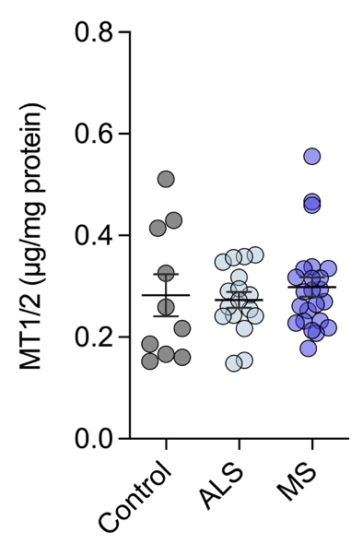
Supplementary figure 2. MT1/2 protein levels in the ALS and MS spinal cord TBS-soluble fraction quantified using LC-MS/MS and compared to control cases. Circles correspond to individual cases (control n=10, ALS n =17, MS n=23) and graph presented as mean ± S.E.M.
Supplementary Figure 3.
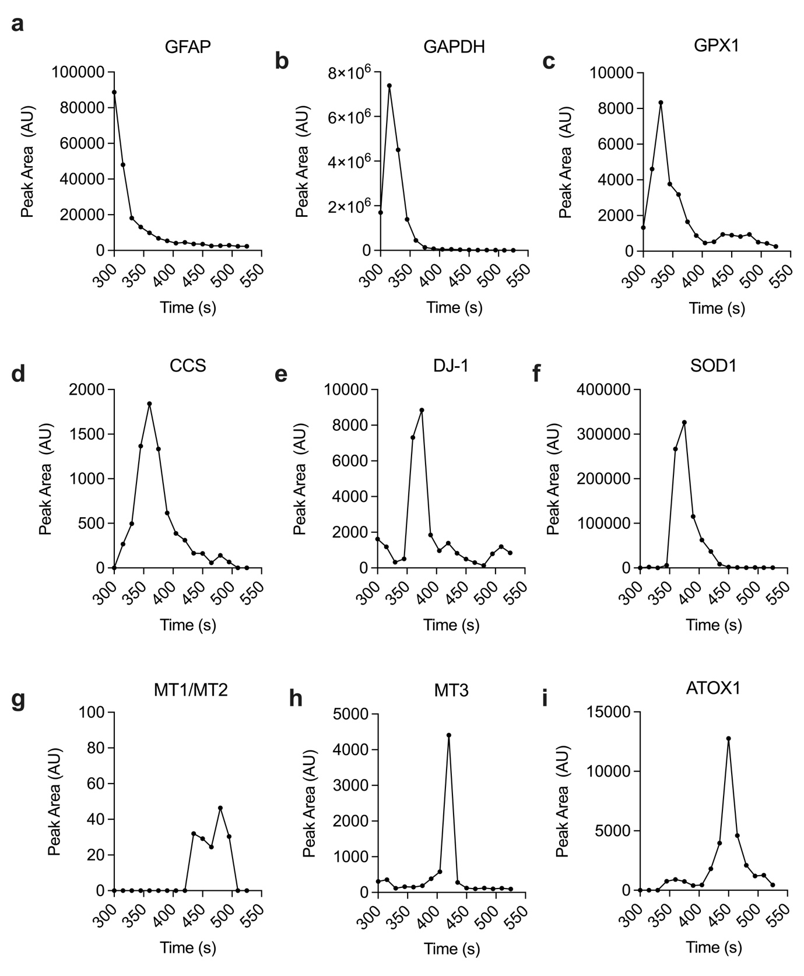
Supplementary figure 3. Elution profiles of selected housekeeping proteins (a-c) and endogenous CNS tissue cuproproteins (d-i) observed during size-exclusion chromatography (SEC). Analytical SEC was performed using conditions identical to the online SEC-ICP-MS workflow (see methods), with the modification of directing the column outflow to a fraction collector to sample fractions at 15 second intervals. The resulting fractions were processed for LC-MS/MS analysis by digesting overnight with trypsin, then desalting and concentrating by solid-phase extraction. Proteins were identified using selected reaction monitoring LC-MS/MS. Signals shown here (sum of peak areas) were plotted for each target against their representative elution times from the SEC column.
Supplementary Figure 4.
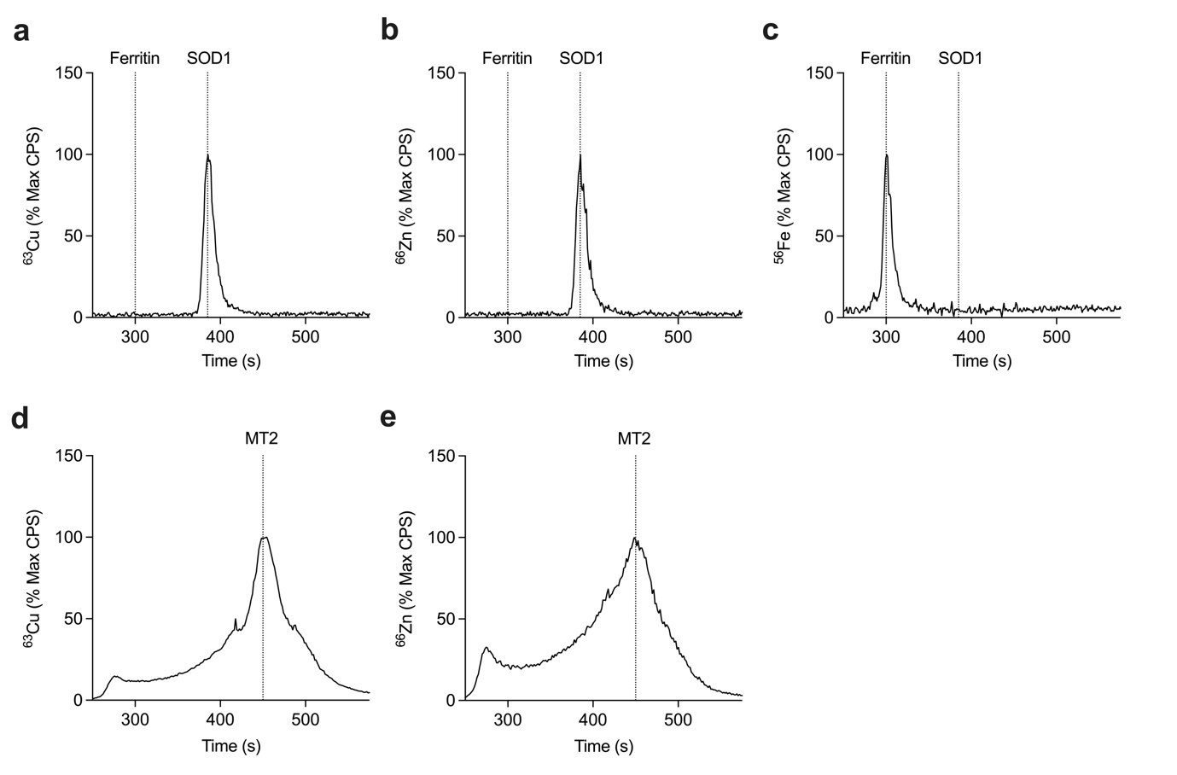
Supplementary figure 4. SEC-ICP-MS traces for SOD1, ferritin and MT2 standards. (a,b) Cu/Zn binding SOD1 (holo-SOD1) showed peaks at ~385 seconds for copper (a) and zinc (b) while the iron storage protein ferritin showed a peak at ~300 seconds for iron (c). Dashed lines indicate 300 seconds and 385 seconds for each trace. (d,e) MT2 showed a broader signal profile with the main peaks at ~450 seconds for copper (d) and zinc (e). Dashed lines indicate 450 seconds for each trace. Traces presented as percentages of the maximum signal measured in counts per second (CPS).
Supplementary Figure 5.
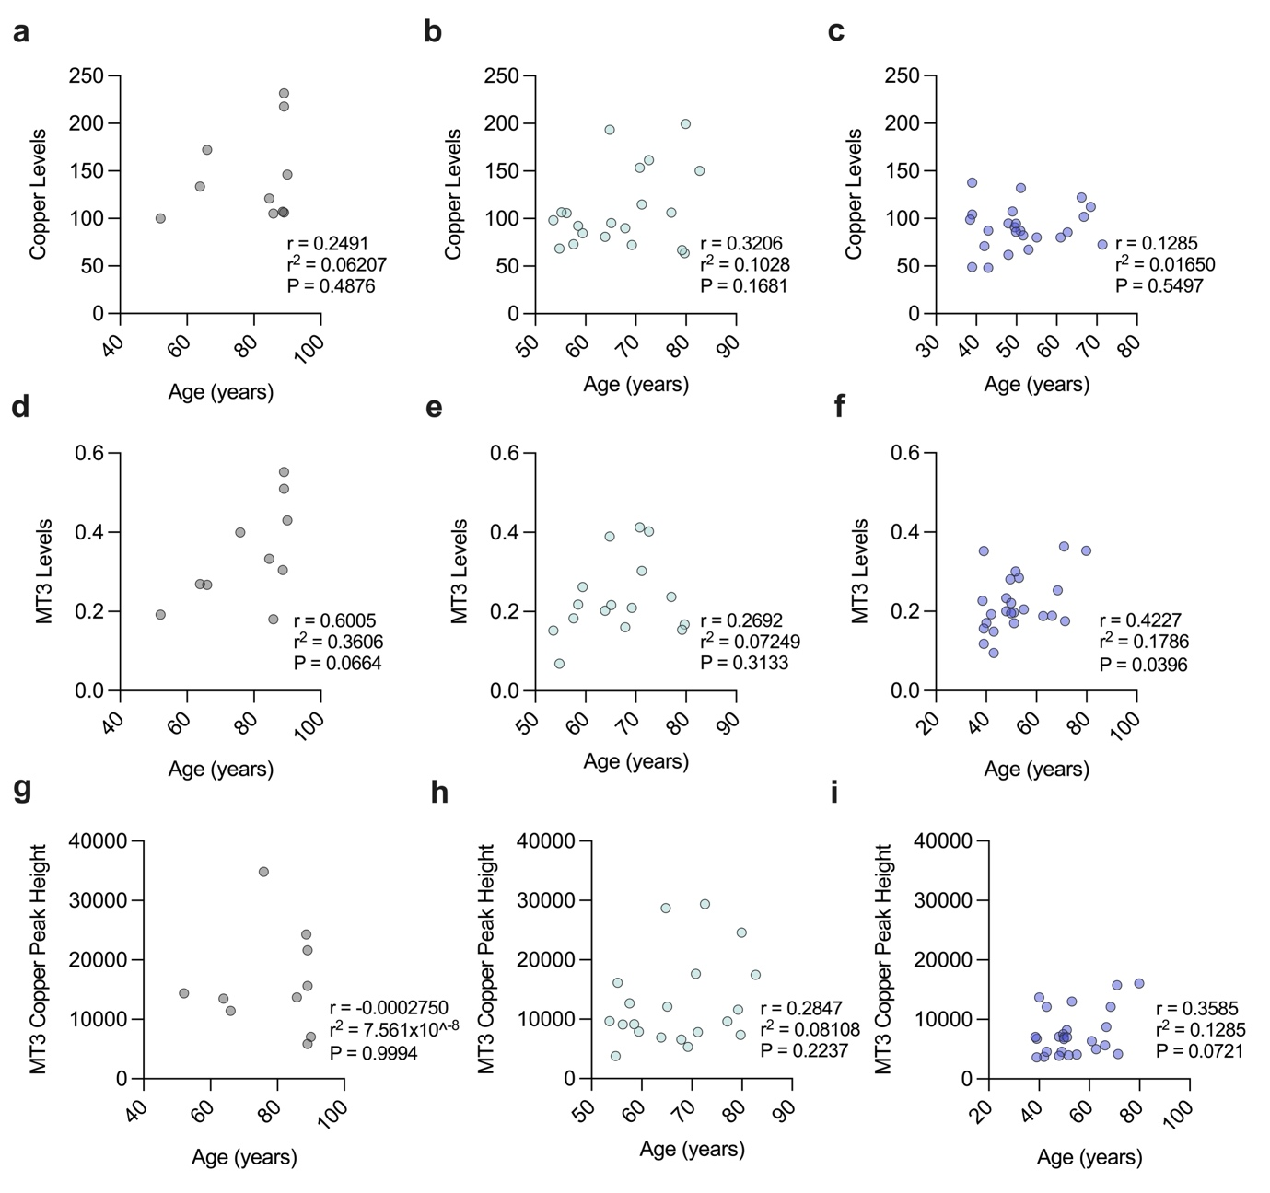
Supplementary figure 5. Correlation analyses for MT3, copper and MT3-copper peak against the age of ALS, MS and control cases used. (a-c) Correlation between copper levels and age for controls (a), ALS (b) and MS (c) cases. (d-f) Correlation between MT3 levels and age for controls (d), ALS (e) and MS (f) cases. (g-i) Correlation between MT3-copper peak height and age for controls (g), ALS (h) and MS (i) cases. Strength of relationship assessed using the Pearson correlation coefficient (r) and coefficient of determination (r²). Cases without values for both variables were excluded from analyses. Circles correspond to individual cases (control n=10, ALS n=16-20, MS n=24-26) with statistical significance determined as p<0.05.

