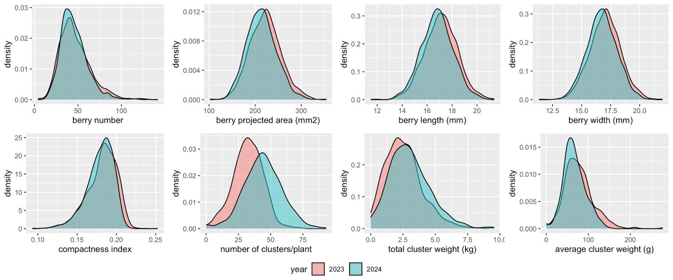
Supplementary Figure 1. Raw data distribution of all the traits measured across both years (2023 and 2024).

