Supplementary Material A
Descriptive Statistics and Response Rates
Table A1
Means, Standard Deviations, Frequencies, and Response Rates for Each Variable
Variable | M (SD)  Total sample | M (SD)  Per group |  | M (SD) response rates (%) | Range  Response rates (%)
 | N = 139 | HSP (n = 72) | Non-HSP (n = 67)
General response rate (%) | 86.20 (16.50) | 84.88 (17.18) | 87.56 (15.69) | 86.20 (16.50) | 34.40- 100
Overstimulation | 4.34 (0.54) | 4.43 (0.52) | 4.24 (0.55) | 86.20 (16.50) | 34.40- 100
SPS | 5.04 (0.86) | 5.73 (0.33) | 4.26 (0.53) | 97.20 (14.90) | 0-100
Pleasantness Higher Senses | 4.02 (0.68) | 3.72 (0.61) | 4.34 (0.60) | 84.40 (17.70) | 28.60-100
Pleasantness Lower Senses | 4.61 (0.56) | 4.49 (0.56) | 4.73 (0.55) | 84.30 (18.20) | 20-100
Mood | 4.51 (0.79) | 4.27 (0.79) | 4.77 (0.71) | 84.40 (17.70) | 28.60-100
Fatigue | 4.24 (1.09) | 4.64 (0.99) | 3.80 (1.01) | 84.20 (18.20) | 17.10-100
Alone versus with others (whom) | 49.50% with others | 49.40% with others | 49.60% with others | 66.10 (21.70) | 8.60-97.10
Private versus public (where) | 30.20% in public environments | 27% in public environments | 34.20% in public environments | 77.10 (19) | 17.10-100
Note. SPS = Sensory Processing Sensitivity, categorized as HSP versus non-HSP. For all time-variant continuous variables the within-person means were calculated, for SPS a between-person mean was calculated. Mood was coded with scores higher scores indicating positive mood; Fatigue entails both physical and mental fatigue. For the type of the environment (alone versus with others and private versus public) frequencies were reported.

Sensitivity analysis: We tested whether the average response rates were influenced based on participant’s average mood and fatigue levels. At the between-person level, response rates were not associated with participants’ average fatigue levels (r = .08, p = 0.34) but were weakly with participants’ average mood levels (r = -.21, p = 0.02).

Supplementary Material B
Pearson Correlations
Table B1
Pearson Correlations Between the Continuous Variables Included in the Analyses
Variable | 1. | 2. | 3. | 4. | 5. | 6.
1.Overstimulation | -
2.SPS | .11*** | -
3.Pleasantness Higher Senses | -.19*** | -.25*** | -
4.Pleasantness Lower Senses | -.10*** | -.13** | .45*** | -
5.Mood | -.19*** | -.30*** | .39*** | .35*** | -
6.Fatigue | .13*** | .24*** | -.23*** | -.24*** | -.56*** | -
Note. SPS = Sensory Processing Sensitivity; Mood was coded with higher scores indicating positive mood; Fatigue entails both physical and mental fatigue; **p < .01; *** p < .001.

Supplementary Material C
Significant Interactions with Lagged Predictors
Figure C1
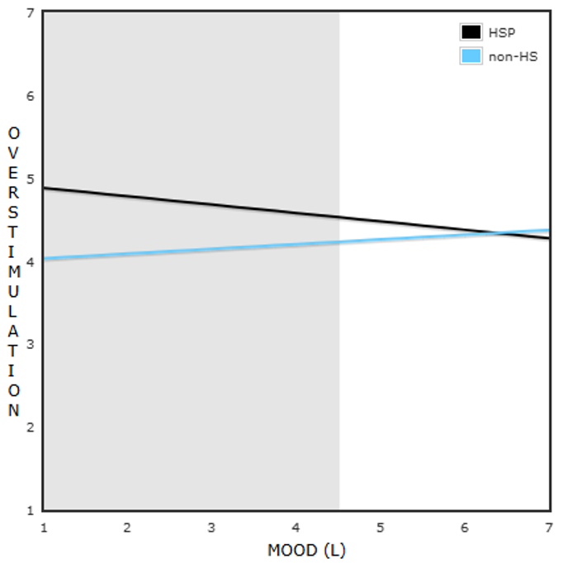
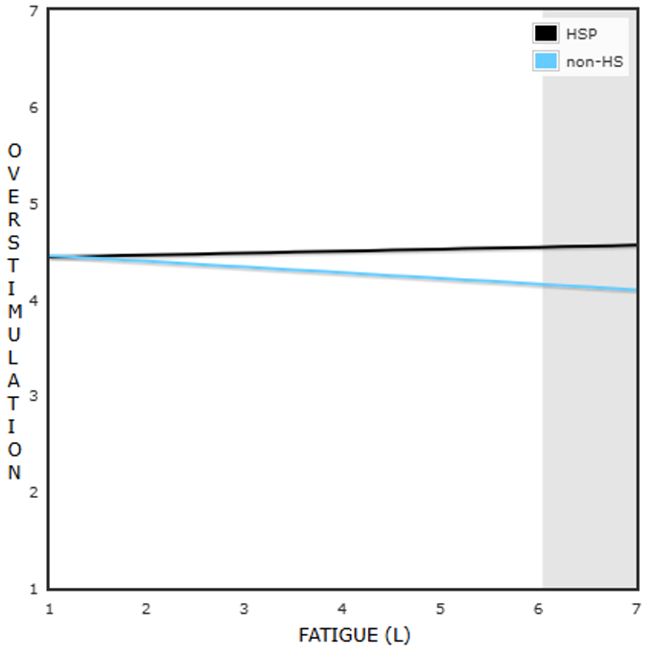
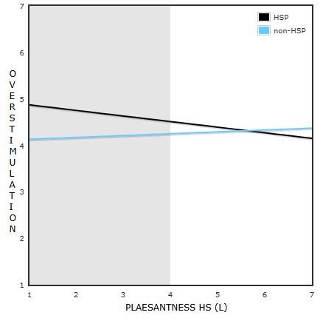
Overstimulation as Predicted by the Interactions of SPS and Pleasantness of High Sense Stimuli (Top Left), Fatigue (Top Right), and Mood (Bottom) as Reported at the Previous Prompt (Lagged Variables)

Note. The grey areas represent the Regions of Significance with respect to X (i.e., Pleasantness high senses, Fatigue, or Mood). HS= high sense stimuli; L = lagged.

Supplementary Material D
Controlling for Age and Sex
Table D1
Multilevel Random Intercept and Slope Model Results Predicting Fluctuations in Overstimulation Including Age and Sex as Covariates (Model 1)
Model 1 | Β (SE) | p -value
Intercept | 4.08*** (0.15) | <.001
Age | 0.00 (0.01) | 0.48
Sex | -0.22 (0.12) | 0.08
Time of the day | 0.45*** (0.08) | <.001
Time of the day² | -0.07*** (0.01) | <.001
Weekday | -0.07 (0.05) | 0.17
SPS | 0.15 (0.13) | 0.28
Time of the day*SPS | 0.04 (0.12) | 0.72
Time of the day²*SPS | -0.01 (0.02) | 0.64
Weekday *SPS | -0.01 (0.08) | 0.38
ICC | .25
R² (fixed effects) | .06
R² (total) | .30
Note. SPS = Sensory Processing Sensitivity, categorized as HSP versus non-HSP; Time of the day² is the quadratic term of time of the day. ICC= Intraclass correlation coefficient. R² = proportion of variance explained by the fixed effects and/or fixed and random effects. Sex was coded with 1 as Female and 2 as Male.
*** p < .001.

Table D2
Multilevel Random Intercept and Slope Model Results Predicting Overstimulation by SPS, the Pleasantness of Stimuli in the Current Environment, the Type of Environment, Mood and Fatigue, and its interactions, Including Momentary and Lagged Variables (Model 2-5), Including Age and Sex as Covariates

 | Within-person centered predictors (momentary observations) |  | Time-lagged predictors (previous observation)
 | Β (SE) | p -value | Β (SE) | p -value
Model 2: Pleasantness of stimuli
Intercept | 4.08*** (0.12) | <.001 | 4.06*** (0.23) | <.001
Age | 0.01 (0.00) | 0.575 | 0.00 (0.00) | 0.579
Sex | -0.17 (0.11) | 0.110 | -0.23 (0.13) | 0.080
Pleasantness high senses | -0.11* (0.05) | 0.022 | 0.05 (0.03) | 0.190
Pleasantness low senses | -0.10** (0.04) | 0.007 | 0.01 (0.04) | 0.880
SPS | 0.13 (0.09) | 0.15 | 0.86** (0.27) | 0.002
Pleasantness high senses * SPS | -0.23*** (0.07) | <.001 | -0.17** (0.05) | 0.001
Pleasantness low senses * SPS | 0.02 (0.05) | 0.683 | -0.01 (0.06) | 0.920
ICC | .25 |  | .20
R² (fixed effects) | .06 |  | .02
R² (total) | .30 |  | .21
Model 3: Type of environment
Intercept | 4.12*** (0.22) | <.001 | 4.23*** (0.14) | <.001
Age | 0.00 (0.00) | 0.586 | 0.00 (0.00) | 0.593
Sex | -0.15 (0.12) | 0.200 | -0.22 (0.13) | 0.086
Alone versus with others | 0.43** (0.14) | 0.002 | 0.15*(0.07) | 0.023
Private versus public | 0.43* (0.20) | 0.030 | 0.05 (0.07) | 0.437
SPS | 0.18 (0.09) | 0.060 | 0.10 (0.11) | 0.367
Alone versus with others * SPS | -0.17 (0.09) | 0.060 | -0.12 (0.10) | 0.239
Private versus public * SPS | 0.05 (0.13) | 0.730 | 0.14 (0.11) | 0.182
ICC | .23 |  | .39
R² (fixed effects) | .06 |  | .01
R² (total) | .27 |  | .39
Model 4: Fatigue
Intercept | 4.12*** (0.11) | <.001 | 4.53*** (0.15) | <.001
Age | 0.00 (0.00) | 0.143 | 0.00 (0.00) | 0.603
Sex | -0.14 (0.11) | 0.210 | -0.28* (0.11) | 0.017
Fatigue | 0.02 (0.03) | 0.495 | -0.06* (0.03) | 0.01
SPS | 0.14 (0.09) | 0.134 | -0.15 (0.16) | 0.333
Fatigue *SPS | 0.13** (0.05) | 0.003 | 0.08* (0.04) | 0.023
ICC | .23 |  | .20
R² (fixed effects) | .03 |  | .02
R² (total) | .25 |  | .21
Model 5: Mood
Intercept | 4.15*** (0.12) | <.001 | 3.89*** (0.28) | <.001
Age | 0.00 (0.00) | 0.341 | 0.00 (0.00) | 0.289
Sex | -0.07 (0.11) | 0.558 | -0.26* (0.12) | 0.035
Mood | -0.12 (0.07) | 0.055 | 0.06 (0.04) | 0.178
SPS | 0.16(0.09) | 0.094 | 0.98** (0.35) | 0.006
Mood*SPS | -0.27** (0.09) | 0.002 | -0.16** (0.06) | 0.006
ICC | .26 |  | .21
R² (fixed effects) | .05 |  | .02
R² (total) | .30 |  | .22
Note. SPS = Sensory Processing Sensitivity, categorized as HSP versus non-HSP; Alone was coded as 0 and with others as 1. Private was coded as 0 and in public places (including the work or school environment) as 1. ICC= Intraclass correlation coefficient. R² = proportion of variance explained by the fixed effects and/or fixed and random effects. Sex was coded with 1 as Female and 2 as Male.
*p < .05; **p < .01; *** p < .001

Supplementary Material E
The Distribution of SPS scores
Figure E1
The Distribution of SPS scores among the Final Sample, as a Continuous Score (a) and a Categorical Score (b)
a
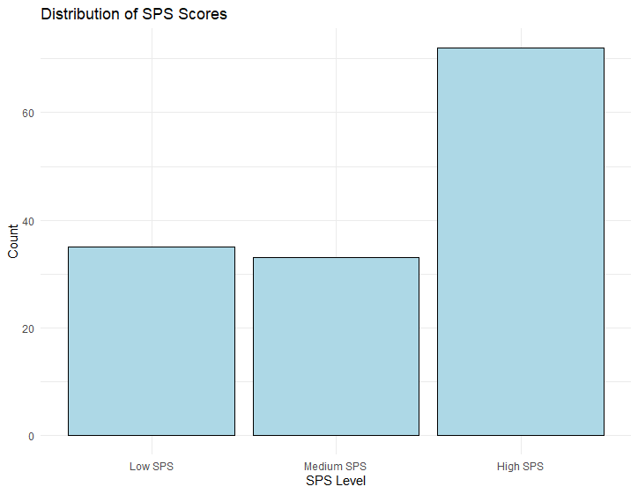
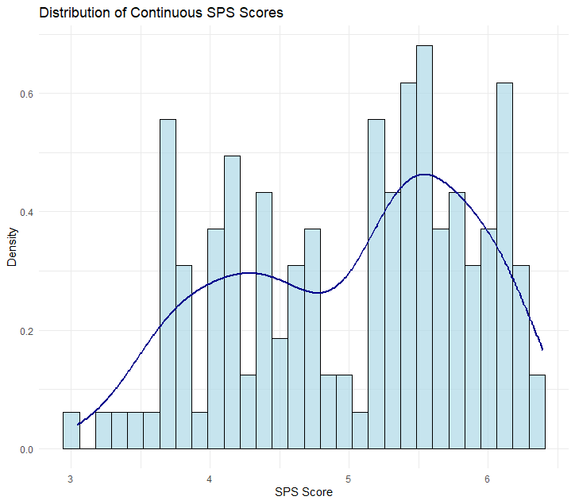
b

Supplementary Material F
Experience Sample Method questionnaire
Stimulation:
How much are you currently under- or overstimulated (-3 to +3)
Pleasantness sensory stimuli and stimulation
    - How unpleasant to pleasant would you rate below stimuli, if present in your current environment: (scale: 1-7)
      - Lights
      - Sounds
      - Bright colors
      - Being touched (by others or by clothes)
      - Tastes
      - Smells
      - Moving objects (passing cars)
      - Art
      - Music
      - Temperature
      - Multiple stimuli at the same time
      - Other:….
Fatigue
    - How physically tired are you? (1-7)
    - How mentally tired are you? (1-7)
Mood
    - How do you currently feel (mood): scale: 1-7
      - Happy (pos)
      - Irritated (neg)
      - Anxious (neg)
      - Satisfied (pos)
      - Uncertain (neg)
      - Lonely (neg)
      - Guilty (neg)
      - Relaxed (pos)
      - At ease (pos)
      - Suspicious (neg)
      - Sad (neg)
      - Restless (neg)
      - Gloomy (neg)
      - Relieved (pos)
      - Lethargic (neg)
      - Agitated (neg)
      - Stressed (neg)
      - Energetic (pos)
      - Good (pos)
Environment
    - Where are you at the moment?
      - At home
      - With family or friends
      - At work or at school
      - Health care
      - Public activity (cinema, concert, …)
      - On the way (on the street, in the train, on the bike)
      - In nature
      - In the supermarket/bakery
      - In a bar or restaurant
      - In the sport club
      - Somewhere else:….
    - At the moment I am with:
      - Nobody
      - Friend(s)
      - Colleague, classmate
      - My partner
      - Parent(s)
      - Brother(s)/sister(s)
      - Family (e.g., aunt, uncle, grandparents)
      - Acquaintance(s)
      - A health care provider (e.g., doctor, psychologist, physiotherapist)
      - Teacher
      - Roomie(s)
      - Unknown other(s)
      - Other: …..

Supplementary Material G
Exploratory and Confirmatory Factor Analyses Pleasantness of Stimuli
Based on theory (Köster, 2003) we checked whether we could reduce the number of dimensions measuring the pleasantness of stimuli across the different modalities by running an Exploratory Factor Analysis (EFA) using principal component analyses and varimax rotation. A multilevel CFA was run in R (package Lavaan) with observations nested within persons, with Full Information Maximum Likelihood (FIML) estimation to deal with missing data and using robust maximum likelihood (MLR) estimation to control for non-normality, to check the model fit indices of the suggested factor structure of the EFA. An acceptable fit is obtained when the Comparative Fit Index (CFI) is .90 or above, and the Mean Root Square Error of Approximation (RMSEA) and Standardized Root Mean Squared Residual (SRMR) are below 1 (Kline, 2016). Results of the EFA showed evidence for a two-factor solution. Factor 1 included lights, sounds, bright colors, moving scenes, music, and multiple stimuli at the same time, further referred to as high sense stimuli. Factor 2 included touches, smells, tastes, and temperature, further referred to as low sense stimuli. Multilevel CFA showed an acceptable model fit for the two-factor solution (CFI = .90, RMSEA = .06, SRMR = .06). The factor loadings are reported in Table G1.

Table G1
Standardized Factor Loadings of the Multilevel CFA Regarding Pleasantness of Stimuli Across Modalities
Pleasantness of Stimuli | Pleasantness of High Sense (λ1) | Pleasantness of Low Sense  (λ2)
Lights | 0.75***
Sounds | 0.71***
Bright colors | 0.74***
Moving scenes | 0.63***
Music | 0.43***
Multiple stimuli | 0.52***
Touches |  | 0.55***
Smells |  | 0.48***
Tastes |  | 0.40***
Temperature |  | 0.52***
Note. Λ = standardized factor loading; *** p < .001.

Reference:
Köster, E. P. (2003). The psychology of food choice: Some often encountered fallacies. The Sixth Sense - 6th Sensometrics Meeting, 14(5), 359–373. https://doi.org/10.1016/S0950-3293(03)00017-X

Supplementary Material H
The Distribution of Age and Sex According to the SPS Scores
Figure H1
The Distribution of Age (a) and Sex (b) According to the SPS Scores
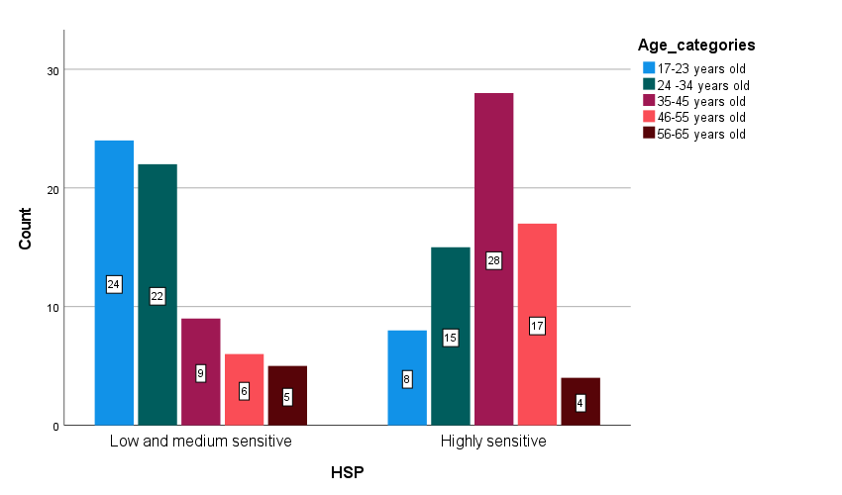
a

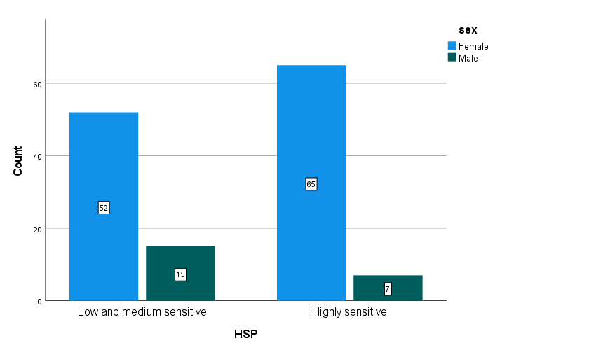
b)

