Supplement Table 1: Characteristics in the training and the validation cohort
 | Total | Training set | Validation set | P
 | N=2494 | N=1745 | N=749
Age, y | 34.00 [31.00;36.00] | 34.00 [31.00;36.00] | 34.00 [31.00;36.00] | 0.941
BMI, kg/m², n (%) |  |  |  | 0.510
≤22.83 | 1609 (64.5) | 1133 (64.9) | 476 (63.6)
>22.83 | 885 (35.5) | 612 (35.1) | 273 (36.4)
LH/FSH, n (%) |  |  |  | 0.172
​≤1.03 | 237 (9.5) | 175 (10.0) | 62 (8.3)
​>1.03 | 2257 (90.5) | 1570 (90.0) | 687 (91.7)
E2, pmol/L, n (%) |  |  |  | 0.487
​≤175.50 | 1469 (58.9) | 1020 (58.5) | 449 (59.9)
​>175.50 | 1025 (41.1) | 725 (41.5) | 300 (40.1)
P, nmol/L, n (%) |  |  |  | 0.033
​≤1.19 | 1224 (49.1) | 832 (47.7) | 392 (52.3)
​>1.19 | 1270 (50.9) | 913 (52.3) | 357 (47.7)
T, nmol/L, n (%) |  |  |  | 0.952
​≤0.74 | 1876 (75.2) | 1312 (75.2) | 564 (75.3)
​>0.74 | 618 (24.8) | 433 (24.8) | 185 (24.7)
A, nmol/L, n (%) |  |  |  | 0.316
​≤11.45 | 2314 (92.8) | 1625 (93.1) | 689 (92)
​>11.45 | 180 (7.2) | 120 (6.9) | 60 (8)
AMH, ng/ml, n (%) |  |  |  | 0.566
​≤3.50 | 1768 (70.9) | 1243 (71.2) | 525 (70.1)
​>3.50 | 726 (29.1) | 502 (28.8) | 224 (29.9)
PCOS, n (%) |  |  |  | 0.741
NO | 2232 (89.5) | 1564 (89.6) | 668 (89.2)
YES | 262 (10.5) | 181 (10.4) | 81 (10.8)
Embryo cryopreservation, n (%) |  |  |  | 0.382
Frozen embryo | 1152 (46.2) | 816 (46.8) | 336 (44.9)
Fresh embryo | 1342 (53.8) | 929 (53.2) | 413 (55.1)
Protocol of controlled ovarian stimulation/Endometrial preparation plan, n (%) |  |  |  | 0.370
CC | 3 (0.1) | 2 (0.1) | 1 (0.1)
Ultralong GnRH agonist | 187 (7.5) | 118 (6.8) | 69 (9.2)
Long GnRH agonist | 295 (11.8) | 203 (11.6) | 92 (12.3)
Short GnRH agonist | 20 (0.8) | 14 (0.8) | 6 (0.8)
GnRH agonist | 837 (33.6) | 592 (33.9) | 245 (32.7)
Natural cycle | 598 (24) | 431 (24.7) | 167 (22.3)
Artificial cycle | 554 (22.2) | 385 (22.1) | 169 (22.6)
Frequency of hysteroscopic surgery | 0.00 [0.00, 1.00] | 0.00 [0.00, 1.00] | 0.00 [0.00, 1.00] | 0.297
Frequency of curettage operation | 0.00 [0.00, 1.00] | 0.00 [0.00, 1.00] | 0.00 [0.00, 1.00] | 0.098
Last intrauterine operation within 6 months from the last menstruation |  |  |  | 0.636
No | 983 (39.4) | 678 (38.9) | 305 (40.7)
Yes | 422 (16.9) | 301 (17.2) | 121 (16.2)
No operation | 1089 (43.7) | 766 (43.9) | 323 (43.1)
G | 0.00 [0.00, 1.00] | 0.00 [0.00, 1.00] | 0.00 [0.00, 1.00] | 0.037
P |  |  |  | 0.648
0, n (%) | 2336 (93.7) | 1637 (93.8) | 699 (93.3)
≧1, n (%) | 158 (6.3) | 108 (6.2) | 50 (6.7)
Twin pregnancy, n (%) |  |  |  | 0.003
No | 1969 (78.9) | 1405 (80.5) | 564 (75.3)
Yes | 525 (21.1) | 340 (19.5) | 185 (24.7)
Prepregnancy diabetes, n (%) |  |  |  | 0.158
No | 2442 (97.9) | 1704 (97.7) | 738 (98.5)
Yes | 52 (2.1) | 41 (2.3) | 11 (1.5)
Prepregnancy hypertension, n (%) |  |  |  | 0.620
No | 2428 (97.4) | 1697 (97.2) | 731 (97.6)
Yes | 66 (2.6) | 48 (2.8) | 18 (2.4)
Uterine length, cm, n (%) |  |  |  | 0.960
​≤4.95 | 1457 (58.4) | 1020 (58.5) | 437 (58.3)
​>4.95 | 1037 (41.6) | 725 (41.5) | 312 (41.7)
Cervical length, cm, n (%) |  |  |  | 0.530
​≤3.15 | 1588 (63.7) | 1118 (64.1) | 470 (62.8)
​>3.15 | 906 (36.3) | 627 (35.9) | 279 (37.2)

Supplement Table 2: LASSO regression screening predictors
Predictors
BMI>22.83, kg/m² | 0.270064629
Testosterone>0.74, nmol/L | 0.704966658
Androstenedione>11.45, nmol/L | 1.238894845
AMH>3.50, ng/ml | 0.18913382
PCOS | 0.378188224
Frequency of hysteroscopic surgery | 0.187945633
Previous gravidity | 0.060439953
Pre-pregnancy diabetes | 0.759875024
Prepregnancy hypertension | 0.109539813
Cervical length>3.15,cm | -0.141304704

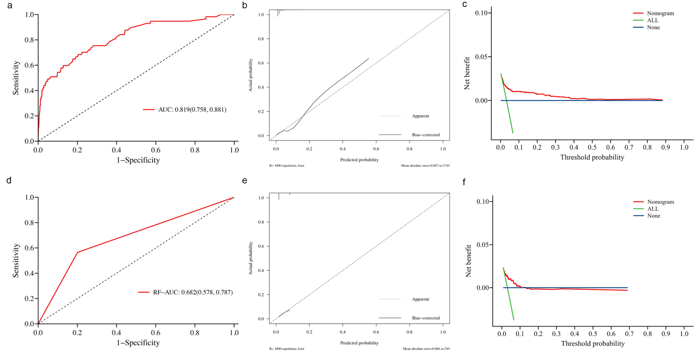
Supplement Figure 1 The optimal cutoff value of the risk score was determined by maximizing the Youden index to achieve the best balance between sensitivity and specificity. In the training set, this threshold was identified as 84.523, a: ROC curve of cutoff value in training set to predict cervical insufficiency rate in patients undergoing IVF-ET. b: The calibration curve of the training set. c: The DCA curve of the training set. d:ROC curve of cutoff value in validation set . e: The calibration curve of the validation set. f: The DCA curve of the validation set

