Additional File

Evaluation of heat warning thresholds with multiple lagged and cumulative health impacts based on a 20-year population database
Shih-Chun Candice Lung^{a,b,c}*, Jou-Chen Joy Yehª, Jing-Shiang Hwang^{d}, and Long-Sheng Chen^{e,f}

ªResearch Center for Environmental Changes, Academia Sinica, No. 128, Sec. 2, Academia Rd. Nangang, Taipei, Taiwan 115. sclung@rcec.sinica.edu.tw; joyyeh100@gate.sinica.edu.tw.
^{b}Department of Atmospheric Sciences, National Taiwan University, No. 1, Sec. 4, Roosevelt Rd., Taipei, Taiwan 106.
^{c}Institute of Environmental and Occupational Health Sciences, National Taiwan University, No. 17, Xuzhou Rd., Taipei, Taiwan 100.
^{d} Institute of Statistical Science, Academia Sinica, No. 128, Sec. 2, Academia Rd. Nangang, Taipei, Taiwan 115. hwang@sinica.edu.tw
^{e} Health Promotion Administration, Ministry of Health and Welfare, No.36, Tacheng St., Datong Dist., Taipei City, Taiwan 103.
^{f} Taiwan Centers for Disease Control, Ministry of Health and Welfare, No. 6, Linsen S. Rd., Jhongjheng District, Taipei City, Taiwan 100. lschen@cdc.gov.tw
*Corresponding author, Research Center for Environmental Changes, Academia Sinica, No. 128, Sec. 2, Academia Rd, Nangang, Taipei, Taiwan 11529; Tel: 886-2-27875908, Fax: 886-2-27833584, email: sclung@rcec.sinica.edu.tw.

List of the tables and figures in this additional file

Table S1. The International Classification of Diseases, Clinical Modification (ICD-CM) for (a) diseases analyzed and (b) hyper group.
Table S2. The relative risks of the selected health outcomes (heat-related illness and cardiovascular disease in this case) in models with lags of 0-2 and 0-3 at thresholds of 33.5 ℃ and 34 ℃.
Table S3. Numbers of daily (a) emergency visits, (b) hospitalized cases, and (c) mortality for the studied outcomes in Taiwan as a whole, for the group of hypertension, hyperglycemia, and hyperlipidemia (shorten as hyper group), for different sex and age groups, insurance categories, and areas in the studied period.
Figure S1. The six divisions of Taiwan and the distribution of the weather stations in this work
Figure S2. The numbers of days with daily maximum temperature (Tmax) in the category of 34-36 (gray), 36-38 (yellow), and ≥ 38 ℃ (orange) in 2000-2019 in (a) N1, (b) N2, (c) Central areas. The other areas have no days ≥ 36 ℃, thus not shown in the graph.
Figure S3. The numbers of cases with consecutive 3 days of daily maximum temperature (Tmax) in the category of 32-34 (gray), 34-36 (yellow), and ≥ 36 ℃ (orange) in 2000-2019 in (a) entire Taiwan, (b) N1, (c) N2, (d) Central, (e) S1 areas. The other areas have no days ≥ 34 ℃, thus not shown in the graph.
Figures S4. The relationships between temperature and multiple health outcomes for (a) emergency visits, (b) hospitalization cases, and (c) mortality. They are mostly linear above certain thresholds in the higher end, with some exceptions at the very highest temperatures which may be affected by rare events. The Y-axis is log RR.
Table S1. The International Classification of Diseases, Clinical Modification (ICD-CM) for (a) diseases analyzed and (b) hyper group.
 | Emergency visits and hospital cases |  | mortality
 | ICD-9-CM | ICD-10-CM | ICD10
- diseases analyzed
Heat-related illnesses (HRI) | 992 | T67 | ..
Cardiovascular Diseases (CVD) | 390-459 | I00-I99 | I00-I99
Ischemic Heart Disease (IHD) | 410-414 | I20-I25 | I20-I25
Stroke | 430-438 | I60-I69 | I60-I69
Respiratory Disease (RD) | 460-519 (excluding 495, 500-508) | J00-J99 (excluding J60-J70) | J00-J99 (excluding J60-J70)
Pneumonia | 480-486 | J12-J18 | J12-J18
Asthma | 493 | J45 | J45-J46
Chronic Obstructive Pulmonary Disease (COPD) | 490-492, 496 | J40-J44 | J41-J44
Diabetes Mellitus (DM) | 250 | E08-E13 | E10-E14
Kidney Diseases (KD) | 580-589 | I12-I13, N00-N05, N07, N11, N14, N17-N19 | I12-I13, N00-N05, N07, N11, N14, N17-N19
Acute Kidney Failure (AKF) | 584 | N17 | N17
Urolithiasis | 592, 594 | N20-N22
- hyper group
Hyperglycemia | 250, 790.2, 791.5, 791.6 | E08-E13, R73.0, R73.9, R81, R82.4 | ..
Hyperlipidemia | 272 | E71.30, E75.2, E57.3, E75.5-E75.6, E77, E78.0-E78.9 (excluding E78.71 and E78.72), E88.1, E88.2, E88.89 | ..
Hypertension | 401-405, 437.2 | I10-I15, I67.4 | ..

Table S2. The relative risks of the selected health outcomes (heat-related illness and cardiovascular disease in this case) in models with lags of 0-2 and 0-3 at thresholds of 33.5 and 34 ℃.

The choice of lag days |  | Model with lags 0-2 |  | Model with lags 0-3
Threshold (℃) |  | 33.5 | 34 | 33.5 | 34
Heat-related illnesses (HRI)
Lag 0 | RR | 2.08 | 5.63 | 2.01 | 5.14
 | (95 % CI) | (1.91,2.27) | (4.25,7.46) | (1.84,2.19) | (3.88,6.81)
 | p-value | <0.0001 | <0.0001 | <0.0001 | <0.0001
Lag 1 | RR | 1.29 | 1.39 | 1.25 | 1.39
 | (95 % CI) | (1.17,1.43) | (1.00,1.94) | (1.13,1.38) | (1.00,1.93)
 | p-value | <0.0001 | 0.05 | <0.0001 | 0.0488
Lag 2 | RR | 1.16 | 0.76 | 1.16 | 0.7
 | (95 % CI) | (1.05,1.27) | (0.53,1.09) | (1.05,1.29) | (0.49,1.01)
 | p-value | 0.0032 | 0.1337 | 0.004 | 0.0553
Lag 3 | RR | - | - | 1.01 | 0.86
 | (95 % CI) | - | - | (0.92,1.12) | (0.61,1.22)
 | p-value | - | - | 0.808 | 0.3904
Cardiovascular Disease (CVD)
Lag 0 | RR | 1.01 | 1.04 | 1 | 1.02
 | (95 % CI) | (1.00,1.02) | (1.01,1.08) | (0.99,1.01) | (0.98,1.07)
 | p-value | 0.0577 | 0.0085 | 0.7801 | 0.2278
Lag 1 | RR | 1.02 | 1.05 | 1.02 | 1.05
 | (95 % CI) | (1.01,1.03) | (1.02,1.08) | (1.00,1.03) | (1.01,1.09)
 | p-value | <0.0001 | 0.0039 | 0.0096 | 0.0238
Lag 2 | RR | 1.01 | 1.02 | 1.00 | 1.01
 | (95 % CI) | (1.00,1.02) | (0.99,1.05) | (0.99,1.01) | (0.97,1.05)
 | p-value | 0.0235 | 0.2963 | 0.8294 | 0.7779
Lag 3 | RR | - | - | 1.02 | 0.99
 | (95 % CI) | - | - | (1.01,1.03) | (0.95,1.04)
 | p-value | - | - | 0.0016 | 0.7732

Table S3. Numbers of daily (a) emergency visits, (b) hospitalized cases, and (c) mortality for the studied outcomes in Taiwan as a whole, for the group of hypertension, hyperglycemia, and hyperlipidemia (shorten as hyper group), for different sex and age groups, insurance categories, and areas in the studied period.
 | HRI | All-cause mortality | CVD | IHD | Stroke | RD | Pneumonia | Asthma | COPD | DM | KD | AKF | Urolithiasis
(a) emergency visits
The general public | 7 (8.2) | ..a | 1222 (217.1) | 222 (28.9) | 275 (49.1) | 2841 (1161.0) | 431 (175.4) | 174 (54.7) | 188 (37.1) | 444 (108.1) | 302 (125.8) | 19 (12.8) | 274 (55.5)
Hyper Group | 2 (3.0) | .. | 984 (201.9) | 178 (27.9) | 225 (44.5) | 560 (186.5) | 170 (89.3) | 52 (13.4) | 110 (25.4) | 434 (108.3) | 255 (118.4) | 14 (10.4) | 81 (26.5)
Sex & age
0-14 yrs
Female | .. | .. | .. | .. | .. | 566 (298.5) | 65 (29.3) | 23 (12.3) | .. | .. | .. | .. | ..
Male | .. | .. | .. | .. | .. | 741 (388.3) | 80 (34.6) | 43 (22.4) | .. | .. | .. | .. | ..
15-39 yrs
Female | .. | .. | 34 (7.7) | .. | .. | 335 (160.8) | 19 (9.9) | 14 (5.4) | .. | 10 (4.1) | .. | .. | 18 (6.0)
Male | 2 (2.6) | .. | 50 (10.2) | .. | .. | 295 (146.5) | 20 (9.3) | 12 (5.4) | .. | 15 (4.9) | .. | .. | 72 (19.5)
40-64 yrs
Female | .. | .. | 186 (30.9) | 26 (6.3) | 28 (6.6) | 203 (89.2) | 27 (14.9) | 19 (6.0) | 12 (4.9) | 77 (17.6) | 49 (15.8) | .. | 42 (11.0)
Male | 2 (2.8) | .. | 245 (51.0) | 56 (11.6) | 57 (12.7) | 218 (82.4) | 43 (21.1) | 19 (6.1) | 27 (8.4) | 96 (27.6) | 59 (26.9) | .. | 113 (28.0)
≧65 yrs
Female | .. | .. | 351 (79.8) | 55 (10.8) | 78 (17.3) | 188 (67.9) | 65 (35.6) | 19 (6.4) | 29 (8.2) | 139 (36.5) | 91 (43.7) | .. | 11 (4.3)
Male | .. | .. | 350 (65.7) | 73 (12.0) | 99 (20.3) | 296 (72.4) | 112 (51.4) | 24 (8.8) | 96 (17.7) | 105 (29.4) | 86 (40.9) | .. | 18 (6.0)
Insurance categories
Manager & teacher | .. | .. | 14 (4.3) | .. | .. | 27 (15.8) | .. | .. | .. | .. | .. | .. | ..
Service & sales worker | 2 (2.5) | .. | 128 (28.4) | 25 (7.0) | 21 (6.6) | 345 (164.8) | 31 (17.6) | 17 (5.7) | 13 (5.7) | 36 (12.2) | 19 (8.4) | .. | 99 (22.5)
Clerical & support worker | .. | .. | .. | .. | .. | 18 (10.0) | .. | .. | .. | .. | .. | .. | ..
Union workers | .. | .. | 114 (18.9) | 21 (5.2) | 21 (5.4) | 150 (62.5) | 20 (9.3) | 11 (4.4) | 11 (4.2) | 45 (11.1) | 32 (10.4) | .. | 48 (12.4)
Farmer | .. | .. | 257 (44.5) | 45 (9.7) | 60 (12.7) | 191 (53.2) | 54 (24.3) | 18 (6.7) | 44 (10.5) | 93 (22.3) | 60 (23.7) | .. | 28 (8.7)
Fishermen | .. | .. | 18 (6.1) | .. | .. | 24 (11.2) | .. | .. | .. | .. | .. | .. | ..
Low income | .. | .. | 29 (10.8) | .. | .. | 92 (45.1) | 14 (8.6) | .. | .. | 14 (6.7) | 11 (7.1) | .. | ..
Veteran | .. | .. | 125 (24.4) | 28 (8.1) | 28 (7.8) | 98 (21.5) | 33 (13.1) | .. | 28 (7.9) | 38 (10.3) | 23 (9.2) | .. | ..
Others | .. | .. | 132 (39.4) | 24 (7.5) | 31 (10.3) | 180 (58.6) | 34 (17.8) | 15 (4.8) | 18 (6.4) | 50 (18.5) | 36 (19.5) | .. | 28 (7.5)
Areas
N1 area | 2 (2.4) | .. | 337 (61.4) | 69 (11.5) | 79 (17.5) | 849 (396.0) | 134 (55.4) | 54 (19.7) | 48 (12.1) | 106 (29.3) | 78 (33.0) | .. | 83 (19.9)
N2 area | 1 (1.9) | .. | 182 (38.8) | 35 (7.9) | 43 (11.3) | 454 (190.0) | 70 (31.4) | 30 (11.3) | 29 (8.2) | 61 (17.3) | 46 (22.0) | .. | 44 (11.5)
Central area | 2 (2.2) | .. | 276 (57.9) | 46 (9.9) | 64 (15.0) | 543 (196.0) | 85 (38.1) | 29 (9.3) | 44 (13.0) | 108 (30.8) | 65 (28.8) | .. | 61 (14.8)
S1 area | .. | .. | 169 (35.7) | 27 (6.6) | 38 (9.4) | 386 (161.0) | 57 (28.1) | 23 (11.5) | 25 (7.2) | 71 (19.2) | 47 (21.5) | .. | 38 (10.2)
S2 area | .. | .. | 177 (30.3) | 30 (7.1) | 33 (7.6) | 431 (190.0) | 57 (22.4) | 25 (8.7) | 27 (7.6) | 67 (15.8) | 47 (18.4) | .. | 36 (9.7)
East area | .. | .. | 82 (19.7) | 14 (4.9) | 18 (5.5) | 176 (78.3) | 29 (13.1) | 13 (5.5) | 15 (5.4) | 31 (10.8) | 19 (9.4) | .. | 12 (4.2)
(b) hospitalized cases
The general public | 1 (1.7) | .. | 2220 (682.0) | 417 (118.6) | 427 (91.2) | 1581 (344.2) | 696 (207.5) | 132 (35.9) | 287 (62.4) | 1021 (299.6) | 368 (180.9) | 105 (50.0) | 183 (66.0)
Hyper Group | .. | .. | 1907 (650.0) | 369 (110.5) | 370 (80.5) | 732 (190.6) | 345 (137.4) | 66 (17.9) | 203 (46.5) | 1021 (299.6) | 300 (170.1) | 80 (42.0) | 89 (33.4)
Sex & age
0-14 yrs
Female | .. | .. | .. | .. | .. | 176 (49.8) | 87 (30.0) | 12 (5.5) | .. | .. | .. | .. | ..
Male | .. | .. | .. | .. | .. | 226 (62.8) | 103 (34.0) | 20 (7.8) | .. | .. | .. | .. | ..
15-39 yrs
Female | .. | .. | 43 (14.0) | .. | .. | 65 (18.9) | 16 (6.3) | .. | .. | 14 (5.4) | .. | .. | ..
Male | .. | .. | 70 (20.9) | .. | .. | 85 (23.0) | 19 (6.1) | .. | .. | 24 (7.6) | 11 (4.5) | .. | 26 (14.3)
40-64 yrs
Female | .. | .. | 308 (107.8) | 42 (14.8) | 43 (11.5) | 124 (34.8) | 39 (14.7) | 18 (6.7) | 10 (4.3) | 168 (49.2) | 47 (18.8) | .. | 34 (13.3)
Male | .. | .. | 471 (174.5) | 103 (41.6) | 89 (24.3) | 195 (54.3) | 75 (28.0) | 13 (5.1) | 36 (11.2) | 239 (81.8) | 68 (36.2) | 20 (10.7) | 67 (26.7)
≧65 yrs
Female | .. | .. | 627 (198.3) | 108 (27.2) | 121 (26.1) | 267 (70.6) | 134 (54.8) | 32 (9.6) | 53 (12.9) | 304 (85.3) | 109 (60.1) | 32 (17.1) | 17 (6.5)
Male | .. | .. | 690 (191.2) | 156 (43.3) | 162 (36.8) | 442 (94.8) | 223 (75.9) | 25 (12.7) | 181 (40.7) | 270 (82.0) | 120 (67.4) | 38 (18.2) | 30 (11.4)
Insurance categories
Manager & teacher | .. | .. | 25 (9.30) | .. | .. | 12 (4.60) | .. | .. | .. | .. | .. | .. | ..
Service & sales worker | .. | .. | 207 (84.90) | 38 (19.10) | 28 (10.70) | 112 (35.70) | 30 (11.80) | .. | .. | 81 (34.10) | 25 (13.20) | .. | 43 (17.50)
Clerical & support worker | .. | .. | 13 (6.10) | .. | .. | .. | .. | .. | .. | .. | .. | .. | ..
Union workers | .. | .. | 202 (66.1) | 35 (12.8) | 30 (8.8) | 89 (23.5) | 29 (9.6) | .. | 11 (4.4) | 105 (31.6) | 32 (13.6) | .. | 30 (13.0)
Farmer | .. | .. | 472 (119.0) | 88 (24.0) | 94 (22.9) | 244 (47.3) | 111 (34.6) | 22 (8.1) | 76 (17.2) | 213 (52.8) | 79 (36.0) | 24 (10.9) | 28 (12.1)
Fishermen | .. | .. | 34 (15.5) | .. | .. | 16 (6.3) | .. | .. | .. | 18 (8.0) | .. | .. | ..
Low income | .. | .. | 55 (20.2) | .. | 14 (5.1) | 56 (20.3) | 27 (13.9) | .. | 13 (5.0) | 27 (11.8) | 11 (7.3) | .. | ..
Veteran | .. | .. | 236 (61.8) | 56 (20.1) | 50 (18.3) | 144 (35.5) | 69 (20.5) | 11 (6.7) | 59 (22.1) | 91 (24.5) | 35 (14.6) | 12 (5.8) | ..
Others | .. | .. | 232 (93.1) | 42 (17.2) | 46 (14.8) | 134 (40.7) | 59 (25.8) | 11 (4.4) | 26 (8.9) | 109 (43.0) | 42 (25.9) | 13 (8.1) | 18 (7.8)
Areas
N1 area | .. | .. | 598 (198.0) | 127 (42.3) | 106 (26.0) | 366 (89.9) | 165 (53.1) | 31 (9.7) | 62 (15.8) | 258 (82.0) | 94 (46.5) | 28 (14.2) | 49 (18.8)
N2 area | .. | .. | 302 (87.8) | 58 (18.5) | 65 (16.1) | 226 (50.4) | 101 (30.6) | 21 (8.7) | 37 (10.6) | 135 (38.3) | 54 (24.8) | 15 (8.0) | 26 (11.2)
Central area | .. | .. | 435 (134.0) | 78 (22.7) | 88 (21.5) | 340 (76.9) | 137 (44.1) | 25 (8.5) | 61 (15.0) | 203 (63.7) | 72 (35.9) | 19 (9.7) | 43 (18.7)
S1 area | .. | .. | 366 (121.0) | 62 (19.7) | 69 (15.7) | 251 (57.6) | 118 (39.3) | 18 (6.7) | 53 (13.5) | 182 (56.5) | 60 (34.9) | 20 (9.9) | 24 (9.8)
S2 area | .. | .. | 380 (111.0) | 65 (18.2) | 71 (16.6) | 284 (61.8) | 123 (36.4) | 24 (8.6) | 50 (13.7) | 179 (49.2) | 65 (33.2) | 17 (8.8) | 28 (10.6)
East area | .. | .. | 138 (44.6) | 27 (10.3) | 28 (9.0) | 112 (30.3) | 53 (17.4) | 12 (5.1) | 24 (8.8) | 64 (21.7) | 23 (12.0) | .. | 12 (5.9)
(c) mortality
The general public | .. | 367 (42.1) | 85 (14.3) | 21 (5.5) | 27 (5.5) | 46 (10.6) | 26 (8.0) | .. | 13 (3.9) | 45 (9.6) | 10 (3.5) | 48 (9.4) | ..
Hyper Group | .. | 225 (35.2) | 60 (11.7) | 15 (4.6) | 20 (4.8) | 30 (8.4) | 18 (6.5) | .. | .. | 36 (8.4) | .. | 45 (8.7) | ..
Sex & age
0-14 yrs
Female | .. | .. | .. | .. | .. | .. | .. | .. | .. | .. | .. | .. | ..
Male | .. | .. | .. | .. | .. | .. | .. | .. | .. | .. | .. | .. | ..
15-39 yrs
Female | .. | .. | .. | .. | .. | .. | .. | .. | .. | .. | .. | .. | ..
Male | .. | .. | .. | .. | .. | .. | .. | .. | .. | .. | .. | .. | ..
40-64 yrs
Female | .. | 27 (5.6) | .. | .. | .. | .. | .. | .. | .. | .. | .. | .. | ..
Male | .. | 61 (9.1) | 12 (3.8) | .. | .. | .. | .. | .. | .. | .. | .. | .. | ..
≧65 yrs
Female | .. | 120 (20.2) | 32 (7.5) | .. | .. | 15 (5.1) | .. | .. | .. | 18 (5.3) | .. | 20 (5.2) | ..
Male | .. | 149 (19.4) | 35 (7.2) | .. | 12 (3.5) | 26 (6.7) | 14 (4.9) | .. | .. | 18 (5.2) | .. | 18 (5.2) | ..
Insurance categories
Manager & teacher | .. | .. | .. | .. | .. | .. | .. | .. | .. | .. | .. | .. | ..
Service & sales worker | .. | 16 (4.3) | .. | .. | .. | .. | .. | .. | .. | .. | .. | .. | ..
Clerical & support worker | .. | .. | .. | .. | .. | .. | .. | .. | .. | .. | .. | .. | ..
Union workers | .. | 21 (4.6) | .. | .. | .. | .. | .. | .. | .. | .. | .. | .. | ..
Farmer | .. | 80 (10.1) | 19 (4.7) | .. | .. | 11 (3.8) | .. | .. | .. | 10 (3.3) | .. | .. | ..
Fishermen | .. | .. | .. | .. | .. | .. | .. | .. | .. | .. | .. | .. | ..
Low income | .. | 12 (3.9) | .. | .. | .. | .. | .. | .. | .. | .. | .. | .. | ..
Veteran | .. | 40 (6.9) | 10 (3.3) | .. | .. | .. | .. | .. | .. | .. | .. | .. | ..
Others | .. | 50 (11.8) | 12 (4.3) | .. | .. | .. | .. | .. | .. | .. | .. | .. | ..
Areas
N1 area | .. | 98 (14.4) | 23 (5.9) | .. | .. | 11 (4.5) | .. | .. | .. | 12 (3.7) | 12 (3.8) | .. | ..
N2 area | .. | 51 (9.2) | 13 (4.0) | .. | .. | .. | .. | .. | .. | .. | .. | .. | ..
Central area | .. | 71 (11.4) | 16 (4.2) | .. | .. | .. | .. | .. | .. | .. | .. | .. | ..
S1 area | .. | 61 (9.9) | 13 (4.0) | .. | .. | .. | .. | .. | .. | .. | .. | .. | ..
S2 area | .. | 65 (10.6) | 14 (4.3) | .. | .. | .. | .. | .. | .. | .. | .. | .. | ..
East area | .. | 20 (4.8) | .. | .. | .. | .. | .. | .. | .. | .. | .. | .. | ..
ª: the daily average cases were less than 10 or no case thus not listed here
Note: HRI: Heat-related illnesses, CVD: Cardiovascular Diseases, IHD: Ischemic Heart Disease, RD: Respiratory Disease, COPD: Chronic Obstructive Pulmonary Disease, DM: Diabetes Mellitus, KD: Kidney Diseases, AKF: Acute Kidney Failure
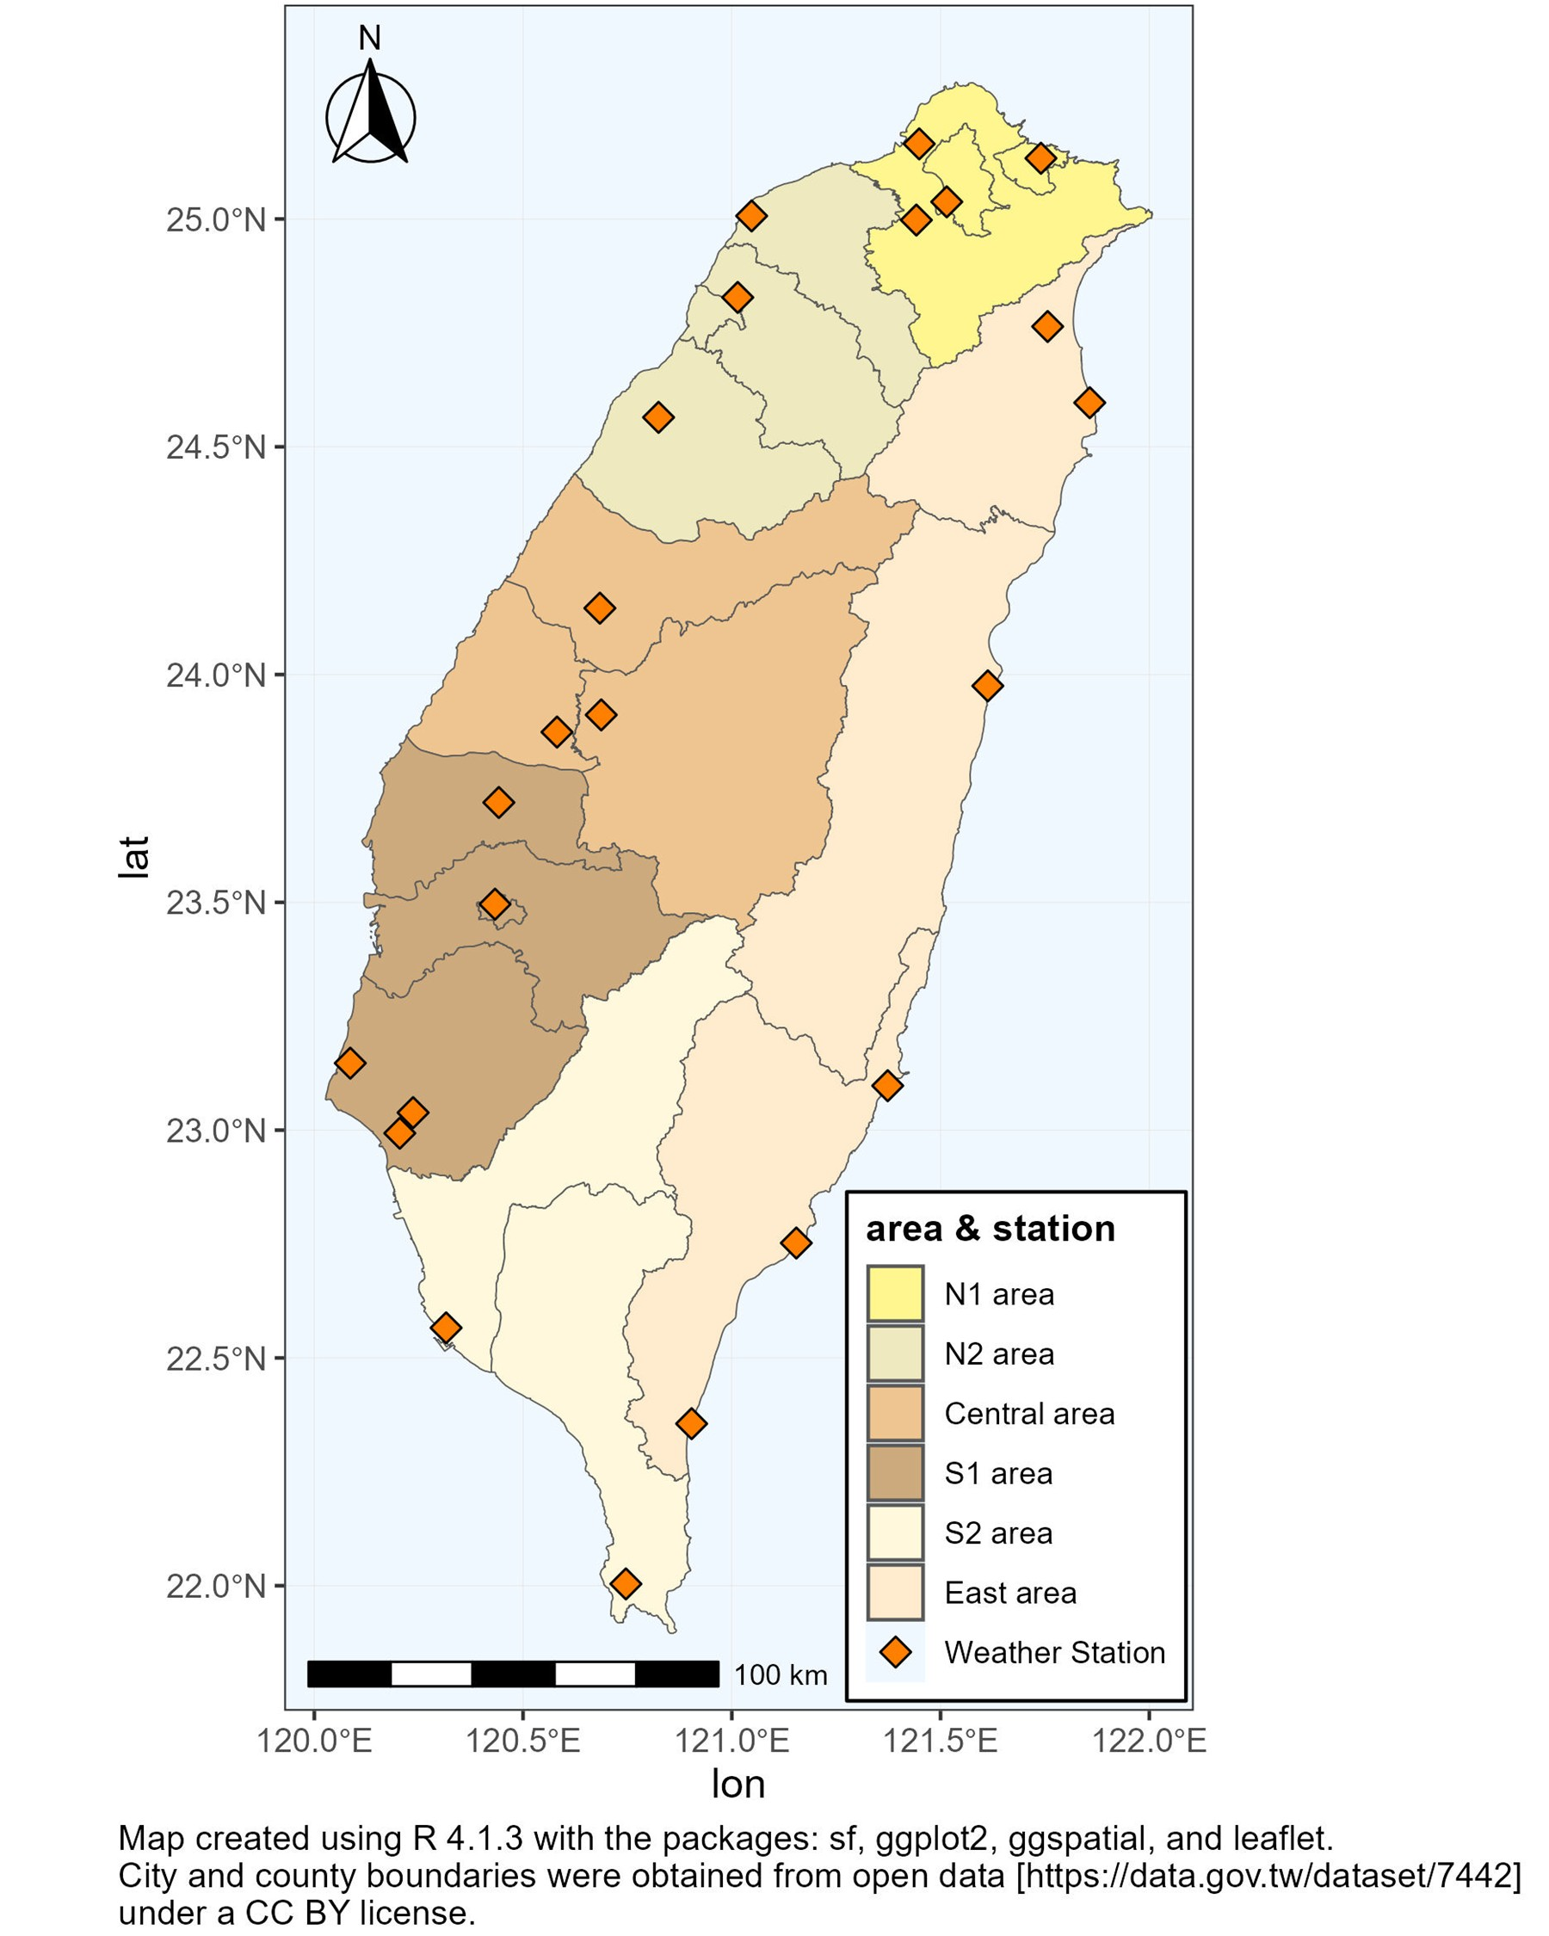
Figure S1. The six divisions of Taiwan and the distribution of the weather stations in this work

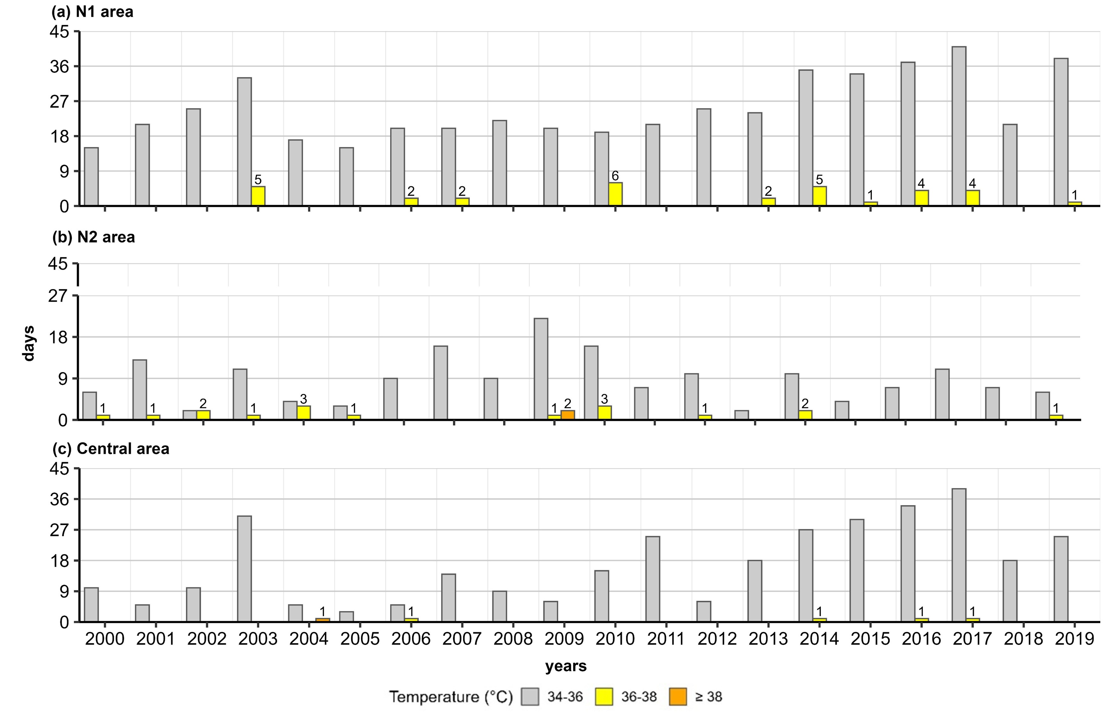
Figure S2. The numbers of days with daily maximum temperature (Tmax) in the category of 34-36 (gray), 36-38 (yellow), and ≥ 38 ℃ (orange) in 2000-2019 in (a) N1, (b) N2, (c) Central areas. The other areas have no days ≥ 36 ℃, thus not shown in the graph.
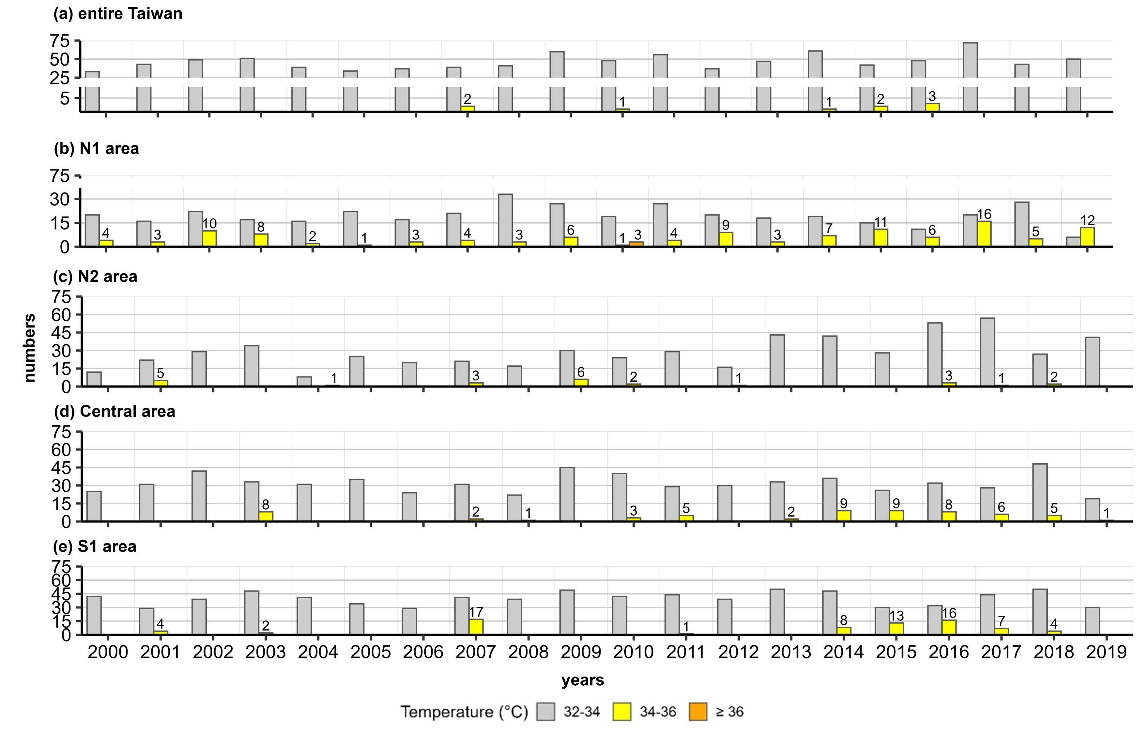
Figure S3. The numbers of cases with consecutive 3 days of daily maximum temperature (Tmax) in the category of 32-34 (gray), 34-36 (yellow), and ≥ 36 ℃ (orange) in 2000-2019 in (a) entire Taiwan, (b) N1, (c) N2, (d) Central, (e) S1 areas. The other areas have no days ≥ 34 ℃, thus not shown in the graph.
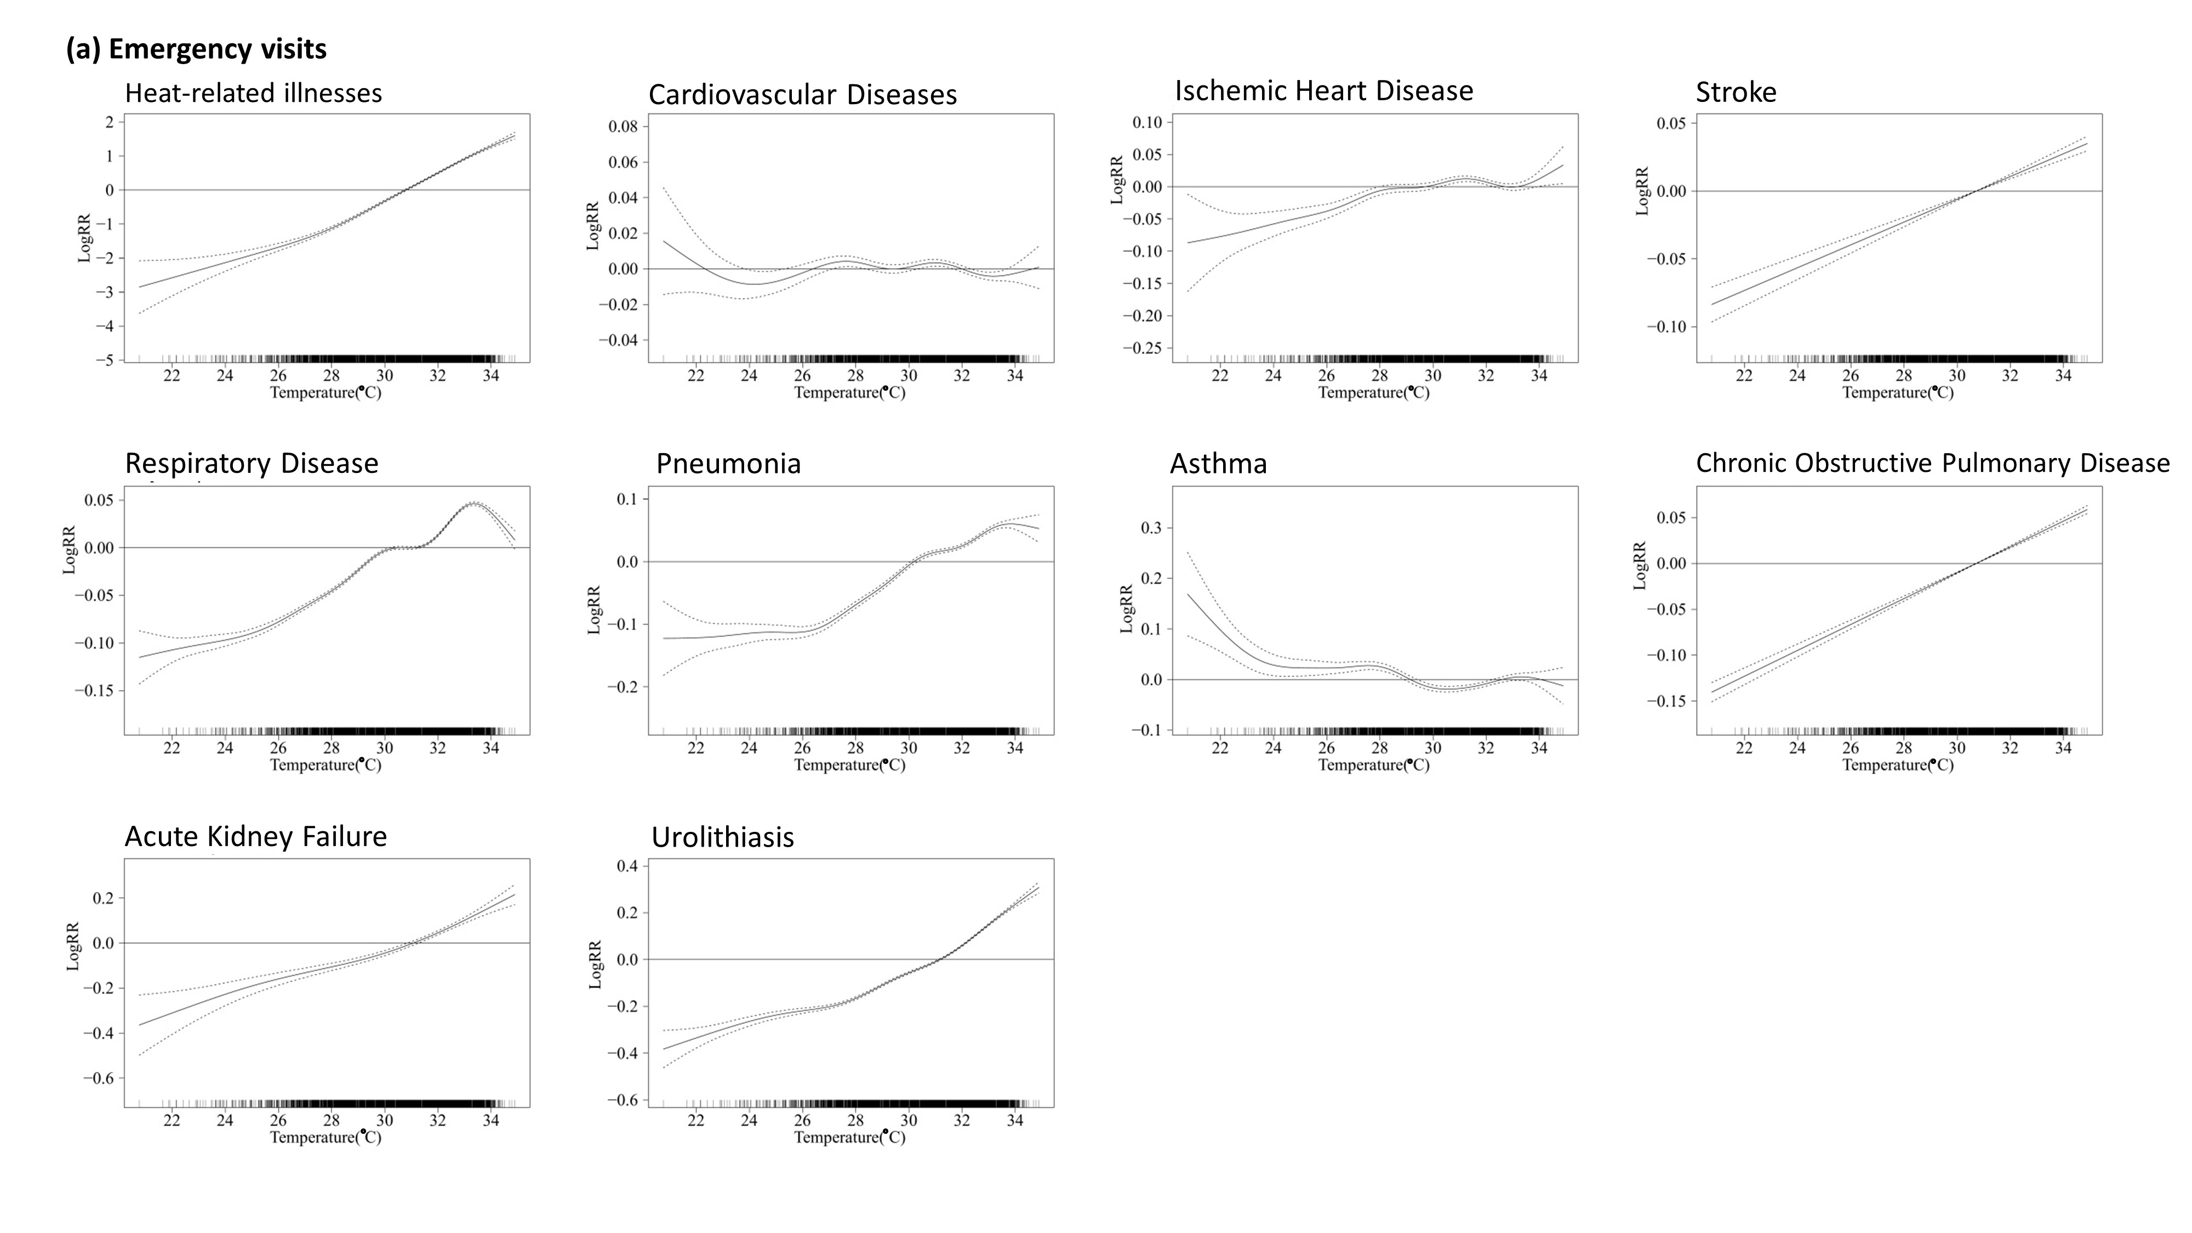
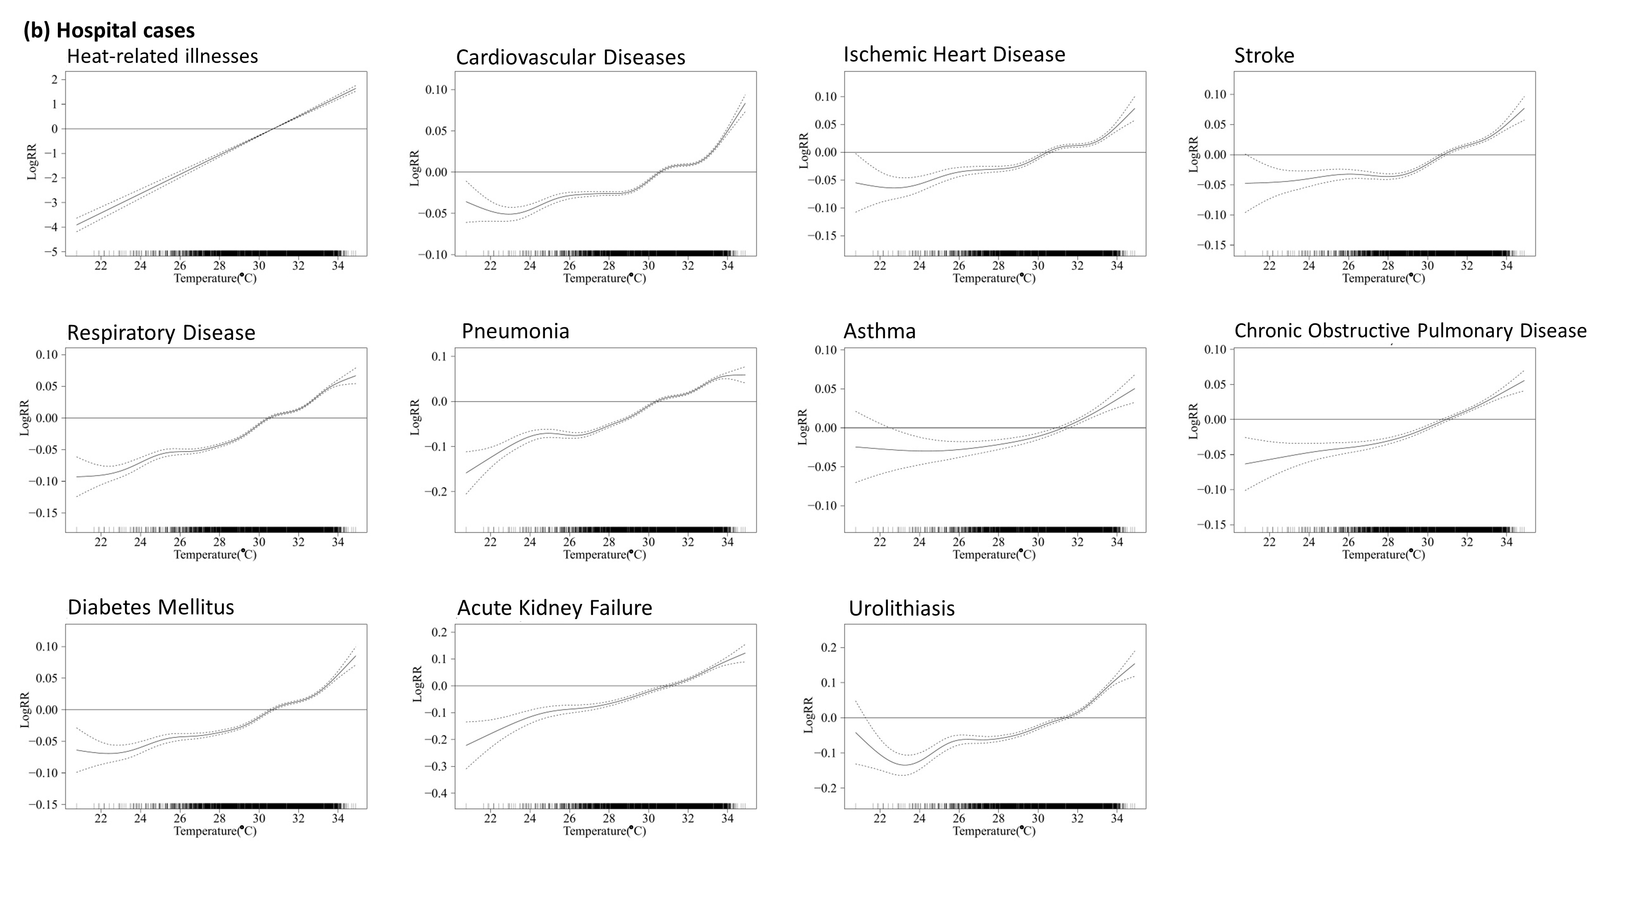
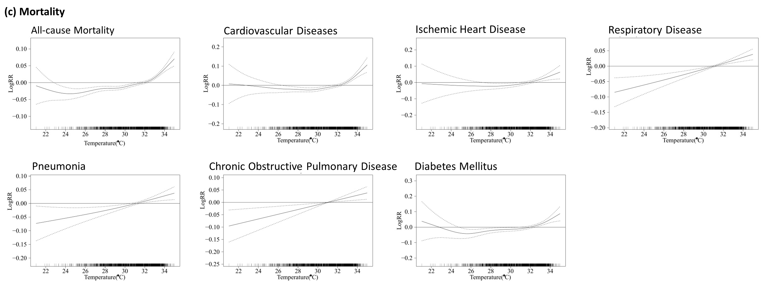
Figure S4. The relationships between temperature and multiple health outcomes for (a) emergency visits, (b) hospitalization cases, and (c) mortality. They are mostly linear above certain thresholds in the higher end, with some exceptions at the very highest temperatures which may be affected by rare events. The Y-axis is log RR.

