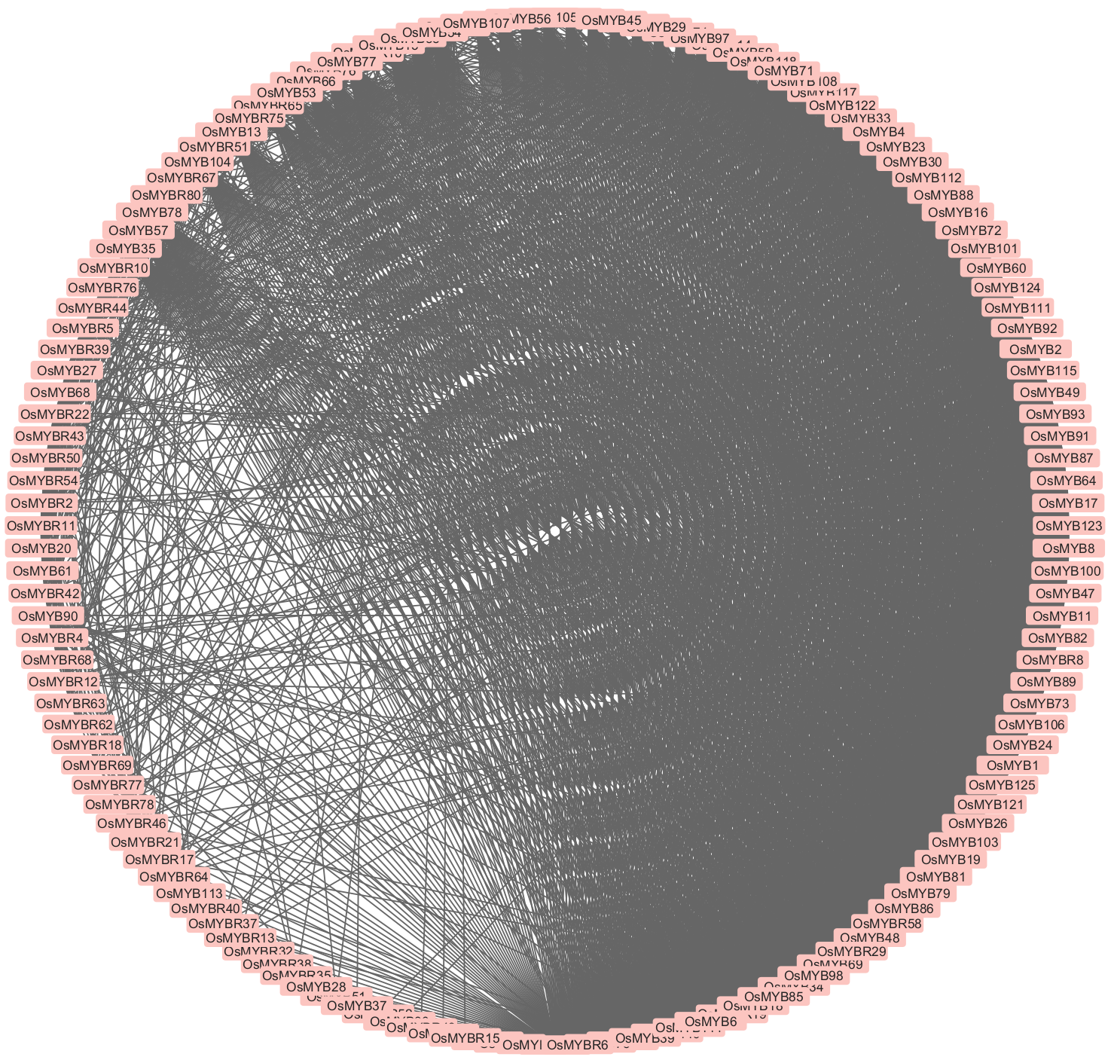Fig. S1. The PPIs network for 183 MYBs TFs (123 MYB genes and 60 MYB-related genes) that have been obtained from the GRASSIUS Grass Regulatory Information Server (https://grassius.org/species/Rice). By adopting the STRING-v11.5 database (https://string-db.org/), the PPIs network of 183 MYBs TFs was created with a confidence score of > 0.62 and an extreme number of interactors of 0, and the Cytoscape-v3.9.1 software was used to figure out the 183 MYBs TFs in the network. Summary of statistics: number of nodes 149, number of edges 3896, expected number of edges 528. characteristic path length 3.325, average local clustering coefficient 0.61, network density 0.065, and P-value < 1.0e-16. In the figure, a deep black color indicates that the genes are more closely related, while a lighter color indicates they are less related to each other. PPIs, protein-protein interactions; TFs, transcription factors.

