Supplementary Tables and Figures in order of appearance:
Supplementary Table I: Characteristics of the control group and a subgroup of 25 pediatric patients with T1D duration of less than 2 years, classified according to HbA1c as specified in the methods section.
Supplementary Figure I: CSA (in mm², Panel A: at wrist (A, Location 1) and B: at mid-forearm (Location 2)) in patients with T1D duration of less than 2 years according to glycemic management (refer to methods section) compared to healthy controls.
Supplementary Figure II: Correlation between HbA1c (in %) and BSA-adjusted CSA (CSA/BSA in mm²/m² at mid-forearm (Location 2)) in patients with T1D duration of less than 2 years.

Supplementary Table I: Characteristics of the control group and a subgroup of 25 pediatric patients with T1D duration of less than 2 years, classified according to HbA1c as specified in the methods section.
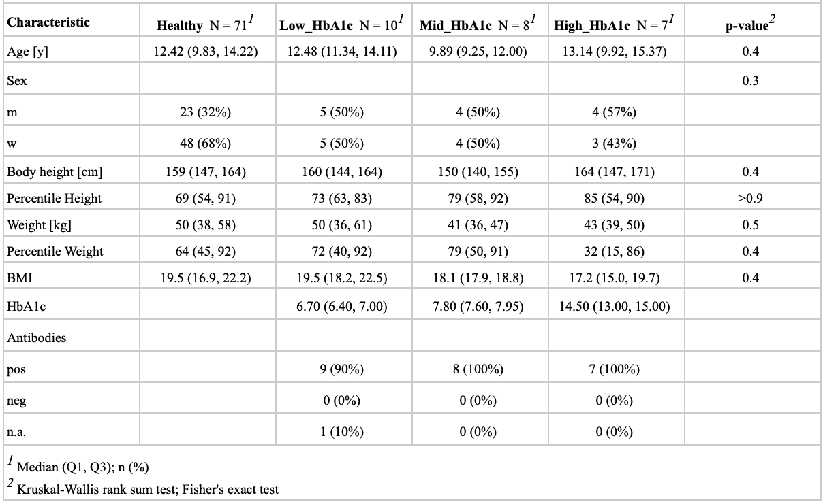

Supplementary Figure I: CSA (in mm², Panel A: at wrist (A, Location 1) and B: at mid-forearm (Location 2)) in patients with T1D duration of less than 2 years according to glycemic management (refer to methods section) compared to healthy controls.

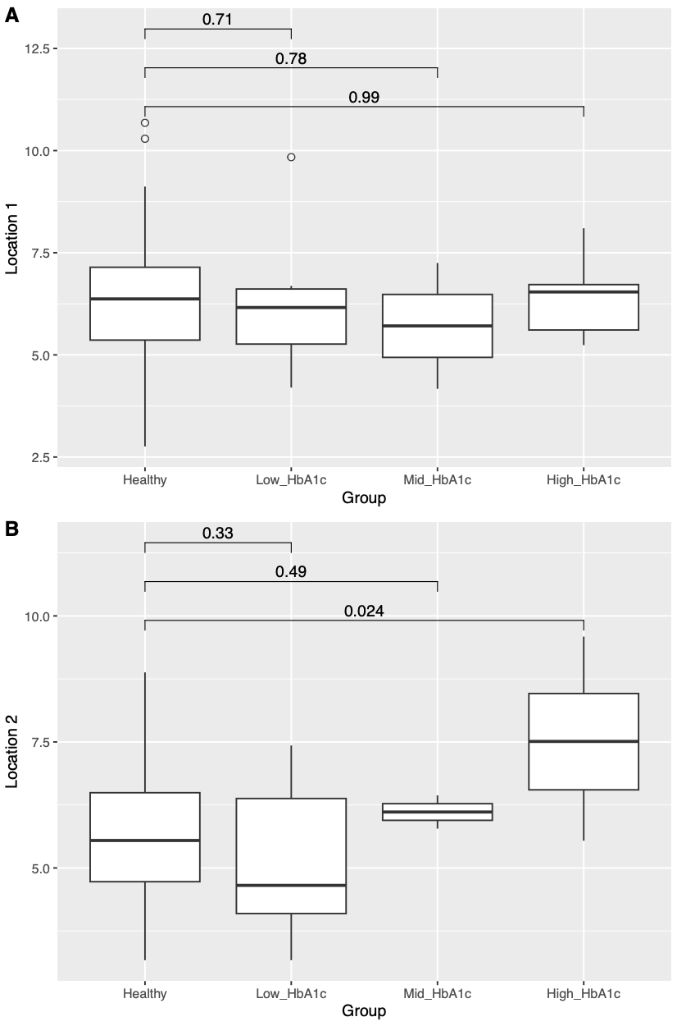

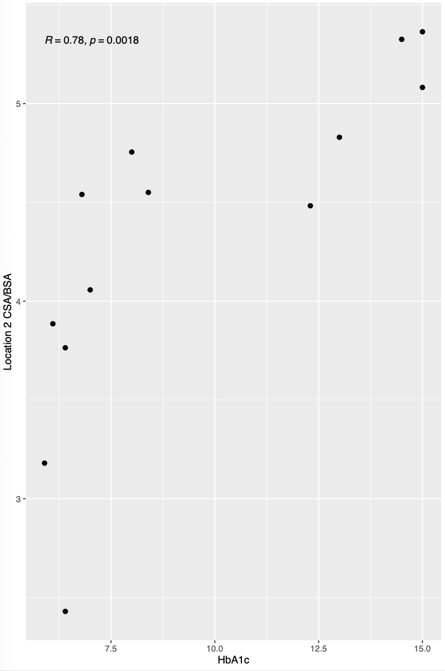
Supplementary Figure II: Correlation between HbA1c (in %) and BSA-adjusted CSA in (CSA/BSA in mm²/m² at mid-forearm (Location 2)) patients with T1D duration of less than 2 years.

