SUPPLEMENTAL DATA

Table S1: Pseudo-total concentrations of 3 TE (Cd, Pb, and Zn) in the soil of the experimental site.Values are means ± SD.
 | Total TE concentrations (mg. Kg⁻¹)
Cd | 6.6±0,4
Pb | 394.7±21,8
Zn | 427.5±4.7
For the determination of total TE, soil samples were digested using a microwave system (Multiwave 3000, Anton Paar, St Albans, UK) in accordance with NF-EN-13656. Briefly, 0.5 g of soil was digested at 180 °C for 20 min in a mixture of 2 mL nitric acid (67%), 6 mL hydrochloric acid (36%), and 2 mL hydrofluoric acid (48%). The resulting extract was filtered through Whatman® filter paper (0.45 µm) and stored prior to analysis. Total concentrations of Cd, Pb, and Zn were determined either by inductively coupled plasma–optical emission spectrometry (ICP-OES, ICAP 6300 DUO, ThermoFisher Scientific, Loughborough, UK) or by inductively coupled plasma–mass spectrometry (ICP-MS, Varian 820 MS, Varian, Palo Alto, CA, USA), depending on the concentration levels. A certified reference material (ERM-CC141, loam soil, Sigma Aldrich, St Louis, MO, USA) was included for analytical quality control.

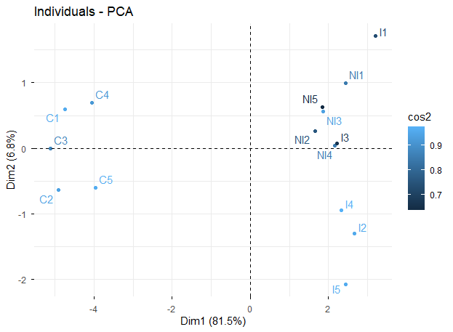
Fig. S1: Principal components of the composition of the three essential oils under study (i.e. inoculated I, non-inoculated NI and Commercial C) showed that I and NI EOs were similar but different comparing to the commercial one.

