Supplementary Figure 2: Population genetic substructure compared to self-reported ethnicity. A: Scatterplot of PC1 v PC2 of the genetic substructure with minimal clustering of self-reported ethnicity evident. B: Scatterplot of PC1 v PC3 of the genetic substructure. C: Scatterplot of PC2 v PC3 of the genetic substructure. D: Scree plot of eigenvalues depicting variance of explained by PCs of genetic substructure, inflection point denoted by red dashed line.
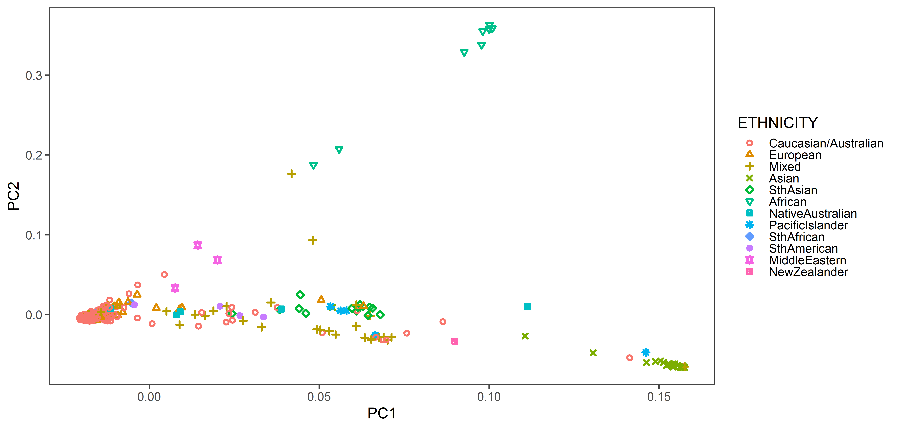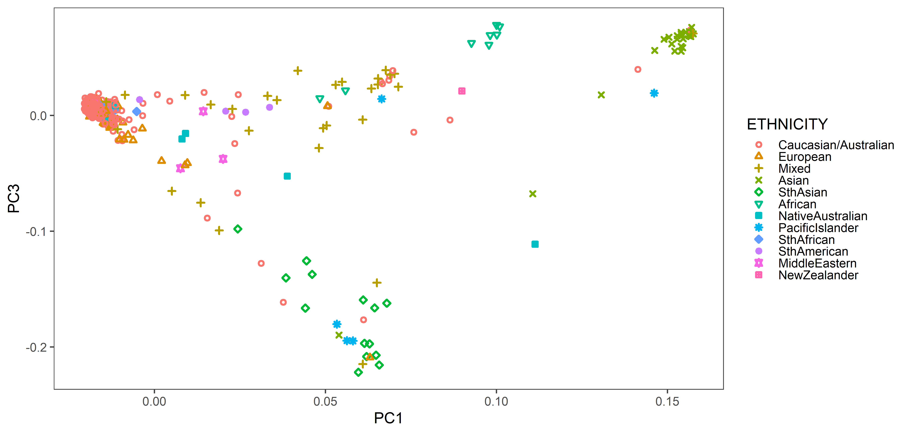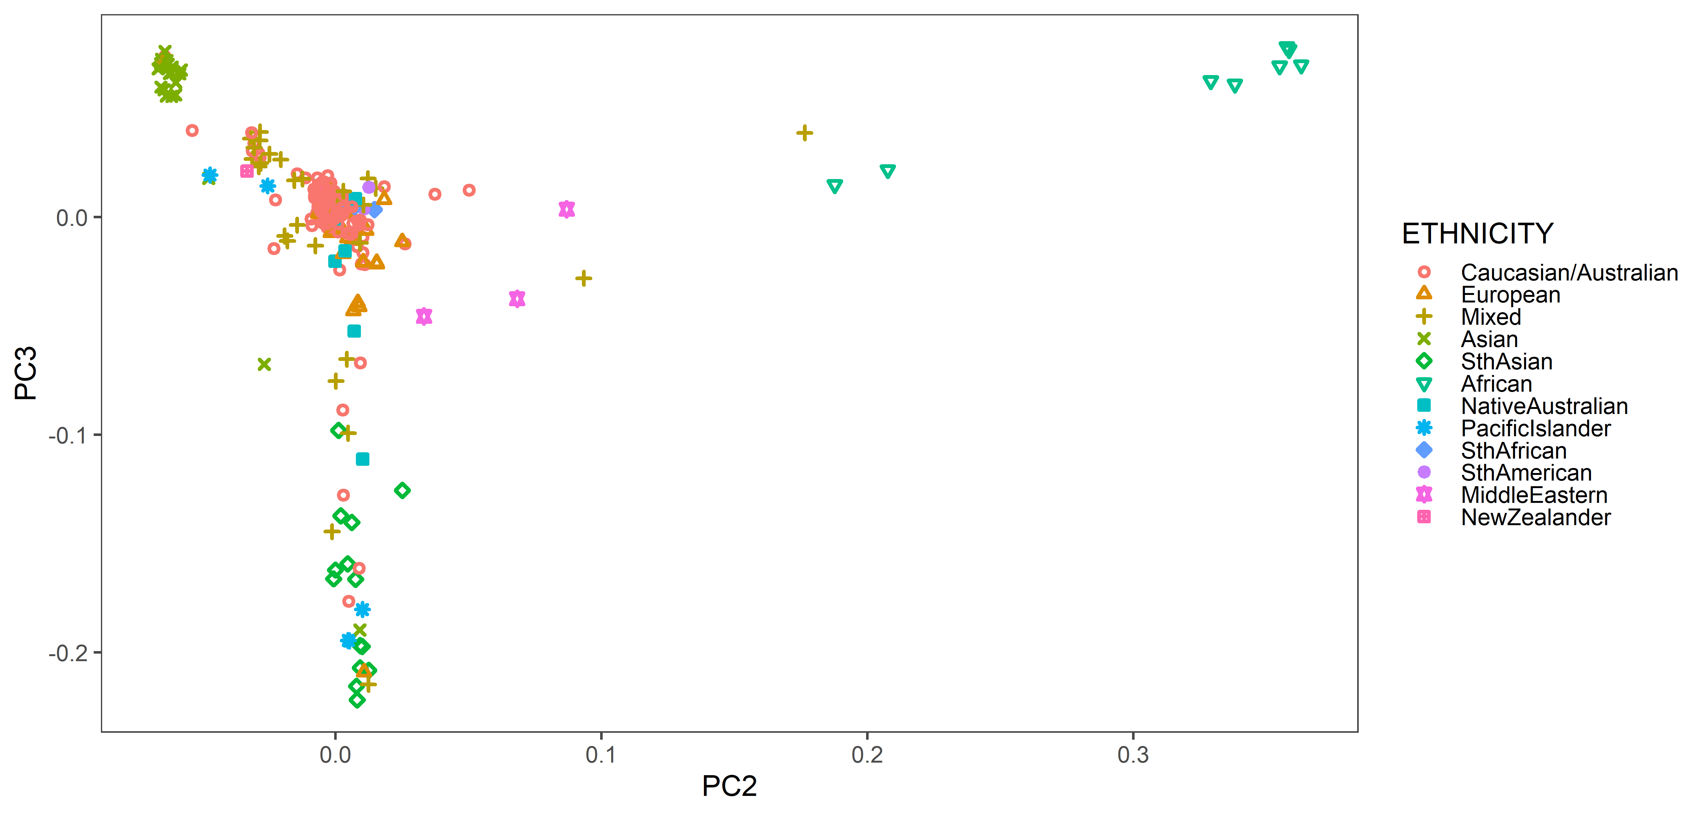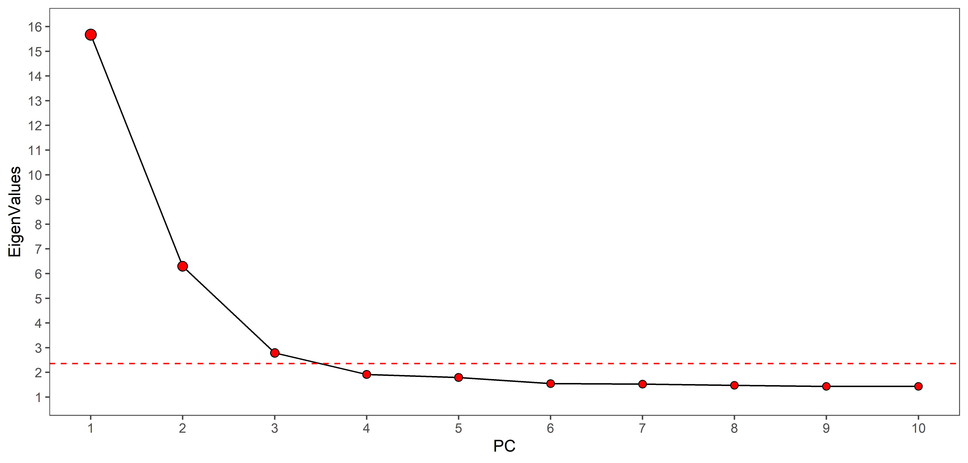
D
C
B
A

