Fig. S1a. Gel electrophoresis images during PCR verification
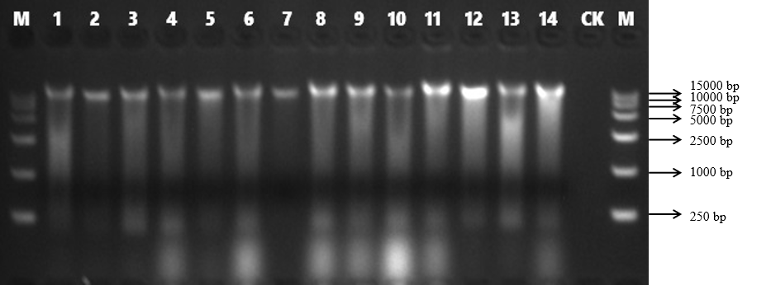

Fig. S1b. Gel electrophoresis images obtained during PCR verification. The samples in the red box are that used in the manuscript
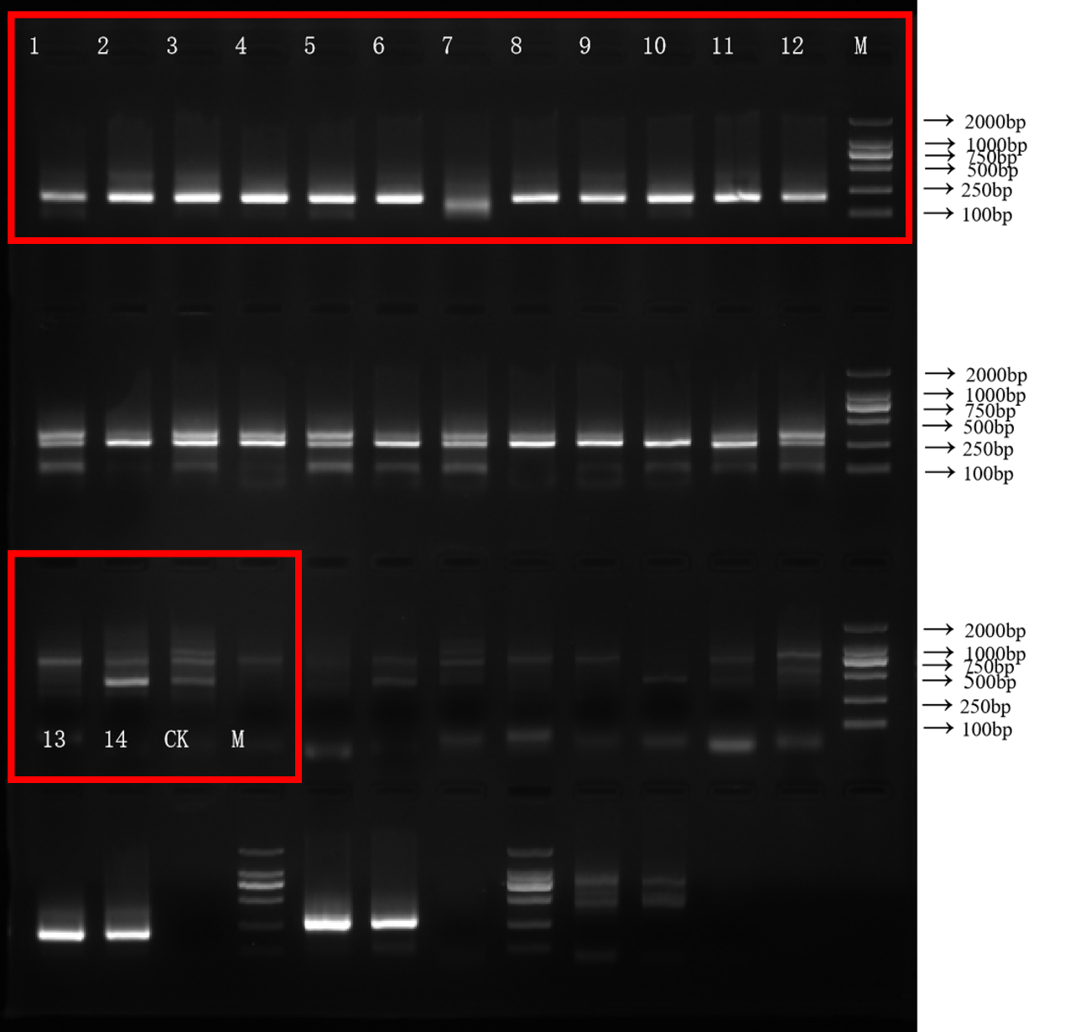
Tab. S1. The table shows the four primers used in this study, (a) Amplification of the mitochondrial 12S rRNA gene in fish, (b) Generic primer for the mitochondrial COI gene, (c) Mifish 12S primer, (d) Mifish 12S primer (high variant type)
Serial number | Gene abbreviations | Gene name | Primer | Amplified fragment size | References
(a) | Amplification of the mitochondrial 12s gene in fish | - | forward: 5'-ACTGGGATTAGATACCCC-3' | Around 200bp | (Miya et al., 2015)
(a) | Amplification of the mitochondrial 12s gene in fish | - | reverse: 5'-TAGAACAGGCTCCTCTAG-3' | PE250 | (Miya et al., 2015)
(b) | COI | Mitochondrial COI gene | COI-CYBF：TTCCTAGCCATACAYTAYAC | 285bp | (Miya & Nishida, 2000)
(b) | COI | Mitochondrial COI gene | COI-CYBR：GGTGGCKCCTCAGAAGGACATTTGKCCYCA | PE250 | (Miya & Nishida, 2000)
(c) | Fish mitochondrial 12s amplification Mifish | Fish mitochondrial 12s amplification | MiFish-U-F：GTYGGTAAAWCTCGTGCCAGC | Around 200bp | (Miya et al., 2015)
(c) | Fish mitochondrial 12s amplification Mifish | Fish mitochondrial 12s amplification | MiFish-U-R： CATAGTGGGGTATCTAATCCYAGTTTG | PE250 | (Miya et al., 2015)
(d) | Fish mitochondrial 12s amplification Mifish** | MiFish-U-F | 5'-GTCGGTAAAACTCGTGCCAGC-3' | Around 200bp | (Miya et al., 2015)
(d) | Fish mitochondrial 12s amplification Mifish** | MiFish-U-R | 5'-CATAGTGGGGTATCTAATCCCAGTTTG-3' | PE250 | (Miya et al., 2015)

Tab. S2. Identification of fish species by traditional ecological methods and eDNA technology at 14 sites in the typical watershed of the Liao River
Samples | Genus | Species | eDNA sequencing results
A1-A3 | Culter | Culter alburnus | +
 | Rhynchocypris | Rhynchocypris lagowskii | -
 | Hemiculter | Hemiculter leucisculusa | +
 | Hypophthalmichthys | Hypophthalmichthys molitrixa | -
 | Arius | Sea catfish | -
 | Cyprinus | Cyprinus carpio | +
 | Pelteobagrus | Pelteobagrus fulvidraco | -
A4 | Hemiculter | Hemiculter leucisculus | +
 | Pseudorasbora | Pseudorasbora parva | +
 | Carassius | Carassius auratus | +
 | Misgurnus | Misgurnus anguillicaudatus | +
 | Hypseleotris | Hypseleotris swinhonis | -
 | Pelteobagrus | Pelteobagrus fulvidraco | -
A5 | Rhodeus | Rhodeus ocellatus | +
 | Hemiculter | Hemiculter leucisculus | +
 | Squaliobarbus | Squaliobarbus curriculus | +
 | Pseudorasbora | Pseudorasbora parva | +
 | Carassius | Carassius auratus | +
 | Silurus | Silurus asotus | +
 | Perccottus | Perccottus glenii | -
A6 | Hemiculter | Hemiculter leucisculus | +
 | Rhodeus | Rhodeus ocellatus | +
 | Squaliobarbus | Squaliobarbus curriculus | +
 | Carassius | Carassius auratus | +
 | Pseudorasbora | Pseudorasbora parva | +
 | Cobitis | Cobitis taeniaLinnaeus | -
 | Misgurnus | Misgurnus anguillicaudatus | +
A7 | Hemiculter | Hemiculter leucisculus | +
 | Pseudorasbora | Pseudorasbora parva | +
 | Rhodeus | Rhodeus ocellatus | +
 | Carassius | Carassius auratus | +
 | Cobitis | Cobitis taeniaLinnaeus | -
 | Misgurnus | Misgurnus anguillicaudatus | +
 | Mimogobius | Mimogobius botelensis | +
 | Cyprinus | Cyprinus carpio | +
 | Pelteobagrus | Pelteobagrus fulvidraco | -
A8 | Rhodeus | Rhodeus ocellatus | +
 | Hemiculter | Hemiculter leucisculus | +
 | Pseudorasbora | Pseudorasbora parva | +
 | Rhodeus | Rhodeus ocellatus | +
 | Misgurnus | Misgurnus anguillicaudatus | +
 | Hypseleotris | Hypseleotris swinhonis | -
A9 | Rhodeus | Rhodeus ocellatus | +
 | Carassius | Carassius auratus | +
 | Pseudorasbora | Pseudorasbora parva | +
 | Cobitis | Cobitis taeniaLinnaeus | -
 | Odontobutis | Odontobutis obscurus | -
 | Cyprinus | Cyprinus carpio | +
A10 | Carassius | Carassius auratus | +
 | Hemiculter | Hemiculter leucisculus | +
 | Silurus | Silurus asotus | +
A11 | Hemiculter | Hemiculter leucisculus | +
 | Pseudorasbora | Pseudorasbora parva | +
 | Rhynchocypris | Rhynchocypris lagowskii | -
 | Pseudorasbora | Pseudorasbora parva | +
 | Carassius | Carassius auratus | +
 | Misgurnus | Misgurnus anguillicaudatus | +
A12 | Hemiculter | Hemiculter leucisculus | +
 | Rhynchocypris | Rhynchocypris lagowskii | -
 | Rhodeus | Rhodeus ocellatus | +
 | Pseudorasbora | Pseudorasbora parva | +
 | Carassius | Carassius auratus | +
 | Cyprinus | Cyprinus carpio | +
A13 | Hemiculter | Hemiculter leucisculus | +
 | Rhynchocypris | Rhynchocypris lagowskii | -
 | Rhodeus | Rhodeus ocellatus | +
 | Pseudorasbora | Pseudorasbora parva | +
 | Carassius | Carassius auratus | +
 | Cyprinus | Cyprinus carpio | +
 | Pseudorasbora | Pseudorasbora parva | +
A14 | Hemiculter | Hemiculter leucisculus | +
 | Pseudorasbora | Pseudorasbora parva | +
 | Carassius | Carassius auratus | +
 | Lophius | Lophius litulon | -
 | Rhodeus | Rhodeus ocellatus | +
 | Cyprinus | Cyprinus carpio | +
Note: “+” indicates those identified by eDNA technology, “-” indicates those not identified by eDNA technology.

