Supplementary Table

Table 1. Structure of cannabinoids used in this study
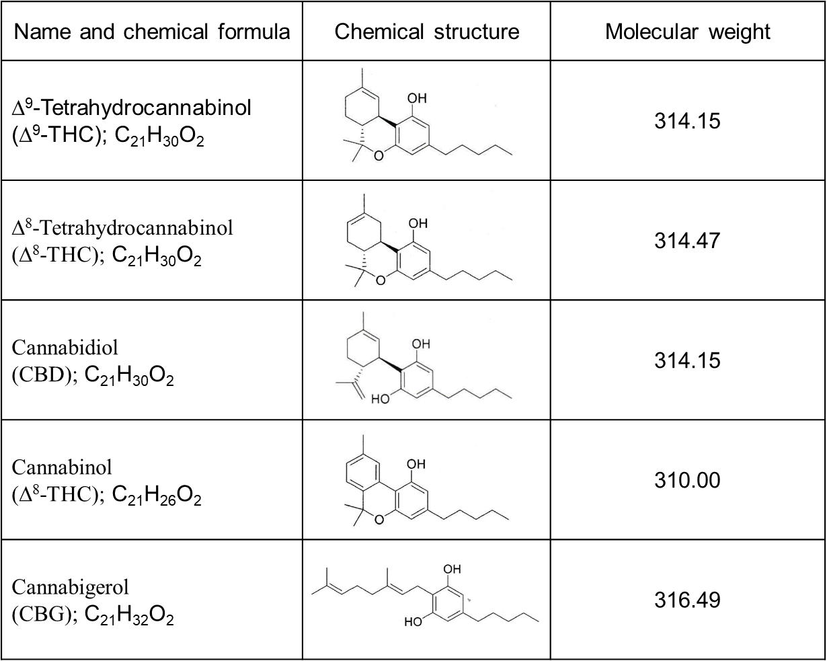

Supplementary Table 2. Sequences of primer set used in RT-qPCR

Gene | Primer sequence (5´3´)
Il1b | For: TTGACTTCTATCTTGTTGA
Il1b | Rev: TATACCTGTCCTGTGTAA
Il12b | For: AACCTCACCTGTGACACGCC
Il12b | Rev: CAAGTCCARGTTTCTTTGCACC
Nos2 | For: CCGAAGCAAACATCACATTCA
Nos2 | Rev: GGTCTAAAGGCTCCGGGCT
Arg1 | For: CAGATATGCAGGGAGTCACC
Arg1 | Rev: CAGAAGAATGGAAGAGTCAG
Retnla | For: AGGAACTTCTTGCCAATCCA
Retnla | Rev: ACAAAGCACACCCAGTAGCAG
Cnr1 | For: ATCGGAGTCACCAGTGTGCTGT
Cnr1 | Rev: CCTTGCCATCTTCTGAGGTGTG
Cnr2 | For: CTCGGTTACAGAAACAGAGGCTGATGTG
Cnr2 | Rev: TCTCTCTTCGAGGGAGTGAACTGAACG
Actb | For: ACCAACTGGGACGACATGGAG
Actb | Rev: GTGGTGGTGAAGCTGTAGCC

