Supplementary Table 1. Antibodies used in the study.
Antibody | Brand | Reference | Source |  | Dilution | Expected MW (kDa)
Primary antibodies
TH | Milllipore | MAB139 |  | Mouse | 1:1000 | 55-60
DAT | Santa Cruz | SC32258 |  | Rat | 1:1000 | 55
D₂R | Santa Cruz | SC5303 |  | Mouse | 1:1000 | 50
β-actin | Abcam | ab40390 |  | Mouse | 1 :2000 | 42
Secondary antibodies
Anti-IgG | Santa Cruz |  |  | Rat | 1:5000
Anti-IgG | Santa Cruz |  |  | Mouse | 1:10000

Abbreviations: D₂R, dopamine D₂ receptor; DAT, dopamine transporters; IgG, Immunoglobulin G; TH, tyrosine hydroxylase.

Supplementary Table 2. Primer sequences used in qPCR studies.

Target | Forward Primer | Reverse Primer
TH (r) | 5’GAGGCTGTCACGTCCCCAA3’ | 5’GGAGGAGGGTTTTGTACCCC3’
DAT (r) | 5’CAACGGTGGCATCTACGTCT3’ | 5’CTGAATTGCTGGACGCCGTA3’
D₂R (r) | 5’GTGCCCTTCATCGTCACTCT3’ | 5’GGTGGGTACAGTTGCCCTTG3’
MAOA (r) | 5’ACTGCTCGGGAATTTGCGTA3’ | 5’CAAATTTCCGTTCCTGGCCG3’
COMT (r) | 5’GTGGCCTTGAGGAGATGCC3’ | 5’CTCCAGGCTTTGCATTCTGC3’
ACTB (r) | 5’TACTGCCCTGGCTCCTAGC3’ | 5’TCAGGAGGAGCAATGATCTTGAT3’

Abbreviations: Actb, β-actin; COMT, catechol-O-methyltransferase; D₂R, dopamine D2 receptor; DAT, dopamine transporters; MAOA, monoamine oxidase A; r, rat; TH, tyrosine hydroxylase.
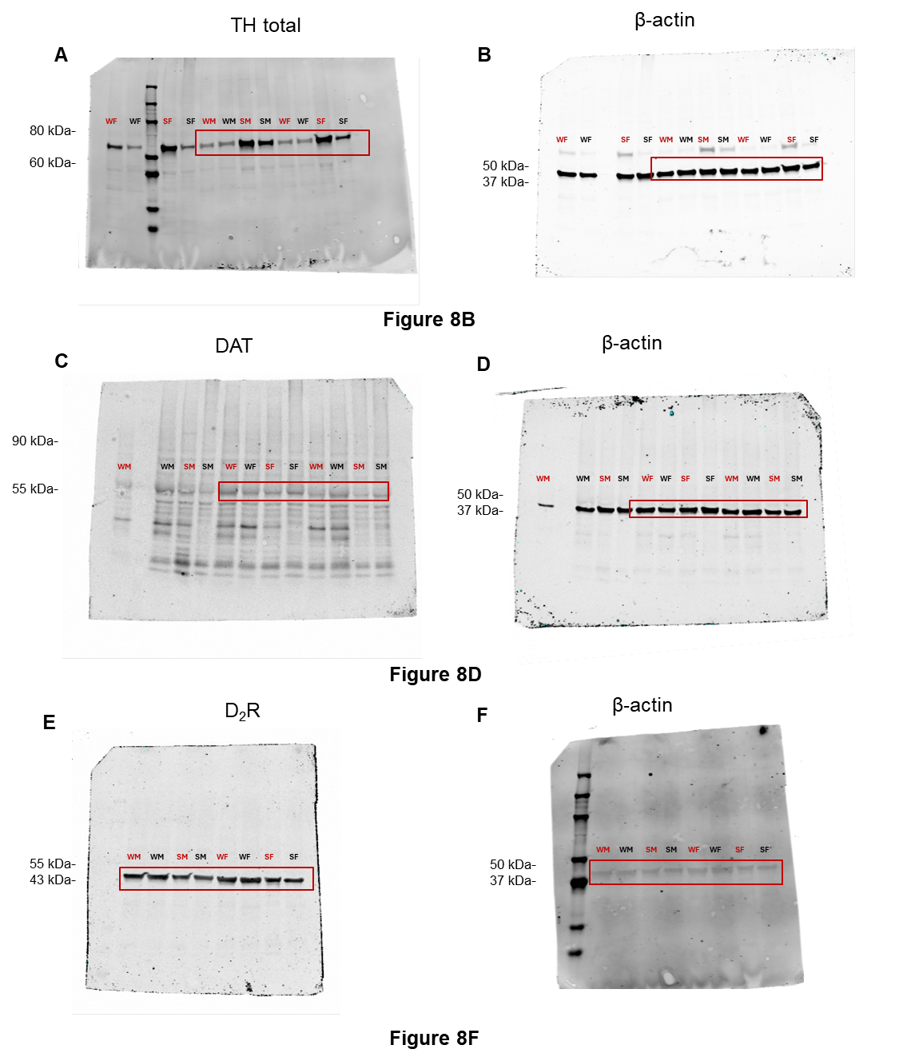

Supplementary Figure 1. Full blots relative to panels presented in Figure 8. Abbreviations: WM, WKY male; WF, WKY female; SM, SHR male; SF, SHR female. Red symbols indicate control groups, and black symbols indicate swimming groups.

Supplementary Statistics Data

Results
Swimming during pregnancy decreased the weight of WKY and SHR offspring in PND 07

ANOVA – Weight PND 07
Cases | Mean Square | F | p
STRAIN | 365.612 | 89.144 | < .001
TREATMENT | 0.082 | 0.020 | 0.888
STRAIN ✻ TREATMENT | 78.634 | 19.173 | < .001
SEX | 5.614 | 1.369 | 0.245
STRAIN ✻ SEX | 4.087 | 0.997 | 0.321
TREATMENT ✻ SEX | 8.589 | 2.094 | 0.152
STRAIN ✻ TREATMENT ✻ SEX | 0.318 | 0.077 | 0.782
Residuals | 4.101
Note. Sum of squares Type III

ANOVA - Weight PND 14
Cases | Mean Square | F | p
STRAIN | 1683.029 | 100.714 | < .001
TREATMENT | 0.319 | 0.019 | 0.890
SEX | 31.925 | 1.910 | 0.171
STRAIN ✻ TREATMENT | 0.626 | 0.037 | 0.847
STRAIN ✻ SEX | 21.890 | 1.310 | 0.256
TREATMENT ✻ SEX | 56.745 | 3.396 | 0.069
STRAIN ✻ TREATMENT ✻ SEX | 43.493 | 2.603 | 0.111
Residuals | 16.711
Note. Sum of squares Type III

Gestational swimming recovered neonatal neurodevelopmental delays in SHR Offspring

ANOVA - Righting reflex PND 07
Cases | Mean Square | F | p
STRAIN | 200.265 | 10.259 | 0.002
TREATMENT | 170.160 | 8.717 | 0.001
SEX | 91.290 | 4.677 | 0.034
STRAIN ✻ TREATMENT | 96.120 | 4.924 | 0.029
STRAIN ✻ SEX | 176.468 | 9.040 | 0.004
TREATMENT ✻ SEX | 72.823 | 3.731 | 0.057
STRAIN ✻ TREATMENT ✻ SEX | 88.348 | 4.526 | 0.036
Residuals | 19.520
Note. Sum of squares Type III

ANOVA - Righting reflex PND 14
Cases | Mean Square | F | p
STRAIN | 2.873 | 15.325 | < .001
TREATMENT | 3.180 | 16.962 | < .001
SEX | 0.199 | 1.060 | 0.306
STRAIN ✻ TREATMENT | 1.182 | 6.304 | 0.014
STRAIN ✻ SEX | 0.129 | 0.686 | 0.410
TREATMENT ✻ SEX | 0.233 | 1.243 | 0.268
STRAIN ✻ TREATMENT ✻ SEX | 0.028 | 0.148 | 0.702
Residuals | 0.187
Note. Sum of squares Type III

ANOVA - Negative geotaxis PND 07
Cases | Mean Square | F | p
STRAIN | 2018.528 | 20.085 | < .001
TREATMENT | 125.439 | 1.248 | 0.267
SEX | 227.783 | 2.266 | 0.136
STRAIN ✻ TREATMENT | 125.439 | 1.248 | 0.267
STRAIN ✻ SEX | 227.783 | 2.266 | 0.136
TREATMENT ✻ SEX | 253.259 | 2.520 | 0.116
STRAIN ✻ TREATMENT ✻ SEX | 253.259 | 2.520 | 0.116
Residuals | 100.502
Note. Sum of squares Type III

ANOVA - Negative geotaxis PND 14
Cases | Mean Square | F | p
STRAIN | 14929.945 | 71.072 | < .001
TREATMENT | 406.135 | 1.933 | 0.168
SEX | 287.336 | 1.368 | 0.246
STRAIN ✻ TREATMENT | 488.814 | 2.327 | 0.131
STRAIN ✻ SEX | 163.315 | 0.777 | 0.381
TREATMENT ✻ SEX | 28.545 | 0.136 | 0.713
STRAIN ✻ TREATMENT ✻ SEX | 7.105 | 0.034 | 0.855
Residuals | 210.067
Note. Sum of squares Type III

ANOVA - Olfactory recognition PND 07
Cases | Mean Square | F | p
STRAIN | 109846.122 | 62.771 | < .001
TREATMENT | 4521.380 | 2.584 | 0.112
SEX | 65.584 | 0.037 | 0.847
STRAIN ✻ TREATMENT | 4521.380 | 2.584 | 0.112
STRAIN ✻ SEX | 65.584 | 0.037 | 0.847
TREATMENT ✻ SEX | 341.249 | 0.195 | 0.660
STRAIN ✻ TREATMENT ✻ SEX | 341.249 | 0.195 | 0.660
Residuals | 1749.938
Note. Sum of squares Type III

ANOVA - Olfactory recognition PND 14
Cases | Mean Square | F | p
STRAIN | 42756.715 | 20.427 | < .001
TREATMENT | 18453.659 | 8.816 | 0.004
SEX | 2802.788 | 1.339 | 0.251
STRAIN ✻ TREATMENT | 4701.630 | 2.246 | 0.138
STRAIN ✻ SEX | 58.478 | 0.028 | 0.868
TREATMENT ✻ SEX | 2342.318 | 1.119 | 0.293
STRAIN ✻ TREATMENT ✻ SEX | 17323.854 | 8.277 | 0.005
Residuals | 2093.134
Note. Sum of squares Type III

Swimming during pregnancy did not alter anxiety-related behavior of WKY and SHR adolescent offspring in the elevated plus maze

ANOVA – Percentage of entries in open arms (%EA)
Cases | Mean Square | F | p
STRAIN | 16.572 | 0.166 | 0.685
TREATMENT | 34.720 | 0.348 | 0.557
SEX | 58.227 | 0.583 | 0.448
STRAIN ✻ TREATMENT | 426.219 | 4.268 | 0.042
STRAIN ✻ SEX | 128.253 | 1.284 | 0.261
TREATMENT ✻ SEX | 66.189 | 0.663 | 0.418
STRAIN ✻ TREATMENT ✻ SEX | 12.544 | 0.126 | 0.724
Residuals | 99.860
Note. Sum of squares Type III

ANOVA - Percentage of time in open arms (%TA)
Cases | Mean Square | F | p
STRAIN | 395.188 | 1.295 | 0.259
TREATMENT | 482.236 | 1.580 | 0.213
SEX | 15.136 | 0.050 | 0.824
STRAIN ✻ TREATMENT | 365.138 | 1.196 | 0.278
STRAIN ✻ SEX | 32.393 | 0.106 | 0.746
TREATMENT ✻ SEX | 898.857 | 2.944 | 0.091
STRAIN ✻ TREATMENT ✻ SEX | 162.799 | 0.533 | 0.468
Residuals | 305.267
Note. Sum of squares Type III

ANOVA - Percentage of entries in enclosed arm
Cases | Mean Square | F | p
STRAIN | 16.572 | 0.166 | 0.685
TREATMENT | 34.720 | 0.348 | 0.557
SEX | 58.227 | 0.583 | 0.448
STRAIN ✻ TREATMENT | 426.219 | 4.268 | 0.769
STRAIN ✻ SEX | 128.253 | 1.284 | 0.261
TREATMENT ✻ SEX | 66.189 | 0.663 | 0.418
STRAIN ✻ TREATMENT ✻ SEX | 12.544 | 0.126 | 0.724
Residuals | 99.860
Note. Sum of squares Type III

Effects of swimming during pregnancy on locomotor activity, memory habituation and emotional behavior of WKY and SHR adolescent offspring in open field

ANOVA - Total distance traveled
Cases | Mean Square | F | p
STRAIN | 288.479 | 5.608 | 0.020
TREATMENT | 440.637 | 8.565 | 0.005
SEX | 185.892 | 3.614 | 0.061
STRAIN ✻ TREATMENT | 479.628 | 9.323 | 0.003
STRAIN ✻ SEX | 67.344 | 1.309 | 0.256
TREATMENT ✻ SEX | 0.069 | 0.001 | 0.971
STRAIN ✻ TREATMENT ✻ SEX | 125.960 | 2.449 | 0.122
Residuals | 51.443
Note. Sum of squares Type III

ANOVA - Latency to first entry in central zone
Cases | Mean Square | F | p
STRAIN | 209311.383 | 18.554 | < .001
TREATMENT | 26763.251 | 2.372 | 0.128
SEX | 316.939 | 0.028 | 0.867
STRAIN ✻ TREATMENT | 12022.842 | 1.066 | 0.306
STRAIN ✻ SEX | 4052.360 | 0.359 | 0.551
TREATMENT ✻ SEX | 9230.697 | 0.818 | 0.369
STRAIN ✻ TREATMENT ✻ SEX | 2616.214 | 0.232 | 0.632
Residuals | 11280.919
Note. Sum of squares Type III

ANOVA - Percentage of time in central zone
Cases | Mean Square | F | p
STRAIN | 29.996 | 2.168 | 0.145
TREATMENT | 29.640 | 2.142 | 0.148
STRAIN ✻ TREATMENT | 20.890 | 1.510 | 0.223
SEX | 3.808 | 0.275 | 0.601
STRAIN ✻ SEX | 3.127 | 0.226 | 0.636
TREATMENT ✻ SEX | 0.027 | 0.002 | 0.965
STRAIN ✻ TREATMENT ✻ SEX | 10.859 | 0.785 | 0.379
Residuals | 13.838
Note. Sum of squares Type III

ANOVA - Percentage of locomotion in central zone
Cases | Mean Square | F | p
STRAIN | 236.165 | 12.575 | < .001
TREATMENT | 25.045 | 1.334 | 0.252
STRAIN ✻ TREATMENT | 7.255 | 0.386 | 0.536
SEX | 1.893 | 0.101 | 0.752
STRAIN ✻ SEX | 0.049 | 0.003 | 0.959
TREATMENT ✻ SEX | 4.307 | 0.229 | 0.633
STRAIN ✻ TREATMENT ✻ SEX | 10.440 | 0.556 | 0.458
Residuals | 18.781
Note. Sum of squares Type III

ANOVA – Total distance day 2
Cases | Mean Square | F | p
STRAIN | 219.782 | 4.486 | 0.037
TREATMENT | 54.004 | 0.979 | 0.326
SEX | 136.456 | 2.475 | 0.120
STRAIN ✻ TREATMENT | 43.313 | 0.786 | 0.378
STRAIN ✻ SEX | 5.439 | 0.099 | 0.754
TREATMENT ✻ SEX | 74.498 | 1.351 | 0.249
STRAIN ✻ TREATMENT ✻ SEX | 55.250 | 1.002 | 0.320
Residuals | 55.140
Note. Sum of squares Type III

Repeated measurements ANOVA - Habituation memory
Cases | Mean Square | F | p
RM Factor 1 | 383.215 | 12.782 | < .001
RM Factor 1 ✻ STRAIN | 2.332 | 0.078 | 0.781
RM Factor 1 ✻ TREATMENT | 93.061 | 3.104 | 0.082
RM Factor 1 ✻ SEX | 1.907 | 0.064 | 0.802
RM Factor 1 ✻ STRAIN ✻ TREATMENT | 405.604 | 13.529 | < .001
RM Factor 1 ✻ STRAIN ✻ SEX | 17.253 | 0.575 | 0.450
RM Factor 1 ✻ TREATMENT ✻ SEX | 39.546 | 1.319 | 0.254
RM Factor 1 ✻ STRAIN ✻ TREATMENT ✻ SEX | 7.183 | 0.240 | 0.626
Residuals | 29.980
Note. Sum of squares Type III

Effect between subjects – habituation memory
Cases | Mean Square | F | p
STRAIN | 505.929 | 6.605 | 0.012
TREATMENT | 401.580 | 5.242 | 0.025
SEX | 320.440 | 5,0 | 0.02
STRAIN ✻ TREATMENT | 117.338 | 1.532 | 0.220
STRAIN ✻ SEX | 55.530 | 0.725 | 0.397
TREATMENT ✻ SEX | 35.020 | 0.457 | 0.501
STRAIN ✻ TREATMENT ✻ SEX | 174.027 | 2.272 | 0.136
Residuals | 76.603
Note. Sum of squares Type III

Gestational swimming reduces novelty seeking in adolescent SHR Offspring

ANOVA - Novelty seeking
Cases | Mean Square | F | p
STRAIN | 3554.085 | 15.465 | < .001
TREATMENT | 1746.864 | 7.601 | 0.007
SEX | 666.320 | 2.899 | 0.093
STRAIN ✻ TREATMENT | 686.937 | 2.989 | 0.088
STRAIN ✻ SEX | 22.097 | 0.096 | 0.757
TREATMENT ✻ SEX | 0.002 | 9.712×10⁻⁶ | 0.998
STRAIN ✻ TREATMENT ✻ SEX | 298.037 | 1.297 | 0.258
Residuals | 229.809
Note. Sum of squares Type III

Gestational swimming decreased the expression of DAT and dopamine D₂ receptors in the SHR in the PFC

ANOVA - TH
Cases | Mean Square | F | p
STRAIN | 1.239 | 2.475 | 0.126
TREATMENT | 0.024 | 0.048 | 0.828
STRAIN ✻ TREATMENT | 0.364 | 0.757 | 0.400
SEX | 0.015 | 0.030 | 0.864
STRAIN ✻ SEX | 0.362 | 0.723 | 0.402
TREATMENT ✻ SEX | 0.210 | 0.419 | 0.522
STRAIN ✻ TREATMENT ✻ SEX | 0.367 | 0.733 | 0.398
Residuals | 0.501
Note. Sum of squares Type III

ANOVA - DAT
Cases | Mean Square | F | p
STRAIN | 123.85 | 2.599 | 0.118
TREATMENT | 201.54 | 4.329 | 0.035
STRAIN ✻ TREATMENT | 137.565 | 2.710 | 0.111
SEX | 95.828 | 1.888 | 0.180
STRAIN ✻ SEX | 25.530 | 0.503 | 0.484
TREATMENT ✻ SEX | 120.284 | 2.369 | 0.135
STRAIN ✻ TREATMENT ✻ SEX | 23.564 | 0.464 | 0.501
Residuals | 50.766
Note. Sum of squares Type III

ANOVA – D2R
Cases | Mean Square | F | p
STRAIN | 28.437 | 11.647 | 0.002
TREATMENT | 23.703 | 9.708 | 0.004
STRAIN ✻ TREATMENT | 14.646 | 5.999 | 0.020
SEX | 2.553 | 1.046 | 0.314
STRAIN ✻ SEX | 6.029 | 2.469 | 0.126
TREATMENT ✻ SEX | 4.118 | 1.686 | 0.204
STRAIN ✻ TREATMENT ✻ SEX | 8.187 | 3.353 | 0.077
Residuals | 2.442
Note. Sum of squares Type III

Swimming during pregnancy did not affect the level of dopaminergic neurotransmission proteins in the FC

ANOVA - TH
Cases | Mean Square | F |  | p
STRAIN | 1.2 | 0.377 |  | 0.545
TREATMENT | 0.080 | 0.324 |  | 0.574
STRAIN ✻ TREATMENT | 0.087 | 0.355 |  | 0.557
SEX | 0.016 | 0.066 |  | 0.800
STRAIN ✻ SEX | 0.261 | 1.061 |  | 0.313
TREATMENT ✻ SEX | 0.014 | 0.059 |  | 0.811
STRAIN ✻ TREATMENT ✻ SEX | 0.017 | 0.069 |  | 0.796
Residuals | 0.246
Note. Sum of squares Type III
ANOVA - DAT
Cases | Mean Square | F | p
STRAIN | 0.237 | 1.510 | 0.231
TREATMENT | 0.019 | 0.124 | 0.728
STRAIN ✻ TREATMENT | 0.013 | 0.080 | 0.779
SEX | 0.112 | 0.715 | 0.406
STRAIN ✻ SEX | 0.081 | 0.515 | 0.480
TREATMENT ✻ SEX | 0.115 | 0.735 | 0.400
STRAIN ✻ TREATMENT ✻ SEX | 0.011 | 0.073 | 0.790
Residuals | 0.157
Note. Sum of squares Type III

ANOVA - D2R
Cases | Mean Square | F | p
STRAIN | 7.054 | 0.464 | 0.502
TREATMENT | 3.576 | 0.235 | 0.632
STRAIN ✻ TREATMENT | 0.639 | 0.042 | 0.839
SEX | 0.002 | 9.999×10⁻⁵ | 0.992
STRAIN ✻ SEX | 8.729 | 0.575 | 0.456
TREATMENT ✻ SEX | 0.378 | 0.025 | 0.876
STRAIN ✻ TREATMENT ✻ SEX | 0.845 | 0.056 | 0.816
Residuals | 15.190
Note. Sum of squares Type III

