Supplementary information

A perfusable decellularized plant-based air-liquid-interface-on-a-chip for investigating inorganic dust aerosol exposure
Omur Sert†, Tolga Erdogan†, Yagmur Arslan, Ozlem Yesil-Celiktas🖂

† these authors contributed equally to this work

Table S1. Functional groups and vibration mode from ATR-FTIR spectra of the native and decellularized spinach leaves

Band position (cm⁻¹) | Vibration Mode | References
3300 | O-H bending of water | [1,2]
1734 | C=O stretching of esters | [1]
1422 | CH₂ scissoring in cellulose | [1]
1317 | CH₂ rocking in cellulose | [1]

Table S2. List of genes used in qRT-RCR

Genes | Primer Sequencing (5'-3')
E-Cadherin (CDH1) | F- GCCGAGAGCTACACGTTCA  R- GACCGGTGCAATCTTCAAA
VE-cadherin (CDH5) | F- CTTCACCCAGACCAAGTACACA  R- TGTTGGCCGTGTTATCGTGA
ZO-1 (TJP1) | F- TGGTCTGTTTGCCCACTGTT  R- TCTGTACATGCTGGCCAAGG
CASP3 (Caspase-3) | F- ATGGTTTGAGCCTGAGCAGA  R- ACACAAGCCCATTTCAGGGT
GAPDH | F- CGTAGCTCAGGCCTCAAGAC  R- GCTGCGGGCTCAATTTATAG

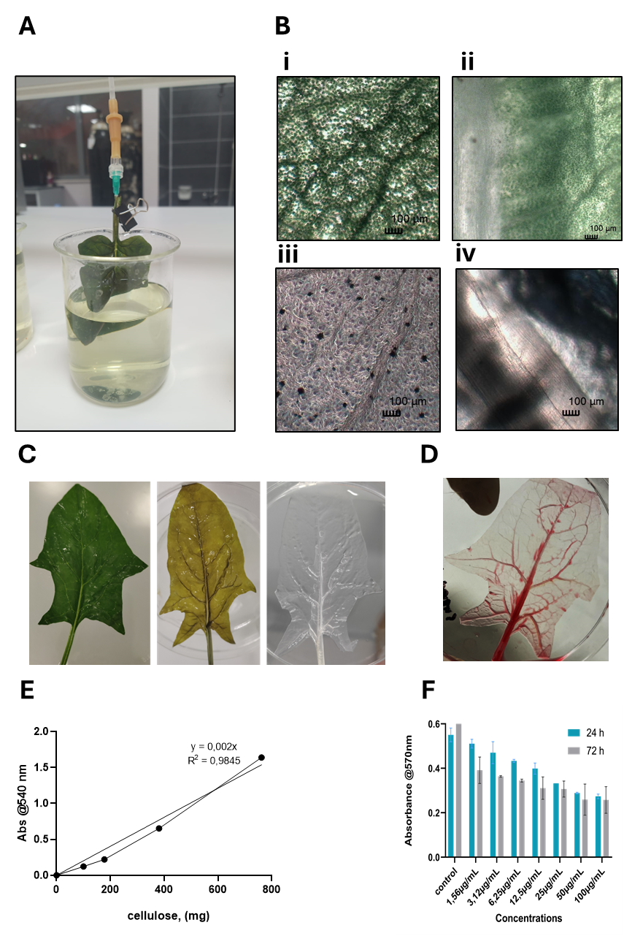

Figure S1. Additional data regarding the characterization of decellularization and cell viability. (A) Macroscopic image of our custom perfusion system. (B) Bright-field images of vascular and non-vascular parts of spinach leaves (i, ii) before and (iii, iv) after decellularization, at 100 µm scale: demonstrating preserved vessel structure and removed cellular material. (C-D) Comparative photographs of leaf surfaces: native (green); decellularized (yellow); post bleach (transparent); and dye perfused (red) scaffolds; showing the integrity of vascular network, down to the capillary level. (E) Cellulose standard curve (R²=0.9845). (F) MTT cell‐viability assay results with optical density measured at 570 nm (mean ± SD, n=4)
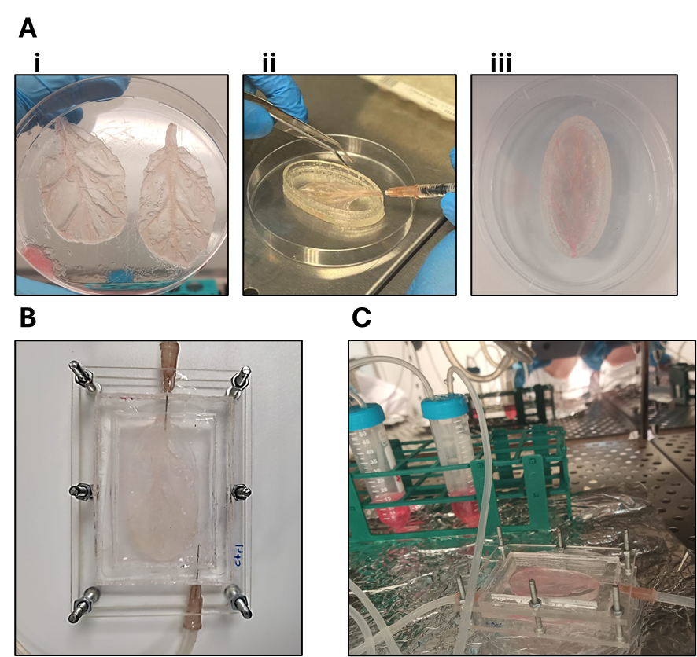

Figure S2. Cell-seeding studies on decellularized leaf scaffold. (A) Schematic of experimental workflow: (i) Conditioning, (ii) HUVEC cell seeding by intravenous injection through the main veins, (iii) BEAS 2B cell seeding on coated leaf surface. (B) Assembled decellularized plant-based ALI on-a-chip platform. (C) Perfusion tubings and reservoirs at 37 °C and 5% CO₂ incubator

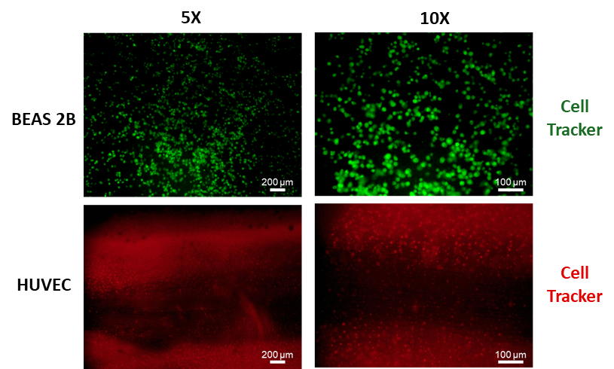

Figure S3. Cell tracker images of the lung epithelial and endothelial cells, green and red, respectively

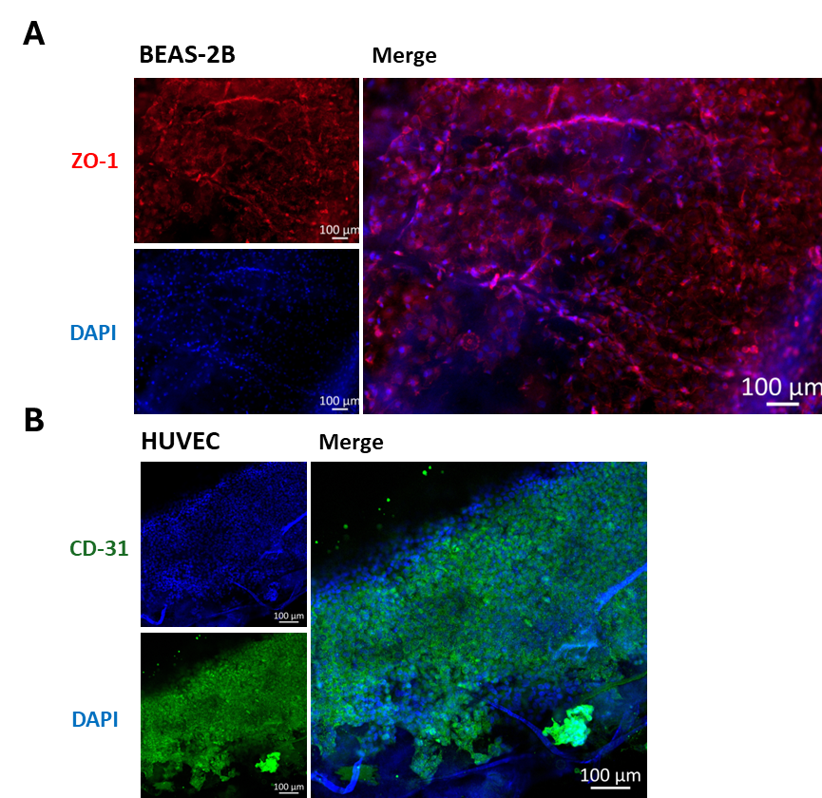

Figure S4. Immunofluorescence images showing (top) ZO-1 (red) and DAPI (blue) localization at the apical epithelial surface and (bottom) CD31 (green) and DAPI (blue) distribution within the vascular endothelial layer

References

[1] A.F. Harris, J. Lacombe, S. Liyanage, M.Y. Han, E. Wallace, S. Karsunky, N. Abidi, F. Zenhausern, Supercritical carbon dioxide decellularization of plant material to generate 3D biocompatible scaffolds, Sci Rep. 11 (2021) 3643. https://doi.org/10.1038/s41598-021-83250-9.
[2] J. A. Hardin, C. L. Jones, P. R. Weckler, N. O. Maness, J. W. Dillwith, R. D. Madden, Rapid Quantification of Spinach Leaf Cuticular Wax Using Fourier Transform Infrared Attenuated Total Reflectance Spectroscopy, Trans ASABE. 56 (2013) 331–339. https://doi.org/10.13031/2013.42579.

Author information
Authors and affiliations
Department of Bioengineering, Faculty of Engineering, Ege University, Izmir, Turkey
Omur Sert

Department of Bioengineering, Faculty of Engineering, Ege University, Izmir, Turkey
Tolga Erdogan

Department of Bioengineering, Faculty of Engineering, Ege University, Izmir, Turkey
Biomechanics section, Department of Mechanical Engineering, KU Leuven, Leuven, Belgium
Yagmur Arslan

Department of Bioengineering, Faculty of Engineering, Ege University, Izmir, Turkey
Translational Pulmonary Research Center (EgeSAM), Ege University, Izmir, Turkey
ODTÜ MEMS Center, Ankara, Turkey
Ozlem Yesil-Celiktas

