Supplemental Material for “Lower Fetal Heart Rate Variability and Parenting Stress Associate with Toddler Psychopathology Risk”

Table S1
Detailed descriptive statistics of key study variables
Variable | N | Mean | SD | Range | Skew | Kurtosis
Fetal HR Mean | 116 | 139.37 | 8.54 | 116.09-162.63 | 0.19 | 0.43
Fetal HR SD | 116 | 5.21 | 1.46 | 2.33-8.53 | 0.20 | -0.80
7-month Parenting Stress | 126 | 58.09 | 13.73 | 29.00-110.00 | 0.58 | 1.30
18-month Internalizing  T Score | 118 | 49.62 | 10.92 | 31.00-90.00 | 0.56 | 0.47
18-month Externalizing  T Score | 91 | 47.07 | 7.31 | 33.00-68.00 | 0.29 | -0.11

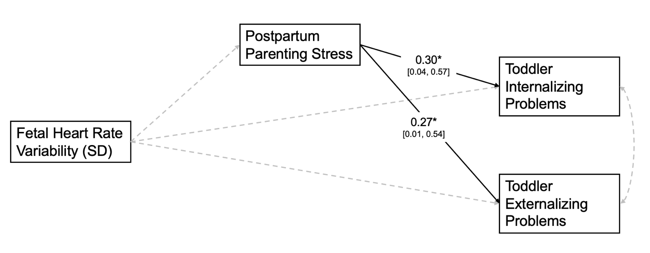
Figure S1. Posthoc path model testing mediation pathway from fetal heart rate variability to toddler psychopathology symptoms via postpartum parenting stress.

